Paraparaumu Bridge Newsletter September (Spring?) 2017

First, congratulations to all members on the success of our annual charity tournament, which was held in conjunction with the Waikanae Club this year. The tournament was supported by some sponsorship from Novella Café and also by generous donations of prizes for the raffles by many of our members. And of course, members’ entry fees were also part of the fundraising.
The donation to the Wellington Free Ambulance amounted to $1,600 – an impressive and highly pleasing result.
The one-session Sunday tournament attracted nearly twenty tables and the winners were our own Jane Bradbury and Stuart Thurston. Runners-up were the Waikanae pair, Graham Cheater and Jeanne Wardill.
Particular thanks to the tournament’s organizer, Bill Sewell and a team of volunteers, especially those providing and preparing the food and refreshments at the end of the day.
A cheerful and happy room – ready for start of play in the Novella Charity Tournament.
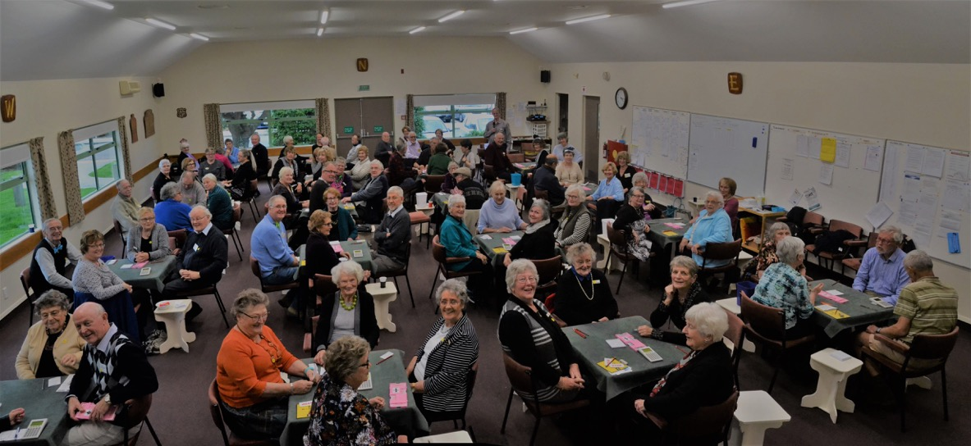
And further congratulations -- to some skilled players on their recent and various successes in regional tournaments. Towards the end of July, Marie Groves and Jane Bradbury were second in the Karori Intermediate Pairs, while Diane Miller and James Winskill competed in our Paraparaumu Junior Pairs and secured second place. In August, Michael Stace and Jane Bradbury won the Waikanae Multigrade Pairs.
New Members
Next, members need to be aware that “newbies” will be starting to appear at the tables in the upcoming weeks. These are players who have been taking the lessons under the overall tutelage of Jane Bradbury, with help from more volunteers, on Monday evenings.
Yes, as well as learning about bidding and playing, they have had help with entering the data on the Bridgemates with how and where to move the boards, and how the Director is called etc
But . . . small slips and mistakes are inevitable, especially as a full session of play at the club may seem daunting to some at first. Please be friendly, supportive, unfailingly pleasant, even when a slip such as a bid or lead out of turn, or a revoke, has occurred. Please give all the newcomers the feeling that they are really welcome in this club. On our website we make the claim that “we’re the friendliest club on the Coast” and let’s back that claim with our words and actions.
Renewal of our lease
After months of negotiations between the owners of the land under our clubrooms, ie the Kapiti District Council, and Ian Nicholls and Brian Pender (representing our Club) we signed off another twenty year lease, under more-or-less identical terms to the previous agreement and it cements in considerable security for the medium to longish term future. The assistance of the Law Connection, one of our sponsors, in these meetings should also be noted.
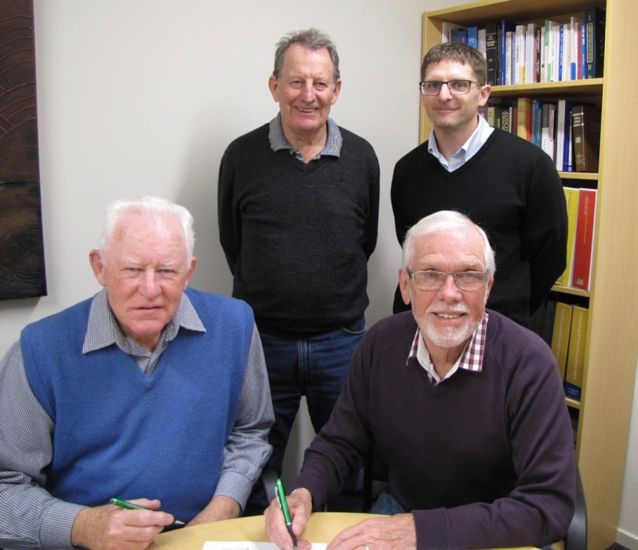
President Brian Pender signs, flanked by Secretary Dennis Lahman, with Past-President, Ian Nicholls (centre back) in support. Peter Corin (The Law Connection) looks on. (“Did you hear the one about the Three Wise Men and the lawyer . . .?”)
The 70% Club
Did you know that there’s a section in the results folder on our website that records the pairs who have achieved a score of 70% (or more!) during the various afternoon and evening club sessions? It’s one thing to win a session, another to attain such a sizzling score when you win.
There are still many, many weeks of club bridge to come in 2017 . . . but if you’re aiming to get your name somewhere on that list, you’d better start improving your game right now. It’s now September (and spring!) but there are only eight pairs who have reached 70% in all the bridge at the club over the previous 8 months of 2017.
Like to make a guess right now at the names that appear most frequently???
Perhaps you guessed right. Jane Bradbury appears three times (with three different partners).
Even more impressive is the top, the absolute peak of the 70% plus club — Leon Hunia and Helen Edwards scored a dazzling 76.5% one night at the start of August.
The 70% club is subtitled, “The Top Twenty Scores of 2017 (over 70%)”. At this rate there might only be a dozen pairs, not twenty, on this particular “honours” list by the time we’re stopping for (or shopping for?) Christmas. So, something to aim for in the next couple of months? 70%!

Paraparaumu Club’s 50th Anniversary
Next year will mark 50 years in the history of our club. The Committee are starting to plan for a celebration over a weekend, including a tournament for all present members and any past members who might want to play and a “birthday” dinner (including partners and spouses). The (tentative) date for the weekend is 14-15 July, 2018. Why then? That is the closest weekend to the date bridge began at the (then) very new Kapiti Duplicate Bridge Club. “The first session was held on July 12, 1968 at the Safari Coffee Lounge with five full tables.” Those of you with extensive social calendars . . . cement it in right now.

Upcoming Tournaments
Our Paraparaumu Multigrade Pairs takes place on Sunday 1 October. This tournament is sponsored by Kena Kena Rest Home and it would be great to fill most of the room with our own members. We do urge your support for “home” tournaments such as this one. Please give this one real consideration.
Other competitions particularly close to home that are looming are the Kapi Mana Intermediate Pairs on 15 October and the Waikanae Intermediate and Junior Pairs on 12 November.
Check the back of your bridge book for other dates in the region between now and the end of the year. The last date listed there is the Wellington Region “Christmas Cheer” on December 9 (a Saturday).
But Sunday 10 December is our final tournament for 2017 – the Paraparaumu Christmas Pairs, sponsored by The Heartland Bank. Again, we do depend on our own members’ support in running these events. Please think about entering this final tournament for the year. A successful and resounding finish to your bridge year?

Housekeeping
A couple of minor matters.
Please keep tidying the tables, clearing the bridgemates and boards, at the end of each session. We don’t want our directors feeling that they are responsible and have to return the room to a ready-for-play state.
Also, some of the committee have tried to eradicate (by water blasting) some stains on the concrete floor of the verandah outside the main entrance. They seem to be the result of spilt coffee and tea. Fine to go out there at the break with your drink, but please run some water over any spilt dregs

Dale’s Tips
Some more on hand evaluation
So the bidding goes N pass, S1D, N1H, S1NT, then all pass. But making 4! Aargh, game missed.
Was it just one of those things where all the cards were nicely placed, or was it less than ideal bidding? Later, there was some “discussion” about North’s bidding, which didn’t reflect well on North.
Here are the hands.

Board 12  Dlr: W  Vul: N-S | J9863  AK73  64  T6
K52  JT2  KQ73  J98 |  | Q7  965  T85  A5432
 | AT4  Q84  AJ92  KQ7 | N/S can actually make 5 spades,  as long as a D or S is not led, by  setting up a C for a D discard.

North’s (faulty) reasoning for bidding hearts before the spades was they didn’t have 10 high card points and therefore couldn’t rebid to the 2 level. They were concerned that if they bid 1 spades then a possible heart fit would be missed. However, as it happened, a spade fit was missed. This is as a result of faulty hand evaluation by North.
The first point is that in modern times bidding to the 2 level is often done with hands down to 8 points. Particularly, as in this case, where North has not opened, so South knows that North has less than an opening hand and any North bids are not forcing.
Secondly, if a heart or spade fit is found then North can revalue their hand to 10 points, adding a distributional point for each doubleton. Or if using losing trick count, there are eight losers, which warrants a bid to the 2 level.
Thirdly, the value of intermediary cards, such as 10’s, 9’s & 8’s are often under estimated. These provide some “guts” to suits and can become winners in their own right. In this case holding 8 to J in the spade suit means there is only one loser in the suit. The 10C and 9D are also useful foils, particularly if in a No Trump contract. This is a useful consideration in close call situations such as this case.

So, how should the bidding have gone? In my opinion something like this (with E/W passing throughout):
N S
P 1D
1S 1NT
2H 3S
4S P
South’s 1NT shows 15 or 16 points, balanced or semi balanced hand. North’s 2H bid is relatively safe because even if a fit is not found then 2NT from South, with combined 23 or 24 points, should usually make. Once North bids 2 hearts then South knows that North has at least 5 spades and 4 hearts. South’s 3S bid shows a maximum hand (16 points) and 3 card support.
North can now revalue their hand and with a combined 26 points, and some good intermediaries, happily go onto game.
However the play is the thing! How do you ensure making four tricks from the spade suit, either with South playing No Trumps or with North playing Spades? Work it through and see!
Also see how you might play the hand with different leads from East or West.
Happy bridging
Dale

