PARAPARAUMU BRIDGE CLUB CHRISTMAS NEWSLETTER

Yes, I know, I know (“Ho,ho! Ho,ho!”) ‘tis the time of year to be flooded with Christmas newsletters.

2018 Prizes
It is impossible to list here all the various winners of so many sessions and competitions decided in 2018 but the following were announced and awarded at the AGM in November.
Eileen Hofland Trophy (most improved player) Eliza Thomson
Couch Award (most promising beginner) Brett and Sandra Windley (shared award)
Babich NZ Wide Pairs Bob Jennings/ Tom Tidey

Life Member!!
At the 2018 AGM, Life Membership was awarded to Helen Edwards. In making the recommendation from the 2018 Committee to the club’s membership (a unanimous recommendation) new President Tony Davies detailed the raft of tasks that Helen has undertaken: Scoring Manager, Bridgemate Coordinator, setting up the Compass system for each new year, directing, ensuring that competition results are correct on the website, distributing information to all members . . . and the list went on and on. It is simpler, perhaps, to quote from Tony’s summary, “If I could, I’d clone Helen, and insert her into the inner circle of quite a few governments to give them some of the same sheer efficiency and stability that this club enjoys.”
Helen’s nomination for Life Membership received a standing ovation from the assembled members and she becomes the fourteenth person to be so recognized by the Paraparaumu Bridge Club. ie there have only been 14 life members in the club’s 50 year history. A very select group.
In a thoughtful reply, Helen stressed how much she felt she’d gained from the Club. Yes, she certainly does get a real sense of personal satisfaction when the club’s operation runs smoothly and efficiently but she also places a high value on the friendships she’s made and maintained through bridge since she joined the Paraparaumu Club in 2002.

Situations Vacant

You will work within a youthful team of positive, motivated and indeed attractive and good-looking colleagues . . . And enjoy high rates of remuneration, with frequent sabbaticals in the South of France.
Sorry, dreams got the better of me just for a moment . . . but the Committee is simply looking for some “back up” ie basically, people who would be prepared to help in some areas that are critical for the club. In general, you are not being asked to be the one responsible, but to assist when we need some extra personnel or back up on the task.
For example? learning the Bar Manager’s role/ assisting the Tournaments Convener/ helping with Tournament Catering/ and do we need from time to time, to keep training members in order to maintain a pool of people who know how to undertake such tasks as dealing and scoring.
That said, there is one specific role where you may be able to help. There is a job/role as Website Manager – keeping our site up to date with results/adding new members/ etc.
Finally, a note about another key area. Trevor Smith has offered to become the Tournament Convenor (accepted with alacrity! And thank you). Trevor has also agreed to have his name put forward to fill a vacancy on the Committee (which will need to be ratified in January).
The Committee are only looking to spread the load by having members who understand what is required for particular tasks and could even be called on to “step up” if the Manager/Convenor is temporarily absent, perhaps through sickness or travel.
Please have a think about any of the above possibilities, over the Christmas break, and have a word to Tony Davies (President) or Rachel Bruce (Vice-President) when bridge starts again in January ???

Slams Bid (and made, too) in 2018
And the award for “slammer of the year” goes to . . . . . . Jane Bradbury. By the absolutely extraordinary margin of 89 slams bid and made to 54. Both Irene Galloway and Doug Galyer tied for that second place on 54 slams. . Certainly plenty of air between first and second place . . .

The 70% Club
Many pairs (18) made it to 70% during 2018. “Best of the best” goes to Michael Stace and Lynda Evans (77%) narrowly from Margaret Norrish and Yvonne Rowe, and Pauline Reid and Averil Wotton.
Club Minutes 2008. (Yes, 2008)
Yes, a mere ten years ago. So who has kept a copy of the minutes/newsletters from that year?
For the club’s anniversary booklet, distributed in June, the accumulated minutes were ploughed through. Remarkably the (hand-written!) minutes of the first years are still extant and then the minutes are archived in order through to the present day but there remains a small gap -- for the year 2008. The minutes for the 2008 AGM are there, but not the Committee minutes from throughout the year. If any of the members who were playing in that year might have any copies of 2008 newsletters etc, they could help to fill in that gap in the history of the club.

The Christmas Pairs.
Another full house jammed the room as the field came under Director’s orders. Sunday 16 December at 1.30. Our last session of bridge for 2018.
Despite the noise, Director Marie Groves tactfully maintained some sense of calm and decorum while Bill Ho-Ho-Ho Sewell (Manager) delivered a copious supply of the spot (or booby?) prizes, rather like Santa Claus cheerfully dispensing Christmas presents to believing children.
Section A: won by some of the usual suspects, Val Manley and Irene Galloway, ahead of Leon Hunia and Ian Mitchell.
Section B: Grinning winners were Chris Farrow and Elva Brown (more about them in a moment) from Elizabeth Steinbauer and Bill van Waas
Section C: Lottie Anderson and Helen Horsfall were ahead of the rest of this section, including Trevor Smith and James Winskill (second)
Section D: Colleen Mankelow and Lyn Dash topped this section from Lyn Berry and Tony Watson
Section E: Moira Wilson and Bob Jennings comprehensively won this section, from Marg Lees and Kip Marshall in second place
Section F: Andrew Li and Cliff Revell prevailed with Tom Tidey and Lorraine Tidey second

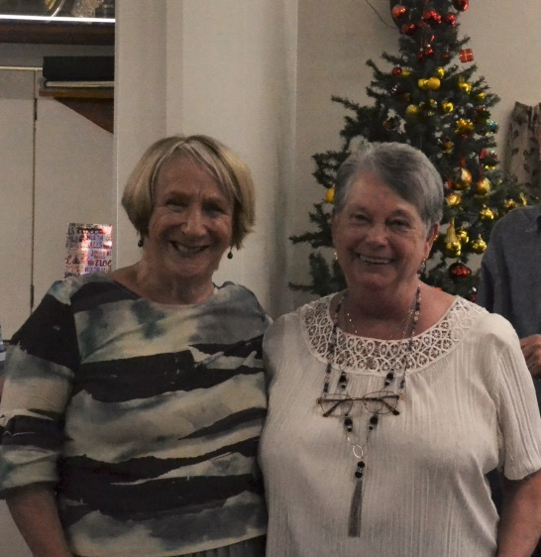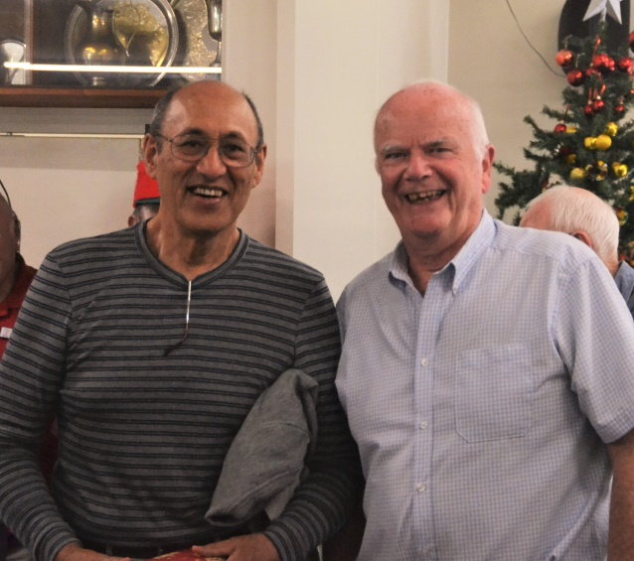
Helen Horsfall and partner Lottie Anderson, and Leon Hunia and Ian Mitchell are full of smiles as they collect their prizes for section placings.

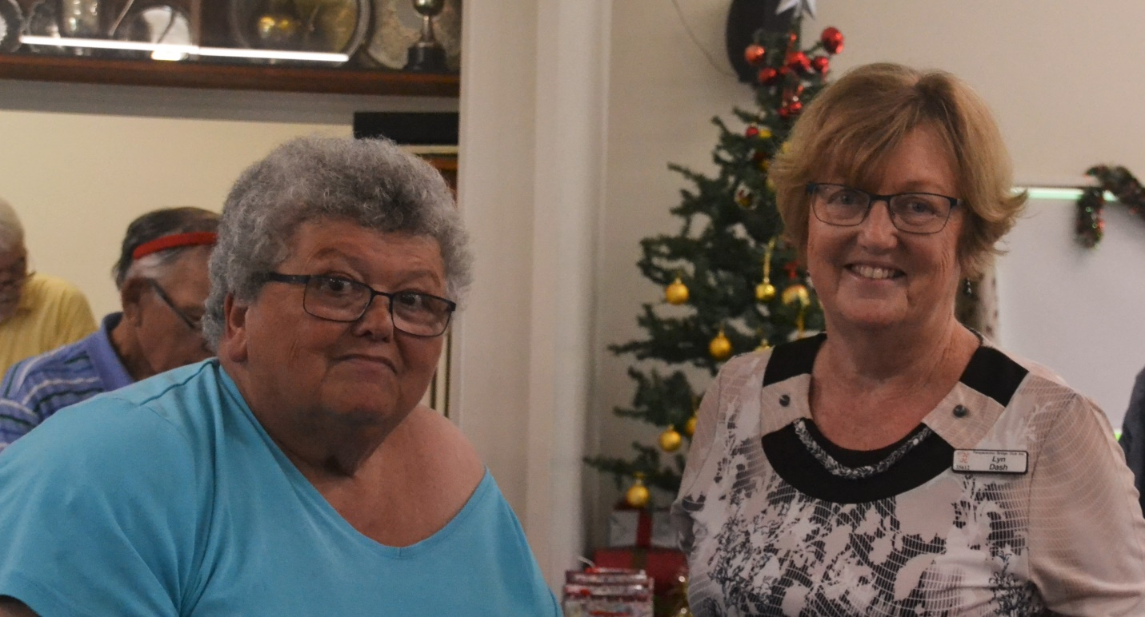
Colleen Mankelow and Lyn Dash, the winners of Section D.

However, in pride of place and ahead of them all, ie the overall winners of the club’s final tournament for 2018, were Chris Farrow and Elva Brown. That’s an impressive result from the second section and ahead of some of the club’s most experienced and senior players. I know Chris and Elva both smile a lot but those smiles were certainly miles wide at the prizegiving. (see below)

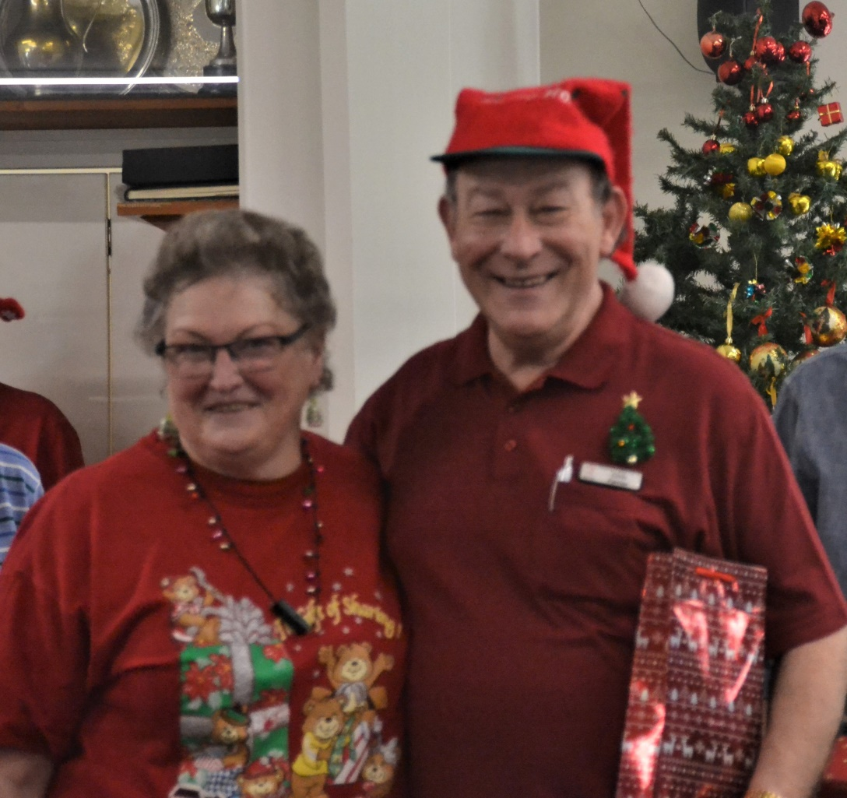
Chris Farrow and Elva Brown cheerfully accept their rewards

Regrettably, there was no prize for “best dressed in the Spirit of Christmas” but this bright combo would surely have taken that award as well as First Place in the Christmas Tournament. Isn’t it so fitting that such a colourful partnership won the event ?

Other notable results were Irene and Val (second in the whole field), Leon and Ian (second in Section A and fourth overall), Colleen and Lyn (seventh overall and from Section C), Bill and Elizabeth (fourth overall, from Section B) and finally, but by no means least, Moira and Bob who were third overall and from Section E! To achieve such a high ranking from Section E is indeed a stunning result for Bob and Moira. Well done and congratulations!

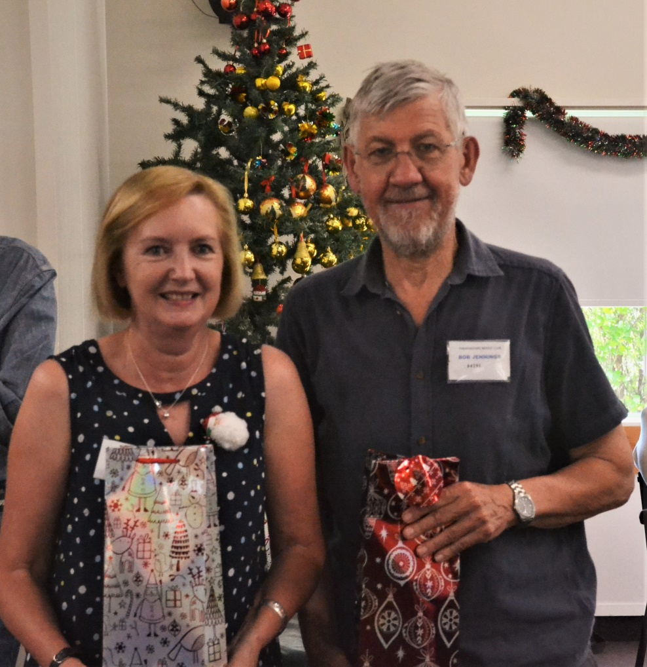

Third in the whole field of 48 pairs, from Section E, was a particularly notable achievement. Moira Wilson and Bob Jennings at the prizegiving.

At the prizegiving, a special presentation of distinctive life members’ badges were made to both Helen Edwards and Bill van Waas. This had been a custom in earlier years but one that had fallen into disuse. The committee decided these badges needed to be reinstated, and so Helen received hers quite promptly but Bill has had to wait quite a while for his. Sorry, Bill.
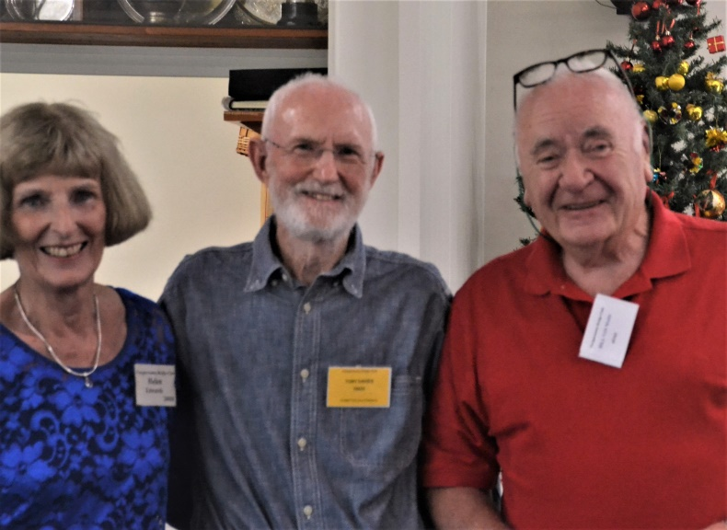
Bill and Helen receiving their life membership badges, with President Tony Davies (centre).

During the after match proceedings, certificates were given out for the winners of the various Christmas Pair competitions. I’m not going to list all those winners here but I couldn’t resist this lovely pic of Edna Garriock and Ngaira Mark receiving their awards and trophy for the Averill Till Christmas Pairs.
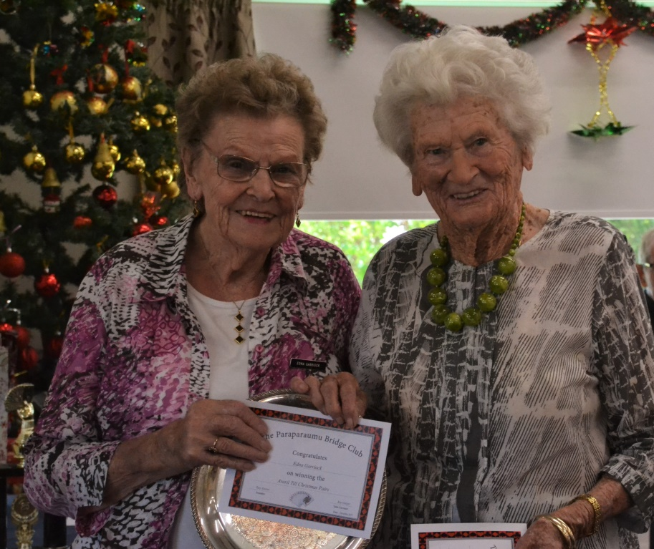

Finally, thanks to Bill Sewell from all the club members for the wonderful job he’s done as Tournament Convenor – a job accomplished with accuracy, efficiency and above all with a consistently cheerful and positive attitude and approach. This last tournament, the 2018 Christmas Pairs, was such a great and enjoyable day that it serves as a fitting finale to all those tournaments you’ve organized for the Club.
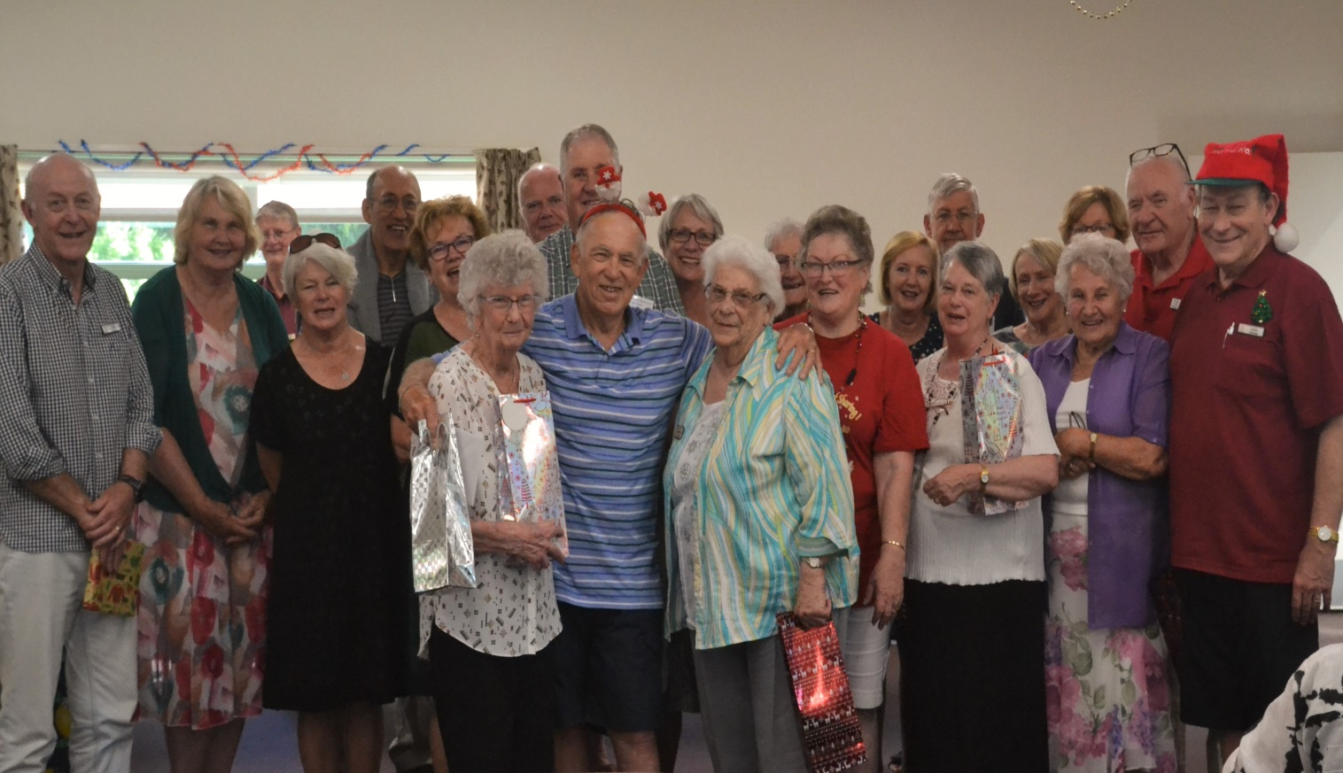
So here’s the final photograph of the day. Bill, rightly, as the centerpiece, flanked by two absolute stalwarts, Irene and Val, and surrounded by the section prize winners. A good day’s bridging, and Bill Sewell at the forefront of some good company.
Footnotes:
Dale’s Tips. Thanks Dale, for preparing and printing your booklet of tips. Those 50 copies simply disappeared on the day. Several members were disappointed that the supply ran out so quickly. However, another 50 copies are being printed and will be available when bridge starts again in 2019.
Remember Monday January 14! That’s when bridge recommences at your club, with “Open” sessions for the first 2-3 weeks.
And . . . the very warmest wishes to all members of the Paraparaumu Bridge Club, over Christmas, the summer, and into the New Year.
Stay well, stay strong, and keep living life to the full.

