PARAPARAUMU BRIDGE CLUB NEWSLETTER FEBRUARY 2018

BRIDGE VOLUNTEER OF THE MONTH = MARION SILLICK
Congratulations to NZ Bridge’s Volunteer of the Month!! ie our very own Marion Sillick.
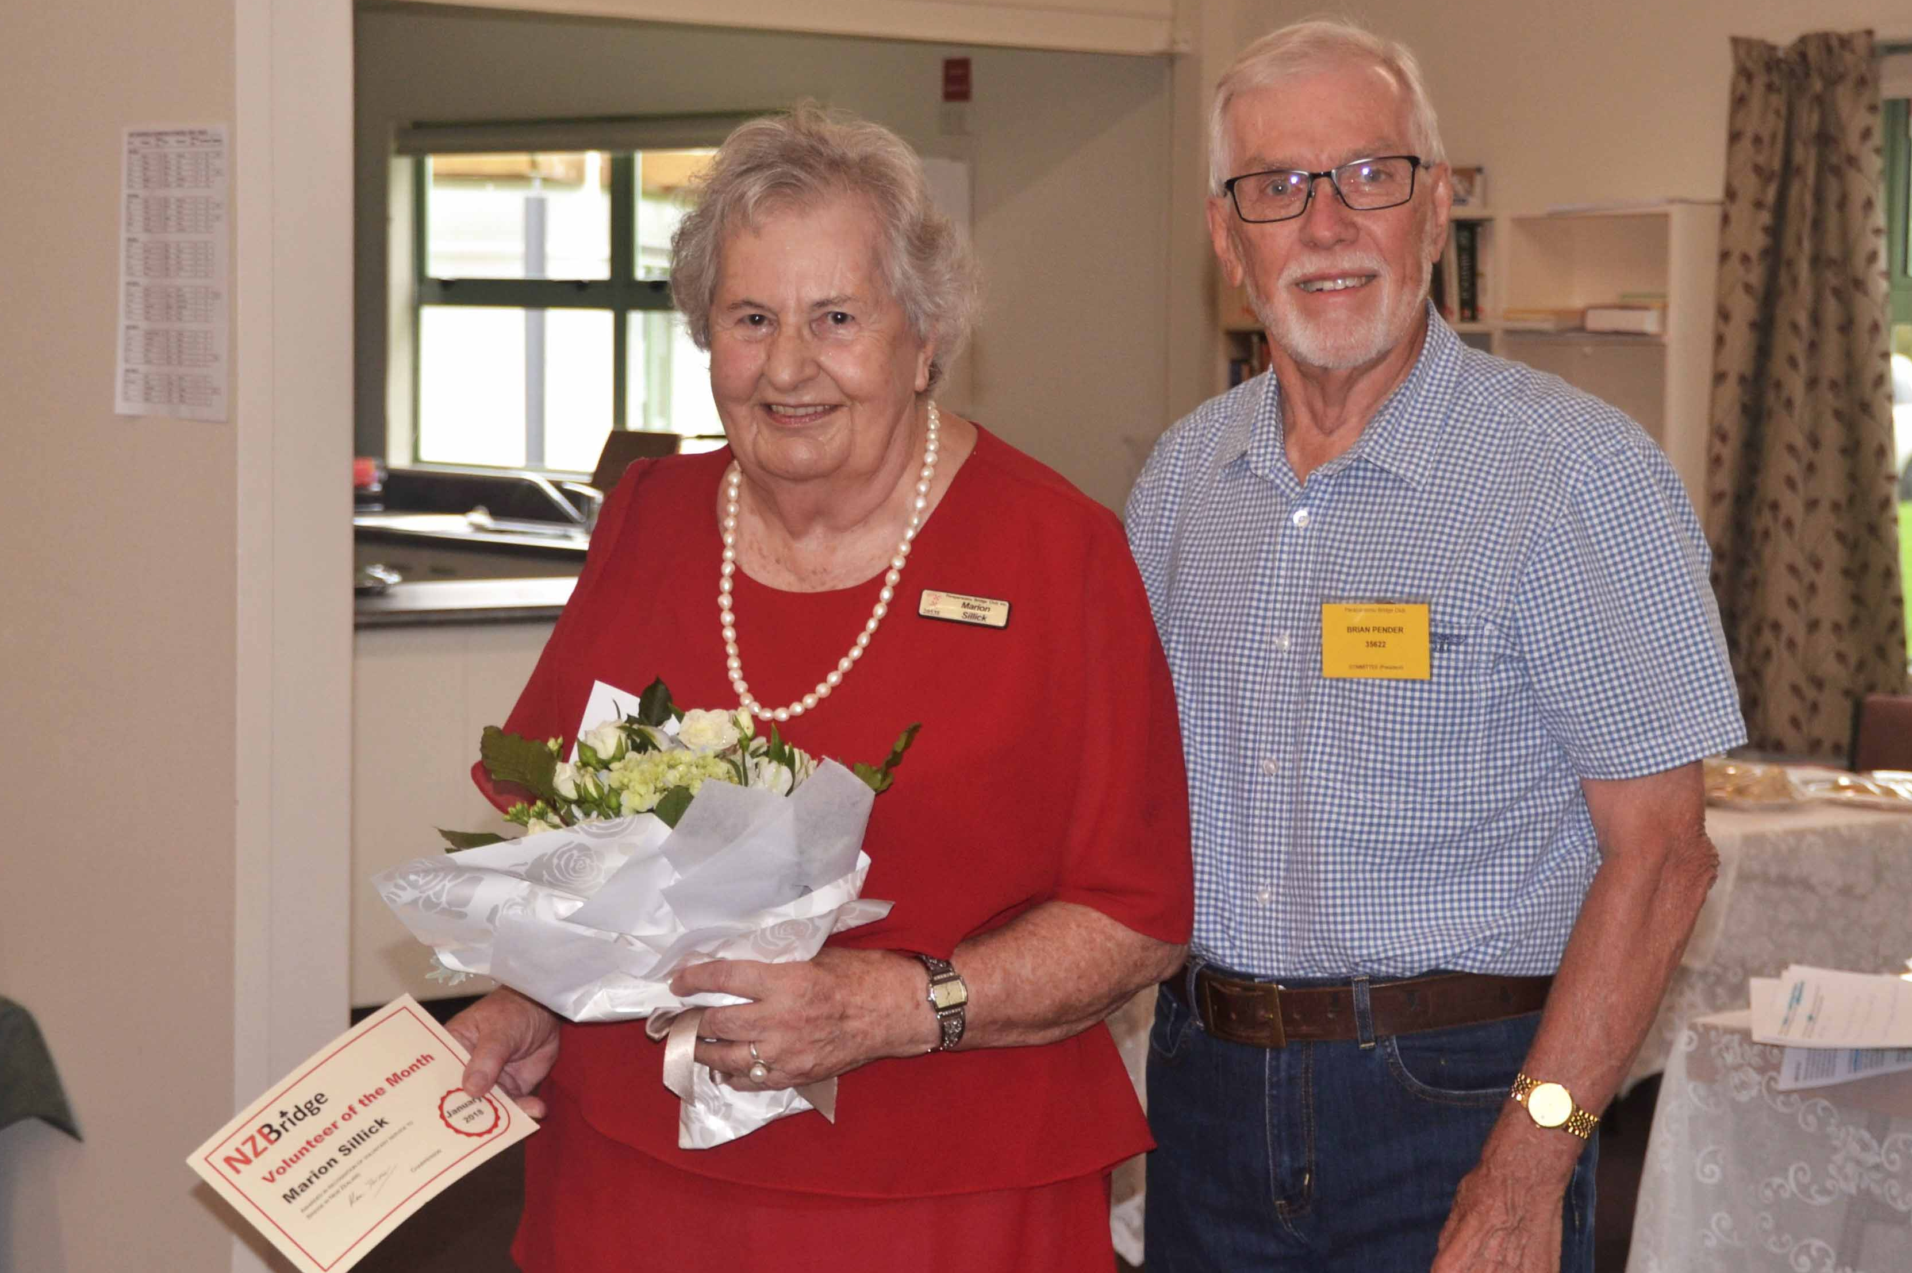

Marion receiving her deserved recognition from President Brian Pender, during the afternoon of the Kapiti Bearings and Locksmithing Pairs, our first tournament of 2018.
Brian stressed the huge number of tasks undertaken by Marion over many years – scoring (and leading the movement towards adopting an electronic scoring system), directing, tutor for beginners and for more advanced players, maintaining club records, keeper of the Honours’ Book, member of the Club Committee and of several sub-committees.
In summary, “when Marion arrived in Paraparaumu in 2004, we found we had a person who could take up any role willingly, competently, efficiently, and with minimum direction”. (Editor’s note: “and with maximum tact and discretion”.)
(Club members may be interested to note the very considerable coverage given to Marion Sillick on the NZ Bridge website. Just enter the site then click on “Latest News” – Volunteer of the Month.)

TOURNAMENT RESULTS
Our first In-House tournament for the year was held on Sunday 18 February. A good entry (35 pairs), excellent refreshments (thanks to Jane McArthur and other kitchen hands) and many prizes spread across six divisions (divisions decided by combined master points) created a very pleasant afternoon’s bridge.

Results: Section A – 1st Jane Bradbury & Michael Stace; 2nd Dale Wills & Marion Sillick
Section B – 1st Robyn Michelson & Jean Crafts; 2nd Helen Edwards and Jocelyn Graves
Section C – 1st Elva Brown & Lyn Dash; 2nd Carol Hill & Yvonne Rowe
Section D – 1st Trevor Smith & Tina Connell-Pine; 2nd Tony and Andra Davies
Section E – 1st Moira Wilson & Bob Jennings; 2nd Fay Manley & Jenny Prendeville
Section F – 1st Ian Mitchell & David Stagg; 2nd Ken Tate and Ken Thomas

The absolute triumph of the tournament had to be the performances of Elva and Lyn and also Carol and Yvonne. These two pairs came from the middle of the field (Section C) to achieve first place and second place overall. And yes, that meant they beat all those “gun” players in Sections A and B. Also really worthy of note were Trevor and Tina (section D) who were placed fourth overall. A great result by these three partnerships. Congratulations!

And a general “thank you” to all those who stayed to help clean-up. With so many helping, it only took 25 minutes to restore our clubrooms to be ready for the next session of club bridge. Well done.

Finally, thanks to Bill Sewell for another successful, competitive, yet highly cheerful, In-House tournament.

Note: the next In-House competition will be Sunday July 15, as part of the club’s 50th anniversary celebrations. It is sponsored by Novella Café. Mark it in your diary now.

A selection of photographs taken during the prize giving.
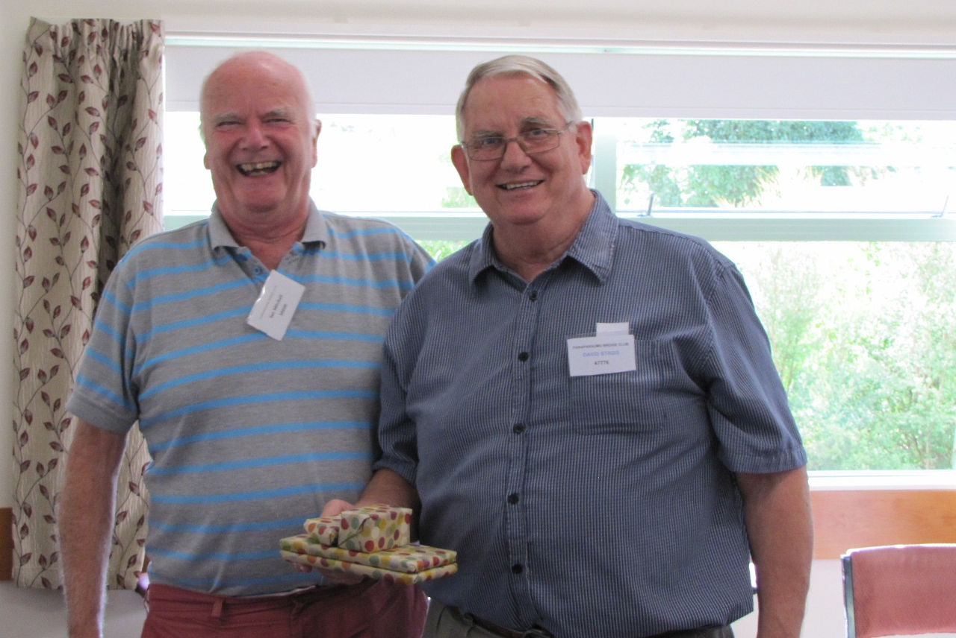
Ian Mitchell and David Stagg seem to have delighted in the afternoon and their result . . .
L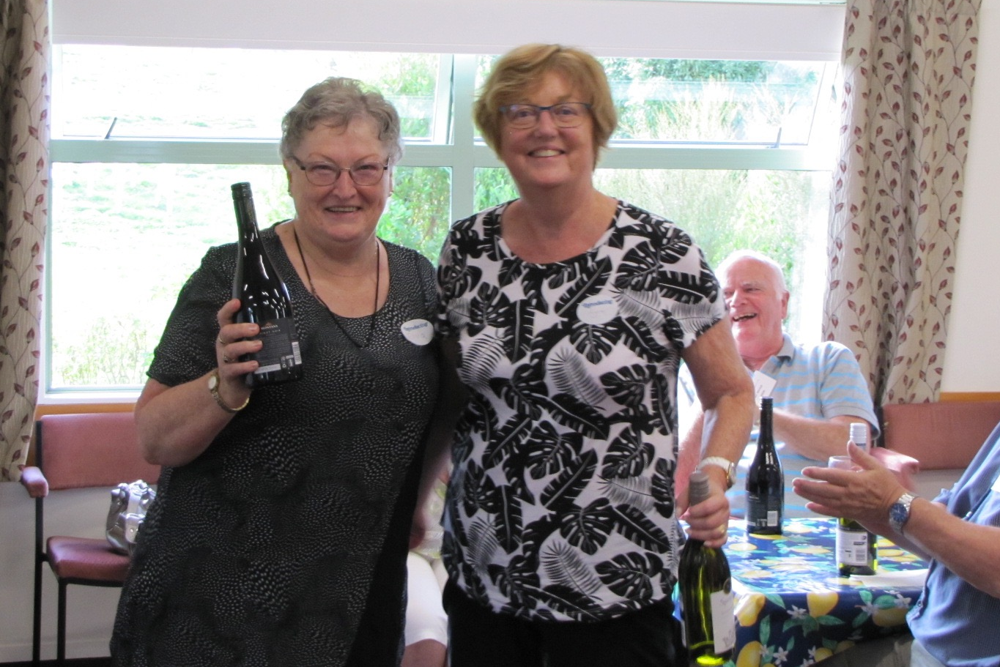
Elva Brown and Lyn Dash brandish the spoils of a very well-deserved win . . .
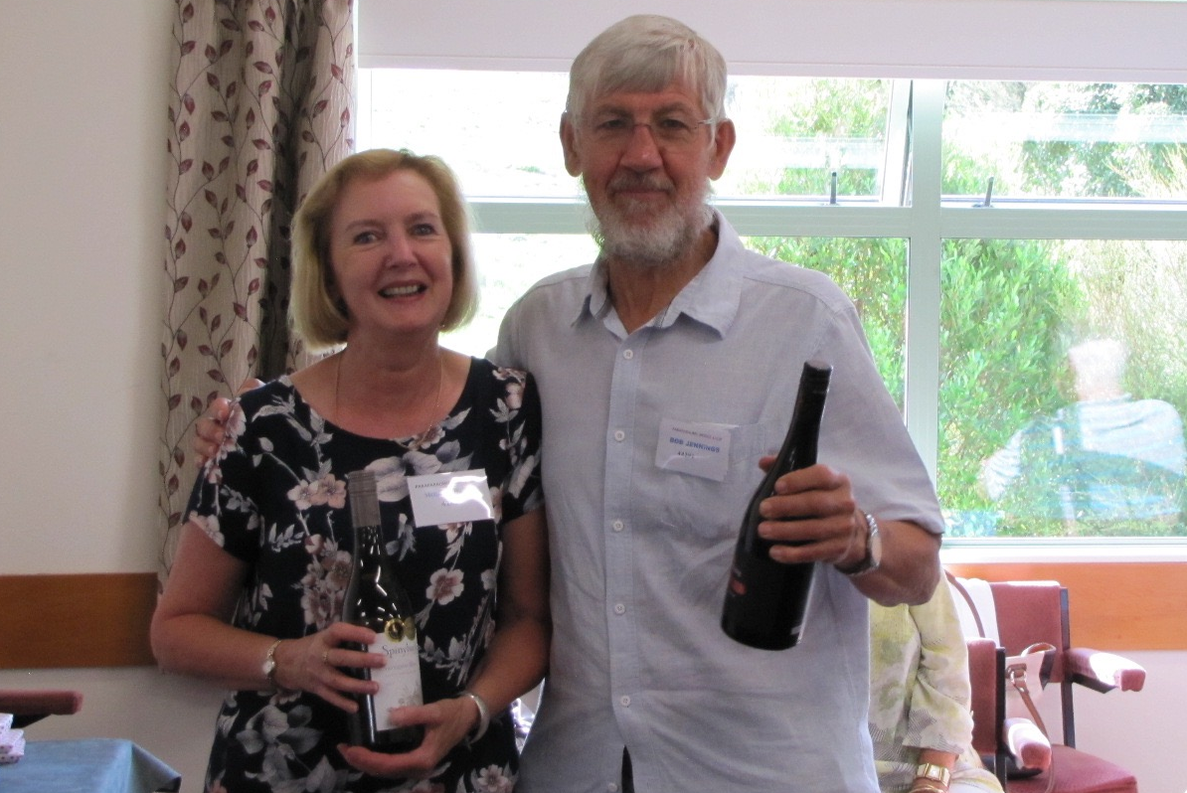
Moira Wilson and Bob Jennings seem quietly content . . . is Bob raising his bottle towards the photographer . . . is he perhaps suggesting I have a drink on him?? Yes, yes, I will. Thanks Bob.
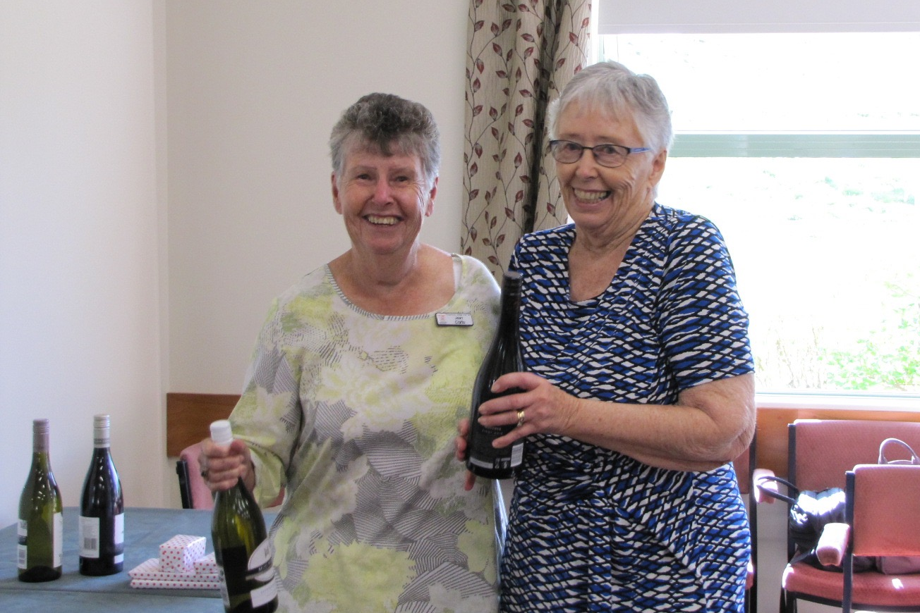
Jean Crafts and Robyn Michelson certainly look as if they are always ready to party!

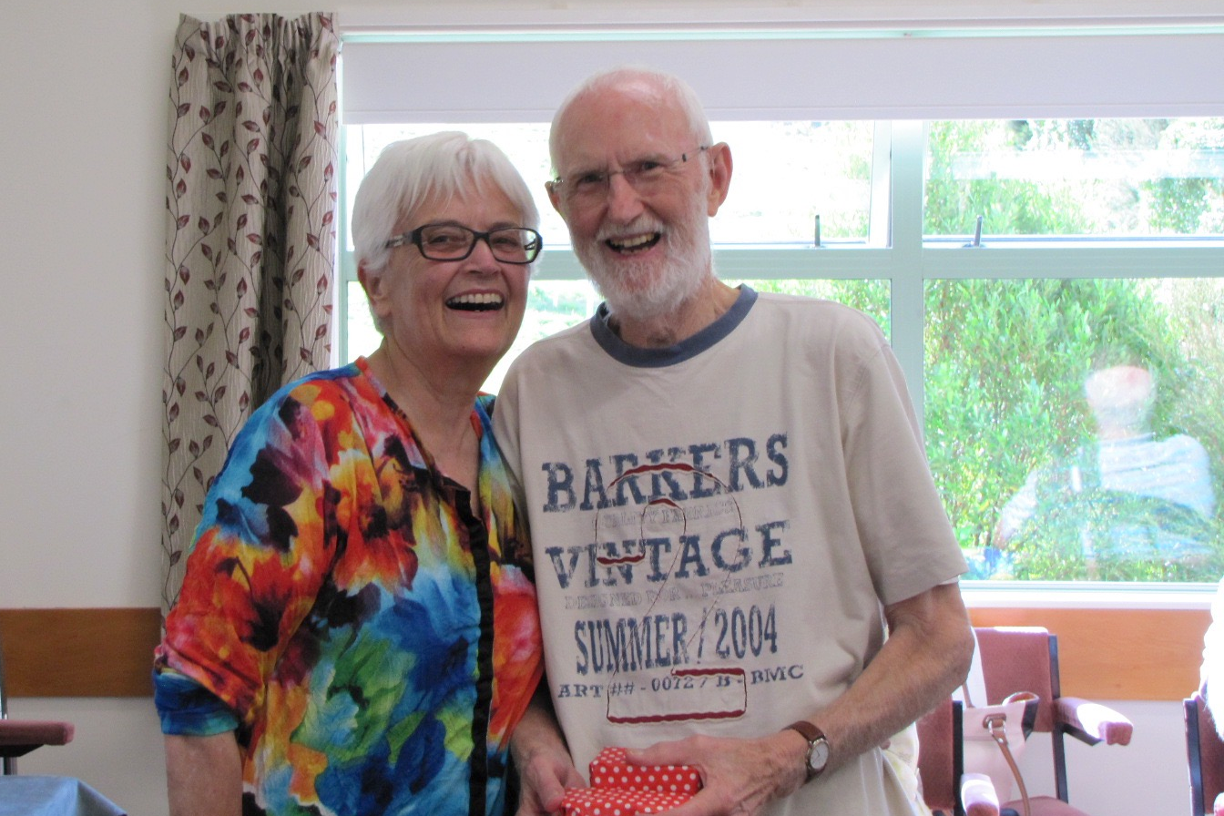
Yes, partners in life can indeed be partners at the bridge table as well. Charming pic of Andra and Tony Davies in great form and good humour (but while Tony’s T-shirt might proclaim “Vintage 2004”, surely that’s a perfect example of a Trumpian “false truth”?)

Of course, if your bridge has been a disaster, there are other ways to win big – just take a raffle ticket. (Thanks to Val Coe for organizing the ever popular raffles on tournament day.)
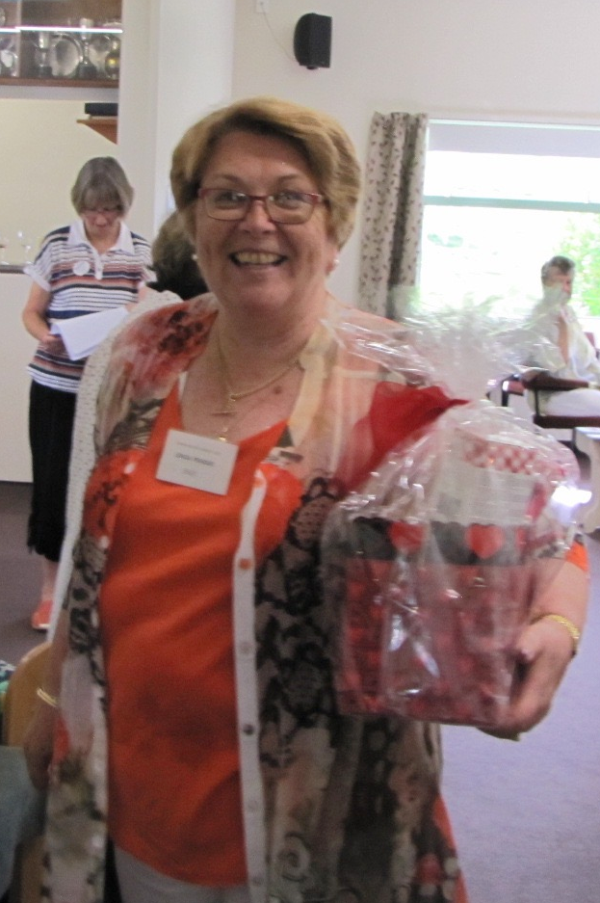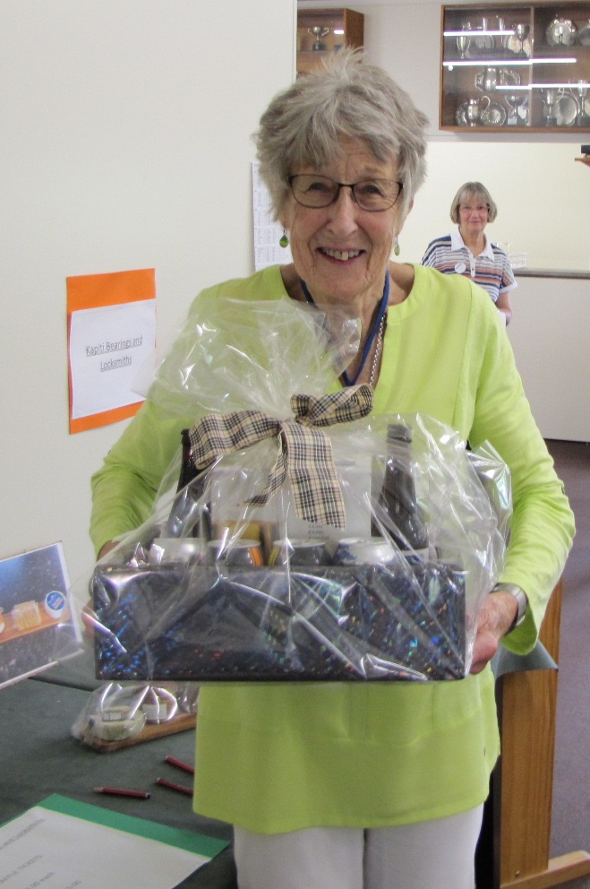
A very happy Linda Pender takes first pick of the prize table, and swoops up a basket of delights while Fiona Souness may be the lucky last but she finds a heavy load of various alcoholic drinks has been left. Hold it carefully, Fiona, there’s plenty in that pack.
BRIDGE LESSONS
Members may notice some advertising (radio and newspapers) for Beginners’ Bridge lessons over the next weeks. In part, this is an initiative from NZ Bridge and our club is also sharing in the costs with other Kapiti Coast clubs. Our beginner lessons will start Monday 9 April.
The classes cost $40.00 and run for 10 weeks. The teacher is Jane Bradbury. If you know of anyone interested in learning to play bridge, please feel welcome to encourage them to contact either Jane or Linda Pender, about our programme of lessons. Further details are also available on our website.

FUND RAISING
A reminder to try M and M Master Butchers (opposite Mitre 10 in Kapiti Road). You pick up a card from the rear of our club rooms, show the card at the M and M shop, they stamp the back of your receipt. Then you drop the receipt into the large cardboard box (red) in the club rooms.
They give our club 5% of the total money sum for all the receipts that we collect. We know from other clubs and organisations that this can be a “nice little earner” and it works without any great commitment of time and effort. This simple process could be very effective in balancing our budget (and yes, keeping subs at the present reasonable level!).
Please try M and M – the staff are friendly and efficient and they stock a large range of cuts and products including meals that you only have to pop in the oven. Just remember, you’ll need the M and M card to get the receipt stamped.

SUBSCRIPTIONS
Did I just mention “subscriptions”? The 2018 subs are well and truly due. $75.00 if you pay before 1 March and after that it will be $80.00. You only have a few more days to get the reduced rate. Instructions about paying (especially by Internet banking) are in your bridge programme books.

UPCOMING EVENTS
Our next tournament is the Kapiti Retirement Trust Open on Sunday 18 March. Please note that this is a two session event with play to start at 9.30. The Kapi Mana Intermediate and Junior Pairs will take place on the same day (unfortunate timing to cut across our event).
Other tournaments in the region include the Hutt Multigrade Pairs (3 March), the Upper Hutt Intermediate Pairs (11 March), the Kairangi Intermediate Pairs (25 March), the Levin Multigrade Pairs (31 March) and the South Wairarapa Junior and Intermediate Pairs (15 April).

AN INVITATION
The Kapi Mana Club invite bridge players to join any of their sessions (Monday day/ Tuesday, Wednesday, Thursday evenings). Table money is $5.00 per session. A further special invitation is extended to all Novice players in the Wellington region (that includes Paraparaumu). Play at the Kapi Mana Club for any three sessions in February, March or April, free of charge.

70% CLUB
Early assaults on the target of scoring above 70% were launched this month. Two particularly big scores that will surely prove difficult to beat, even with almost all the bridge year to come. Pauline Reid and Averill Wotton hit 74.9% last Friday. Yes, impressive. But Grant Franklin and Marg Lees nearly reached that mark with 74.6% on Tuesday night this week. (I did think it was just a touch unkind for Marg to point out how much she might achieve with a younger man . . .)
Wait! There’s more . . . just last night, Tony Gibbons and Stafford Marshall racked up 71.5%. And on a Wednesday night too. How good is that?

Editor: Keith Lees

