PARAPARAUMU BRIDGE CLUB NEWSLETTER AUGUST 2018
50TH ANNIVERSARY WEEKEND
The anniversary was certainly celebrated with style as well as substance. Brian Pender (President) reminded the guests gathered for the 50th Birthday lunch of the dedication and sheer hard work of so many stalwarts who had secured such pleasant amenities for the Club, and stressed the strength of the ongoing friendships formed at the bridge tables.
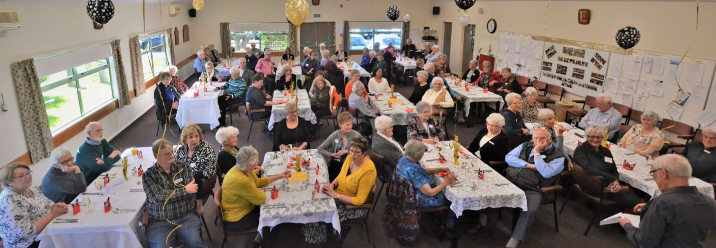
The decorated clubrooms were a delight to the eye. The meal and the refreshments were superb. The Birthday cake was cut with appropriate ceremony. (Dale and Irene – see below)
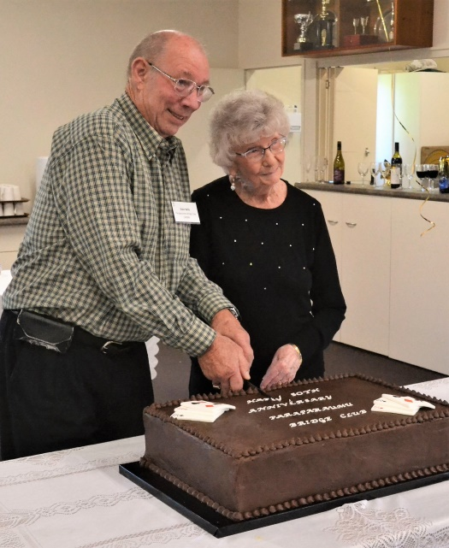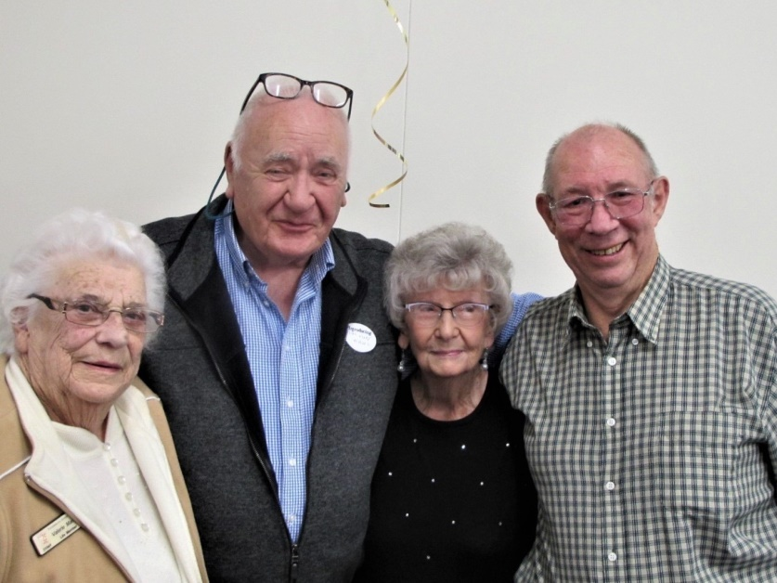
And then (right) a photo of four life members, still very active in the Club: Val Manley, Bill van Waas, Irene Galloway and Dale Wills.

Yes, some names from the past were recognised – and honoured. There was a brief account of a trawl through 50 years of the Club Minutes – with lighter moments. Stories of the past and of past members were told – and retold. No doubt some of them are true.

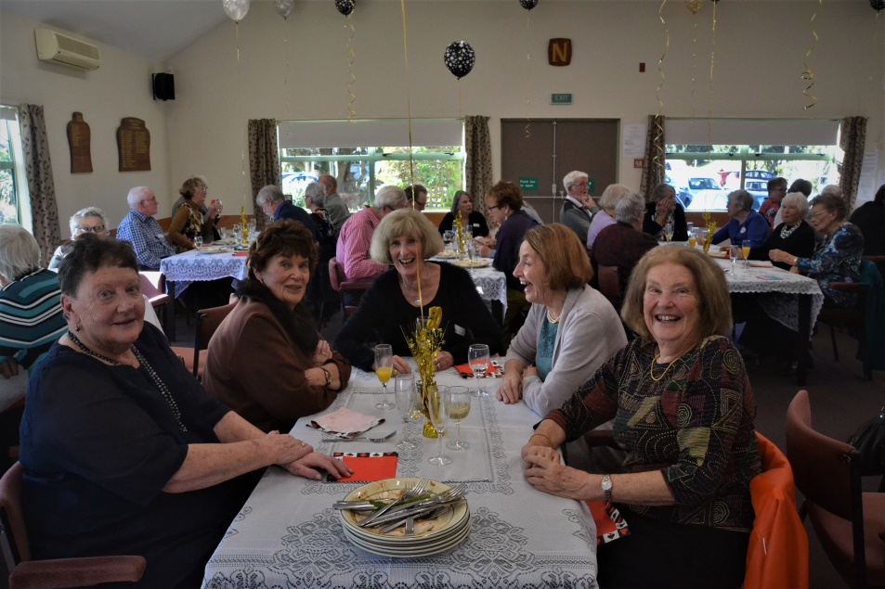
(From left) Kaye Hay, Jocelyn Graves, Helen Edwards, Barbara Mador and Margaret Norrish.

Margaret and Barbara seem particularly delighted at the prospect of this year’s Christmas Party emulating the spirit of 1973 ie “Six bottles of whisky, six bottles of gin, two bottles of brandy, two of sherry . . .”

Then we were stunned by the talent of one of our very own – the amazing Linzee Inkster. Who knew, who imagined, such a rich, powerful voice and creative energy? And these were not “covers”, these were her own songs, and performed with a vibrant presence, perhaps unexpected when we all know her quiet demeanour at the bridge table.
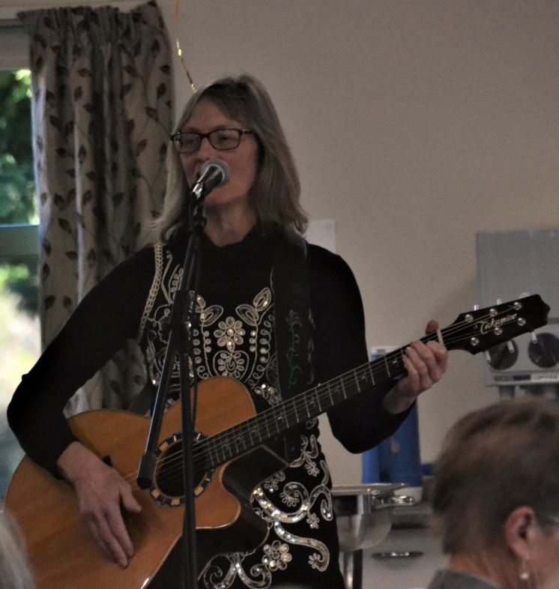
(And yes, her CDs are indeed still available . . . see or contact Linzee if you would like one. $20. Twice the number of songs performed at the Anniversary lunch.)

So the long Birthday Lunch lingered on through to the late afternoon. Many helped in the creation of such a lovely atmosphere but special recognition must go to Linda Pender and Jane McArthur who created the design and detail of both the décor and the meal.
Now that everything is finally and perfectly in place for the lunch, Jane decides that not only does she want a drink – she needs a drink. Any one like to guess the hour of the day . . . ?

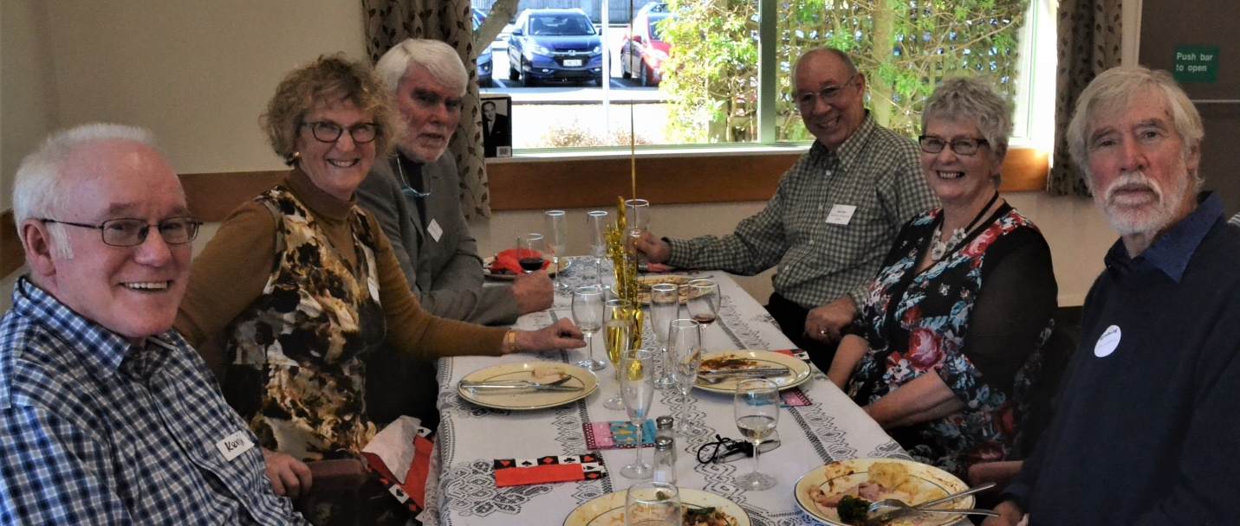
Another cheerful group waiting for more entertainment. (From left) Kevin MacManus, Jane Bradbury, Ken Barrett, Dale Wills, Judy MacManus, Michael Stace.
The next day, a full house played and enjoyed an In-House “Multigrade” session with Multiprizes (and Multi miniprizes for various bridge infractions). No table money and the prizes were sponsored by the nearest Café to our Club, Novella Café. (Thank you again, Novella.) Bill Sewell organised the whole afternoon, and doesn’t Bill just love the part of distributing all the prizes . . . ?
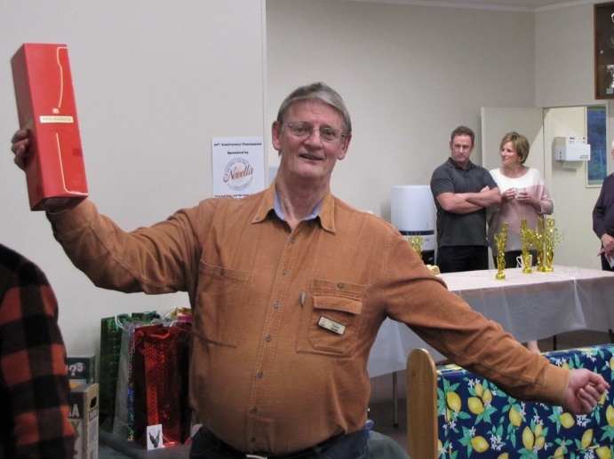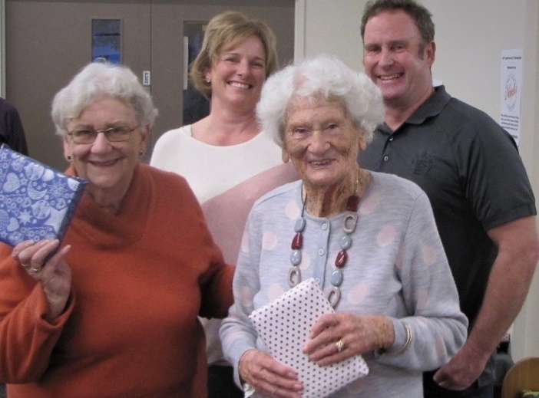
Trevor Smith goes 100% when he wins a bottle of champagne (did he think this was “Dancing with the Stars”?) while Carol Bullen and Ngaira Mark show more grace and decorum when winning prizes for second in their section. (Novella Café sponsors behind.)
Section winners were Doug Galyer and Jane Bradbury (Section A); Liz Steinbauer and Bill van Waas (B); Derek Bullen and Francie Vagg (C); Marg and Keith Lees (D); Jenny Prendeville and Tina Connell-Pine (E) and David Stagg and Ian Mitchell (F).

However, the overall winners of the Novella Café Anniversary Tournament were Marg and Keith, followed by Jenny and Tina, and then Doug and Jane.

A WORD FROM THE PRESIDENT (Well . . . 3 comments)

1 Wow!

What a great weekend we had to celebrate our 50th anniversary.

The clubhouse looked beautifully festive for the occasion, the luncheon was superb, the entertainment was varied and lively and Linzee Inkster’s singing was stunning.

My congratulations and personal thanks to all those who helped create such a warm and positive weekend, and especially to Jane McArthur and Linda Pender, to Linzee, to Keith Lees and Dale Wills, and to Bill Sewell who organised (impeccably) the Café Novella 50th Anniversary Pairs Tournament on the Sunday.

It was a fun weekend and a great way of celebrating half a century of competitive bridge and half a century of friendships formed across the table. Moreover, it was a wonderful opportunity to show appreciation of all the hard work done by so many members, past and present, over 50 years, to make the Club what it is today.

2 Welcome to our new learner players

I am delighted to welcome the following new members to our Club who have come up through the learner programme run by Jane Bradbury:

Eddie ALLEMAN | Ken MUIR | Rosemary SPENCER
Marty BARRETT | Shane O’MAHONY | Brett WINDLEY
Ted HAWKER | Marilyn RENSHAW | Sandra WINDLEY
David MCCRAE | Robert RENSHAW | Sue VEART
Denise MINOGUE | Heather SIMPSON

These new members are immensely important to the Club and, the fact that they have joined, is all due to the great work done by Jane Bradbury and the loyal band of helpers who turned up every Monday evening to assist and help organise the lesson programme. Jane and her team have done their job – now it’s up to us to do ours.
It may surprise you to learn that many learners are absolutely terrified of playing at the Club and of us individually – yes, I mean terrified of you and me. A single thoughtless word will be enough to put them off bridge forever.

So, while they may play a little more slowly than we would like at times and make the odd mistake, please ensure that you are always friendly, and supportive towards them - just as you would if they were guests in your own home.

We pride ourselves as being “The friendliest club on the coast.” Let’s prove that we are.

3 Please help our directors

Among the most valued of our many volunteers are our Club Directors. They undertake hours of study to acquire the knowledge they need to perform their role and have to take a Directors’ examination. They then they give up much of the enjoyment they would otherwise get from their own play at the Club to run our sessions for us and to help us get back on track when we make mistakes.

Unlike many clubs our directors are playing directors and are unpaid. This enables us to keep our subscriptions to an absolute minimum.

We have difficulty in ensuring that there are adequate directors to cover each session yet some of our directors are considering giving up the role because they feel that they are not appreciated. That is a great pity.

Here’s what you can do to help:

Play at a reasonable pace. When some players are very slow and others quicker it
causes problems with the move.

Call the director politely - Not an angry demand but - “Director, please”.

Don’t dispute the Director’s ruling. If you and your partner both agree, you may politely request that the ruling be appealed and the Director will arrange this.

Allow the Director to decide when the move is to be made. Do not call out yourself when you think the move should be made - this only causes confusion.

Show your genuine appreciation of the director when the last move is called.

Brian Pender

RECENT RESULTS
Impressive results which have not been acknowledged (until now) include Bill Sewell and James Winskill who were the Top Intermediate Pair and Ken Thomas and Lyn Berry who were the Top Junior Pair at the Kapi Mana Multigrade Tournament way back in May.
And also congratulations to Linzee Inkster and Bob Jennings who were placed second in the Paraparaumu Intermediate Tournament in late June. Another impressive performance.
The Club may not have produced the winner of our own Junior Pairs on July 22 . . . but at least players from Paraparaumu were second, ie Noelene Rust and James Jones; and third, Yvonne Rowe and Colleen Mankelow; and fourth, Ken Thomas and Brian Pender. Congratulations all of you, especially Noelene and James.

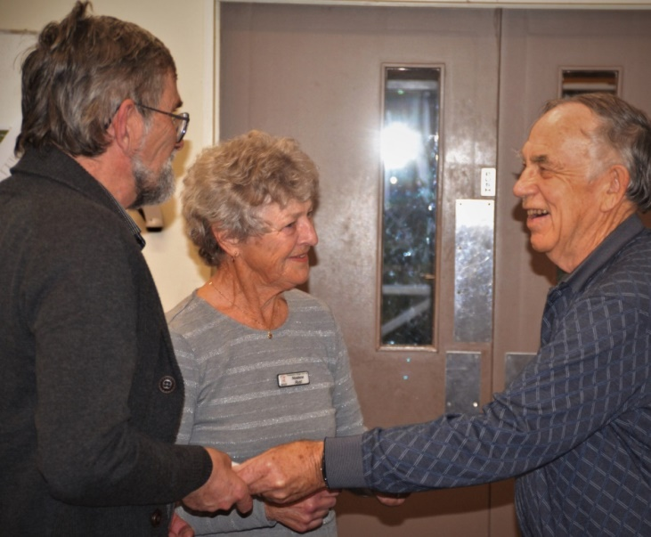
James and Noelene picking up their prizes for second place in the Paraparaumu Junior Pairs. Well done both of you. (Bill really does love this role, doesn’t he?)

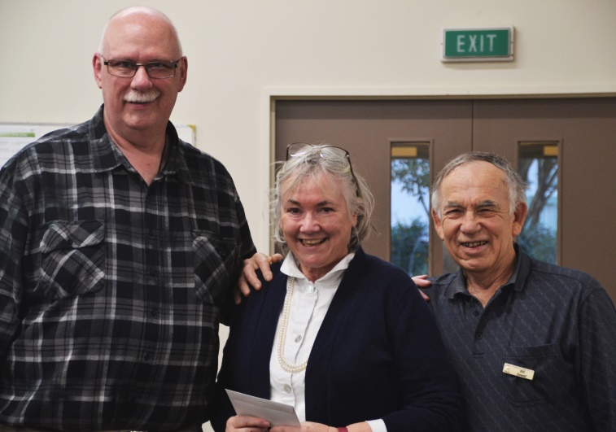
Paul Baines and Anna MacDonald proudly face the camera after picking up their prize for first place. Worthy winners, from the South Wairarapa Club. (Editor’s note: I’ve been looking for a partner who might help me to bid and play those big, big hands . . .)

INTERCLUB EVENTS
Please note that some dates are now different from those published in your 2018 Programme Book. ie the following
Horowhenua-Kapiti Interclub at Levin, Sunday 23 September
Jackways Shield v Kapi Mana at Paraparaumu, Sunday 7 October
Waikanae Interclub at Waikanae, Saturday 27 October
Wellington Regional Club Champs. (Venue still to be confirmed.) Sunday 28 October
Entries will be called for closer to these events.

PARTNERSHIP UNDERSTANDINGS
Players are reminded that, if your partnership is long-standing, or, at least, regular, then your usual practice regarding bidding should be acknowledged if asked. Bridge law states that each partnership has a duty to make its understandings available to opponents if asked. It could be unethical for such partnerships to deny knowledge of the meaning of a conventional bid.
If you are not satisfied with the response from your opponents in this regard, you should call the director, who will determine if you have been disadvantaged.

50th ANNIVERSARY BOOKLETS
They are still available. If any member has not yet received a copy, please let me know (Keith Lees at 299 4747) and I’ll make sure you get one.

And, finally, just another couple of cheerful images from a great Anniversary Weekend.
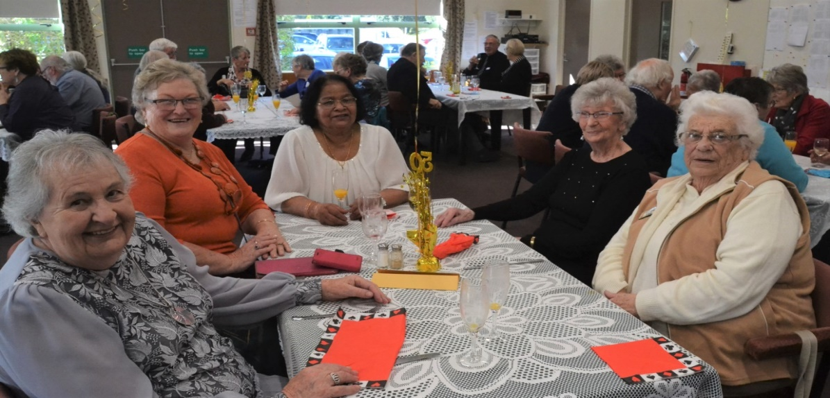
From left: Marion Sillick, Elva Brown, Menike Dias, Irene Galloway, Val Manley
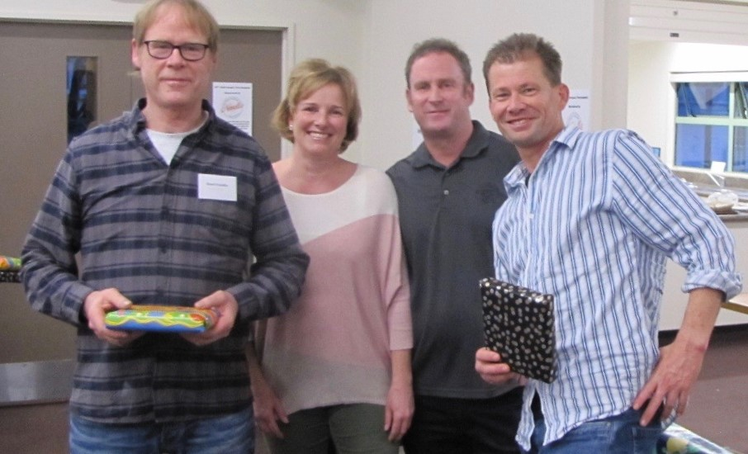
Grant Franklin (left) and John Murtagh (right) pick up their prizes for second in their section.
EDITOR : KEITH LEES

