Paraparaumu Bridge Club Newsletter November 2017

First, please note the date of the Club’s AGM is Monday 20th November. It’s a time to ask questions, raise issues, listen to the views of the committee and others, and show your support for the club with your attendance.
Next, the last club event/tournament of 2017 is the Heartland Bank Sponsored Christmas Pairs. And it takes place on Sunday 10 December. Start time is 1.30 pm with players asked to be seated by 1.15. No entry fee / charge is needed but please bring a plate. Refreshments and light food will be served at close of play. Tournament convener Bill Sewell stresses that this is always a popular end-of-year celebration. Let’s make it a lively, fun finale.
(You may need to get your entries in. We are limited to 24 tables. And yes, last year the room was full.)

New Members
A very warm welcome to Margaret and Ray Cachemaille, who have recently transferred to Paraparaumu from the Marton Club. We hope you enjoy your bridge with us.

Recent Results.
The excellent result in defeating Kapi-Mana and retain the Jackways Shield in early October has already been noted (see Club website). Paraparaumu emerged as comfortable winners with 8 of the top ten places being filled by our own players. Averil Wotton & Lynda Evans/ Kevin MacManus & Michael Stace/Laurel Nalder & Jill Browne were 1st, 2nd and 3rd respectively.
The results from the Kena Kena Rest Home Multigrade Tournament were also impressive. Lynda Evans and Michael Stace were 2nd overall (out of 44 competing pairs) and 1st in the Open/Other section; Val Manley and Irene Galloway who were 5th overall; Alice Henke and Lois Anderson who were 1st in the Intermediate section; and Barbara Mador and Lyn Berry who were 2nd in the Intermediate/Junior section. Congratulations to all these players.
Also notable was the support for this tournament by our members – 20 of the 44 pairs competing had at least one Paraparaumu Bridge member.
After such pleasing performances comes the fall (isn’t that bridge?). We lost the annual interclub contest against Waikanae on October 29! However, in defence, Waikanae were a little short of players and so we lent (gave?) them a couple of our members to make up even table numbers . . . and those we gave, gave freely of their skills and expertise . . . and we lost the friendly encounter, played, as ever against Waikanae, in a very good spirit.
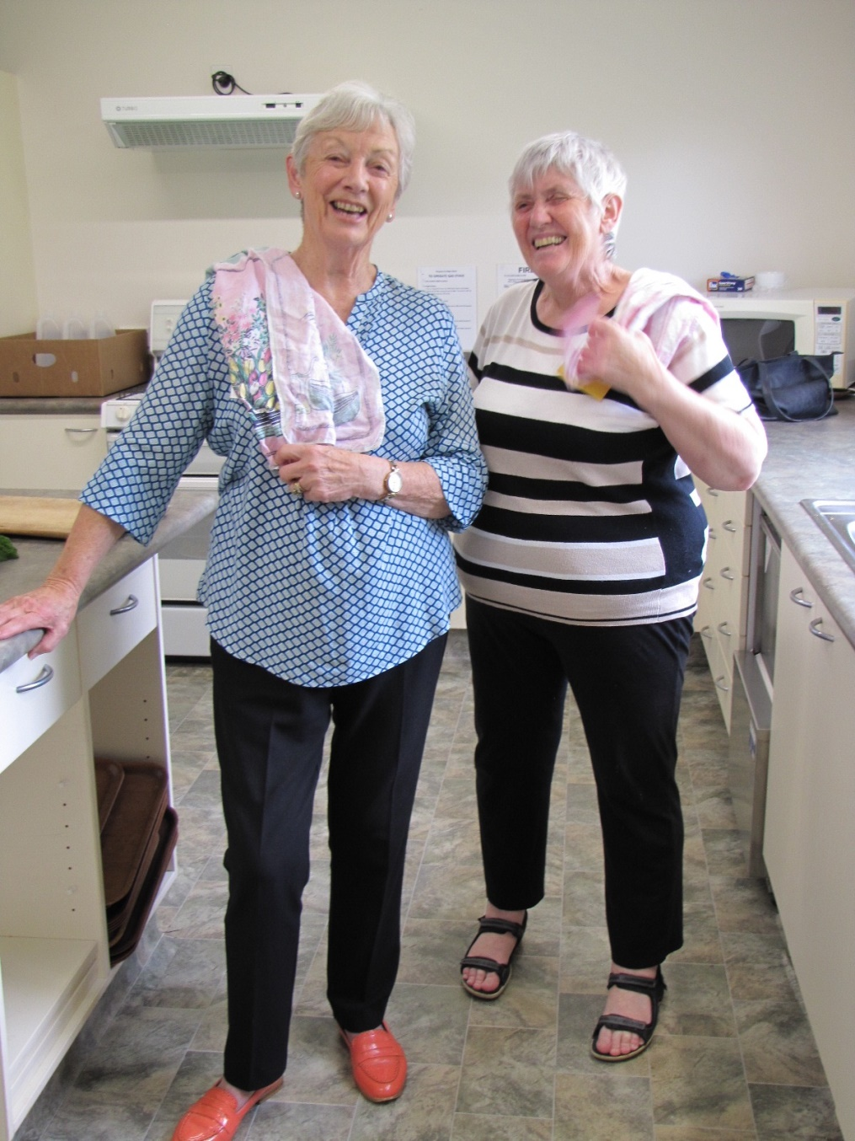
It’s hard to get good staff, impossible to get staff as delightfully cheerful as Pat McArthur and Gillian Travers working in the kitchen during the Waikanae v Paraparaumu Interclub.
(I think the President caught Pat and Gillian at the moment when someone asked for “a Chamomile Raspberry tea with a little soy milk” during the halfway break – Ed)
A small Bonus
At the October meeting the club committee determined that no fees or table money be charged for the final sessions of the year ie play for all day and evening sessions during the week 5 – 8 December shall be free. (Directors, please be aware of this.)

70% Club
Since last newsletter the numbers who have scored 70% or higher at one of the club’s sessions have indeed increased (though no one has threatened the position of Leon Hunia and Helen Edwards at the top of the table with a remarkable 76.52%).
Of the dozen or so pairs on the list there are the names of some of the usual suspects – Jane Bradbury (x3), Pauline Reid (x2), Stafford Marshall (x2) and Kevin MacManus (x2).
These results are up to and including the end of October. Not much time left in 2017 to get your name on that honours’ list and keep bragging rights through the summer break . . .

Replacement of Plastic Card Holding Boards
The club has recently replaced a number of the plastic boards that we use to transfer the cards from table to table. The old boards are still usable, and are available (free) to club members on a first come / first served basis.
So, if you would like some of the old boards, please contact:
Ken Barrett
Ph = 902 3170

A gentle reminder
The list of members and their phone numbers is on the noticeboard at the club. Would you please check to see those details (names/spelling/phone numbers) are correct. The accuracy of this information is vital as we move towards the production of the bridge programme books for 2018.

The five F’s of contract bridge.
I recently read a column by Paul Elstein. Elstein, an American, can’t be a great player as he is still classed as an Intermediate player despite playing the game for 55 year ! However, he has become a very popular and much sought teacher of beginner bridge classes.

Elstein always stresses the five F’s of bridge to his beginner classes.
FUN = You’re not a professional, so you’re playing (playing!) to enjoy yourself. It’s a game.
FOCUS = Part of the fun of bridge is flexing your brain and you stretch yourself mentally by following the bidding and by keeping track of the tricks/cards ie You do need to apply your mind and focus and concentrate (especially on counting the cards as they fall).
FORGIVE = To make a mistake is human. Harping on about your partner’s errors does neither of you any good at all.
FORGET = Yes, to make a mistake is indeed human. When (not if, but when) you make a mistake you have to go to the next board and calmly bid and play that hand ie don’t keep brooding over your blunder, it’s in the past, move on.

And, if none of these F’s help you . . . after the session is over, drive home muttering (to yourself) the fifth F . . .

Keith Lees (Editor)

