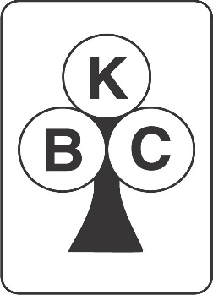
5A Karori Open Tournament
Kindly sponsored by Ryman Healthcare

Sunday, 21 August, 2022
KARORI BRIDGE CLUB

Karori Bridge Club
274 Karori Road, Karori
BYO Lunch
Prize for top pair not including an Open player.
Start Time | 9:30 am Morning tea 9:00 am
Entry Fee | $30 per head. Payment may be made online (03 1540 0002677 00)
 | Bring your own lunch
 | Morning tea will be provided
 | Finger food and a complimentary drink will be provided at end of play
 | Please indicate if seating rights required
 | Wheelchair access and facilities available
 | Masks are mandatory at the playing tables, unless an exemption certificate is produced.
 | Entries close noon on Thursday, 18 August 2022
Entries to: | karoribridge@gmail.com, telephone 04 476-6179 or via NZB https://www.nzbridge.co.nz/events/6863/Karori-Open-Pairs

Name | Computer # | Name | Computer#

