PARAPARAUMU BRIDGE CLUB NEWSLETTER Christmas 2017

First, the results of the Heartland Sponsored Christmas Pairs, the finale of the club year.

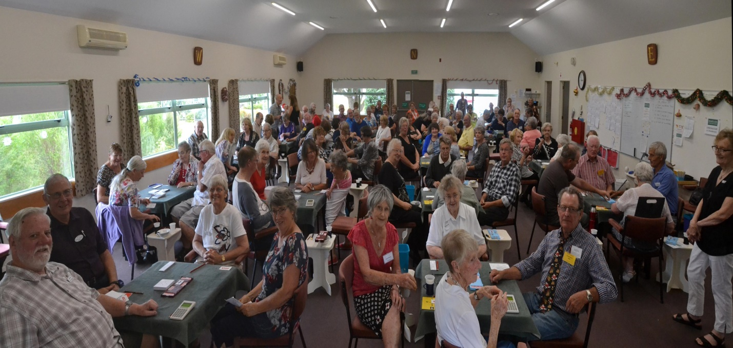

Great support for the last club event of 2017. A buzz of anticipation and tension as the Director prepares to call the room to order.

A large field of 44 pairs filled the clubrooms and came under starter’s orders at 1.30. A cheerful, chatty, yes, even noisy field turned to their cards, and, encouraged and “shushed” by the Director, there was almost a muted hush. That hush certainly didn’t last long . . . with frequent yells of “Bill!” to grab the various spot prizes planted by Bill Sewell, the Tournament Manager, interspersed with the usual calls for the Director.

A hot but pleasant and even at times hilarious afternoon’s bridge saw several examples of pre-Christmas goodwill demonstrated by over-optimistic bidding gratefully accepted by the opposition.
Members competed and won prizes in several sections but in the end, the overall winners were Lynda Evans and Michael Stace who prevailed (deservedly!) over Keith and Marg Lees, followed by Carol Hill and Yvonne Rowe.

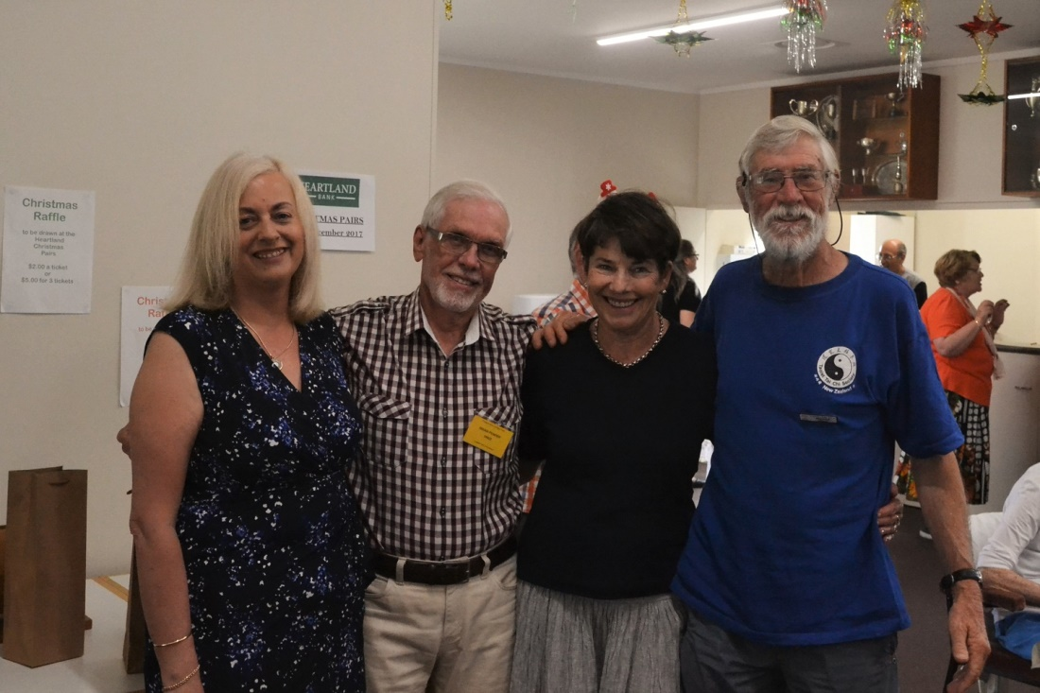

Winners . . . are grinners! (Left to right, Donna Wilson (Relationship Manager, Heartland Bank), President Brian Pender, and the successful pair, Lynda Evans and Michael Stace.)

A superb table enhanced by some Christmas fare and reinforced by wine and drinks was enjoyed before the prize giving began. There were plenty of prizes and just as well, as there were plenty of prize winners with the field divided into six sections. The club’s thanks are due to Bill Sewell for his overall supervision of the event and to Jane McArthur for her organization in the kitchen of all the bulging plates of food contributed generously by you – the members.

A representative of the tournament’s sponsor, The Heartland Bank, spoke and then the President, Brian Pender, closed the proceedings by thanking members for their positive support for this last event of the club calendar and by wishing all a happy Christmas and a safe return in 2018.
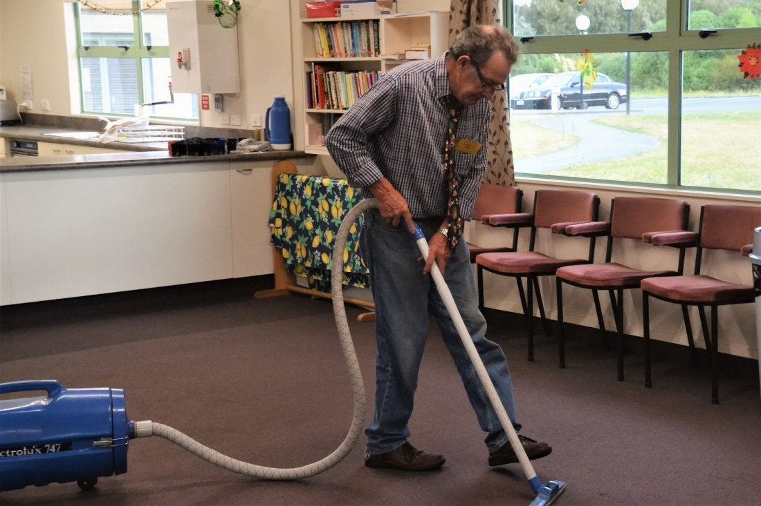
After the Lord Mayor’s Show comes the . . . But what focus and concentration on the task at hand. Note the demonstration of the correct stance, with the eyes and head directly over the nozzle, and the classic, double-handed grip . . . Ian Nicholls shows us how the right technique is vital for the after-tournament clean up.

The 70% Club
Perhaps as expected, it was impossible to knock Helen Edwards and Leon Hunia off the perch they reached in early August when they scored a remarkable 76.5 %. Jane Bradbury and Stafford Marshall were very near with 74.6%. Yes, close . . . but no cigar.
There are some very familiar names on the 70% list ie you can “round up the usual suspects”. Stafford and Leon feature three times, alongside Stuart Thurston and Pauline Reid (also three times). Particularly noteworthy is the achievement of Jane Bradbury who appears five times, and played with 4 different partners. That is a very impressive stat.
Prize Winners
It is impossible to list all the various winners of all the various sections and Pairs Events . . . but congratulations all of you!
The following prizes have been awarded earlier but may have escaped the attention of many members.
Eileen Hofland Trophy : for the overall most improved player, John Murtagh
Couch Trophy : for the most promising beginner, Kirsty Ethnyes
For their success in the Babich NZ Wide Pairs, Julia England and Brian Edwards
And the winner of the award for the most slams bid and made in a year of bridge was Irene Galloway (frankly, she just romped away from the rest of the field).

Any athletes in our bridge club? The Westport Bridge Club recently held their annual tournament. Nothing remarkable about that. Entries from clubs around the top of the South Island and nothing remarkable about that either. But Beth Burdett (pictured below) from the Golden Bay Club played in the Westport Tournament and then took the short cut home ie she cycled back to Golden Bay along the mighty Heaphy Track! Here she is on the easy part, the doddle before the tougher stuff.

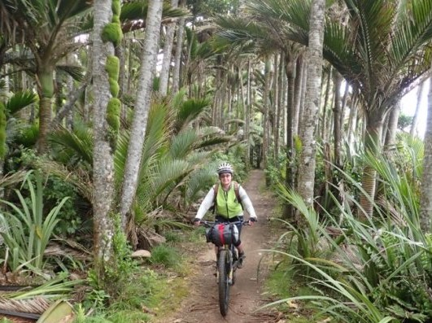

What a way to return home after a bridge tournament! No traffic delays, just a mere 80km through beech forest, boulder outcrops, tussock plains, nikau palm groves. According to rumour, our own noted cycle enthusiast Bill Sewell is considering leading a tour party from Paraparaumu Bridge to play in Westport and bike the Heaphy in November 2018. If you do want to be in the peleton, just tell Bill.

Dale’s Tips
No tips in the newsletter this time, but a very, very canny article on re-evaluating your hand has just been placed on the club’s website. Just scroll down to Dale’s Tips and the latest is No. 19. Thanks, Dale, for your suggestions to improve our bidding and play. Always thoughtful and helpful.

Finally, a thought to end the 2017 year, with just a touch of a bridge theme.
“Life consists not in holding all the good cards, but in playing well what you have been dealt.”

Merry Christmas to all members, relax with friends and family and we’ll see you back in mid-January.
Sessions begin in the week starting Monday January 15.

Editor: Keith Lees

