Our Website uses Bridge Solver Online (BSOL), written by John Goacher, which is a free software application that allows you to replay a hand and analyze the results.
You can change the contract, the lead, cards played, etc. and see what happens. If you have ever played a hand and thought you might have gotten another trick if you had taken a different line, this is exactly what you need. If you have ever looked at the Double Dummy (DD) analysis makeable contracts and been unable to figure out how you could possibly make that many tricks, BSOL is the answer.

To start Bridge Solver, go to the Results page on the PBC website and click on Replay and Analyze
The best way to understand how it works is by an example. If you want to look at board 25, click on Go To… on the bottom line and select number 25 from the grid.
That will bring up a screen like this one:

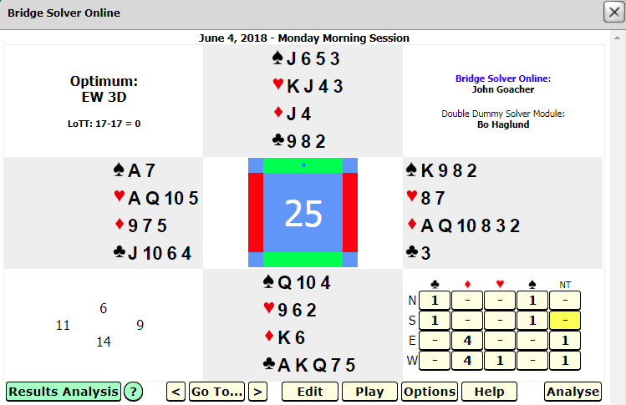

How to Start a Replay
Start playing a contract interactively by clicking on any entry in the makeable contracts table (including entries shown as '-' or '*'). In this example, the board was played in 1 Notrump by South so that box is highlighted. According to the DD analysis, South was not supposed to make 1NT.
That doesn’t matter – if you click on that box, the following screen will display:

The contract is shown with the expected result assuming optimal play by declarer and the defenders.
Optimum Contract
North is the dealer
E/W Vulnerable
The cards of the player on lead are highlighted. The small numbers (like the values on Scrabble tiles) indicate
the number of tricks which can be made by that player if that card is selected. Cards highlighted in green give the best result for that player (assuming optimal play by all players from that point forward), the cards in yellow an inferior result. The number of possible tricks will update as each card is played.

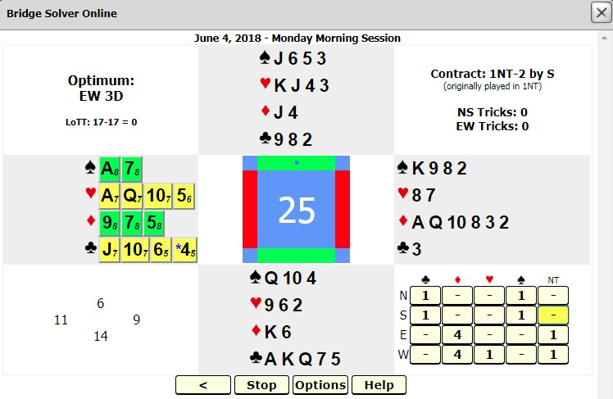A card value preceded by a blue asterisk indicates the lead card that was actually played by the defender on lead in the selected contract.

In this case, if West leads the ♣6 or ♣4, the defence can only make 5 tricks, allowing declarer to make 2NT. If he leads the ♣J or ♣10, they can make 7 tricks. If he leads an optimal card, (any of the cards highlighted in green), the defenders will make 8 tricks and declarer will go down 2.

Click on a green or yellow card to play it. In this case I will click on the ♣4.

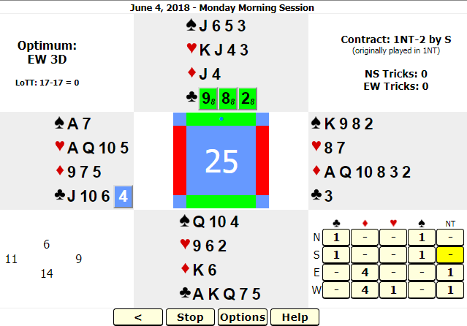The ♣4 is now highlighted in blue, indicating it has already been played. You must now select one of the clubs in the North hand by clicking on it.
Play continues by clicking the cards from each hand that you want to play.

If you make a mistake or would like to back up, click the “<” button.
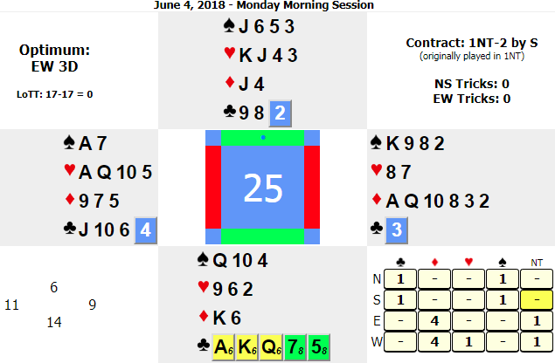

South can win the first trick with the ♣5 and with optimal play, can make 8 tricks.

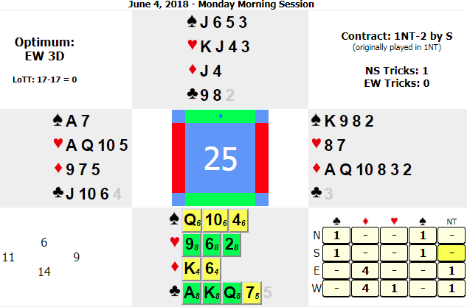
Since South won the first trick, the trick count has been updated.

It’s now time for South to play to the second trick, and you can see that the choice of suits can make a big difference in timing and number of tricks possible. As an example, a spade lead at this point can cost you two tricks. The optimal “double dummy” line (indicated by green cards) is to lead a heart or a big club.

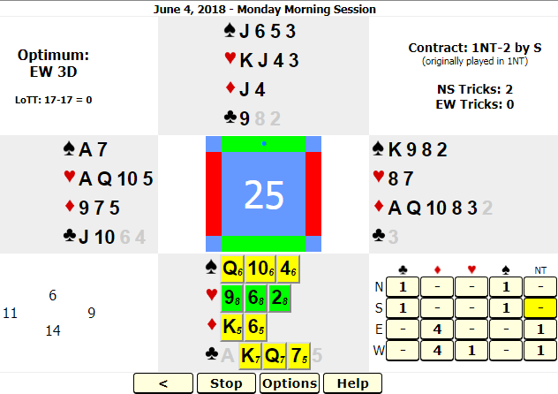

I chose to lead the ♣A and won that trick. Now I need to lead a heart to take the finesse.
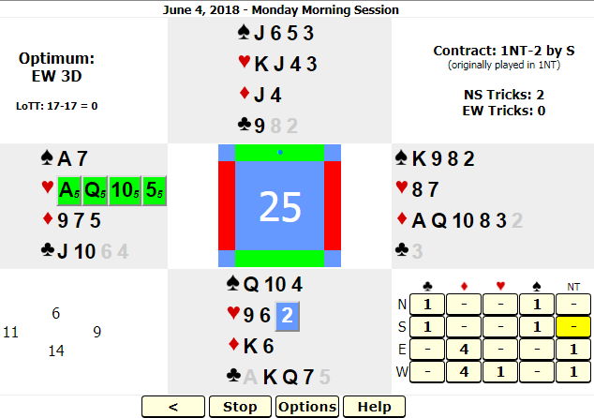

I lead the ♥2 and assume West ducks with the 5.

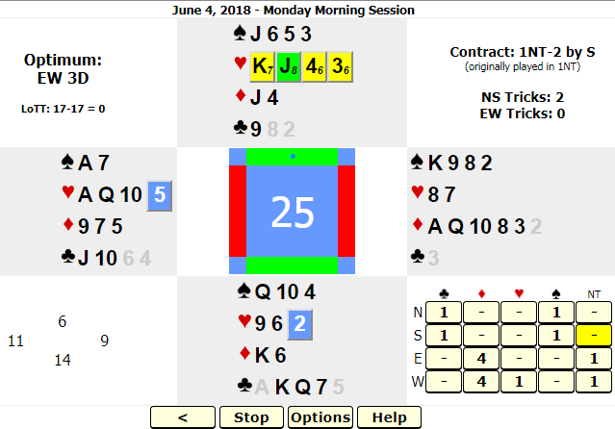

If I put up the ♥J I can still make 8 tricks. If I put up the ♥K, I can only make 7 tricks.
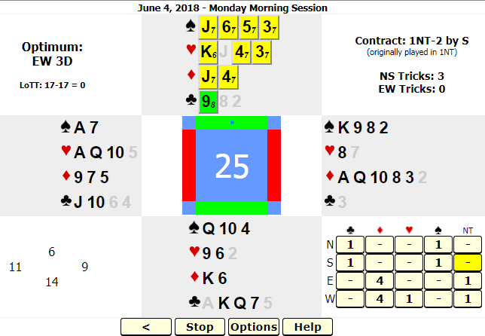

Now if I lead anything but the ♣9, I will make fewer tricks than the optimal line.

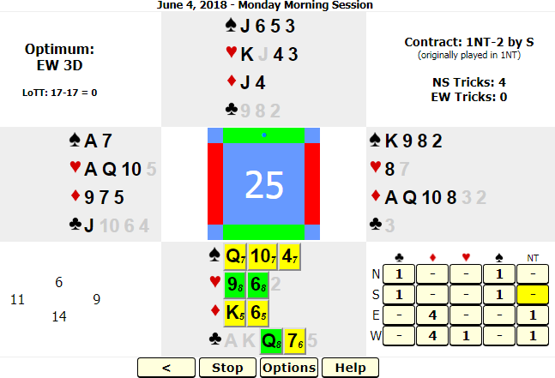

Now I lead the ♥6 and win the ♥K
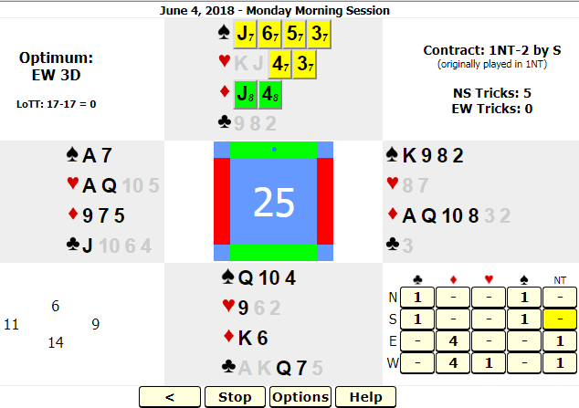

Now, I’ll lead the ♦4 towards my hand and show what happens if East wins with his ♦A.

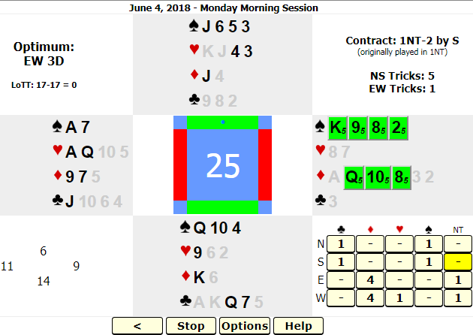

East will lead his ♠2 towards partner’s ♠A.
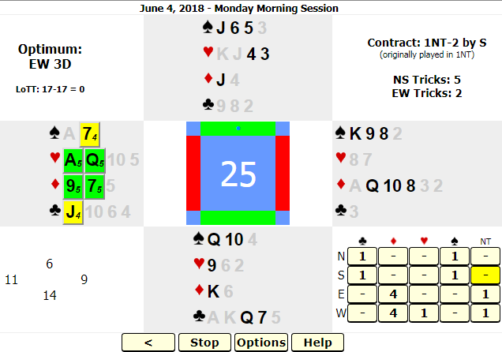

Now West can cash his hearts and exit with a diamond. In this deal, you can see he could lead diamonds first, which will set up partner’s diamond winners and E/W will still make 5 tricks. With BSOL you can try it either

way and see what happens. It is a great tool for improving your play of the hand, defence, end plays, squeezes, etc. Let’s try the ♦7 and see what happens.
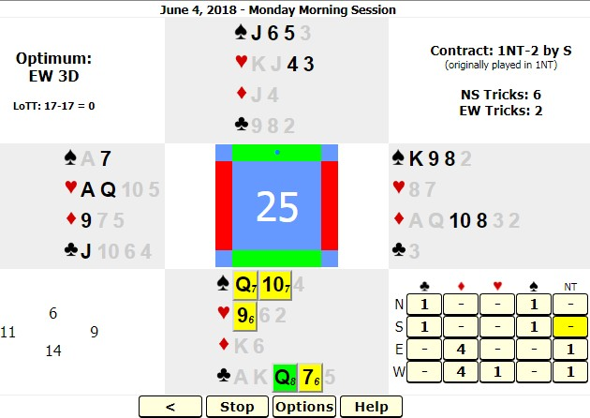

South wins the ♦K and cashes his clubs from the top.
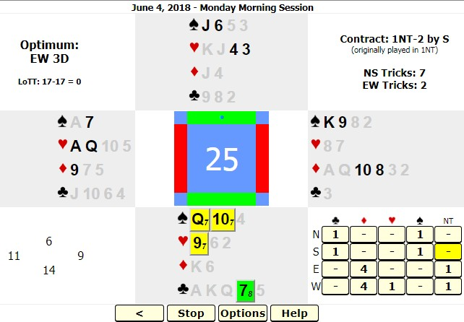

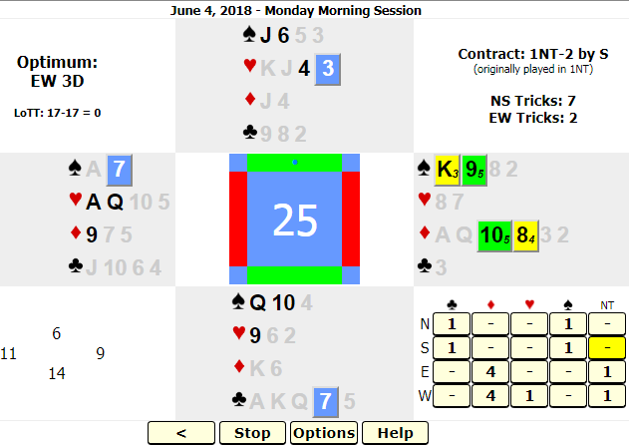

Here it is time for East to discard on South’s final club. Suppose he has forgotten the count and chooses to discard a diamond. If he discards the ♦8, his side can only make 4 tricks because he will be thrown in with the ♠K and can win the ♦10 but will then have to lead the ♠9 to North’s ♠Q. If he discards the ♦10, when he wins the ♠K he can lead his ♦8 to West’s ♦9 who then has 2 good hearts to make their 5 tricks.

