
9th July 2026
Hi All,
Welcome to another, shorter newsletter!

[1] Paraparaumu Junior Tournament sponsored by Kapiti Coast Funeral Home, Sunday 19th July
Entry Fee Per Player: $45.00 NZD Online Booking: Yes
Booking Cutoff: July 15, 2026 09:00 PM Register: https://www.nzbridge.co.nz/
This tournament is now less than 2 weeks away. These tournaments are an enjoyable way to play Bridge and help cement skills. All Novices and Juniors are encouraged to participate.
Currently there are only 8 pairs registered with only one Paraparaumu pair. It would be great to have more from our club so please consider playing and register on the NZ Bridge site.

[2] Directors –
[A] Pauline Reid has advised that she is no longer available to direct club sessions. Her last day was Friday 3nd July. Just before close of play Francie Vagg presented Pauline with a token of appreciation from the current directors.
On behalf of all our club members thank you Pauline, for your service over the years. Sessions directed by you were always relaxed and well run!
[B] Director Training
The Directors have recently embarked on in-house sessions to train new people to become Club directors. Currently there are four learners. This is a great initiative by the Directors and we wish the new recruits all the best.

[3] Portable Dyson V8 cordless Vacuum Cleaner STILL not being emptied
Last month I reported that the portable Dyson Vacuum Cleaner was not being emptied after use. Alan Stevens implores users to please empty this cleaner after use. The instructions are on the wall above the cleaner.
[4] Chairs
The Club owns 100 chairs which are all currently in the Clubrooms. We probably have about 8 - 12 surplus chairs. Should anyone like to acquire one or more chairs for a (reasonable contribution) please talk to Alan or one of the Committee members.
[5] Fundraising –
[A] The Committee has endorsed a proposal for the regular club raffles to have a $50 Compass voucher as a prize which would be credited to the winner’s compass account to go towards table fees
[B] Vouchers - when submitting vouchers to the Treasurer for reimbursement please make sure the reason for the voucher is included on the voucher.
[C] Christmas Calendar Raffle
Unfortunately, Club funds are at a critical level due to an overspend with the Clubrooms recladding and refurbishment. The overspend was mainly due to the unexpected costs relating to the steps and handrails outside the North Emergency Exit doors.
Holding another calendar raffle will help boost the club finances.
Organising is now underway. As I mentioned in May we are looking to obtain 30 prizes, each with a value not less than $100. Last year’s Christmas Calendar raffles reaped over $8,000 and we are hoping to do even better this year.
If you have any connections, please explore the possibilities of obtaining a donated prize or prizes. Each raffle ticket will include publicity for the donor. If you can help please contact me or a member of the committee.

[6] Proposed member survey.
The Committee has recently focused on succession and training of members in the various support areas vital to the running of the club and day to day sessions. To this end a survey of club members is proposed to determine the Club’s strengths and weaknesses and to assess potential for new blood in the various roles.
The most critical issue facing the Club is the need to elect a new President at the AGM in November! If anyone is interested and available there is room on the committee now for a vice president.

[7] 25 New Members from the Lessons!
Welcome to all new members. The intake from this year’s lessons was very successful. As mentioned in my last newsletter the new members and learners are now attending Monday night sessions with Tutor and Director Trevor Smith and mentors.
Normal bridge sessions are being played so that the learners will be much more familiar with the process when they start playing our programmed sessions. Some are already doing so, please make them welcome and as Chris Farrow would say “be gentle”.
[8] Charity Tournament
The annual charity tournament involving Waikanae and Paraparaumu was held at Waikanae on Sunday 28th June. The charity being supported this year was the Kapiti Kaibosh Food Rescue.
There were 20 tables for the afternoon, with 17 pairs from Paraparaumu.
Waikanae has advised that along with the household items donated $1,800 was raised for Kaibosh. A great effort and Hugh Wolfensen reported that Marg Gott organised what was probably the best raffle in the club’s history. There were around a dozen prizes with 3 or 4 winners from Paraparaumu.
There were prizes for the overall winners and the winners after the compass handicaps were applied. Special congratulations to Glen Lust and Anne Brunt who came first in the Handicapped result!
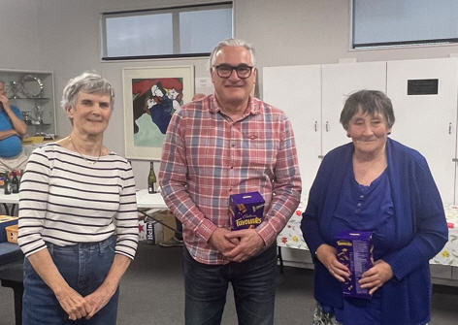 | 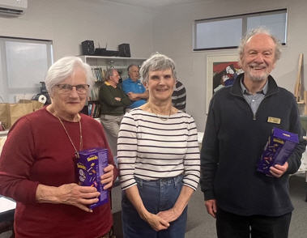
Winners Handicapped – Isobel Ross (Kaibosh) with Glen Lust and Anne Brunt | Winners (without handicap)  Jeanne Wardill and Graham Cheater with Isobel

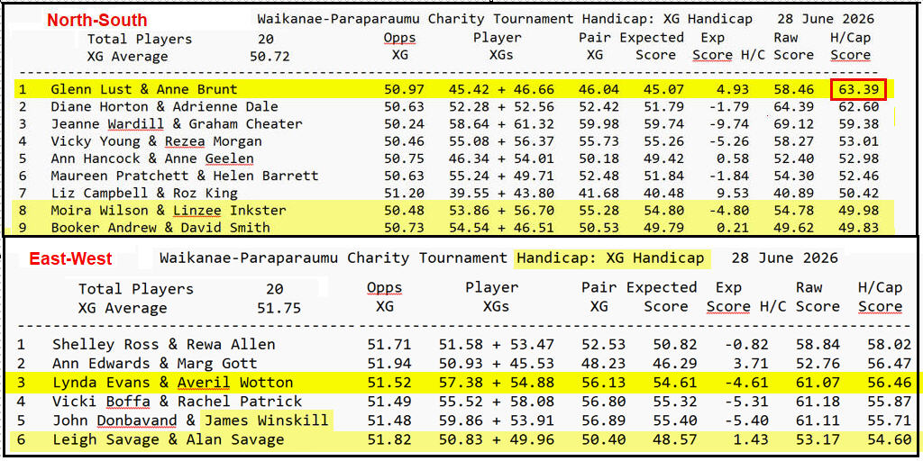
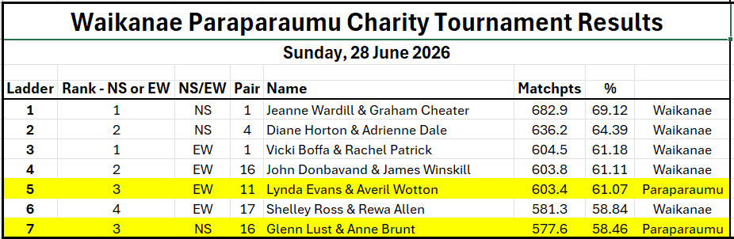

Thank you and regards,
Bob Jennings, President, Paraparaumu Bridge Club
Ph. 021 115 0008 email: rjennings@xtra.co.nz
P.S. About 10 years ago President Brian Pender included the following famous “James Bond” Bridge hand in one of his newsletters. It was from the novel “Moonraker”. I thought it was worth including again.



