
25th May 2026
Hi All,

Welcome to another newsletter. First of all, two important reminders:

Working Bee: Saturday 30th June from 10am:
(5 to 7 able-bodied people should be sufficient)
- To lift the turf from the area in front of the clubrooms.
- Excavate and level the area,
- There is one stump that may be troublesome.
- Then replace the turf.
- Washing outside of windows on the North and West of the building.

Tools required:
- At least 2 wheelbarrows
- Shovels, spades, and rakes.
- An axe and possibly a chainsaw?
- A trailer to remove surplus soil.
- Garden hose to water the finished product.
- Hoses, brushes, and cloths

Wellington Free Ambulance: Heartbeat training
Wellington Free Ambulance has offered to run a free CPR training course at Paraparaumu Bridge Club on Wednesday 3rd June 2026 from 10:00am till 12:00 noon.
To confirm numbers, interested club members are asked to put their name and contact details on the sheet on the noticeboard.
Friends and non-members are also welcome.
Space is limited so first come first served!
For further information, contact Alan Stevens 027433130

Sponsor Update
Anita Humphrey, one of our table-mat sponsors, has left Harcourts and is now part of Sotheby's Real Estate based in Margaret St, Raumati Beach. She is preparing a new table-mat design to replace her current one.
Anita will donate $500 to the club from any sale referred to her by a member, and Sotheby's will refund a portion of the marketing fee for any member of Grey Power.

The portable Dyson V8 cordless Vacuum Cleaner is not being emptied
Our building manager, Alan Stevens, has noted that this vacuum cleaner (which resides on the wall adjacent to the water dispenser) is not being emptied often enough and continued use while full is not good for the cleaner.
Instructions have now been stapled to the wall above the machine. Alan emphasises that one of the main instructions for this machine is to “Empty the bin often! Don’t let it overfill!”.
If you are using it and are unsure how to empty it, Alan will be happy to show you.

Respectful Play
Page 9 of our programme Book sets out the guidelines for respectful play. When new players arrive at the table, they should be greeted courteously.
Everyone should be welcome, whether or not they are novices or skilled players. They both bring exciting challenges to the table – one, to help and encourage and second, to learn from more experienced players.

Lateness and Session Starting Times
The programme book clearly states that all players must be seated 10 minutes before the start of play.
This allows the Director to ascertain the number of tables and determine the appropriate movement. The Director then conveys that to the Scorer who is anxiously waiting to set up the computer system correctly and ensure that the tablets are talking to the computer before handing them out.
When a member turns up late and is allowed to play, the system set up on the computer often has to be completely cancelled - then the tablets may have to be collected up and reset, resulting in a late start and then a late finish with possibly fewer boards being played. Consequently, it may mean that the late player cannot be accommodated.
The Committee recently discussed lateness and decided that late players should not be allowed to play. However, the Directors have also considered this matter and as the Director is the person in charge of the session, he or she has the discretion to decide whether or not late players will be allowed to play.
Therefore, any player who arrives after 10 minutes before play is to commence MAY not be allowed to play.

Hiring of Clubrooms
Currently, there are opportunities for outside groups to hire our Clubrooms. Margaret Jamieson does a diligent job of managing this, and we are looking to place flyers on the Clubroom entrances and North window, as well as other places such as the library and notice boards around the area.
Cleaner
Our regular cleaner has left abruptly, and Margaret has been busy arranging a new cleaner to take over. If you have any concerns regarding cleanliness at any time, please let a committee member know.

Club Funds
Club funds are currently very tight after the recladding project. The unexpected costs of remediating the steps outside the North emergency exit has not helped. Any opportunity to bring additional income helps the situation.
Proposed December Raffle
To this end, the Committee is preparing to hold another December calendar raffle. Our recent raffles have been very successful, helped by the donation of prizes from local businesses. We are looking to obtain 30 prizes, each with a value not less than $100. If you have any connections, please explore the possibilities of getting prizes donated with wide publicity for the donor on the proposed raffle tickets.

Yes, there are 31 days in December, but we already have one prize. In providing promotional material for our recent Intermediate Tournament, Bloom Hearing also included a Headphones - Streaming bundle, which they are happy to be included in our calendar raffle. Google tells me the package sells for US$599 (NZ$1000).

Succession
We are now nearly halfway through the year, and I don’t plan to flout the Constitution and stay on as president for a third year!
We will need a new President for 2027/28 so please ask about the job if you think you could do it. Past presidents and the current one will be happy to advise what the position entails. Job Descriptions are available on our website under the Members’ Area once you are logged in.
The Committee is also acutely aware that there are some roles in the club that are stretched, principally the Directors and Scorers.
We will be exploring ways to foster and address these issues.
Directors
The Directors are looking to hold an in-house short course for members to become a Club Director. They are seeking members who would be interested in learning about the intricacies of Bridge and the resolution of indiscretions.
If you are interested, talk to any of the directors, especially Brian Pender or Francie Vagg. The Club needs you because our directors are at a critical low level.
Lessons 2026
The formal lessons for new learners wishing to play Bridge are now complete. Trevor Smith and his group of mentors have done a great job with Trevor as the master tutor, and the mentors helping in playing sessions after the lessons.
Last Monday night, Trevor arranged a Graduation ceremony for all those who had completed the lessons. There were approximately 25 potential members with several already applying and obtaining club membership. I was at the ceremony to help with the presentation of a Certificate and Books on playing the game of Bridge.
The plan is to now continue with learner sessions each Monday night through to the end of the year. Novices and Juniors will be invited to attend the sessions at some stage. The sessions will operate under normal playing conditions controlled by a Director.
The goal is for this programme to help learners cement what they have been taught, become members, and transition to playing in regular sessions operated by the Club.

Recent Tournaments
[1] The Terramark Sponsored Pairs Tournament was held on the afternoon of Sunday 3rd May. There were 20 pairs competing, split into 4 sections, A, B, C and D, based on current handicaps.
About halfway through, Trevor challenged the players with a general knowledge quiz using the new television to display the questions, then followed them with the answers.
There were a number of questions about Bridge. Learning that the 10 was an honour card certainly helped Linzee and me!
The scorecard and photos of the Section winners are listed below.
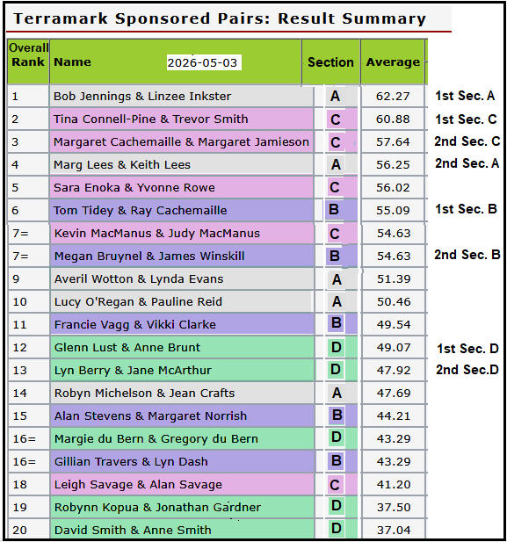

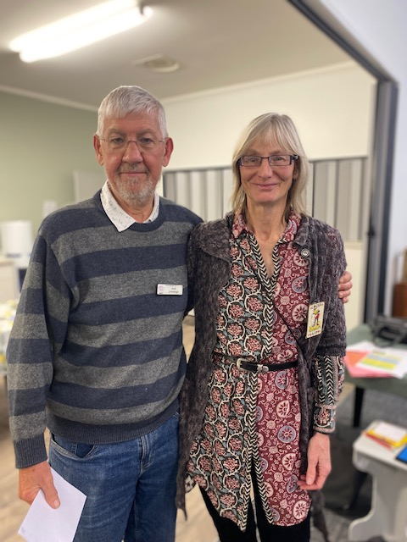 | 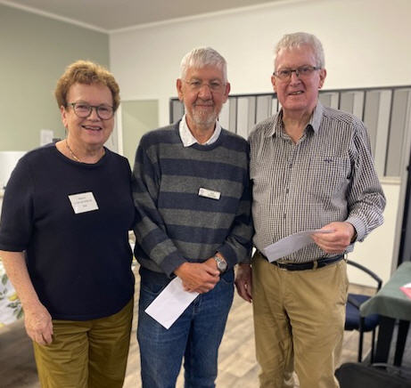
1^{st -}Section A and overall - The President and Linzee Inkster | 2nd Section A – Marg and Keith Lees

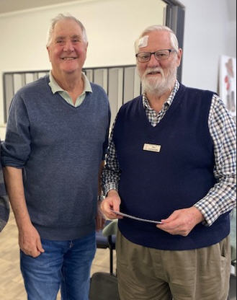 | 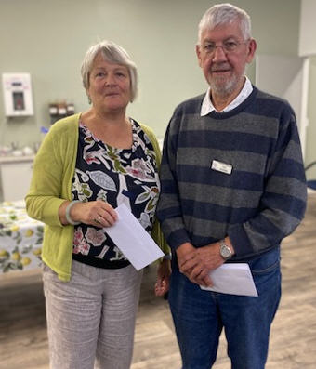
1st – Section B - Tom Tidey and Ray Cachemaille | 2nd Sect. B-Megan Bruynel & James Winskill (absent)
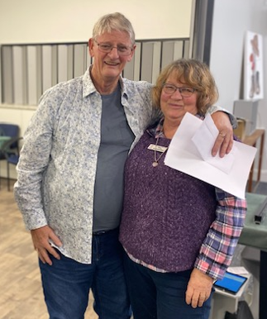 | 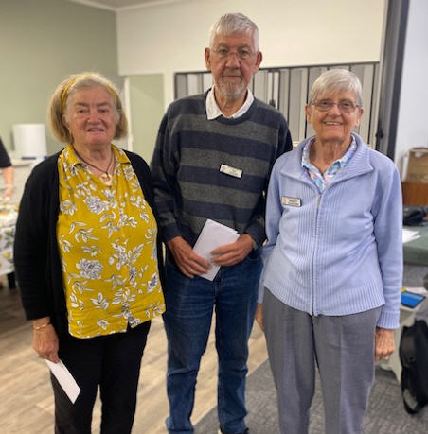
1st Section C (2nd Overall) Trevor Smith and Tina Connell-Pine | 2nd Section C (3rd Overall) Margaret Jamieson and Margaret Cachemaille
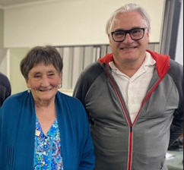 | 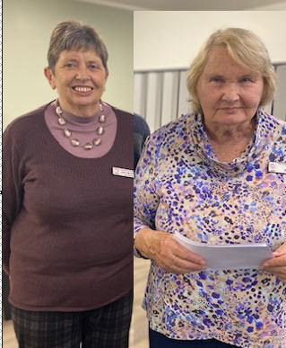
1st Section D – Anne Brunt and Glen Lust | 2nd Section D – Jane McArthur and Lyn Berry

[2] Bloom Hearing Intermediate Tournament
This was held on Sunday 17th May. The tournament was very successful with 17 pairs competing.
Our club’s best performers were Jane Bradbury and Dale Wills coming 2nd Equal for the day.
A scorecard of the first 8 pairs for each or the sessions and the overall tournament are listed below and followed by photos of the various winners.
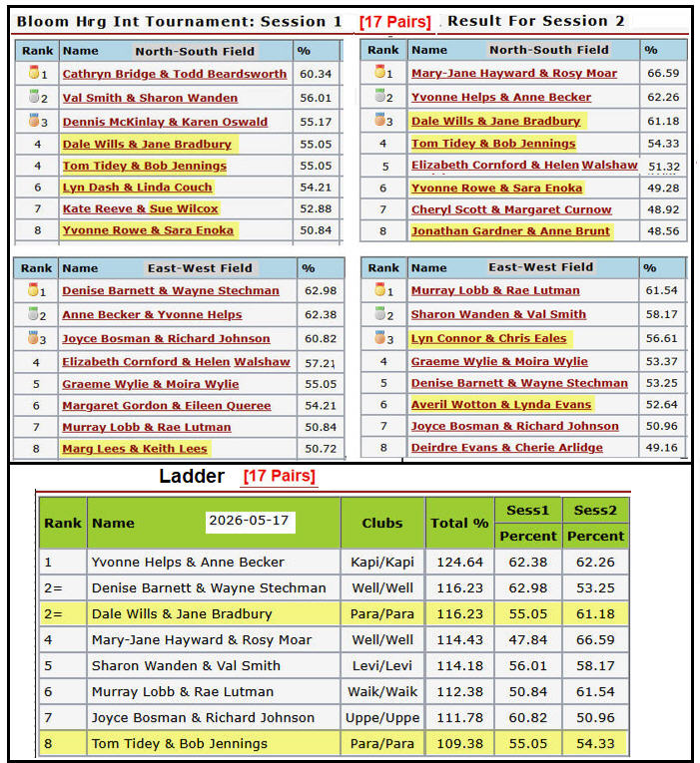
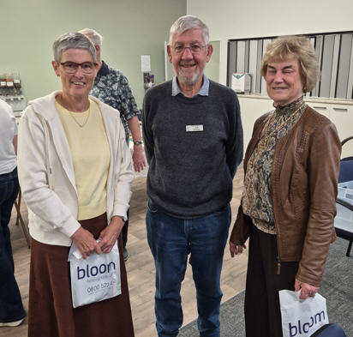 | 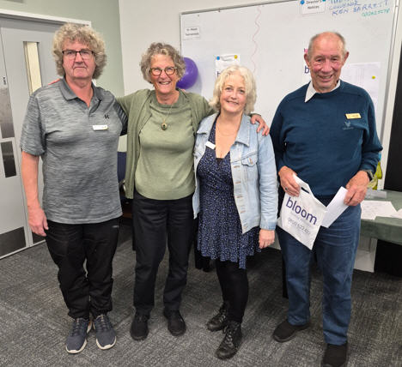
1st Anne Becker, President and Yvonne Helps | 2= Wayne Stechman, Jane, Denise Barnett, Dale
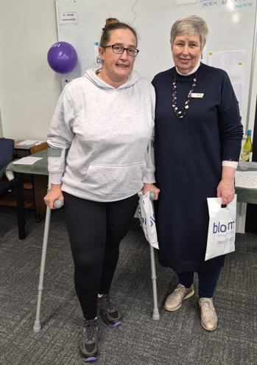 | Bloom Hearing Intermediate Tournament  Prize Winners
4th - Rosy Moar and Mary-Jane Hayward 4th | 17th May 2026
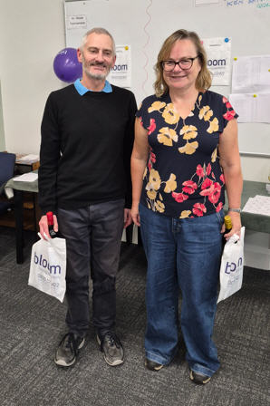 | 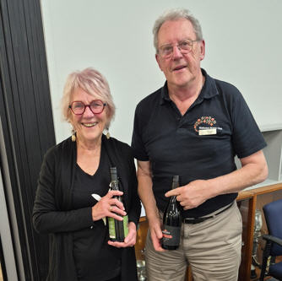
NS Sesson 1 Todd Beardsworth and Cathryn Bridge | EW Session 2 – Rae Lutman and Murray Lobb

Many thanks to our sponsors, Bloom Hearing and the following members who were involved in the running of the tournament
- Noella Squire and her helpers for providing a generous lunch, which was very well received.
- Lyn Connor, a new committee member for her organising. Our Director was Bryan Green from Levin. He had a busy time and kept things running smoothly.
- Our scorer Jane McArthur with input from Helen Edwards.
- Ray and Margaret Cachemaille for handling the bar.
- All those who helped clean up at the end and put the room back to its usual state.

Upcoming Matches and Tournaments
The first Forbes Team competition will be held over 3 Wednesday nights in June [10, 17 and 24].
The list for Team entries is up on the notice board. A number are already entered, but we could do with more. Please consider building a team and entering.
Each Team is made up of a NS pair and an EW pair who play the same set of boards against each of the other teams. This year’s Convenor is Linda Couch ph. 027 244 0363

Waikanae – Paraparaumu Charity Tournament to be held at Waikanae on Sunday afternoon 28th June – Please Note - Starting Time 1pm – Need to be seated by 12.45 pm
This is a great competition that will be held in a familiar setting. This year will be handicapped using the Compass XG system, which should level the playing field for Novices and Juniors and encourage them to enter.
The Charity being supported this year is Kapiti Kaibosh Food Rescue. The tournament cost will be $20 and players are asked to bring along a food contribution. e.g Dry Goods – Rice, Pasta; Household Items – Toothpaste, Toilet Paper, Sanitary Products. Raffles will also be available.
Please record your names on the entry sheet. If you require sitting rights or other special needs, please email WaikanaeBridge@gmail.com.
Paraparaumu Junior Tournament sponsored by Kapiti Coast Funeral Home
Sunday 19th July 2026.
Although this is 6 weeks away, I would encourage all Novices and Juniors to participate. It is a great way to learn and build your playing skills.

Thank you. Bob Jennings, President, Paraparaumu Bridge Club

