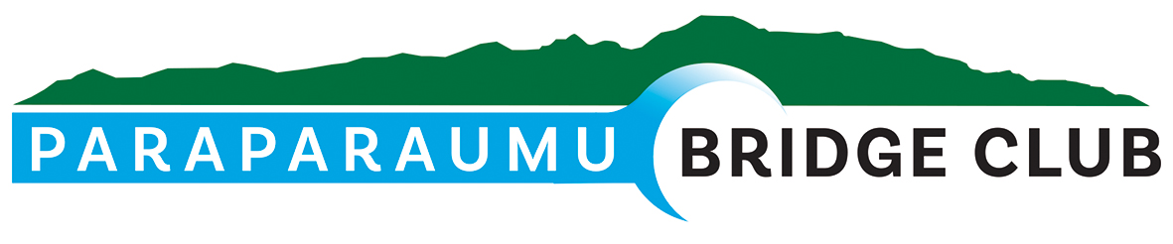
28th April 2026
Hi All,

Official Re-opening - 3pm on Sunday 22nd March
The official reopening was a successful event. The inclusion of a karakia, blessing the building, people and food by local Kaumatua Alby Allison and his team, Aaron Cronin and Karl Webber added a special dimension to the re-opening. The blowing of the conch shell, known as a putatara by Karl was particularly haunting, being a sacred act used to signal important events, herald guests and connect with the spiritual realm.
Afterwards Alby took the time to translate his words and explain the ceremony which was appreciated by all. Alby congratulated the club on “an outstanding asset now that it is upgraded. He also acknowledged the community support and fundraising that helped make the project possible.
After Alby’s words I welcomed special guests and thanked everybody for attending with special mention to Alby, Aaron and Karl for their participation. I then went on to thank all those that been involved with the project through to its completion especially Alan Stevens and Trevor Smith. I expressed our gratitude to Hugh Wolfensohn, President of the Waikanae Bridge Club for the generous use of their clubrooms so that we could complete our 2025 programme.
After this I asked Dale Wills, member since 1977 and Life Member for the last 15 years to say a few words and cut the ribbon to declare our Clubrooms officially reopened. Dale spoke of the journey of the Club from the time he joined to the construction of the current Clubrooms in 1998 through to today. He then cut the ribbon (refer photo) to complete the proceedings after which afternoon tea was served.
I have attached my speech notes and thank-you’s as an addendum to this newsletter for members that did not attend the re-opening.
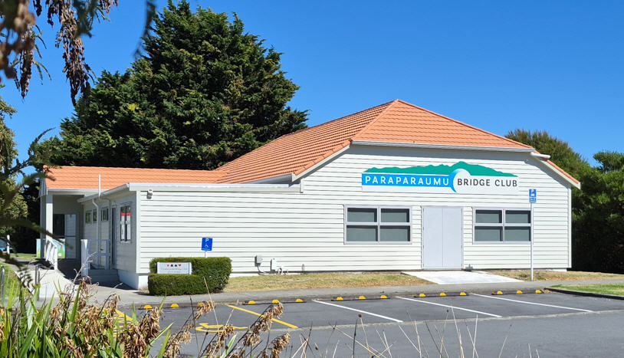  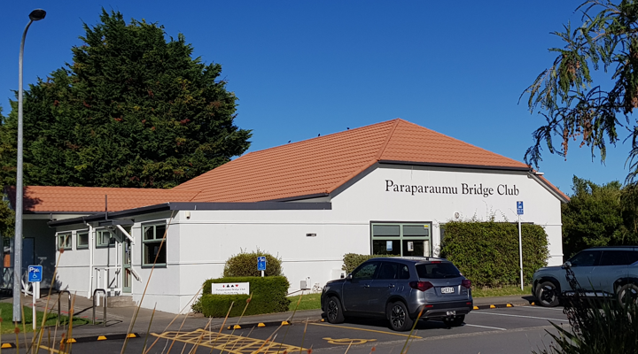 | 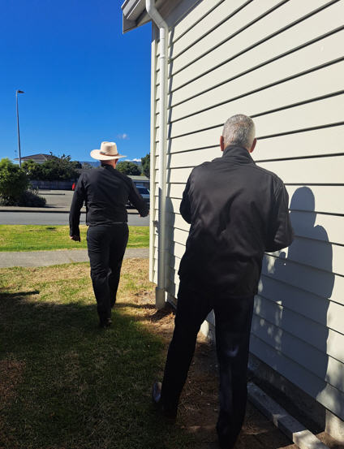
Clubrooms – Before and After | Aaron and Alby leading the karakia
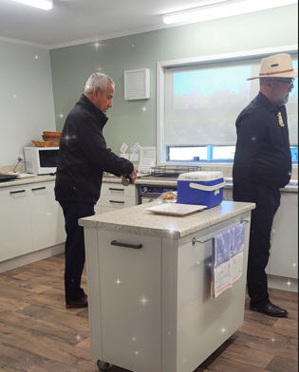 | 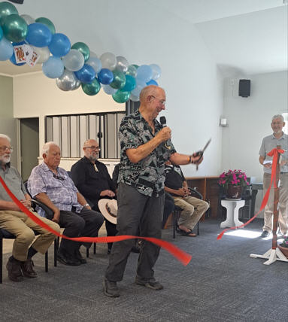
Karakia in kitchen | Dale Wills cutting the ribbon to officially reopen the Clubrooms

Current Status of Clubrooms
Our construction work is just about complete! As you may know the Emergency North Doors were closed off due to the Council advising that the step down and exit concrete did not meet current requirements even though we believed the existing construction was in accordance with the consented plans.
We had to apply for a Certificate of Public Use which was conditional on the North Doors being closed off and a limit of only 50 persons being able to use the premises at any one time. This has resulted in extra unexpected cost to the Club.
However, the doors and new steps are now operational and handrails will soon be fitted to complete the work.
This will mean that we will be able to apply for a Code Compliance Certificate from the Council which means that all work has been competed to the satisfaction of Council.
Application for Discretionary Grant from Paraparaumu Community Board
To help alleviate costs to the above exit ramp Alan Stevens put together an application for the extra costs the above incurred which was submitted in time to be considered at a meeting of the Board on 21 April 2026. Trevor Smith and I attended the meeting in support of the application.
While we did not receive full compensation for the work the Paraparaumu Community Board resolved to make a grant to Paraparaumu Bridge Club Inc. for the amount of $1500 which was double their usual maximum grant.

Television
Many of you will have notice the TV positioned on the North Wall.
An application was made by Trevor Smith to the Lottery Wellington / Wairarapa Community Fund for funds to purchase a Television and this was successful, so well done Trevor!
The TV will be very useful for lessons, sponsorship advertising, director’s tips, tournament information and seating on the day, and having a visible timer to manage session play. I’m sure there will be other uses also.

Paraparaumu - Waikanae Interclub
This was played on Saturday Afternoon on 28th March at Waikanae.
14 pairs from each club competed. Unfortunately, Waikanae were again winners retaining the shield. Overall Waikanae achieved 710.44 total points (average 50.74%) opposed to Paraparaumu’s 689.56 (average 49.25%)
Paraparaumu’s best performers on the day were:-
Rank |  |  | %
5 | Dale Wills | Jane Bradbury | 59.75
6 | Jane McArthur | John Donbavand | 57.14
7 | Tina Connell-Pine | Trevor Smith | 56.73

However, an enjoyable and friendly afternoon’s play took place followed by a well-catered afternoon tea where both club’s players brought plates!
We did our best to provide the wine and drinks then clean up at the end. Many thanks to Gillian Travers who led the way and worked like a Trojan to ensure all was washed and clean the way we found it.

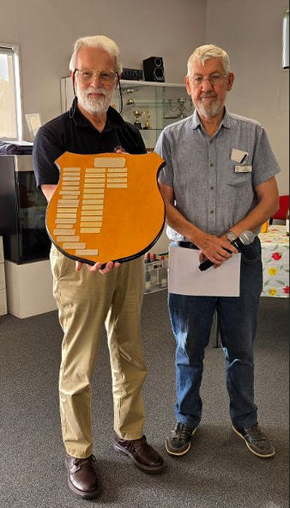 | 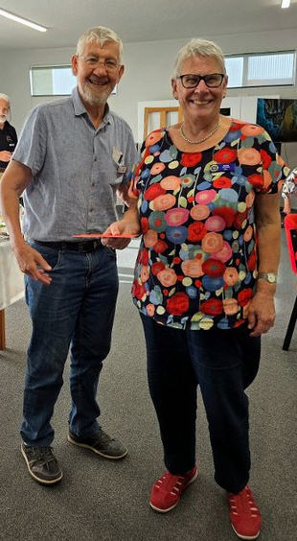
Waikanae President, Hugh Wolfensohn with shield after Waikanae’s success | Bob with Director Basia Arnold from Otaki

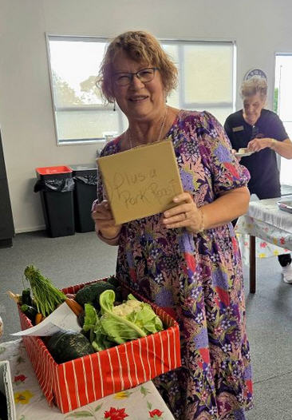 | 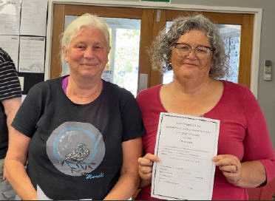
Tina Connell-Pine indicated that a Pork Roast goes with the wonderful raffle prize she won with the number 1! | Yvonne Rowe and Sara Enoka after winning 3rd prize at the Levin Multigrade on Sunday 4th April

Levin Multigrade
Congratulations to Yvonne Rowe and Sarah Enoka who came third in the Levin Multigrade played on 4th April. They averaged 57.81% for the morning and afternoon sessions - a great result!

Paraparaumu Open Tournament (Sponsor - Kapiti Retirement Trust)
Sunday 12th April 2026
Yvonne and Sarah bravely entered the tournament. but the winners were:-
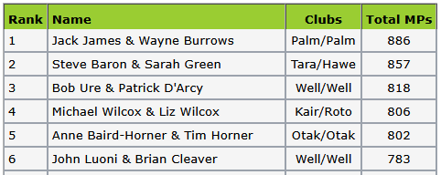

Peter and Vikki Cogswell made a major contribution to the lunch which was enjoyed along with the after-event snacks. Noella Squire was still involved and helped with the transfer of her vast experience.
Thanks to Jane Bradbury for fronting the tournament, Hugh Norton’s organisation and all those club members who helped on the day including those who were able to provide a plate.

Wellington Region Congress – ANZAC Weekend
This event was held over ANZAC Weekend and apparently was one of the largest yet.
Francie Vagg and James Winskill came 12th in the Intermediate Pairs (30 pairs) and
Jonathan Gardiner and Glenn Lust came 3rd in the Junior Pairs (15 pairs).
Special congratulations to Jonathan and Glenn for a great result!

Future Club Tournaments
Sunday afternoon, 3rd May - Terramark Sponsored Pairs
A list is currently available on the notice board for members to register to play.
Please bring a plate.

Sunday (all day), 17th May - Bloom Hearing Intermediate Tournament.
Please bring a plate
Please note that as Peter and Vikki are away on their honeymoon, we are looking for helpers in the kitchen/catering line for this tournament.
If you could lend a hand during one or more of the three busiest times – before the tournament, during the lunch period and after the tournament – please could you let Noella know.
This is a good fundraiser for the club so if you are a junior and not playing perhaps you could help out (juniors are, of course most welcome to compete in the tournament.)
Thank you.

Session Attendance
Just one final note about session punctuality. The directors have alerted me to recent occurrences of lateness and partners not turning up. This makes it difficult for the Director and Scorers to determine the number of tables and set up for the session to start on time.
All players must be seated 10 minutes before the scheduled start of play.
As a courtesy you should phone or text your partner on the day of the session to confirm arrangements. If you are definitely playing but could be late, please alert your partner so that they can advise the Director.

Thanks and regards
Bob Jennings, President, 021 115 0008

Addendum:
Paraparaumu Bridge Club Official Reopening
22 March 2026
President Bob Jennings - Welcome and Thanks

Good afternoon and welcome you all
It is an honour to welcome our Official Party seated here with me
Thank you Kaumatua Alby for taking the time to be with us today and bless our newly refurbished building. Your presence adds a special mana and dignity to our re-opening.
Thanks also to Aaron Cronin and Karl Webber who represents both the iwi and the Kapiti District Council.
The rest of our official party are
- Alan Stevens – Club Building Manager
- Trevor Smith - Life Member
- Dale Wills – Life Member
- Hugh Wolfensohn – President - Waikanae Bridge Club
- Mark Wickens – Our Quantity Surveyor and Engineer to the Building works
I mention these gentlemen in my following speech so I’ll won’t go into too much detail at the moment.
We have representation from various organisations who have helped us or followed our progress from leaky building to where we are today
Welcome our special guests
- Ōtaki Bridge Club members
- Claudia Duncan – Wellington Regional Bridge
- Amber Moffitt – Community Advisor (Apology)
- Dianne Lester from Kapi-Mana
- Leeann Ware – Kapiti News

A special Welcome to our Club Members. You are also mentioned later on in my notes.
We have Apologies from Carl and Jae van der Meer of CD van der Meer Builders and Steve Ransley.
It is unfortunate that Jae and Carl from CD van der Meer Builders cannot be here today as they have contributed so much to our refurbished building! We plan to definitely recognise them in person at a future opportunity.
It is a privilege and a pleasure to be able stand here and celebrate the reopening of our Paraparaumu Bridge Club rooms—refreshed, renewed, and ready for many more years of friendly competition and fellowship.
Beginning
This project began with a problem and the vision to fix it. Consequently, we owe a very magnanimous and special thanks to Alan Stevens, our Building Manager.
Alan’s initiative and determination set the whole process in motion. Without Alan’s drive, (and Marsha’s good-natured tolerance) we would not be here today enjoying these impressive restored facilities.

We are grateful to Steve Ransley, engineer from Miyamoto for his thorough timber moisture report and clear recommendations, which gave us the knowledge and confidence to move forward.

We are indebted to Greig Hayward, our architect, for his efficient and economical preparation of plans and specifications that turned the vision into practical reality. Receipt of the Building Consent from KCDC was the culmination of this initial work. The Building Consent was a vital document to progress what needed to be done to fix our “leaky building problem”.

Our sincere appreciation goes to Mark Wickens, Quantity Surveyor and Engineer to the contract, for his excellent advice and continued support. Mark, your guidance has ensured we have remained both prudent and practical at every stage.

We are also indebted to our immediate past president, Trevor Smith. Trevor was President of the club at the time the manure hit the fan. That was at the time Steve’s moisture report findings were made available. As the current President I can only sympathise with Trevor having to come to terms with the problem and the enormity of the fix.

However, with Alan and the Committee’s support and that of two newish club members at the time, Victoria Bolton and Roger Simmons, a way forward was mapped out. Trevor was instrumental in preparing the applications for funding and what’s more being successful!

Special thanks to our Club members for your encouragement and generosity. Your donations, and tireless fundraising efforts and working bee help demonstrated the true spirit of our Club. This building is not just timber, paint and plaster; it is a result of your commitment and just wanting to play Bridge!

We are very especially grateful to Pub Charity and the Lottery Community Facilities Fund for their significant funding support. These contributions made a huge difference and helped transform plans into completion.

To CD van der Meer Builders and their subcontractors, thank you for your dedication, craftsmanship, and efficient execution of the works. Your professionalism shows in every detail around us. And to P&J Plastering, we appreciate your early advice, expertise, and efficiency in accommodating the increased scope of work as the project evolved.

Special thanks also to Hugh Wolfensohn and your Waikanae Bridge Club for accommodating us from Labour Day through to mid December while the recladding was underway. It was a privilege to be able to use your Clubrooms and play Bridge as usual. Our members certainly appreciated the opportunity to complete our 2025 programme in a very comfortable and welcoming environment.

One last thank you is to Theresa Cook who has helped organise me and the decorations for today. She is responsible for giving our reopening some pizzazz. The balloons are the efforts of some of her young friends and Theresa also supervised Trish and Linzee with the decorations, flowers and the presentation of the food. Thank you again Theresa!

Today, we reopen not just a building, but a hub of friendship, strategy, laughter, and community. Let us hope these renovated rooms serve us and the wider community well for many years to come.
Thank you.

Dale Wills – Life Member

I’d now like to ask our own Bridge “Kaumatua”, Dale Wills to come forward and carry out the last and most important function of the day.
For those of you who may not know Dale has been a member of our club for 49 years and a Life Member for the last 15 years! His knowledge of the game of Bridge is profound, and he continues to Direct playing sessions with ease.
Dale – in your own time can you please cut the ribbon and declare our clubrooms officially re-opened.

Bob Jennings
President
Paraparaumu Bridge Club
22 March 2026

N.B. - Leanne Warr, Editor of the Kapiti News wrote an article on our Re-opening on page 10 of the Kapiti News dated 1st April

