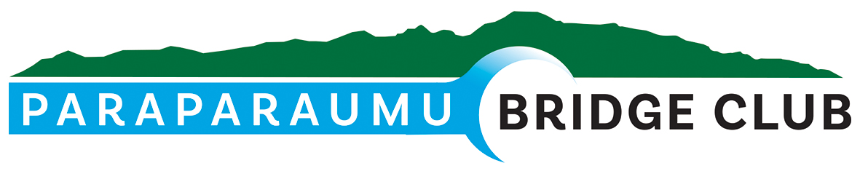
5th March 2026
Hi All,

Official Re-opening - 3pm on Sunday 22nd March
A reminder to you all that the official re-opening of our refurbished clubrooms will take place at 3pm on Sunday 22nd March. All members are most welcome and are encouraged to bring a plate.
Currently the proposed timetable is :-
- Doors open for arrivals from 2.30pm
- 3pm – a welcome with acknowledgements and thanks to all those who participated in the process through to its conclusion.
- The official opening by a special guest.
- This will end the formalities and be followed light refreshments.

Law Connection Pairs Tournament
The following are the winners of the tournament. Prizes were awarded by our sponsor, Peter Corrin representing the Law Connection which I understand has supported our club for over 30 years!
Rank |  |  | % |  | Section
1 | Chris Eales | Lyn Connor | 64.55 | 1 | B
2 | James Winskill | Chris Farrow | 60.23 | 2 | B
3 | Barbara Horner | Sue Wilcox | 57.73 | 1 | A
4 | Averil Wotton | Lynda Evans | 56.14 | 2 | A
5= | Theresa Cook | Ian Nicholls | 55.45 | 1 | C
7 | Ray Cachemaille | Elizabeth Steinbauer | 55.00 | 2 | C
8 | Glen Lust | Anne Brunt | 54.32 | 1 | D
9 | Jocelyn Graves | Jane McArthur | 53.18 | 2 | D

Prize Giving 2025
The 2025 prize giving was successfully awarded after the Law Connection Tournament with Trophies awarded first and then Certificates to competitions where there was no associated trophy. Congratulations to all winners.
You can access the prize winners on our club website - https://www.paraparaumubridgeclub.co.nz/prize-winners-year

Below are photos captured of some of the awards - thanks to Chris Eales.
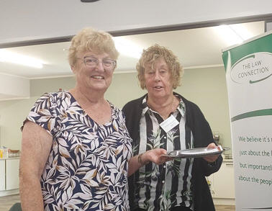 | 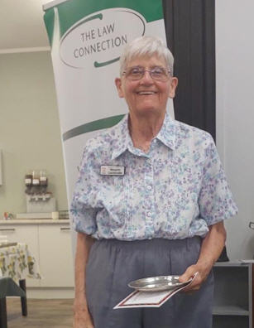
Lyn Dash and Pauline Reid  Winners of the Sillick Trophy, B and A respectively. | Margaret Cachemaille – winning the Zena Suisted Ladder Trophy
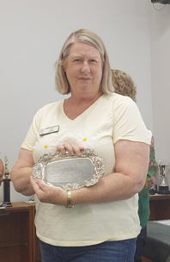 | 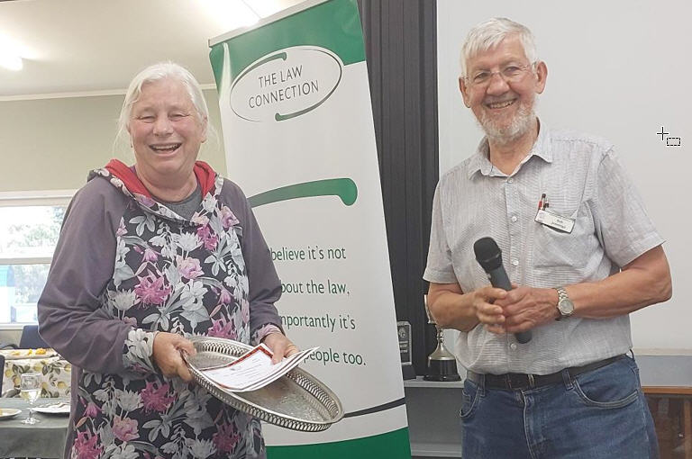
Lyn Connor – winning the Forbes Handicap Teams Tray | Yvonne Rowe – winning the Thank You Christmas Pairs with Noella Squire
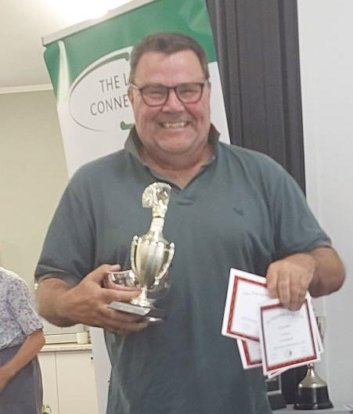 | 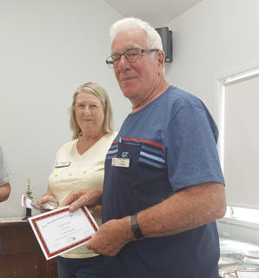
Chris Woods winning the Alyth Brady Trophy and Kilmister Pairs Rose Bowl along with partner John Luoni | Alan Stevens receiving his share of the Forbes Handicap Teams Tray along with Lyn, Margaret Jamieson and Gordon Whittleston

Unsung Heroes
The following article appeared in the Wellington Regional Bridge Newsletter February 2026 <newsletter@wellingtonregionbridge.nz>
Unsung Heroes
Bridge clubs across the country rely on the hard work of many unsung heroes to enable them to thrive. Whether you are a director, dealer, scorer, or one of the many people without whose contribution we would not be able to exist, I thank you. However, there comes a time when one person stands as a tall poppy amongst those who dedicate so much time to ensure our clubs continue. This is about our giant of a hero.
Fifteen months ago, the prospects for Paraparaumu Bridge Club looked bleak. We had become a leaky building. From the get-go our building manager was determined that the club would continue. He first organised a working bee during the heat of summer and sealed all the cracks that were letting in water, giving us time to raise the funds to reclad the building.
He then worked with others to raise funds in innovative ways, securing enough to apply for grants. He prepared the applications and remained positive that we would have all the funds in place in time to minimise disruption to our bridge playing. With the help of Waikanae Bridge Club, we were able to transfer our club nights there for six weeks while the work was completed.
Throughout the closure he was on site, ensuring that as each tradie needed access to certain areas these were kept clear. This required long hours, including over the holiday season.
However, he secured not just a reclad, but a complete internal revamp — new carpet and linoleum, freshly painted walls, a new security system, new heating system, new windows and doors, new shelving, and a completely refreshed club.
It was a mammoth three months’ work, supported by a series of working bees to prepare the building and move everything back in. So many members of our club contributed to this project — whether through working bees or buying yet another raffle ticket — but there has been one person, Alan Stevens, who worked tirelessly with positive influence and drive to make this happen.
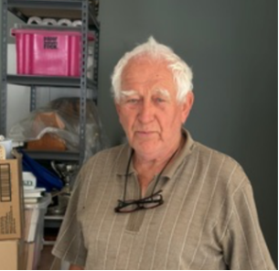 | He is pictured here on a hot Tuesday afternoon moving items so we could remove the carpet coverings and expose the floor for the carpet layers.  Thanks to his dedication, we are now back in our beautifully renewed clubrooms — the result of 12 months of fundraising and months of hard work.
So thank you to all the club members who made this happen, thank you to the unsung heroes across the region who keep our bridge clubs functioning, and most of all, ngā mihi nui — a very big thanks — to all of our giants, especially our building manager, Alan Stevens.
Vikki Cogswell, Club Secretary, Paraparaumu Bridge

Finally
Please do come along and support our official re-opening. As I said in my last newsletter we could have been in a much more drastic situation had we not had the input and drive of some our very competent and energetic club members.

Thank you and regards, Bob Jennings, President, 021 115 0008

