
WISHES YOU A
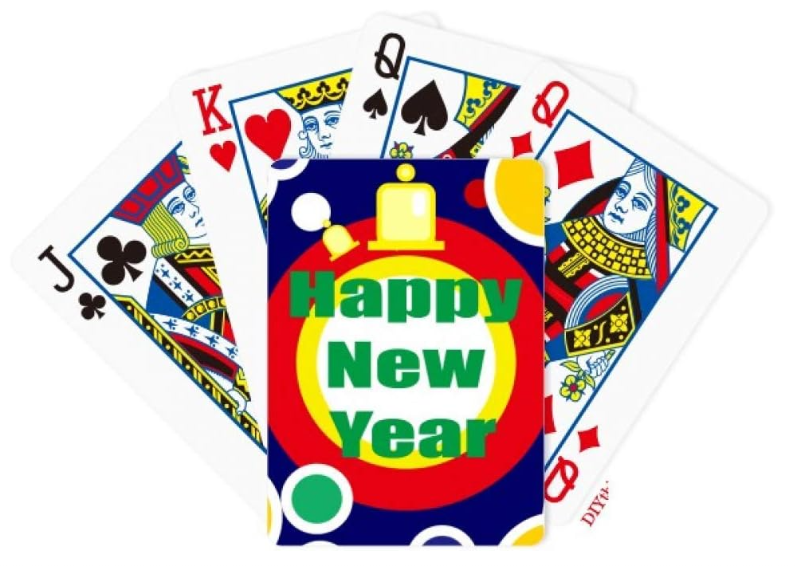

…AS WE’RE ABOUT TO START A NEW YEAR OF BRIDGE. MAY 2026 BE A GREAT YEAR FOR YOU.
IT’S BEEN A LONG TIME COMING, BUT WE’RE READY TO BEGIN PLAYING IN OUR NEWLY RENOVATED AND DECORATED CLUB.

PROGRAMME BOOK LAUNCH
The Programme Book launch will be held AT THE CLUB from 3pm to 5pm on SUNDAY 1st of February.
Come along and check out our NEW clubrooms!
Pick up your book, mingle and have a chat, chew on a few nibbles, and maybe book in a few partners for the new year.

START OF PLAY
Play will commence on Tuesday 3rd of February.

The committee decided to allow the contractors to complete their work up to the 31st of January, the agreed end of the contract date, without interruption.
There will still be some internal finishing work to be done in early February, but this should not interfere with normal play.

BRIDGE LESSONS
Our lessons begin on Monday, the 9th of February, at 7pm. They are FREE and will run for 12 weeks, followed by practice sessions on Monday evenings for the rest of the year.
Please spread the word. Tell your friends, neighbours, relatives, co-workers, and everybody you meet about our lessons and the wonderful game of Bridge.
Any members who would like to refresh their basic skills are very welcome to come along.

