
23rd October 2025
Hi All,
This newsletter is to remind you about sessions at Waikanae Bridge Club Rooms while the building work is in progress and for you to check your details in the attached list. There are also a few other bits of news.

Playing at Waikanae
The summary sheet of play is appended to this newsletter and now includes access times to the Waikanae Clubrooms.

Things to remember
- Tuesday Afternoon, Thursday Evening and Friday Afternoons are at the usual times with access to the clubrooms 30 minutes before start time. Note: there are 3 exceptions, 2 in November and 1 in December (See below)

- Because Waikanae has a Tuesday Evening session our Tuesday Evening session will transfer to Wednesday Evening with access to the clubrooms at 7.30pm due to the clubrooms being used by Guides from 5 – 7pm on Wednesday nights.

- The Directors and scorers will have early access to be able to prepare for the sessions play. The Directors will also give notice of the exceptions a week before as well.

Carpooling
If you are playing, look to arrange getting to Waikanae with your partner and may be with another pair who you know are also playing.
If you do not have transport, please contact the Convenor for that session and they will help arrange transport.

2026 Programme Book
Jane Bradbury is currently beavering away with next year’s programme book. All the information in the book is critical to next year’s operation and the bulk of it needs updating with the 2026 details.
This includes is ensuring members phone numbers are correct.
As we are vacating our clubrooms it will not be helpful posting a printout on the notice board for members to check and correct. Consequently, a member name and telephone number list is attached to this newsletter.
Please check your details. If the spelling or telephone number is incorrect, please email Trevor Smith otsmith@nowmail.co.nz with the correct details by 31st October 2025

Tournaments coming up
Sunday 26th October - Style Hair Design Sponsored Halloween Pairs
Sunday 2nd November - Waikanae Junior Pairs – Afternoon only
- Open to Juniors and Novices.
- Registration opens at 12.30 and play begins at 1.00pm Entry Fee $20
Sunday 16th November – Jackways Shield at KapiMana
- We need at least 13 pairs,. and so far we have only 4! Please sign up to play in this afternoon competition. We were scheduled to host the event, however, KapiMana has kindly agreed to host instead while the recladding is underway.
Sunday 14th December – Forsyth Barr Christmas Pairs

Tournament Results
Kena Kena Rest Home Multi-Grade Summary
Overall Rank | Group Rank | No. Pairs in Group | Name | Clubs | Total % | NZB Grades
 |  | Total 38 | JUNIOR & JUNIOR GROUP | * | * | *
10 | 1 | 3 | Murray Lobb & Craig Jackson | Waik/Waik | 109.6 | JJ
 |  |  | INTERMEDIATE & JUNIOR GROUP | * | * | *
18 | 1 | 5 | Alan Jennings & David Haines | Hutt/Hutt | 103.4 | IJ
29 | 2 | 5 | Francie Vagg & Vikki Clarke | Para/Para | 90.06 | IJ
 |  |  | INTERMEDIATE & INTERMEDIATE GROUP | * | * | *
3 | 1 | 13 | Wayne Stechman & Denise Barnett | Well/Well | 119.4 | II
9 | 2 | 13 | Bob Jennings & Tom Tidey | Para/Para | 109.7 | II
 |  |  | OPEN & JUNIOR GROUP | * | * | *
27 | 1 | 2 | Vivienne Gray & Angela Gattsche | Waik/Waik | 93.05 | JO
 |  |  | OPEN & INTERMEDIATE GROUP | * | * | *
4 | 1 | 6 | Paul Brinkman & Anthea Black | Waik/Waik | 116.5 | IO
 |  |  | OPEN & OPEN GROUP | * | * | *
1 | 1 | 8 | John Donbavand & Murray McMillan | Waik/Well | 123.5 | OO

Below are some photos of participants and the key volunteers who made the day a success. Sadly, Noella and Tina will be “retiring” from catering next year. Their ploughman’s lunches were legendary!
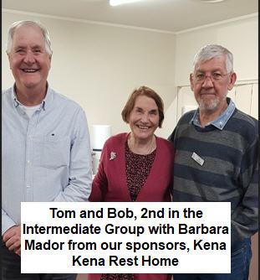 | 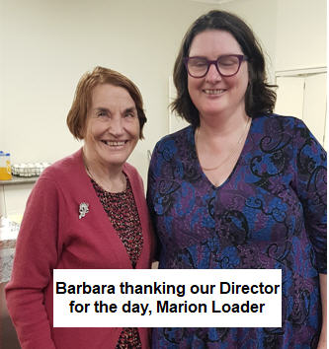
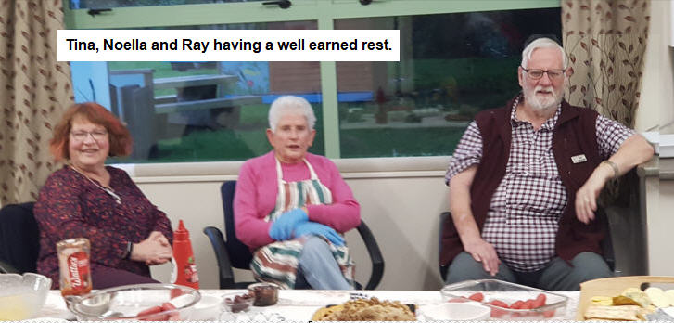
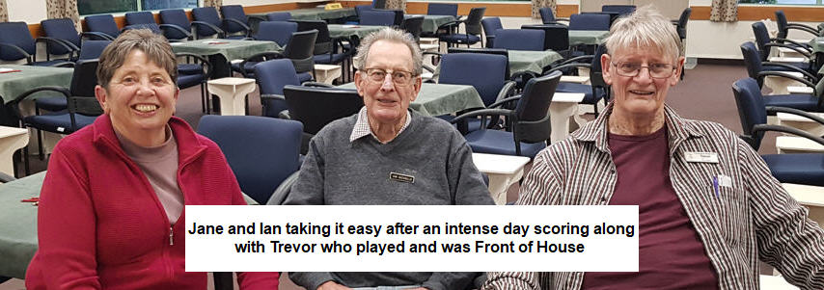
*
Monday 17th November – Annual General Meeting at Waikanae
Nominations for Officers are still light. Please consider coming on the Committee and becoming involved in the running of the club. You will be most welcome!

Nuptials
At the Tuesday Evening session (21st), Vikki Clarke, our very competent secretary and “Bride to Be” was guest of honour. Her playing frhens surprised her with a celebration for her pending nuptials. Below are a few photos of the happy event.
Hallam Creswell, who has been a member of the club for over 30 years, said was it the first time he had been to a hen’s party at the Bridge Club!
As noted above Vikki also came second with Francie Vagg in the Intermediate-Junior group of the Multigrade tournament. And I see she also came first North-South on the night with Rachel Bruce. Not bad for a player of only 2-3 years.

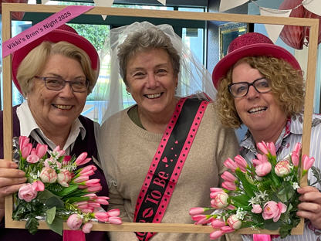
Linda, Vikki and Theresa

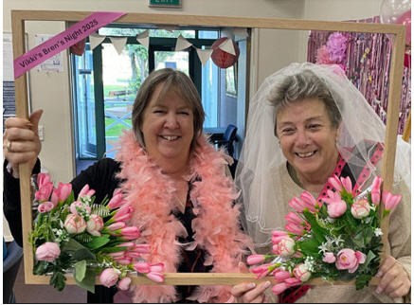
Winners on the night - North-South - Rachel and Vikki

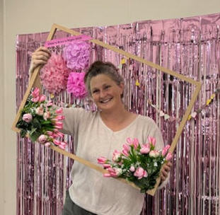 | 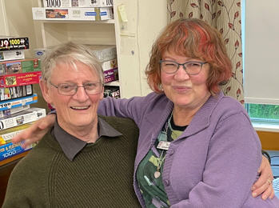
Who’s next?

Kapiti News Interview
On Wednesday 22nd Trevor Smith, Alan Stevens and I met at the club with Leanne Warr, Kapiti New Editor.
I had contacted Leanne to let her know we had a story to tell. Alan and Trevor explained the journey from discovering the leaks to obtaining the funds necessary to be able to repair and reclad the building.
Having the necessary concurrent investigation work, obtaining a building consent, costing, and tendering were a vital part of the process. Not forgetting members donations and prepaid subscriptions along with partnership funding from Pub Charities, the raffle, tablecloth sponsors and gin sales helping us build the club’s one third amount to apply for full funding from the Lotteries Community Facilities Fund.
So, our story may feature in an upcoming Kapiti News edition.

2026 Programme Book Launch
At our recent committee meeting it was noted while at Waikanae it will not be so easy to hold an evening to pick up one’s programme book and to find partners.
Provided our building work is complete, we are looking to hold a Re-opening, Programme Book launch and Partner finding evening sometime in January 2026.

Raffle
Sales are proceeding albeit slowly. We had a successful day selling at Coastlands with 105 tickets sold. Victoria Bolton was selling all day from 9am until just after 4pm. Margaret Jamieson, Brian and Linda Pender helped out from 10am until 2pm and I put an appearance in at the start and finish. Many thanks to Coastlands for making a selling space available to us.
Another good day was held last weekend at the market with over 40 tickets sold.

If you can help out at our weekend selling venues, please let Victoria know. We will look to see if we can post selling times at Waikanae.
Sales continue until 28th November but there are still many tickets to be sold.

Committee News
- Trevor recently attended a Bridge Teachers Conference and was pleased to learn how other clubs fared and what initiatives our club could utilise.
One of the main ones was to keep the Learner’s group together for longer and continue with structured Monday night playing sessions for the remainder of the year where the learners only would participate. Some clubs have adopted this approach and found that their learner retention increased markedly and was well above 50% of the initial intake.
Free Lessons will commence next year on 9th February 2026 and run until Easter Monday.
2) The Committee agreed to change the evening sessions start of play to 7pm rather than 7:30pm which will mean you get home 30 minutes earlier. This is what most clubs do, including Waikanae. This proposal is to be considered at the AGM.

Bob Jennings
President

See next page for Paraparaumu Bridge Club programmed sessions to be played at Waikanae Bridge Club from 28th October.

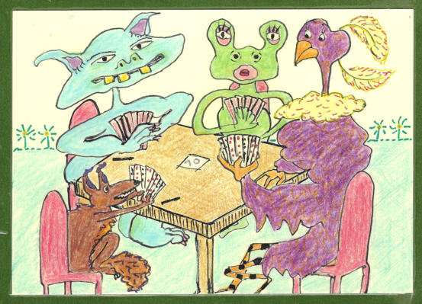
“It takes all types” – sketch by Linzee Inkster (2019)

Paraparaumu Bridge Club will play programmed sessions at Waikanae Bridge Club from 28th October until the
Forsyth Barr Pairs Tournament on Sunday 14th December.

N.B. January 2026 sessions will depend on Recladding progress.
Social Bridge is being played at the Uniting Church in Raumati.

Tuesday Afternoon, Thursday Evening and Friday Afternoons are at the usual times. However, there are 3 exceptions (see 4, 5 and 6 below!)

- Main Clash! Waikanae has a regular Tuesday Evening Session.
Therefore, each Paraparaumu Tuesday Evening Session will transfer to the following Wednesday Evening. Clubroom
access 7.30pm (due to Guide’s use of clubrooms 5 - 7pm.)

- AGM - The Paraparaumu Annual General Meeting will be held at
the Waikanae Clubrooms 7pm the evening of Monday 17th November.

- Waikanae rents its premises out to Quilters’ groups which meet on the 1st Thursday of the month (7pm to 9pm) and on the 3rd Tuesday (10am to 3pm). Only November sessions are affected.

- The Paraparaumu Thursday Evening session, 6th November will move to Monday Evening, 10th November. Clubroom access 7pm.

- The Paraparaumu Tuesday Afternoon session, 18th, November will move to Wednesday Afternoon, 19th November. Clubroom access 1pm due to cleaning.

- The Waikanae Christmas Function is on Thursday 11th December at starting at 4:30pm.

Therefore, the Paraparaumu Thursday Evening session, 11th December is therefore, rescheduled back to Monday Evening, 8th December. Clubroom access 7pm.

7) Please note these changes in your programme book and remind your partners of the changes.

