
10 September 2025
Hi Folks,
Time for a newsletter for your information
Constitution and Incorporation
The New Constitution was passed at the special general meeting (SGM) on Monday,11 August 2025 with thanks to Trevor Smith for his diligent work in addressing the required changes and the consultation with members. Thanks also to the members who braved a cold night to approve this important document.
Trevor lodged the application and new constitution with the Companies Office straight after the meeting.
On 15-Aug-2025 the Companies Office advised that they had accepted our application to reregister PARAPARAUMU BRIDGE CLUB INCORPORATED (217689) (NZBN: 9429042801603) under the Incorporated Societies Act 2022 (2022 Act). Attached to their email was the updated Certificate of Incorporation which is now on display in the clubrooms.
Recladding Update
Following the constitution business, the Building Manager, Alan Stevens gave a report on the “recladding” project.
The key point of the report was the matters that had to be achieved to get to the position of being able to make the application to the Lotteries Community Facilities Fund and submit that on the 24th May 2025. These are noted as follows:
- The engagement of Greig Hayward to prepare plans and apply for Building Consent to reclad our clubrooms.
- Building Consent applied for and received on Wednesday, 27th November 2024.
- Engagement of Quantity Surveyor, Mark Wickens, to prepare an estimate of the cost of the project.
- Tenders were received and evaluated. We are still undertaking the final evaluation of two of these before we award the contract.
- We have raised approximately $45,000 with prepaid subs of $10,780, Donations of $18,475, April Calendar Raffle of $10,000, Tablecloth Sponsorship of $4,500, Gin promotion $1,450.
- This along with available savings of $32,818, Pub Charity funding of $32,884, and money already spent of $10,475 allowed us to apply to Lotteries Community Facilities Fund for $232,930.
Relocating Playing Sessions during the Construction
The cost and time required for the recladding will be reduced by vacating the clubrooms during the construction period. This will ideally commence on 28th October 2025
We have met with Waikanae Bridge Club officials and they are keen to support us during the recladding. Their committee has agreed to accommodate us during the construction period.
This would mean that we would play November and December sessions at the Waikanae Bridge Club. The only session that clashes with one of Waikanae’s is our Tuesday evening. We would look to hold our Tuesday evening on a Monday or Wednesday evening at Waikanae. We may have to cancel the January Open Day sessions.
We do hope that you won’t mind travelling to the Waikanae Club rooms, and continuing to support our club during what may be a challenging time.
We still require access to our office area during this period as it would be inconvenient to relocate our computers and office equipment.

We will know more once we hear from the Lotteries Community Facilities Fund on the 17th of September!

December Calendar Raffle
The Funding Subcommittee is currently in the process of organising another “Calendar” raffle for the month of December. 2000 tickets at $10 a ticket are currently being printed. The intention is to sell as many as possible. Victoria Bolton has again done a sterling job securing prizes and we have 31 prizes of $100 or more for each day of December 2025.
The tickets are now printed and will be handed out at sessions the week of September 22nd to 30th.
Sales will commence on 1st October and continue through to the end of November.
The proceeds from the raffle will contribute to providing us with a buffer to accommodate the prepaid subs and to replenish our bank balance and financial reserves.
The following venues have agreed to allow us to sell tickets and promote Bridge on the following days
- Coastlands Mall - Saturday 11 October – from opening hours to close
- The Warehouse – Saturday 25 October, Saturday 8 and Saturday 22 November
Selling at these venues last time was a great success.
Pencil in the above dates and allocate some time to come along, you will be most welcome. We’ll be putting a list up of venues and dates where you can record times you will be able to assist.
We do hope you will support the selling of raffle tickets for December as much as the last raffle as that was a great success.

“BridGIN the Gap”
Selling continues slowly. We have contacted local clubs and our neighbouring Bridge Clubs with the offer to assist them with hosting a Tasting Session to attract more sales.
We are planning an open Tasting at the Club on Wednesday 22nd October commencing at 7pm. We will be inviting all local clubs and their members to the event and our members, friends and acquaintances are also welcome.
With Christmas approaching fast a bottle of our bespoke gin distilled by our local Imagination Distillery may be the ideal present. The price will be discounted by $5 at the tasting evening.
Attached below is an order form and flyer for the Tasting to get the ball rolling!

Recent Tournaments
Life Flight Charity In-house: Club: Paraparaumu Bridge Club 6th July 2025

Rank | Names | %
1 | Vicky Young & Ann Edwards | 62.81
2 | Rezea Morgan & Angela Gattsche | 62.40
3 | Pryor Rowland & Nicky Bradley | 61.46
4 | Averil Wotton & Lynda Evans | 60.83
5 | Lucy O'Regan & Pauline Reid | 60.31
6 | Vivienne Cannell & Maureen Pratchett | 59.69
7 | Robyn Michelson & Jean Crafts | 57.71
8 | Derek Snelling & Isobel Ross | 54.90
9 | Marg Lees & Moira Wilson | 54.58
10 | Shelley Ross & Ann Verboeket | 53.85

Four Paraparaumu Pairs performed well and were in the top 10 results.
Overall, the tournament raised $1703.88 for Life Flight. This was a great result and thank-
you to all participated, especially the great support from the Waikanae Club.

Below is the email response from Lifeflight on receipt of the donation.

From: Hannah McDowell <hannah@lifeflight.org.nz>
To: "treasurer@paraparaumubridgeclub.co.nz 04/08/2025
Subject: RE: Donation from Charity Tournament
Hi Rachel,
Thank you so much for the incredibly generous donation!
Please find attached your donation tax receipt dated 30th July 2025.
With so many worthy causes out there all asking for help from their local communities, it means so much to us and to the people you help, that you choose to support Life Flight.
Please pass on our heartfelt thanks to all the members of the Paraparaumu Bridge Club.

Kindest regards, Hannah McDowell Corporate Services Administrator lifeflight.org.nz

Kapiti Funeral Home Junior Tournament 20th July 2025

Rank | Name | Clubs | Total MPs | Total % | Sess1 | Sess2
 |  |  |  |  | Percent | Percent
1 | Jane Lawless & Mary-Jane Hayward | Well/Well | 532.8 | 123.33 | 60.14 | 63.19
2 | Laura Kelly & Jim Gordon | Waik/Waik | 490.1 | 113.45 | 55.58 | 57.87
3 | Elizabeth Fuge & Peter Hammond | Levi/Levi | 484.1 | 112.06 | 52.34 | 59.72
4 | Chris Eales & Lyn Connor | Para/Para | 483.7 | 111.97 | 57.80 | 54.17
5 | Hugh Norton & David Stagg | Para/Para | 478.3 | 110.71 | 58.40 | 52.31
6 | Sharon Henry & Marie Hammond | Para/Para | 478.2 | 110.70 | 57.92 | 52.78

Three Paraparaumu Pairs performed well and were in the top 6 results.
Well done to our new members, Chris Eales and Lynn Connor who were placed 4th overall
Hugh Norton and David Stagg took out a session prize for being top in the East-West pair in the morning session. A good result!
Thanks to Francie Vagg– director, Jane Bradbury - front of house, Jane McArthur and Ian – scorers and Tina and Noella for the fabulous food.

Waikanae Multigrade Pairs Waikanae Bridge Club 3rd August 2025
Dale Wills and Jane Bradbury had a successful day coming third in the tournament.

Otaki Intermediate Tournament - Otaki Bridge Club 24th August 2025
This was a very competitive tournament with 14 tables.
Jane Bradbury and Linzee Inkster won the morning North- South session prize with a great result. Congratulations!
Francie Vagg and James Winskill were the best performing Paraparaumu pair achieving 10 place overall.

Recent Teams Series
This was held over 3 Wednesday nights in each of June and August with the latter being a handicapped competition. The series was ably organised by Gillian Travers and on the night Francie Vagg was the director with Jane McArthur and Helen Edwards scoring. Many thanks to these members for devoting their time so that 10 teams of 4 players could compete.
Congratulations to the series winners for the June series, Laurel Nalder, Andrew Li with Kevin McManus and Chris Eales.
The series winners for the handicapped event in August were Margaret Jamieson, Lyn Connor with Alan Savage and Gordon Whittleston.
Congratulations to the winners of the August competition and it was great to see Gordon Whiitleston participating, having just completed the lessons this year. It was also great to see other newer members also playing – Roger Keene, Vasanti Govan, Mary Manderson, Chris Eales and Lyn Conner. I have a feeling the last two have played a bit before!

Tournaments still to come: Quadrangular Teams at Ōtaki 21st September, the Kena Kena Rest Home Multigrade on 12th October, and the Nationwide Loveblock Pairs on 17th October.

FROM THE DIRECTORS GROUP - CARDHOLDERS
When using a cardholder, you must be careful not to give unauthorised information to your partner. For example, the cards must not be arranged into suits such that the number of cards in each suit can be identified. A good suggestion is to place a piece of paper or cardboard at the top of the cardholder to shield the cards so that their arrangement is not visible.

Planning for 2026
Compilation of the handbook for 2026 has commenced with Tournament dates now determined.
The session programme will be very similar to this year’s programme.

Nomination of Officers for 2026
Our AGM is looming up and will be held on Monday the 17th November 2025.
We have posted a form on the Notice Board where Committee nominations can be recorded.
All positions are open and contestable. Please think about contributing to the governance of your club.
It would be great to some vice president nominations in anticipation of filling the President’s position at the AGM next year.

Bob Jennings,
President,
Paraparaumu Bridge Club
Below: Tasting Evening Flyer and BridGIN the Gap order form


You are invited to a tasting evening to sample our Bespoke Gin at our Clubhouse, 1 Brett Ambler Way, Paraparaumu
Wednesday 22nd October 2025 from 7:00pm
Come join us to have a taste, enjoy some nibbles and hear from
the Master Distiller who created this gem, BRIDGIN THE GAP Dry Gin.

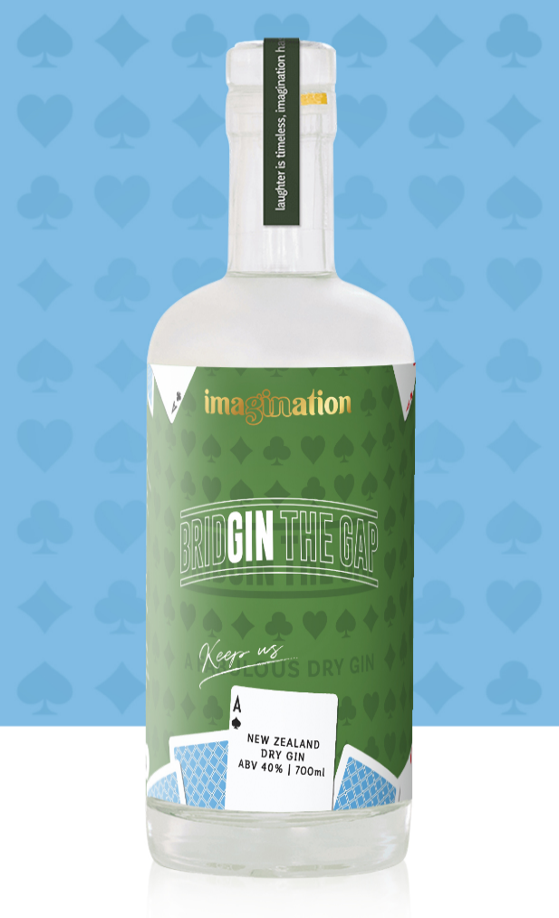 | The Paraparaumu Bridge Club’s building is leaking, and we are going to reclad it! To do that the Club has embarked on a major fund-raising mission.  This gin has been created specifically for the Club to assist in our efforts.  As you enjoy this gin, reflect on the excellence of its maker, Imagination Distillery here on the Kapiti Coast. Thank you to Imagination for creating this bespoke sin for our Club to assist us in our fund-raising efforts.  BRIDGIN THE GAP is a unique aromatic blend of citrus brightness and warm spice underpinned by traditional gin botanicals. Enjoy with light tonic or a yuku soda.  Thank you for supporting us and enjoy this gin. Sip by Sip  Come along – you’ll be most welcome. Sales available on the night $80 a bottle (normally $85)
BRIDGIN THE GAP Dry Gin is available on-line for sale at $85 per bottle
To purchase email orders@imaginationgin.nz, state your Club for delivery and pay via Bank Transfer to: Wilson & Lawrence Limited, Account 02-0733-0232394-00,
Reference – Initials and Surname
Or fill out an order form at the Paraparaumu Bridge Club
We will deliver orders from your members to your Club


Y O U R D E T A I L S
❒ Please deliver my order (Please ensure delivery details are clear and complete)

Name: ____________________________________________________________________

Club : ____________________________________________________________________

Delivery Address: (if not Paraparaumu Bridge Club – Refer *Freight below)

_________________________________________________________________________

_________________________________________________________________________

Delivery Instructions: ________________________________________________________________________

Phone: ______________________ Email: ______________________________________________

H O W T O P A Y :
Choose from below what you would like to order

Bank Transfer: | Need some time to think about it?
Wilson & Lawrence Limited | Still need help or advice?
02-0733-0232394-00 | Get in touch with the team
Reference – Initials and Surname | You can email your order through to us to orders@imaginationgin.nz.

- Legal Requirement: Only persons aged 18 years or over may order or receive alcohol as a gift or on behalf of the buyer.
- Delivery: If goods have not been received within 7 days, please contact us immediately.
- *Freight: Freight is free if delivery address is the Paraparaumu Bridge Club
- Damage Claims: Orders should be unpacked immediately upon receipt and checked for damage or shortages in the presence of the delivery agent.
- In the event of breakage or pilferage, it should be reported immediately to the carrier and to Imagination Distilling within 3 days.
O R D E R H E R E
DESCRIPTION (all prices are GST inclusive) | Price per 700ml | 2 bottles or more | Order (Quantity)
BRIDGE THE GAP DRY GIN 700ML | $85 | $85 each
027 4806446 orders@imaginationgin.nz www.imaginationgin.nz

