23 June 2025
Hi All,

It’s time for another newsletter to update you where things are at and to report on our recent tournaments so here goes.

Current State of Funding Application
You will have recently received the good news from Trevor Smith that our application to Pub Charity Ltd for a grant of $32,884.16 was approved.
Thanks to the good work done and continuing to being done by Trevor and Alan Stevens they are now preparing the application for the two thirds of the money needed to reclad the whole building. They will use the Pub Charity grant as "Partnership Funding" in our application to the Lotteries Facilities Fund which has to be submitted this week
We then have to wait until September to know if we are successful. If we plan to start the recladding work at the end of October.
As Trevor indicated, during the recladding it is possible some playing sessions may need to be temporarily relocated. Discussions on alternative venues are currently being investigated.
If you have any questions, please contact Trevor Smith or Alan Stevens.

Recladding Project – Redecoration Opportunity
Alan Stevens, our building manager has provided the follow information.
“In our Long-Term Plan it was expected that by 2026 the inside and outside of the club rooms would need repainting.
During the Kitchen upgrade the kitchen was repainted in the original colours, as we had surplus paint available.
During the Recladding Project there will be significant damage to the internal Gib-board lining and all the damaged areas will need to be replastered, and the inside of all the external walls repainted.
The only walls in the main room that will not be affected are the noticeboard wall and the dividing wall between into the supper room.
The ceiling should also be considered.
This provides us with an opportunity to redecorate the interior of our clubrooms.”
In Alan’s initial discussions with members, he has received the following suggestions: - remove the curtains; have brighter colours; redo the notice boards and have a Sponsors Board rather than picture framed logos.

This situation is a unique opportunity for club members to be involved in making suggestions or recommendations of how they would like the interior of their/our clubrooms to look. Any suggestions should be forwarded to our secretary Vikki Clarke; secretary@paraparaumubridgeclub.co.nz
Remember, all going well with our funding application, the proposed recladding construction period will start after Labour Weekend so there is plenty of time to formulate and confirm a final colour scheme.

Proposed New Draft Constitution and Special General Meeting (SGM)
I mentioned in the last newsletter in early April that the committee has recently considered a draft new Constitution prepared by Trevor and Brett Windley to meet the requirements of the new 2022 Incorporated Societies Act. The Committee endorsed the changes which have been reviewed by past presidents.
The draft new constitution has now been forwarded to members for consideration and approval.
Approval to adopt the new constitution must be by a resolution of a SGM convened under the existing constitution. Notice of this SGM, to be held at the clubrooms at 7pm on Monday 11th August 2025 has also been sent out. At the same meeting, a recommendation to approve the re-registration of Paraparaumu Bridge Club as an Incorporated Society will also be put to members. A 66% majority vote will be required in each case.
This will be an important meeting to progress the re-registration of the club as an incorporated society by April 2026.

Bridge Lessons 2025
These have now come to an end. 15 new members have joined the club from this mammoth undertaking. A big thank you to Trevor, Theresa, Tina and all the mentors who stuck at it for 18 weeks. Copies of a list of all the new members are available to the club members and are on the “raffle” table.
If you can, please offer to partner these new members so that we can make them feel welcome playing at the club sessions.
Many of the new members are playing at the social bridge sessions on Wednesday afternoons so this provides an opportunity for more experienced players to go along and play with them and offer to partner them at club sessions.
You may all remember the apprehension of playing at the club for the first time and trying to do everything right including bidding and playing. Most of us are still trying to master this!
Interestingly we have had three queries as to when our next lot of lessons will start!

Charity Tournament 6th July - Life Flight (in conjunction with Waikanae)
Life Flight is a charity providing emergency air services. Every 6 hours someone needs their services. Through your support they are able to continue to provide a 24/7 dedicated emergency air service.
Please help us support Life Flight by coming along and enjoying a relaxed afternoon of Bridge with our Waikanae colleagues on 5th July. New players are especially welcome to come along.
Where: In our Club rooms 1 Brett Ambler Way, Paraparaumu
When: Sunday 6th July, 2025 at 12.45 for a 1.00pm start
​Cost: $20.00 plus a Raffle
Afternoon Tea with complimentary drinks will be available at the end. Please bring a plate.
Please register your intention to attend on the notice board list, even if you do not have a partner lined up, as efforts will be made to pair you up.

Kapiti Coast Funeral Home Junior Tournament 20th July 2025
This is a 3B junior competition and a chance for all novices and juniors to attend and experience a local tournament involving a morning and an afternoon session.
The entry fee is $40 and for Paraparaumu juniors the fee will be deducted from your compass account. Entries close on the 18th July.
Starting time is 10am and participants must be seated by 9.45am. A Ploughman’s lunch will be provided between sessions and is usually very popular.
It is also customary for Paraparaumu members to bring a plate of savoury or sweet delicacies to be enjoyed with a glass of wine and the end of the day’s play. Some have been known to find these delicacies at the local supermarkets while others are much more imaginative and creative, exercising their culinary and baking skills!
Again, I would encourage novices and juniors to attend this local tournament opportunity. The tournament flyer is on the notice board with a list where you and your partner can record your entry. Even if you do not have a partner lined up efforts will be made to find you a suitable partner,

Kapiti Coast Funeral Home is a difficult sponsor to “promote”. I think their advertisement on page 25 of our Programme Booklet says it all when they say they are “there in times of need.”

“BridGIN the Gap” Launch Friday, 6th June 7:15pm
Together with our sponsors, Imagination Distillers, a very successful launch of our very own bespoke “BridGIN the Gap” gin was held at the club. This function was attended by about 30-40 people and a very pleasant evening was enjoyed by all. There were tastings of the Gin with various splits.
Thanks to Roger Simmons and Theresa Cook for organising the drinks and food.
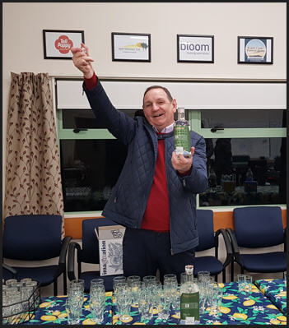
Roger opening the first “BridGIN the Gap” with a flourish!

Over 50 bottles were sold on the night proving what a very nice tipple “Bridgin the Gap” is. This will have netted the club around $1150 which will go to bridging the gap in our funds to reclad.
If you would still like a bottle and have friends or acquaintances or belong to a club who may be interested in our Gin then orders can be made via the Imagination website, at the club on an order form or to Imagination on an order form via email. orders@imaginationgin.nz
https://imaginationgin.nz/product/bridgin-the-gap-dry-gin/
We have set up a delivery system whereby bottles can be uplifted from various points at no charge or couriered at $10 per bottle.
What better way to commence a game of social bridge than with a toast with a “Good BridGIN”.
Remember every bottle of “BridGIN the Gap” sold by Imagination nets the club over $23. Over 60 have been sold to date.

Management of Sponsors
The Committee has noted that, with so many sponsors now, we need someone nominated to manage them as a cohort. The following needs to happen :
- Manage invoices for advertising, tournaments, table covers, bidding pads and follow up on payment
- Checking no overlap in promotion - so tournament sponsors get the whole tournament for promotion
- Managing annual sponsorship for table cloths
- follow up on terms and conditions of agreements
It is a sufficiently large job that we are asking if any member would be prepared to take on this role. If you believe you could help in managing our sponsors as outlined above please contact our secretary Vikki, secretary@paraparaumubridgeclub.co.nz

Terramark Sponsored Pairs – Sunday afternoon 4th May
This tournament included 26 pairs and was divided into 5 sections.
Pairs were graded allocated to their section by using their combined Club handicaps as opposed to their combined NZ Bridge rating which has been used previously.
It was a successful afternoon enjoyed by all. Below are photos of the winners, photo bombed by the president. I’ll have to have a word to him about this so that in future the winners are the main focus of celebration!
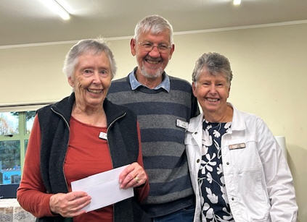 | 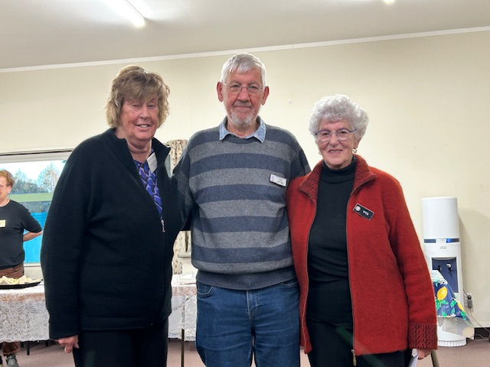
Jean Crafts & Robyn Michelson,  1st= Section A and 3rd = Overall | Pauline Reid & Lucy O'Regan,  1st = Section A and 3rd = Overall
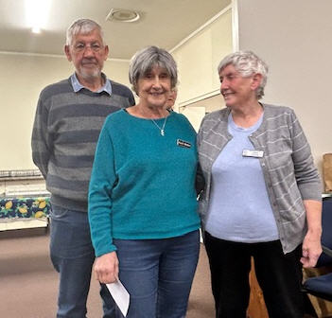 | 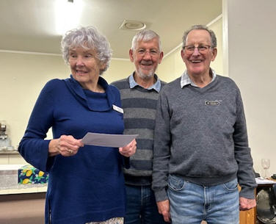
Averil Wotton & Gillian Travers,  1st Section B and 1st Overall! | Margaret Norrish & Ian Nicholls, 2nd Section B and  2nd Overall!
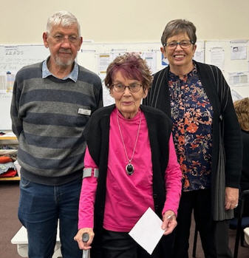 | 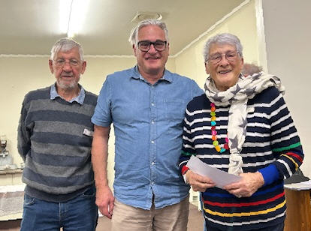
Jocelyn Graves & Jane McArthur, 1st Section C | Glenn Lust & Beverley Lust, 2nd Section C
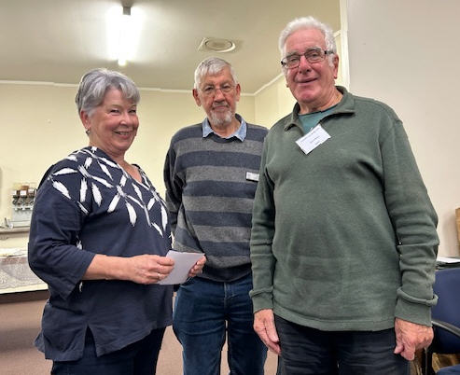 | 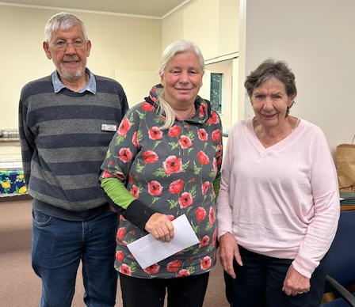
Leigh & Alan Savage, 1st Section D | Yvonne Rowe & Valerie Coe, 2nd Section D
Roger Keene & Brian Tester, 1st Section E | Helen Edwards & Leon Hunia, 2nd Section E

Bloom Hearing Intermediate Tournament 18th May
The Bloom Hearing Intermediate Tournament was held here on May 18 with 16 full tables. Anne Brunt and Johnathon Gardner played well above their ranking and were the best placed local pair.
Elizabeth Steinbauer was left without a partner for the afternoon session. However, Jane Bradbury dropped everything and was able to step in and partner Elizabeth at very short notice. They performed together admirably and won the session comfortably!
Sue Wilcox and her partner Kate Reeve from Kairangi also had a successful day coming in at 5th place overall.
Thanks to all who made this a successful event. The ploughman’s lunch provided by Noella Squire and Tina Connell-Pine at lunch time was a highlight and again there were many compliments from the players on the great fare.
P.S. Sue and Kate’s practise at our Bloomfield Hearing tournament served them well as they won the Levin Intermediate Pairs on 15th June. Congratulations and well done!
P.P.S. We are looking for a keen photographer to step in and capture key club happenings, especially tournament events and the prize winners. If you fit this role, and would like to help out, please let our secretary know.

Thank you, good Bridgin!

Bob Jennings
President
Paraparaumu Bridge Club
rjennings@xtra.co.nz
Ph: 021 115 0008

