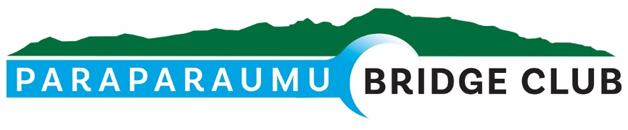

**APRIL NEWSLETTER**

It’s been a while since we had a Newsletter, so it’s time to update you all on some happenings in and around the club.

Firstly, here’s an apt quote I came across:

*The difference between genius and stupidity at the Bridge table is that genius has its limits.*

**St Pat’s Day**

Kapi-Mana held a Multi-grade tournament on St Patrick’s Day last month. The Kapi-Mana club didn’t celebrate St Patrick’s Day in any particular way, but Tina and I attended the tournament, and we sure did.

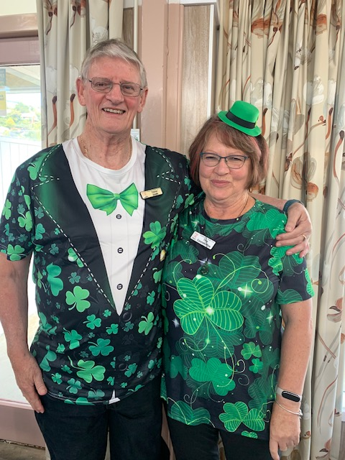Unfortunately, no costume prizes were awarded. Our clover designs stood out well from the comparatively drab attire of our competitors, but sadly, our bright apparel did not enhance our ability to win.

**Paraparaumu-Waikanae Interclub**

At the interclub tournament on April 7th, Paraparaumu Club succeeded in

**winning back the Trophy**

Huge congratulations to all members who participated in our victory. It’s been seven years since we last won the shield, so for those of us who remember back that far, it’s been a drought too long endured. Waikanae are formidable opposition indeed with plenty of Open players, so we can be justly proud of our team.

Top Paraparaumu performers were Lucy O’Regan & Pauline Reid (61.38%), Martin Wren & Lyn Berry (59.13%), and Alan Stevens & Tom Tidey (56.09%). WELL DONE!

**Paraparaumu Open Tournament**

Just a week later, on the 14th, we hosted the Paraparaumu Open Tournament, which was well attended by a raft of GrandMasters and Silver GrandMasters filling 13 tables.

At the end of two hard-fought 30-board sessions, we had a tie for first place:

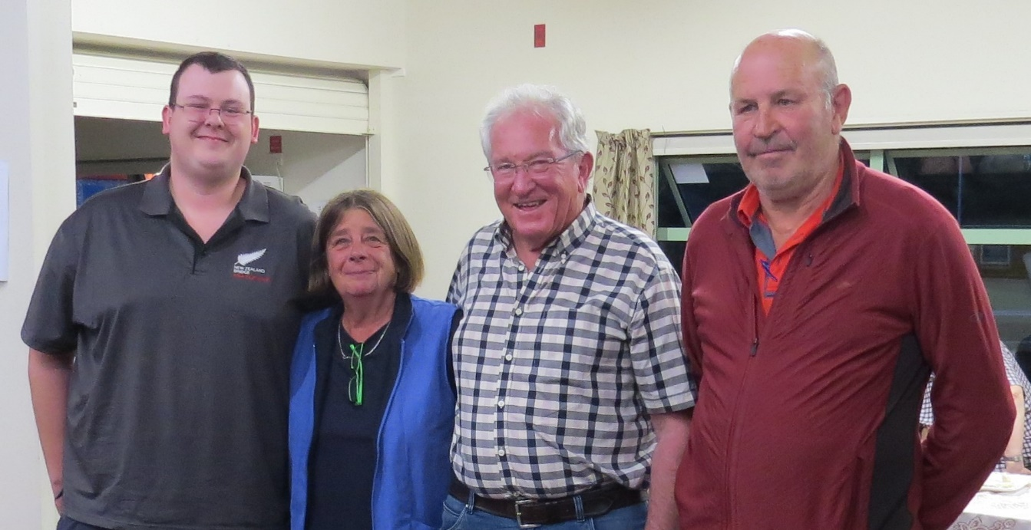

L to R: Jack James (Palmerston Nth) & Lorraine Stachurski (Palmerston Nth) and Brian Cleaver (Wellington) & John Luoni (Wellington/Paraparaumu).

Congratulations to our winners, and thanks to Allan Joseph for Directing and to our members who helped out on the day – Hugh Norton for Tournament management, Helen Edwards and Ian Nicholls for the scoring, Noella Squire, Tina Connell-Pine, and Yvonne Rowe for the catering and kitchen, and Ray & Margaret Cachemaille for the bar. Thanks Guys – without your willing help, successful events like this one just wouldn’t happen.

**2024 Lessons update**

We have just completed 10 weeks of lessons, with around 20 promising learners attending. The formal lessons will now be followed by six weeks of mock sessions, during which we simulate a normal club session with a Director (but no scoring), and the learners play random boards. The learners have been given application forms and invited to join the club. We’re hoping most, if not all, will join.

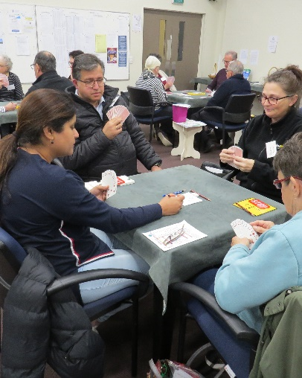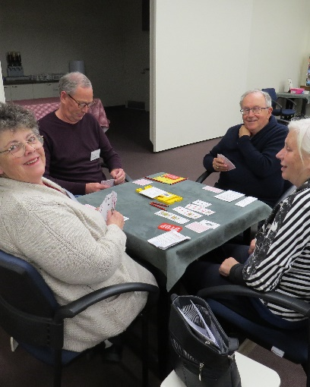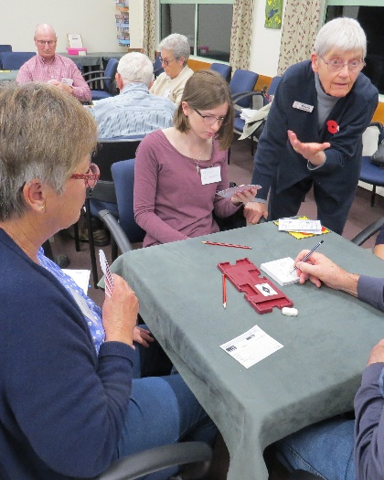

Our Beginners, looking happy and comfortable at the table – ready for any challenge.



**Wow! Big changes for one member!**

One of our members has gathered some significant life changes into the last few weeks. Imagine this… You…

1. Recently retire
2. Get Engaged
3. Buy and move into a new house… all in a matter of WEEKS.

This has happened to Vikki Clarke. So, hearty CONGRATULATIONS, Vikki. If you can handle all that, Bridge will be a breeze.

However, just make sure this doesn’t happen…

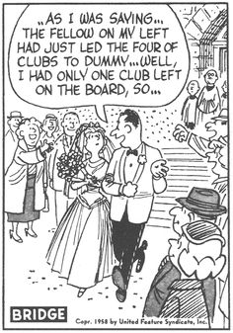

**Reminder: Social Bridge**

There’s a Social Bridge session held at the club each Wednesday at 1pm.

You can come and enjoy a game of Bridge in a comfortable, relaxed social atmosphere, where you can discuss the hands even while you’re playing, ask advice about that thing you never really understood, and meet nice people. That old adage is never truer than here – the more, the merrier, so come along and join in.

**Directors**

Have you ever wanted to understand the laws of the game better? Then maybe you’re the right person to become a Director. We need more Directors, so if you’d like to check it out, talk to Brian Pender or Trevor Smith, and they can let you know what it’s all about.

Finally, I’m sure we can all relate to this…

*Wife to Husband after he places Dummy on the table:*

*“Thank you, dear, but where is the hand you held during the bidding?”*

That’s all for now, Folks.

Trevor