PARAPARAUMU BRIDGE CLUB THE FINAL NEWSLETTER
Kia ora koutou and haere mai. Hi to all.
This is the last newsletter (last in more ways than one . . . see later). Soooo, let’s get underway with a slightly crazy, but fun afternoon in October.

THE STYLE HAIR DESIGN HANDICAP HALLOWEEN PAIRS
I’m never really sure about marking Halloween here in this country, but wow, members certainly got into the spirit and dressed accordingly with a vast range of devilish accessories.
22 pairs contested this one session, “In-House” tournament, across three sections. The experienced pairing of Lucy O’Regan and Pauline Reid won the overall event and they were also, of course, placed first in their A Section. Not far behind were Gillian Travers and Lyn Dash, second overall and second in that same section. Dennis Kerr and Anne Kerr were third in the section.
Fay Manley and Jos Graves were third overall and won their B Section from Yvonne Rowe and Jane McArthur and then Marg and Keith Lees.
Rachel Bruce and Margaret Norris were winners of Section C and a good result for them as they were also placed fourth in the overall field. In that C section, Hugh Norton and David Stagg were second, and Lyn Berry and Barbara Mador were third.
Here, Barbara, resplendent in red, plots her next move. What’s in your handbag, Barbara, a wand, a gun, a devil’s sting?
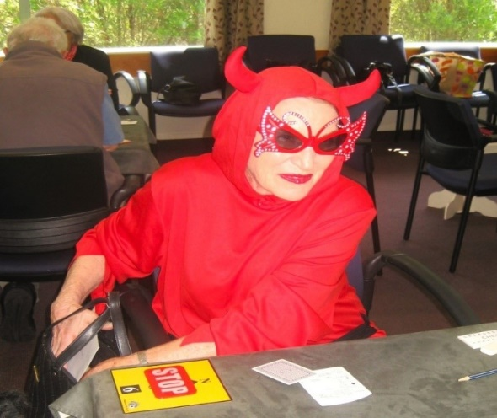

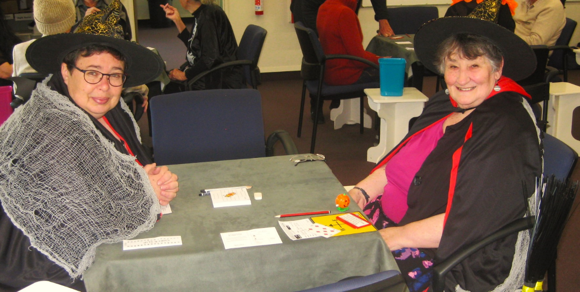
And here are Sharon Henry and Anne Brunt, totally in role. Black everywhere.
And below, another quartet of witches. Stylish Hair owner and sponsor Anne Bedford (thanks again, Anne) on the left and Gillian Travers on the right seems to have set herself on fire. Lyn Dash and Rae Lutman look on.

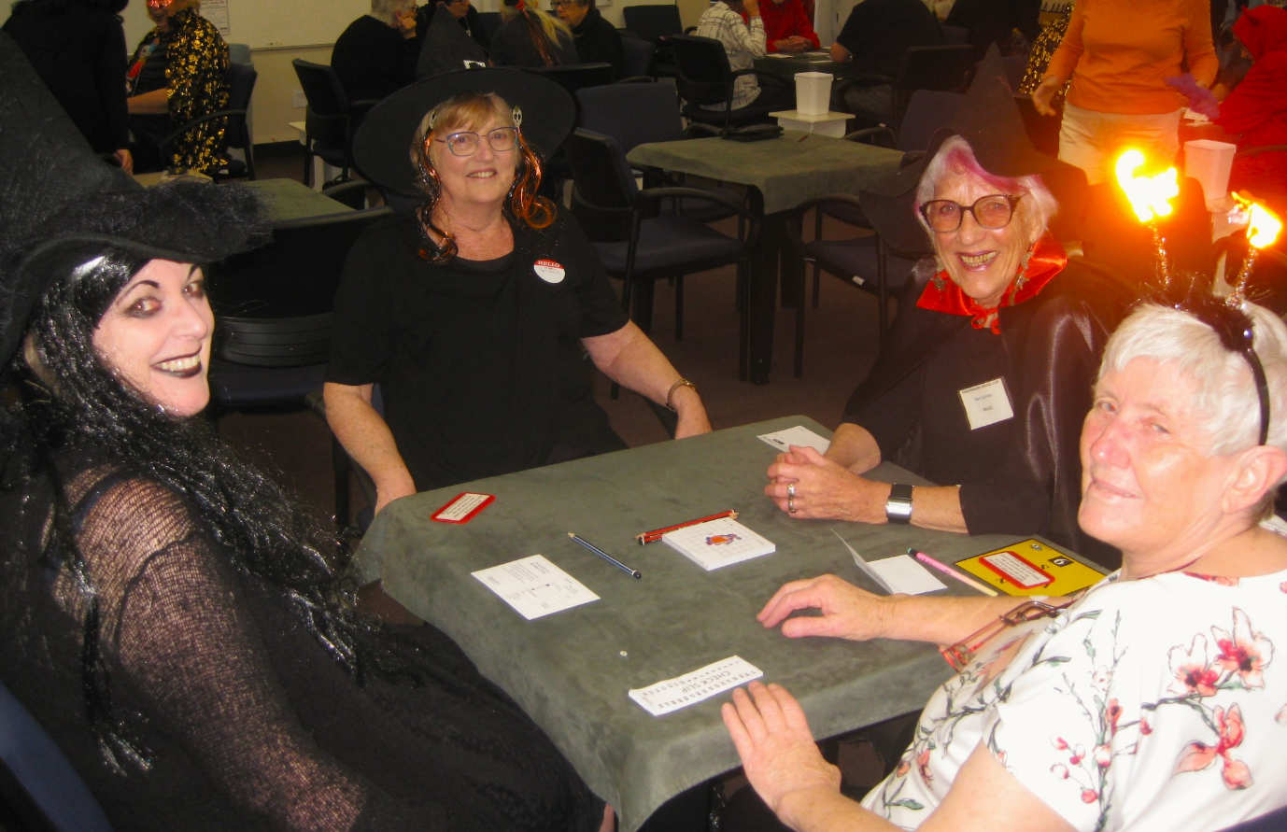
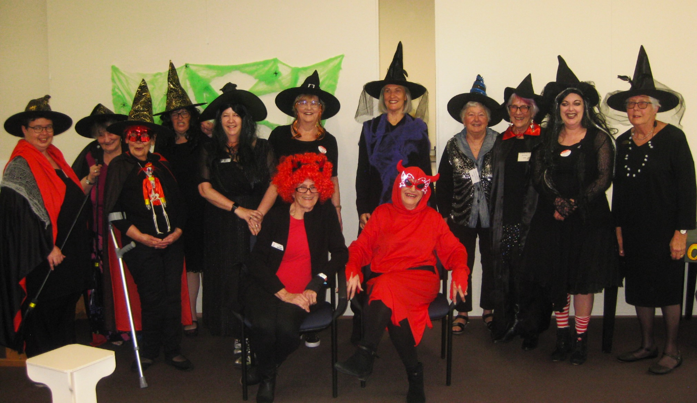
And of course, you’ll have already seen this up on the wall at the clubroom . . . Lyn Boswell and Barbara Mador sit centre stage. Aren’t they a beautiful bevy, coven, cauldron of evil? No, perhaps they smile too much to be really evil. But a great group for getting into the Halloween theme of the day.
And I did like the winning caption under the photo at the club ie “Double, redouble, toil and trouble”! (someone clearly knows their Shakespeare!)
And here’s a pic of some more idiocy, but note the thought that’s gone into the garb, as three “Weird Sisters” (yes, Macbeth again) can’t stop laughing (at themselves?). Fay and Jos receive their prize from the sponsor with real delight.
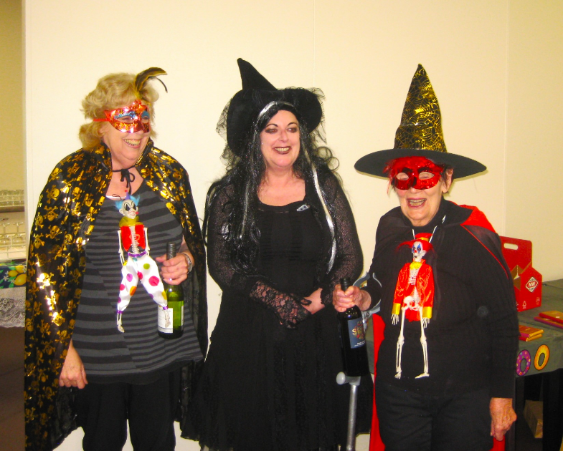
But the clear winners of “best dressed” were a total package: AKA Ghost Busters, Theresa Cook and Myf Skuse. Here they greet members on arrival for the session. Though maybe they concentrated on the dressing up and not on the cards . . .?

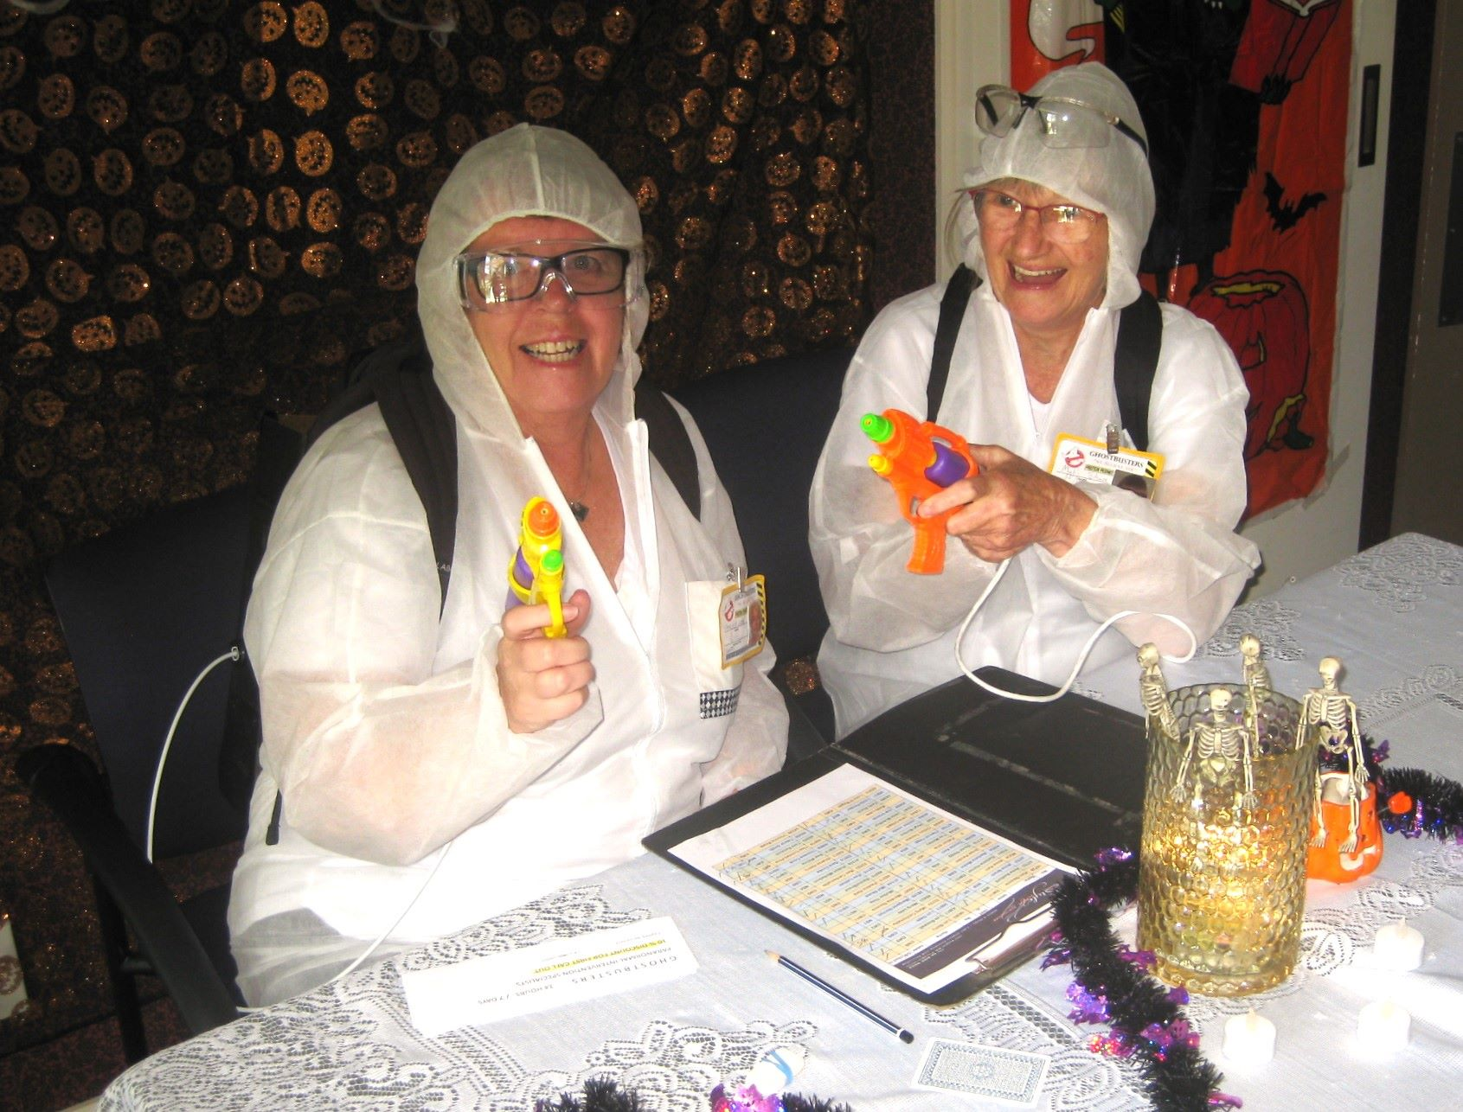

An Apology
In my previous newsletter I listed Team David Stagg as winners of the Winter Teams of Four competition . . . well I was quite wrong, and the real winners were Team Cachemaille (a team of two Cachemailles and two Penders). Sorry about that. The results as listed on the club website are quite confusing, but I should have double-checked. . . and I didn’t.

OPEN DAY AT THE COASTLANDS MALL 24 October
Some of our members braved the stares and scrutiny of the shopping public when they played a series of boards to showcase the Club and the game of bridge during a Coastlands Mall “65+ Open Day” featuring various clubs and interest groups. Members answered questions and encouraged some of the more interested passers-by to join up for our lessons in early 2024.
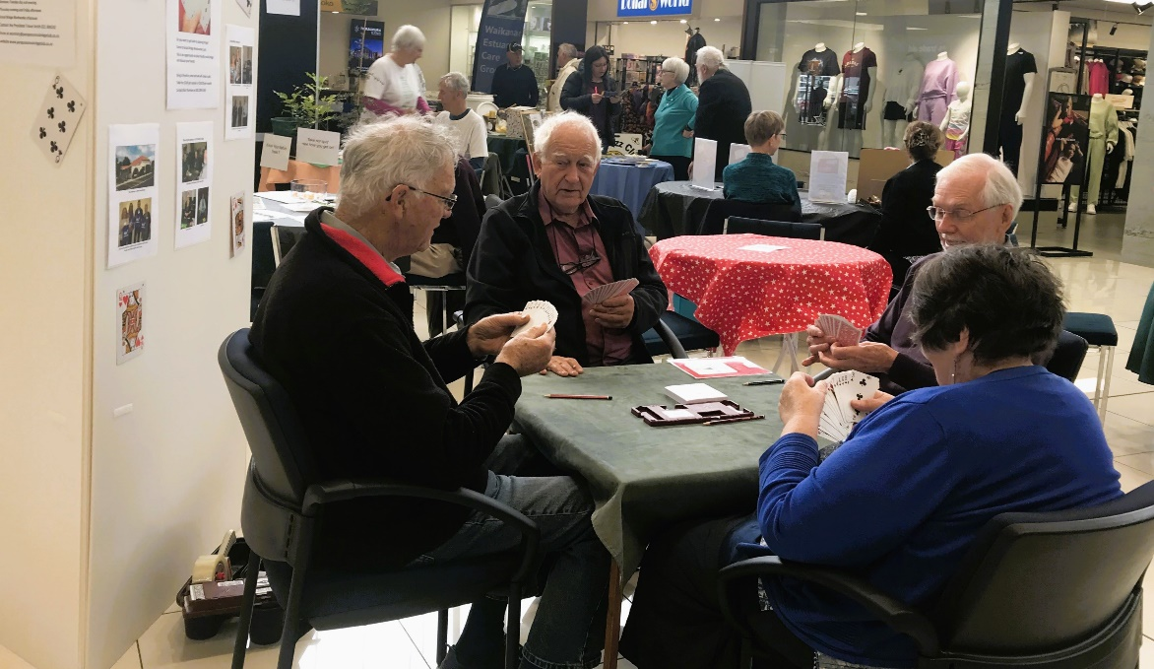
Alan Stevens looks quizzically at Hugh Norton, (“C’mon Hugh, what are you going to bid?”) while Brian Pender and Anne Brunt count their points. The display board at the back featured photos from some of our past tournaments.
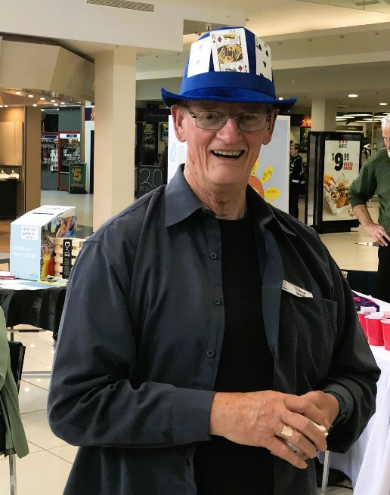
Trevor tried to turn himself into a walking-talking display board. Isn’t he lovely?
OUR CLUB’S LATEST LIFE MEMBER IS . . . NOELLA SQUIRE
At the AGM, in November, Noella joined the list of life members of the Paraparaumu Bridge Club. She was nominated by the President, Trevor Smith, and endorsed by the enthusiastic acclaim of those present.
An excerpt from the Rules regarding Life Membership reads “the nominee must have served the Club in a unique way, ie their contribution must stand out from the tasks done routinely by others . . .”
Trevor pointed to Noella’s outstanding work running the kitchen for all tournaments, above all in presenting the food for lunches, and working long hours to ensure that our Club is well-known for the quality of our refreshments and lunches, over a period of more than twelve years. Noella also organised the tournament raffles for many of those years.
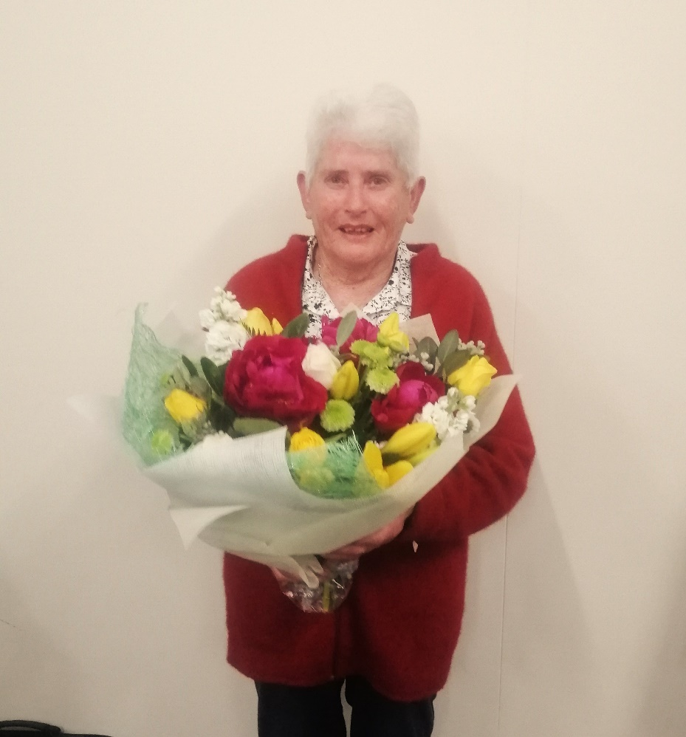
If you think, Noella seems a little stunned . . . well, she insists she was just amazed, just “blown away” by the honour. She was simply delighted and a bit overwhelmed with the sudden attention and recognition.
A couple of weeks later I enjoyed a coffee and a chat with Noella, as she pondered over her time in bridge. She joined our club about twenty years ago after going to classes run by Marion Sillick. “I was never interested in daytime bridge but I’ve loved the company, enjoyed the club, yes, even enjoyed doing the catering.”
Noella’s life and career has been centred on nursing. She started as a Nurse Aid at the age of sixteen, then went on to full nursing training, then in maternity and midwife nursing, and finally, many years in the intense pressure of working in A and E, which “I just loved”.
Noella is still drawn back to the Marlborough Sounds and enjoys several summer weeks at her holiday home on D’Urville Island (no shop, no access by road) indulging in another love, fishing from her twelve-foot-long boat. “I still know one or two places where you only have to look at the water, and they’ll try to climb on board . . . but I’m afraid I can’t tell you or anyone exactly where.”
And she remains totally committed to the Crusaders, a nod to her Mainland background, and even flies the Crusaders colours at her Kapiti home.
Finally, I ask Noella what she has learned from all that time producing all that food for all those players . . . and she grins, “well, you never want to underestimate the elderly when it comes to eating . . .”

AGM AWARDS
At the AGM, two other awards were made. John Barton received the Eileen Hofland Trophy for “Most Improved Player” and Sharon Henry received the Couch Trophy for “Most Promising Beginner”. Well done, and well-deserved to both of you.
Sharon is delighted, while Noella is still clutching those flowers and still stunned.
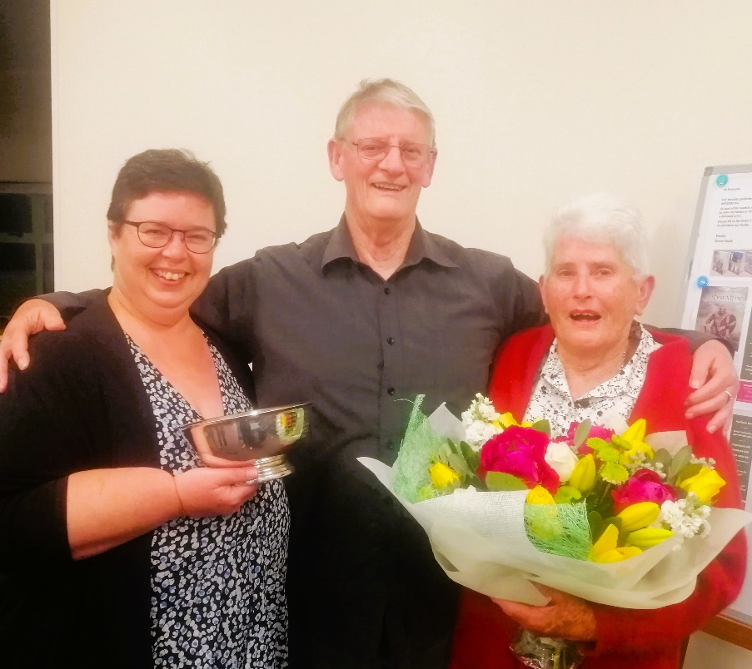

THE FORSYTH BARR CHRISTMAS PAIRS.
First, this illustrates the great value of an ongoing relationship with a sponsor. I have a Bridge programme booklet from 1995 and Forsyth Barr is listed as major or tournament sponsor for that year. A sponsor for nearly 30 years. Real commitment.
Next, the results! Plenty, plenty of prizes for the 64 contestants. A full field and a full clubroom and a room full of Christmas dress-ups and Christmas delights. Spot and quiz prizes and a wonderful spread of festive food at the end of the day’s play all combined to make a lively and lovely afternoon.
The absolute top story and success of the competition has to be the climb from the 5th section to the peak of top pair across all the 6 sections by Sara Enoka and partner Annette Downey. Together they beat many well-known and experienced pairings. Of course, they also won section E, and they scored a very respectable 62%.
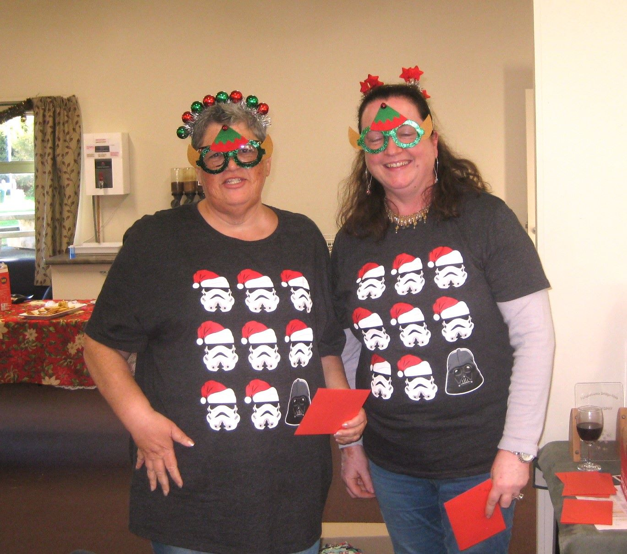
The success story of the day and aren’t they perfectly “ensemble”?
In brief, Lynda Evans and Averil Wotton won the “top” section (60%) from Lucy O’Regan and Pauline Reid. Sue Wilcox and Barbara Horner won section B, from pairs Tina Connell-Pine and Trevor Smith and Jean Crafts and Robyn Michelson.
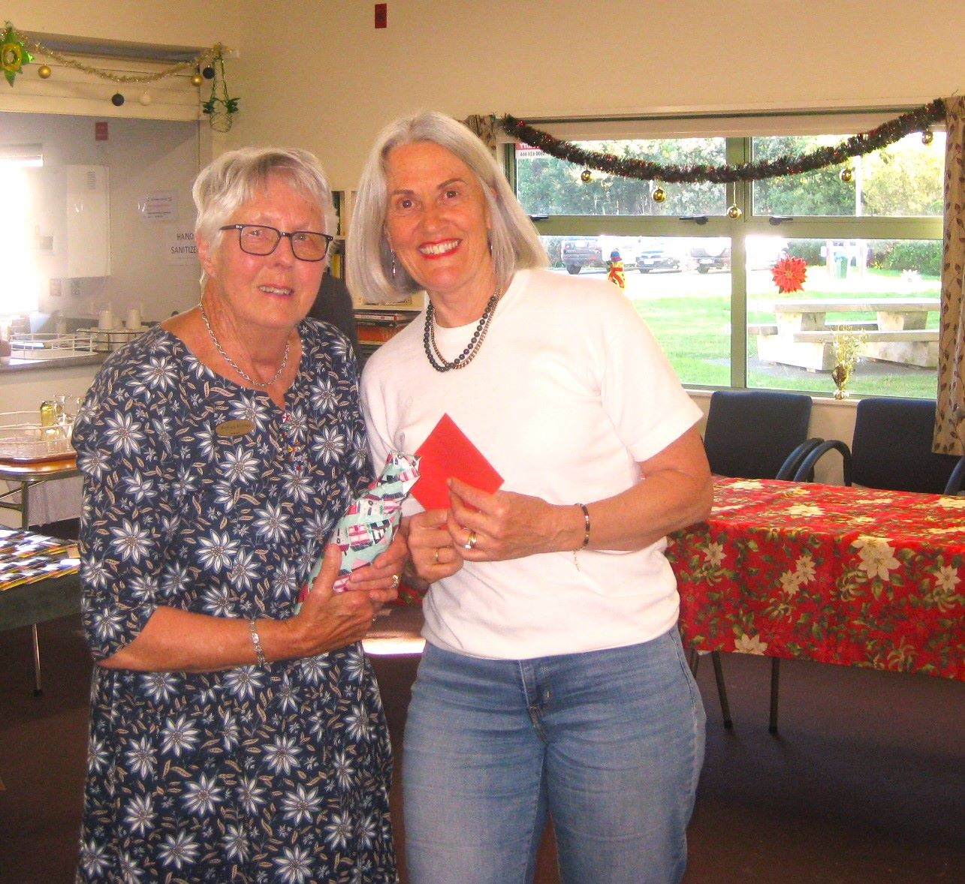
Barbara and Sue, a good day, and a good win in Section B
Laurel Nalder and Ian Nicholls prevailed in Section C, over Keith and Marg Lees, and then Tom Tidey and Alan Stevens.
Yeeess!!! Ian thinks he has become a Grandmaster of NZ Bridge. Sorry, Ian, NO. While, in the background, Ray is appropriately astonished by such misplaced joy . . .
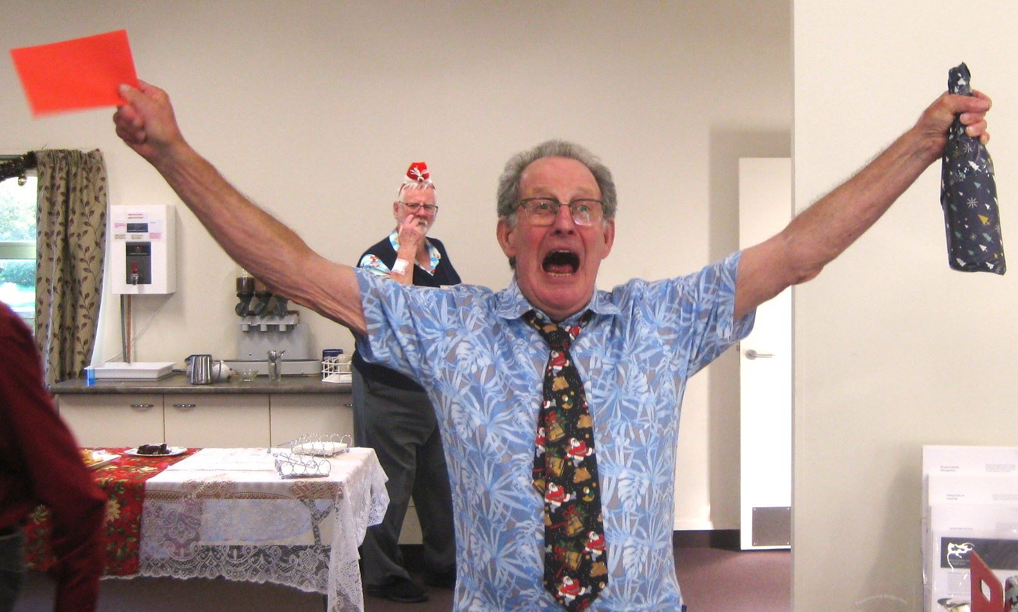
Martin Wren and Kevin Mildenhall won Section D from Lottie Anderson and Gary Jenkins.
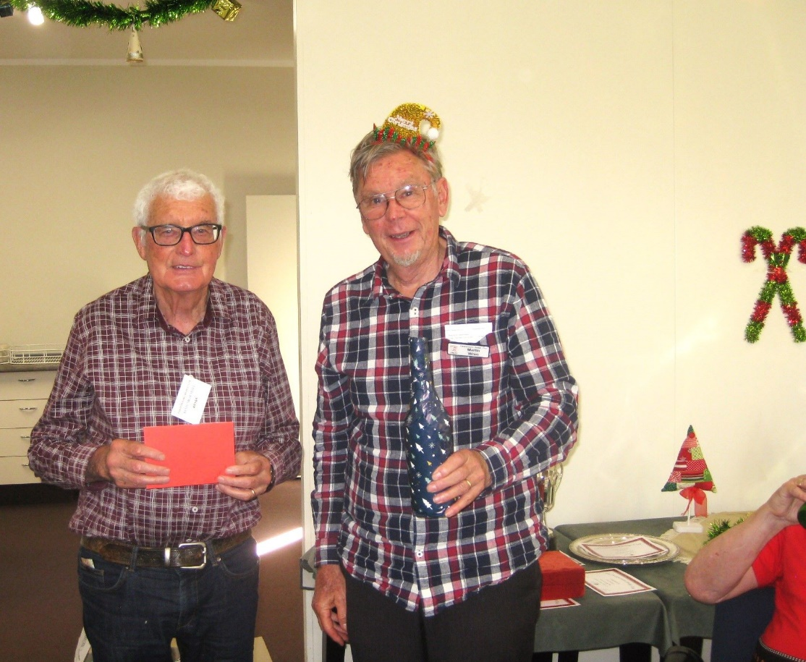
Kevin and Martin, resplendent in checked shirts, winners of Section D.
As noted above, Sara and Annette smashed Section E, from Will and Tina Fulton, and then back to Sharon Henry and Anne Brunt. Maureen Knox and Theresa Cook pipped Lindsey Bryson and Alvaro Lacunza in Section F.
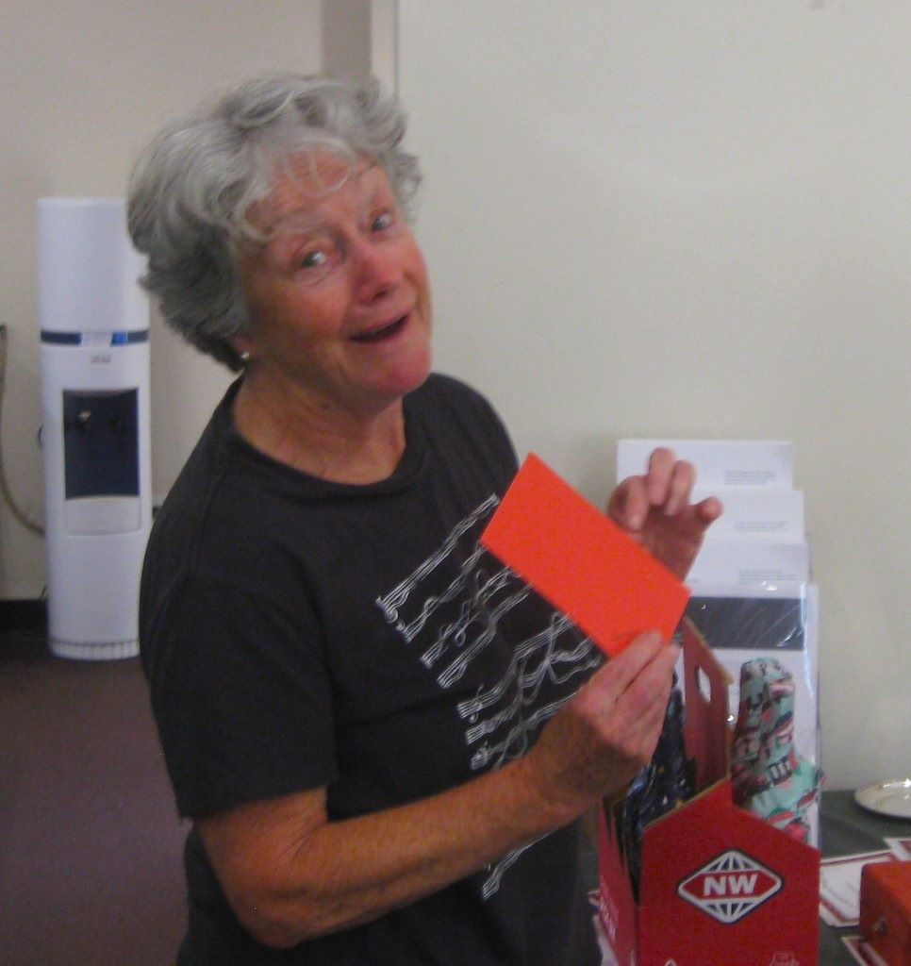
Maureen looks perfectly happy with what she imagines lies in that little red letter.
Well done to all of you. And thanks to helpers in the kitchen, scorers, the bar staff, and to Director Marie Groves and Tournament Manager Hugh Norton.
At the prize giving, winners of the various trophies for club competitions over the latter half of 2023 were given their cups, salvers, trays, plates and medals. A grand finale to a wonderful day and an appropriate climax to a positive year for our club.
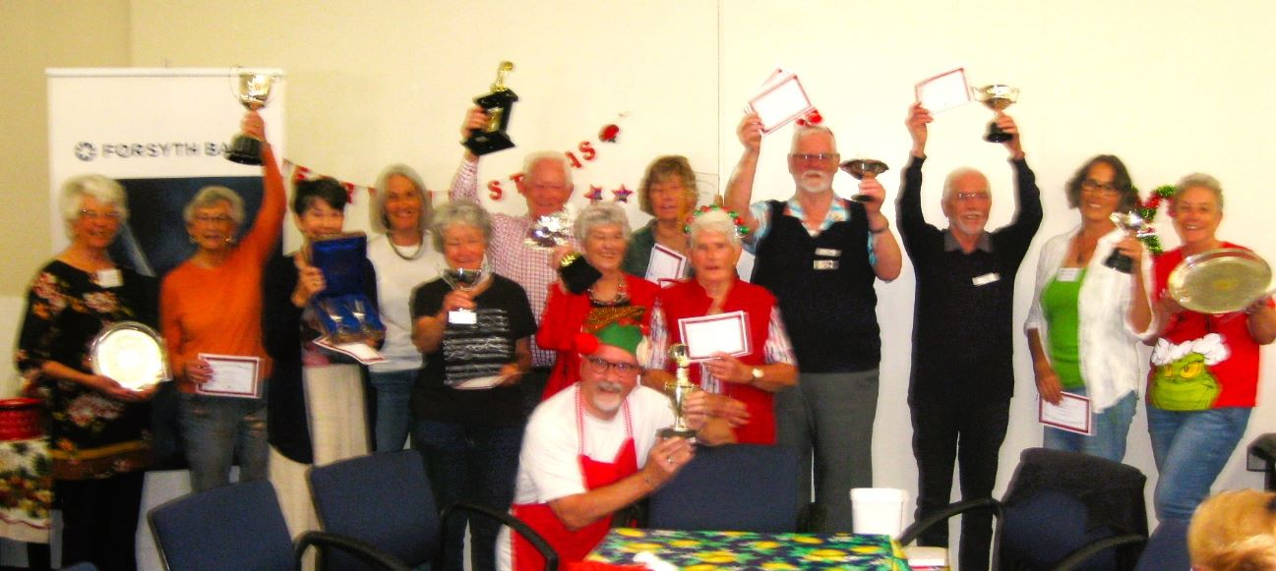

Worthy and cheerful winners of all manner of trophies and awards.

THE SLAM HONOUR TABLE
Well, Trevor Smith suggested that this was won by a “country mile”. I’m not quite sure that covers the extent of Jane Bradbury’s success here, she simply buried any opposition. Of course, it does depend to some extent on how often you play, but to an even greater extent, it depends on how well you play and bid!
Jane is recorded as having 41 successful slams . . . the next best, way way back, were Gillian Travers and Lindzee Inkster, both on 26. We all need to try to close that yawning gap between Jane and the rest of us in 2024. More slam bidding next year, please.

THE 70% CLUB
A total of 16 pairs managed to reach the goal of a 70% score during the year. James Jones and Ray Cachemaille topped the board with a massive 75%. And James also reached that 70% scoreline with two other partners (Tom Tidey and Linzee Inkster). That’s not bad at all, 70% scoring with three different partners.

THE END
And that’s finally enough from me. I’m taking a break from the Newsletter (and about time, yes, I hear you . . .) I think it’s been eight years. Thanks, especially for putting up so cheerfully with me trying to take a photo or even two. (I know that can become a drag but I’ve been trying to keep the newsletters bright and lively.)

So, ka kite ano . . . catch U later . . . cheers, bro. Yeah, I’m outta here.
At least for the interim, Trevor Smith will be taking over the production of the Newsletter in the New Year.
Have a great Christmas with family and friends and come back safely. If you want a game in the New Year, play starts early in January with Open sessions. The first is Tuesday, Jan 9th.
KEITH LEES

