PARAPARAUMU BRIDGE CLUB OCTOBER NEWSLETTER

Kia ora koutou and welcome everyone to another round-up of recent tournament play . . . and then perhaps at the end, a note, a message of inspiration to all of us.
(Not so many photographs this time. I stuffed up.)

THE KAPITI QUADRANGULAR TOURNAMENT
This multi-team event was held on the 17th September. We enjoyed home court advantage but well, that was perhaps the only positive feature of the day’s play.
Teams from Levin, Otaki, Waikanae, and Paraparaumu competed in Open, Intermediate, and Junior Grades. We were well beaten in the Open and Junior Grades but our Intermediate team of Trevor Smith, Francie Vagg, Averil Wotton and Lynda Evans held their collective heads above the water and were placed second. Thanks to you four.
Francie may have escaped but these three seem really happy to have kept their “heads above the water”!
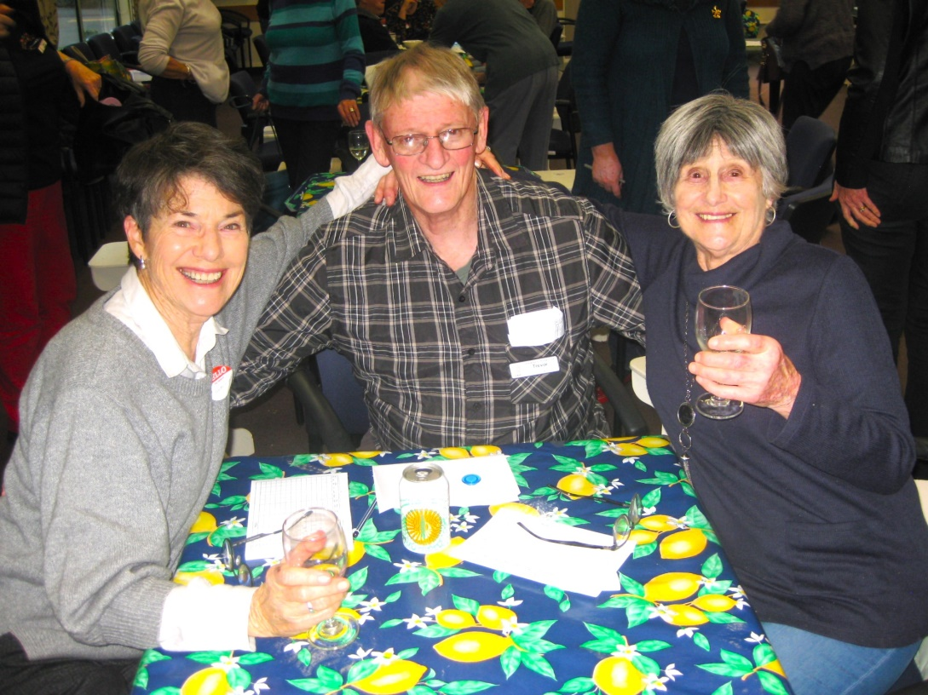

JACKWAYS SHIELD
This head-to-head clash with our southern rivals, Kapi-Mana, was fought on the 24th September. Once again, home advantage proved meaningless . . . and, to be blunt we were simply well beaten. The contest (if you could call it that) involved 13 pairs from each club playing in one session, and then comparing the percentage scores between the two clubs.
We did have some of our very capable, reliable players at the tables but on the day our stars seemed to fail to light up. The only pairs from Paraparaumu to do well . . . sort of . . . almost . . . just OK . . . were the Penders and the Cachemailles and both these pairs scored over 50%.
Our thanks to the four of you for representing us well.

THE KENA KENA REST HOME MULTIGRADE TOURNAMENT
This two-session tournament was held on Sunday 8 October, and drew a pleasing field with 26 pairs. The outright winners were Alan Grant and Anne-Marie Russell, a pairing from the Wellington Club. They took out the Open section and scored a stunning 75% in one session.
Dale Wills and Jane Bradbury had a comfortable win in the Intermediate section and placed second overall. Well done! They also scored an impressive 68% in one of the sessions.
Doug Galyer and Murray Smith played steadily and creditably to finish in sixth place; and Francie Vagg and Marie Groves were top East-West after the first of the two sessions. You will all know that it is highly unlikely that either, or both, of these two players indulged in anything untoward during the lunch break… but Francie and Marie drifted down, down, from the heights of the morning to the depths of the afternoon. That’s Bridge.
One resounding success of the day was the result achieved by Anne Brunt and Sharon Henry, who were placed top in the Junior section and eighth overall. It must be noted that Sharon has not been playing for very long at all and is only just emerging from the Beginner ranks. That’s a great day’s Bridge.
Finally, Lesley Gilhooly (Kapi Mana) and Rae Lutman won a prize for Best mixed pairing (Intermediate/Other).
And a significant footnote to this tournament, Anne Brunt had been on the door at the start to register players, allocate tables etc AND to welcome all the guests. She noted that at the end of the day, she happened to be sitting by the door and ten visitors stopped briefly to compliment the club’s facilities and organization.
Comments included: the sheer friendliness of the day, the efficient and novel introduction of the spot prizes, the quality of the Directing (thanks to Dorothy McKay!), the speed of delivery of the results (thanks scorers), the cleanliness of the toilets, the easy way that Trevor led proceedings, the warm welcome to visitors, the smiling and ‘full of cheer’ kitchen people, and, and, and, of course . . the quality of the lunch!!
There is a huge amount of work by so many that goes into running a successful event. That so many help so positively means a huge lift to the running of our club.

THANK YOU, NOELLA SQUIRE!!!
Across all these events in our home rooms, the organization and work in the kitchen has simply been outstanding and we thank our outstanding volunteer, Noella, for everything that she does and has done to make these occasions and tournaments so pleasant and so successful. Her commitment in time , energy and good humour through it all, is amazing.

THE WINTER TEAMS OF FOUR
Sincere thanks to Gillian Travers for her organization of this event. As Gillian points out, teams-of-four can be just a tad more social, in that after each session your team gets back together at one table to check the results and scores, laugh at the disasters, chat about the hands (and commiserate as well.)
Ten teams battled it out throughout the scheduled Wednesday nights. In the end, Team Wotton was the comprehensive and clear winner. Over nine rounds, they notched seven wins, one draw, and a single loss. Not bad bridging at all.
Team Wotton comprised Averil, Lynda Evans, Barbara Horner, Pauline Reid and Sue Wilcox. Congratulations.
The Handicap section of the competition was taken out by Team Stagg, made up of David, Leon Hunia, Linda Aarsen, Margaret Jamieson and Jane Gilbert. Well done to all of you (who was the team member responsible for keeping some kind of a check on Leon’s aggressive bidding?)
The Wednesday night Teams of Four is in the programme book for 2024, with a slightly reduced format and series. Start to select your team now.

UPCOMING EVENTS
You might, just, get your names down for the In-House Halloween Tournament this coming Sunday (29 October). It was a great, fun afternoon last year and this year’s session promises to be the same. Remember, a prize for the best Halloween-themed costume.
And remember, the final club event for the year is on Sunday 10 December. It’s the popular Forsyth Barr Christmas Pairs. Book a partner and book it in your busy pre-Christmas diary.

SO, TO THAT FINAL NOTE OF INSPIRATION . . .
A Bridge winner, at 101, and an Open Tournament at that.
He’s led Kiwi athletes to Olympics gold medal victories, made a Companion of the New Zealand Order of Merit and recently, 101-year-old Arch Jelley has added another win to his name with a Bridge title at his local club.
Jelley, New Zealand’s oldest Olympic coach after he guided legendary runner John Walker to a gold medal at the 1976 Olympics in Montreal, won the Billie Tohill Open Pairs in Mt Albert in late August – just a few days after his 101st birthday. Organised by the Auckland Bridge Club, Jelley defeated some skilled bridge players, including a gold and two silver grandmasters, and a couple of players who have represented NZ, over two sessions and 56 boards.
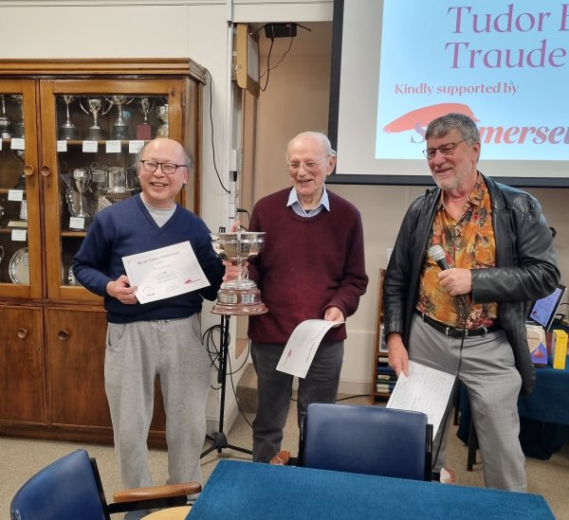
Arch Jelley (centre) receives the winning trophy.
It’s a small feat compared to his distinguished coaching career but Jelley loves it – playing bridge is one of his favourite pastimes.
He’s very modest about the win, and admits it’s not an easy competition to be in. “You have to be pretty good to compete and there were more skilled players than me. I’m pretty lowly ranked in bridge, I’m not in the elite or anything like that,” Jelley said. “I’m only reasonably good, and all tournaments are challenging.”
Three days after winning the tournament, Jelley said he played bridge again with the same player and lost. “We played like dogs, bridge is a tricky game, you can win one day and lose the next.
“I think it’s a fantastic game, it has so many ups and downs, and you can stick to it if you’re keen on improving.”
For the last 20 years Jelley has lived at Pinesong Retirement Village in West Auckland’s Green Bay and spends his days playing bridge both online and at the local club, along with writing and reading.
He still loves to stay active, although not as much as he would like, and makes sure he goes on his exercycle and walks 4 kilometres a day. (!!!)
Below, Arch Jelley with Gold Medallist, John Walker.
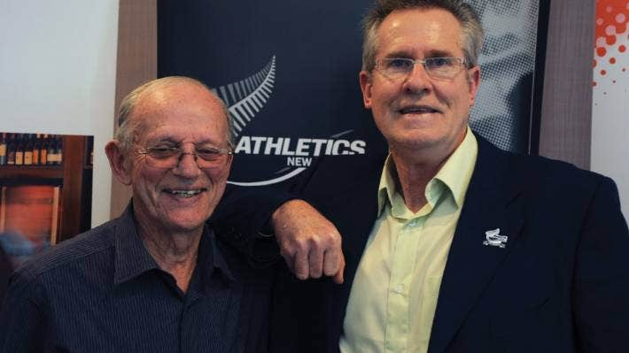

So, the secret seems to be that combination of heaps of Bridge and heaps of walking (yes, four kilometres each day, at 101). Maybe we need to forget Improvers’ Classes and start a walking group instead. Who’s up for the 4 kms per day regime??

EDITOR : KEITH LEES

