PARAPARAUMU BRIDGE CLUB AUGUST 2023

A very warm welcome to another of these occasional newsletters and nga mihi nui kia koutou to all members of our bridge club. A couple of tournament results and a sprinkling of other matters worth noting. And then a spectacular bridge hand, from the highest levels of the game, but one with some implications for all players.

THE “IN HOUSE” LAW CONNECTION SPONSORED PAIRS

This took place on the 25th of June. Always popular, this event attracted a field of fifteen tables, organized into five sections, so there were multiple opportunities for some prizes. After a very pleasant afternoon’s bridge, the winners were announced. Lynda Evans and Averil Wotton were the deserved outright winners on the day, with 63%. They were not too far ahead of Tom Tidey and Bob Jennings, on 62%. Tom and Bob emerged from Section D, to come second overall, across all the pairs, and that was a particularly good result for them.

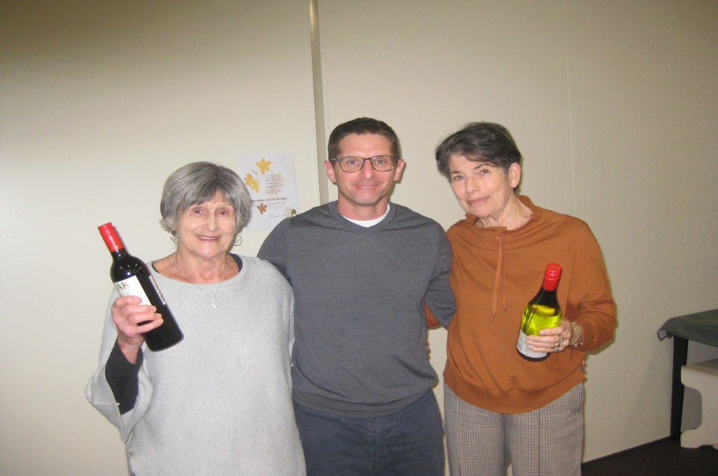

Averil and Lynda, (always happy to get the wine eh?) With the generous sponsor from the Law Connection. Congratulations, Averil and Lynda, top in Section A and top overall.

And here Tom and Bob grasp their bottles. Well done, the two of you.
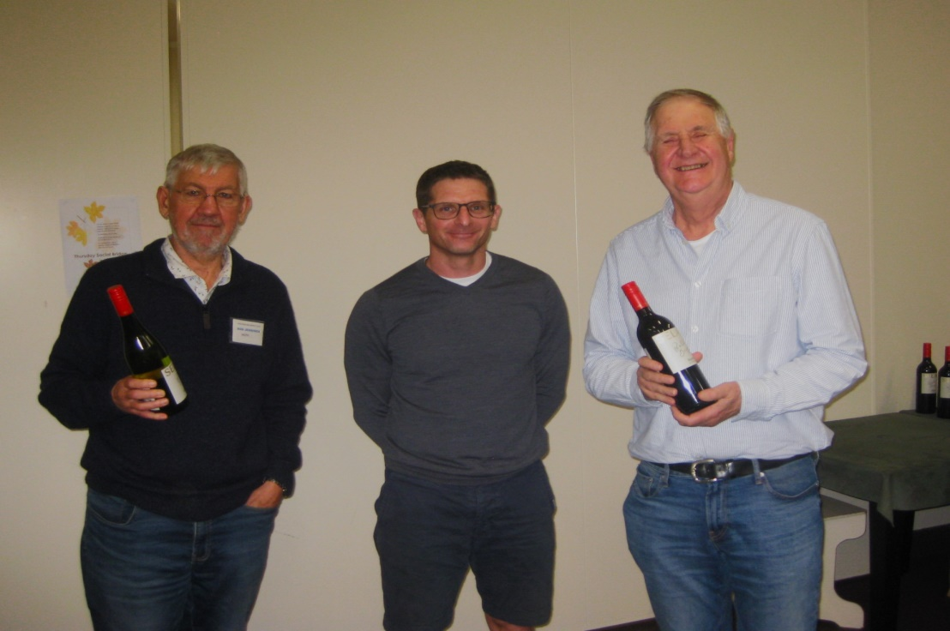

James Jones and Linzee Inkster were first in Section B, from Anne and Dennis Kerr, and Keith and Marg Lees won Section C, from Jean Crafts and Moira Wilson.
As noted above, Bob and Tom placed first in Section D, from Pat McArthur and Kevin Mildenhall. Rachel Bruce and Lyn Berry nudged out Jane McArthur and Margaret Jamieson in Section E.
The “in House” sessions are always well attended, and they do provide a chance to have a wine and enjoy the generous spread of food and chat with club members. Social and competitive bridge together.

THE KAPITI COAST FUNERAL HOME JUNIOR PAIRS
This two-session tournament was held in mid-July. Not a massive field by any means with only 16 pairs (ie 8 tables), but they certainly came from all over the region. At the end of the first session, one pair representing both the Palmerston and Hokowhitu Bridge Clubs were leading, then one of our Paraparaumu pairs, then pairs from Waikanae, Wellington, Kapi-Mana and the Hutt Valley club respectively.
However, after the two sessions, Brett and Sandra Windley had improved from the morning round and had pushed up into top place. Well done, and thanks for representing us at our own Junior Tournament in excellent fashion. They won from a pair from Kapi-Mana, Dianne Grain and Deirdre Evans. The performance of our Jo Buck and Sara Enoka should also be acknowledged: they were in fourth place.

Here, Brett and Sandra, accept their prize and congratulations from a representative of the sponsor. Sandra seems delighted . . . and fair enough!
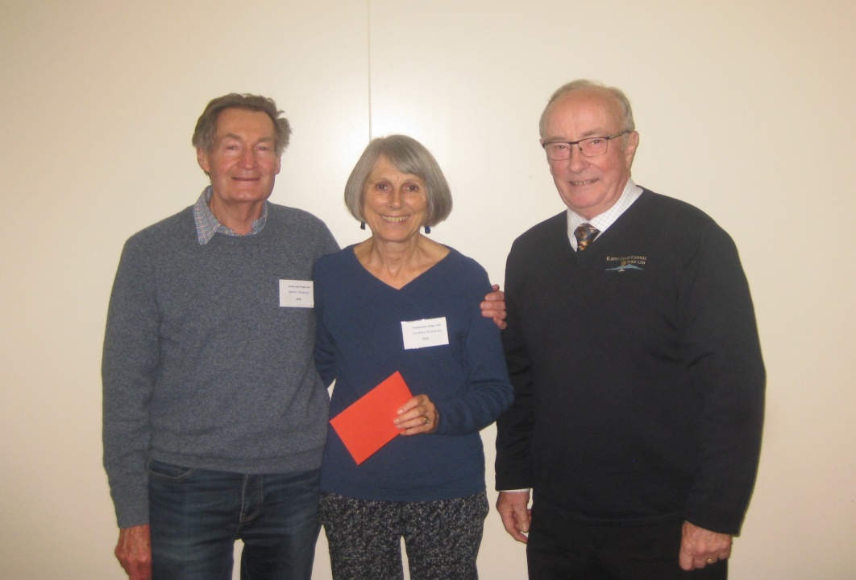
And thanks too, to Noella (ever present in that kitchen), the Cachemaille pair ie Ray and Margaret (behind the bar), and Brian Pender (Director).
THE WAIKANAE MULTIGRADE PAIRS
At the end of July, several of our players competed in this event. It attracted a large field, with 36 pairs from right across the Wellington-Hutt-Horowhenua regions. Dale Wills and Jane Bradbury bid and played superbly and were placed second! A great result for them and also pleasing to have players from our club competing at this high level.
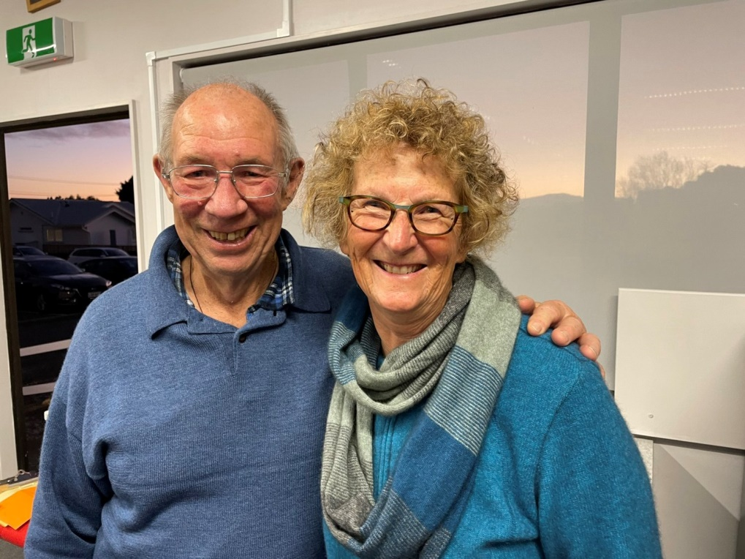
I do like this photo. Dale and Jane both seem so pleased and happy – and why not?
And also Averil Wotton combined with a player from KapiMana, Lesley Gilhooly, to be placed 7th (and 1st in the Open/Intermediate section).

WELLINGTON REGIONAL CLUB COMPETITION
A team from the Paraparaumu Bridge Club represented us in a Wellington Region Club Teams event in July. This was a competition to determine which club might represent the Wellington region in a National Play Off final.
Our team comprised : Open section = Vivienne Cannell and Kate Walker (and if you do not recognise these players, that’s perfectly understandable for they were “borrowed” from our neighbouring Waikanae club, when we struggled to get players at that level)
Open Reserve = Averil Wotton and Lynda Evans
Intermediate = Sue Wilcox and Barbara Horner
Junior = Sara Enoka and Joanna Buck
They faced a mere 12 hours of competitive bridge !! Considering that 2 of our pairs were playing above their NZ Bridge ranking, Team Paraparaumu did really well and eventually came 7th overall. And Sara and Joanna were 4th in the Junior section. Well done and thanks for representing us.

RUBBER BRIDGE
They were not the only members from Paraparaumu to have a crack at some of the big guns in Wellington over the last couple of months. For example, pairs from around the region competed in a Rubber Bridge Tournament for the right to advance to the National finals.
Gillian Travers and James Winskill reached the semi-finals only to be knocked out by a particularly lucky slam sitting in the opposition’s cards. Luck does play a much, much bigger part in rubber bridge and at times there’s just nothing you can do but just watch and try to keep smiling. This rubber bridge contest in Wellington played out over the first seven months of the year and Gillian and James were in the running almost to the end.

SOCIAL BRIDGE
These afternoon sessions continue to be well supported. Some members really appreciate an opportunity to bid and play without the pressure of the Director’s clock. It’s an opportunity to discuss the hands with one or two experienced club members and to continue learning. And it’s pleasant to have a more leisurely chat over a cuppa as well.
As you know, “Social Bridge” has now moved from Thursdays to Wednesdays (1.00 pm start). Play a few hands, stop for a chat and a cup of tea, then a few more hands and above all, no pressure.

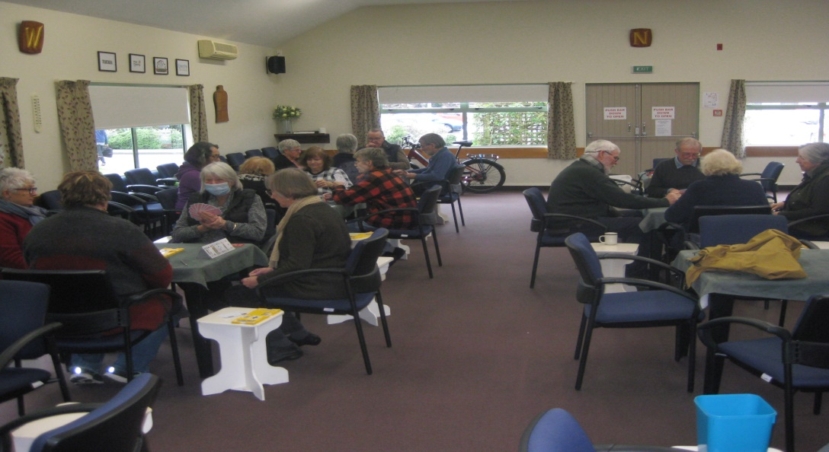
A recent afternoon at “Social Bridge”. As you can see, four full tables, with a more experienced player at each table. Thanks again to Eliza Thomson, for her initiative and organization in starting up this new session in our clubrooms.

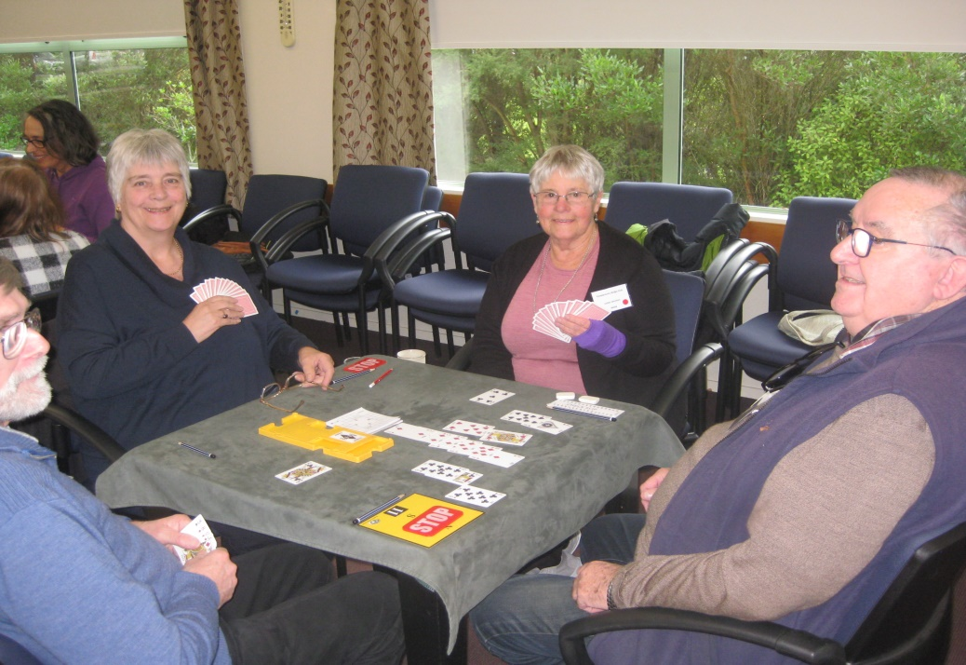
And here are four of them. Jasmine Thompson is declarer, Kevin Thompson is sitting dummy, while Lesley Johnston has made the opening lead, and yes, that’s James Jones sitting East and keeping an encouraging eye on proceedings. A very relaxed group, right?

HOME4ALL TRUST
Remember playing in this Charity tournament last November and Averil Wotton’s call to “come and play for charity”?
Home4all is a local trust which provides day care for people suffering from early and moderate stage dementia. Outdoor activities, such as gardening, looking after animals, and occasional visits to parks and beaches are stressed. “Soaking up the outdoors” helps to contribute to the sense of purpose and well-being that the visitors gain from the experience. This model of care is based on an initiative developed in the Netherlands.
We (Averil?) raised $1,500.00 and this was put towards the purchase of a special electric duo bike, a “tricycle made for two”, which could be used to take someone with dementia out for a coffee, or shopping, or on a trip through the paved tracks in QE2, with a volunteer or staff member sitting alongside.
The bike arrived two months ago from the Netherlands, (well, if you want a really good bike where else would you go?). Marianne and Jan Westrate, who run the programme, want to shout out their thanks to all who donated so generously.
Ian and Averil demonstrate . . . Ian in a rather rakish cap (no, helmets are NOT required in your own driveway!) and Averil looks as if she could go on to compete in the Tour de France (version pour femmes). Allez les Wottons!

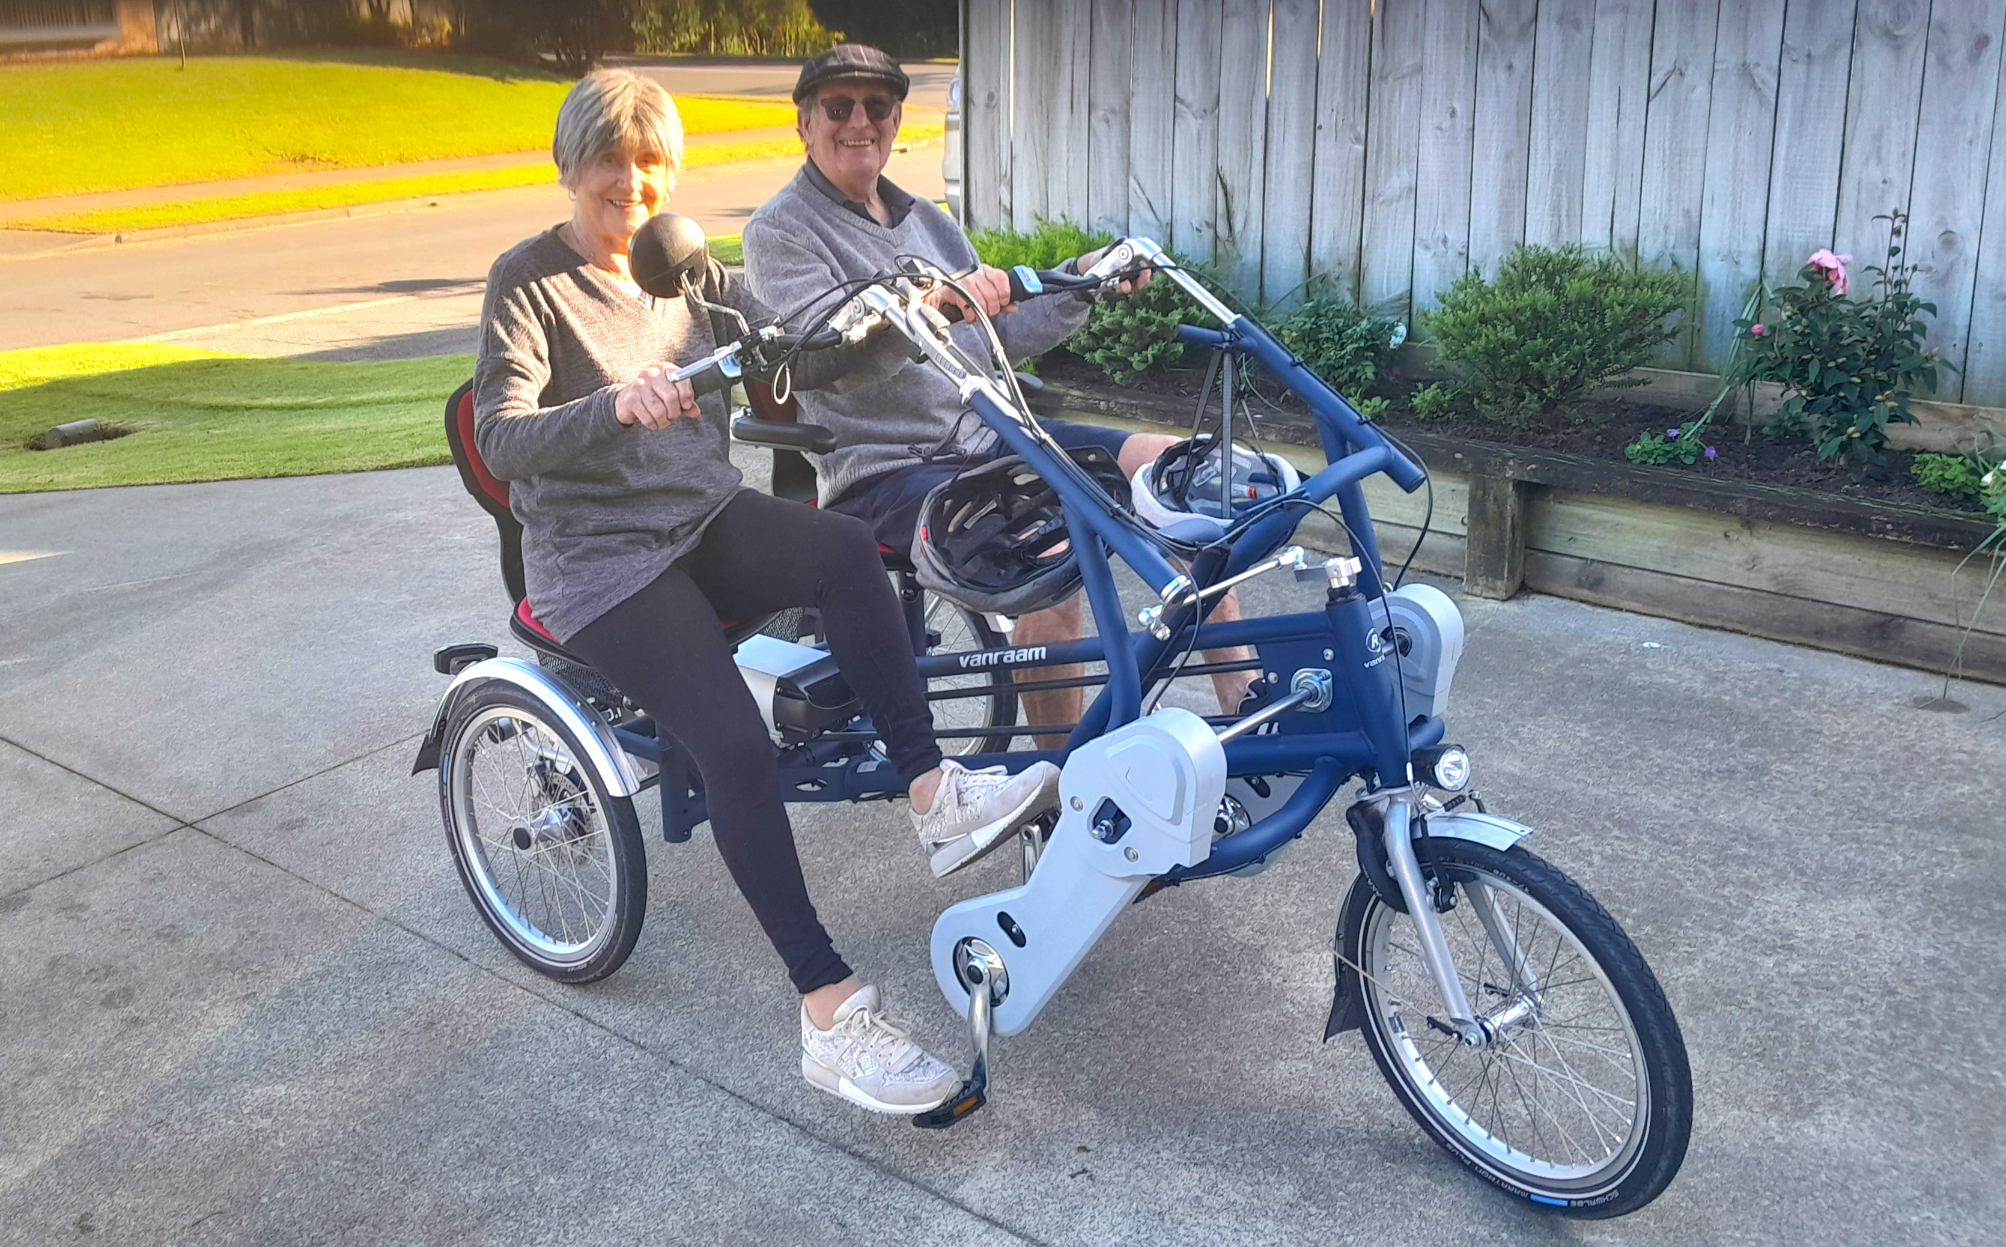

THE 70% CLUB
Up to 3 August, there were 9 pairs who have scored 70% or more at one of our regular club sessions. Jane Bradbury and Lynda Evans head the list with 73.5%, Laurel Nalder and John Barton are really close but not quite close enough, on 72.9%.

JACKWAYS SHIELD – Change of date.
PLEASE NOTE: Due to a late change of date, the Jackways Shield interclub competition between us and Kapi-Mana club will be held on 24 September – not 27 August as advertised in the programme book.
If you want to play in this interclub competition, an entry sheet will be posted on the noticeboard shortly.

FINALLY, A BRIDGE HAND TO PONDER . . . AND THEN PONDER SOME MORE?
This hand occurred earlier this year during the European Transnational Championship. The story is adapted from the bridge column by Susanna Gross in “The Spectator”.
One of England’s top young players, Tom Paske, features here with a stunning piece of sheer skullduggery which produced an amazing grand slam. Paske is a mere 22 years old, by the way, but he has already been a professional player for two of those years.
Paske is sitting West, playing in the Open Pairs Section of this international event.
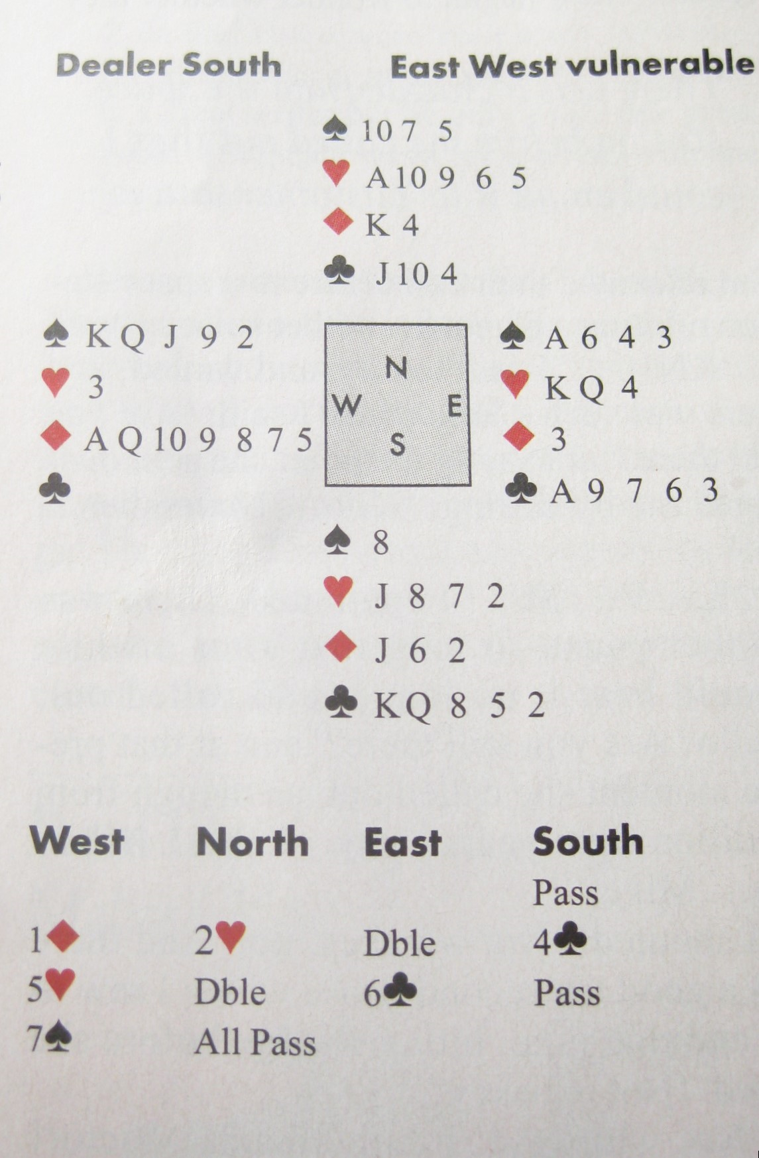
Paske opens a diamond. Fair enough, 12 points, a singleton, a void and 7 diamonds.
North bids 2 Hearts . . . an aggressive pre-empt. Pushy but North-South are non-vulnerable.
East doubles = it’s a kind of negative double, showing at least 4 spades and 10 + points.
Paske, knowing that they have a fit in spades, decides a slam might be on and he should ask for aces. Either the Ace of Hearts or the Ace of Spades will be enough for slam . . . but what if his partner holds the Ace of Clubs? That would provide a discard for his singleton heart . . . but only if North does not lead a heart! A glimmer of a possibility of a grand slam must have emerged.
Paske decides to lie by jumping to 5 Hearts. According to their partnership understanding (readily available to the opposition) this bid shows a void in hearts, and asks West what key cards he holds . . . but excluding the Ace of Hearts!
The 6 Clubs (above), by East, showed 2 key cards (aces in Spades and Clubs) and Paske jumped straight to 7 Spades. His gamble/subterfuge/outright lie to persuade North NOT to lead his ace against the grand slam paid off superbly! After a trump lead, he made the contract easily by . . . yes, discarding his heart singleton on the Ace of Clubs, and ruffing a diamond.
But wait . . . how do you get away with misinformation and deliberate, cold, calculated misinformation at that? I’d sure be miffed if I’d been North and suckered out of leading the Ace of Hearts because West has told the table that he has a void in Hearts, and thus suckered out of a good board. How would you feel?
Is it possible to plead a case with the Director then, to appeal, to whimper and cry for a revised score, on the grounds that you’ve been completely misled?
I ran this case past our own Directors Group. In summary, our Directors concluded that this misleading bid was indeed within the rules of Bridge. An appeal by the opposition would be disallowed.
Apparently, there are two rules that come into consideration – under the heading of “Deceptive Calls and Play”, in the NZ Bridge Manual.
35.1 A psyche bid is a deliberate gross representation of your high card strength and/or the length of your suits. Note that the two key words are “deliberate” and “gross”.
And further :
35.2 A player may depart from his/her agreed partnership methods in an attempt to deceive opponents, as long as their partner is no more aware of the violation than the opponents.
Note the implied proviso that their partner is being misled just as much as the opposition.
Finally, a general comment from the Chair of the Directors Group, Brian Pender: many tournaments do limit the number of “psyche” bids that can be made in a session, and some clubs do maintain “psyche” registers in order to keep a record of the frequency of such bids, and if particular players are making extensive use of “psyche” bidding.
Interesting? Sometimes you may get incorrect information and yet it could well be within the rules of Bridge.
Of course, each case would have to be determined on the particular merits and context.
EDITOR : KEITH LEES

