PARAPARAUMU BRIDGE CLUB NEWSLETTER END OF MAY 2023

Kia ora koutou and hello to all members
Another brief round up of club happenings over the last couple of months. And then to finish, a board that perhaps illustrates just how great bridge is. A “game for life”.

THE BLOOM HEARING INTERMEDIATE TOURNAMENT
This was held on Sunday 14 May. Fifteen full tables (ie thirty pairs) fought it out over two sessions. And the entries came from all over the lower-mid North Island. From Palmerston North to Wellington and from New Plymouth to the Wairarapa. And local clubs such as Waikanae, Kapi Mana, Otaki and Levin were well represented.
Congratulations to Sue Wilcox for her big win, with her partner from the Kairangi club, Kate Reeve. A well-deserved and very satisfying result for the two of you.
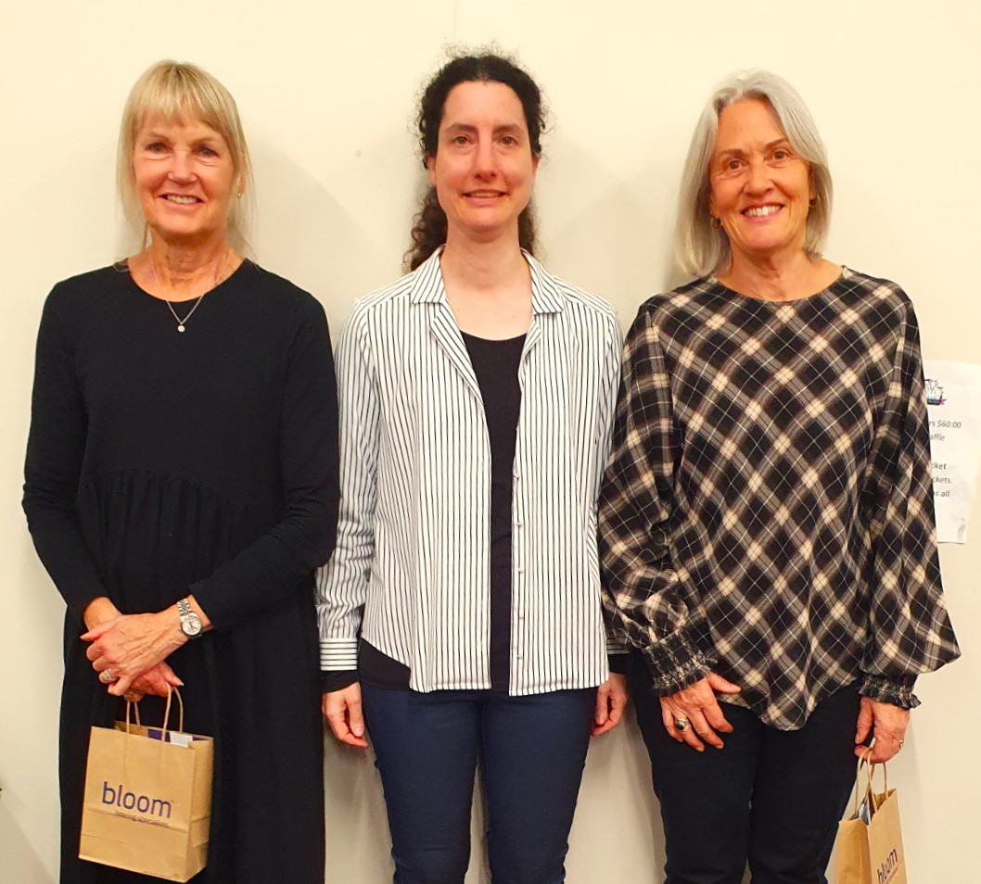

Kate and Sue clutching their winnings courtesy of Maja (centre) from Bloom Hearing.

A Palmerston-based partnership, Michael Hardman and Julie Bunnell, nudged our own Jane Bradbury and Lynda Evans, out of second place. Jane and Lynda had been well in the hunt after the first session of play but couldn’t quite nail it in the afternoon round.

Jane holds up the sponsor’s prize while Lynda looks as if she’s not finished, she wants to add a comment . . .

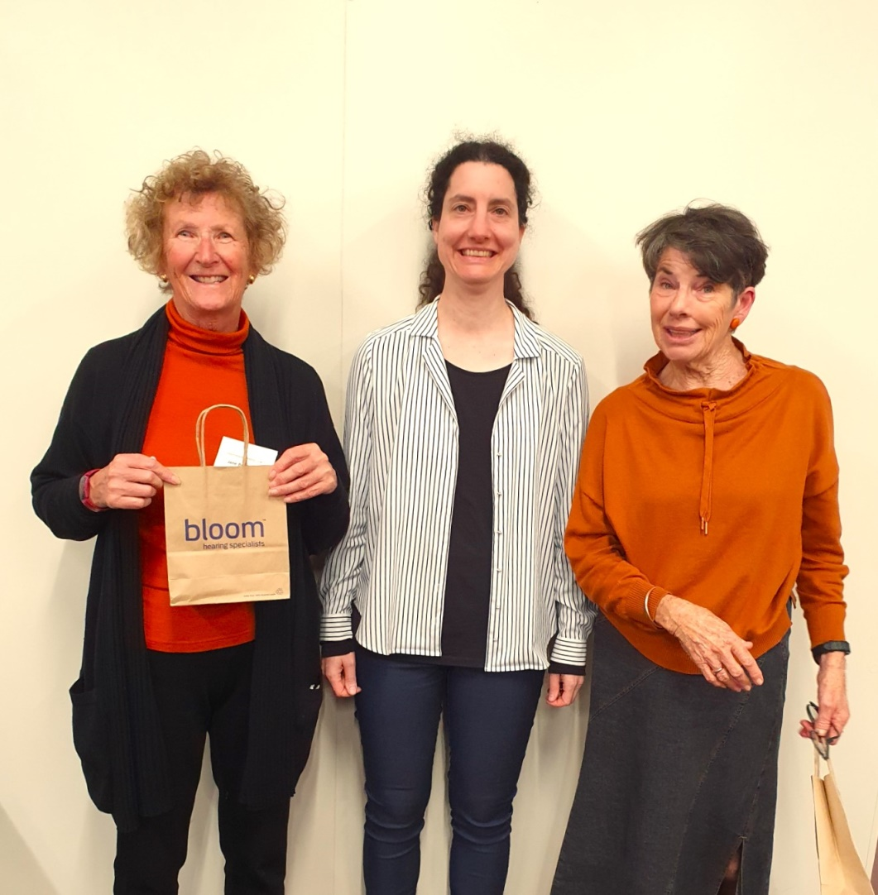

Also, worthy of mention were Tom Tidey and David Stagg who played steadily throughout both sessions and finished in fifth place.

BEGINNERS CLASS
The graduation ceremony has been held and those who have opted to join the club are now filtering through to playing at various sessions. Please introduce yourselves and give a warm welcome when you notice these newbies.
Most of those coming from the classes have been given a “red dot” to wear, which means that yes, you can double” but your “double” must be for takeout, not for penalties. Some of those coming from the classes have in fact, played the game before, in various contexts such as rubber bridge, or have taken the approach that they needed a refresher course before returning to Contract Bridge.

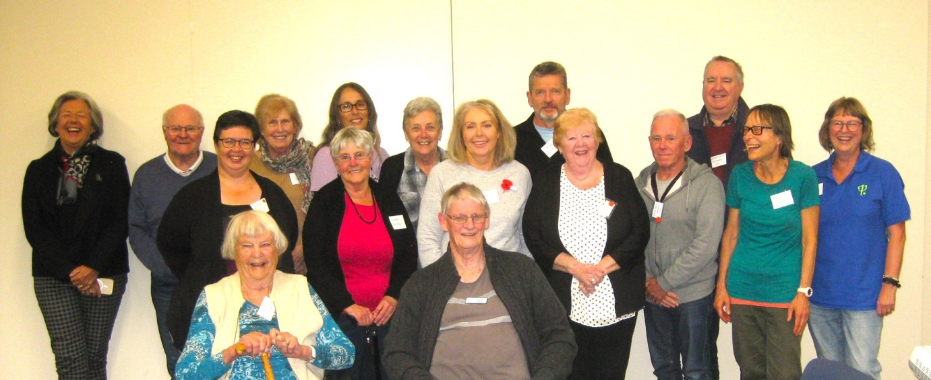
And here they are . . . well most of them, some were away that night. Don’t they all seem very happy and kind of pleased with themselves?

No, no, our President Trevor Smith is NOT one of the beginners . . . he’s been their TEACHER and almost their guru over several months. A calm, patient and encouraging teacher. And yes, you can “double” Trevor whenever you like, and yes for penalties! (Though good luck to you with that bid.)

You’ve noticed Marty Barrett looking highly amused at the back left. Marty had been at the classes to help and mentor, but then claimed that she was really having a kind of refresher course herself and so claimed that she deserved her very own certificate of proficiency.

The graduating class were all given this certificate:
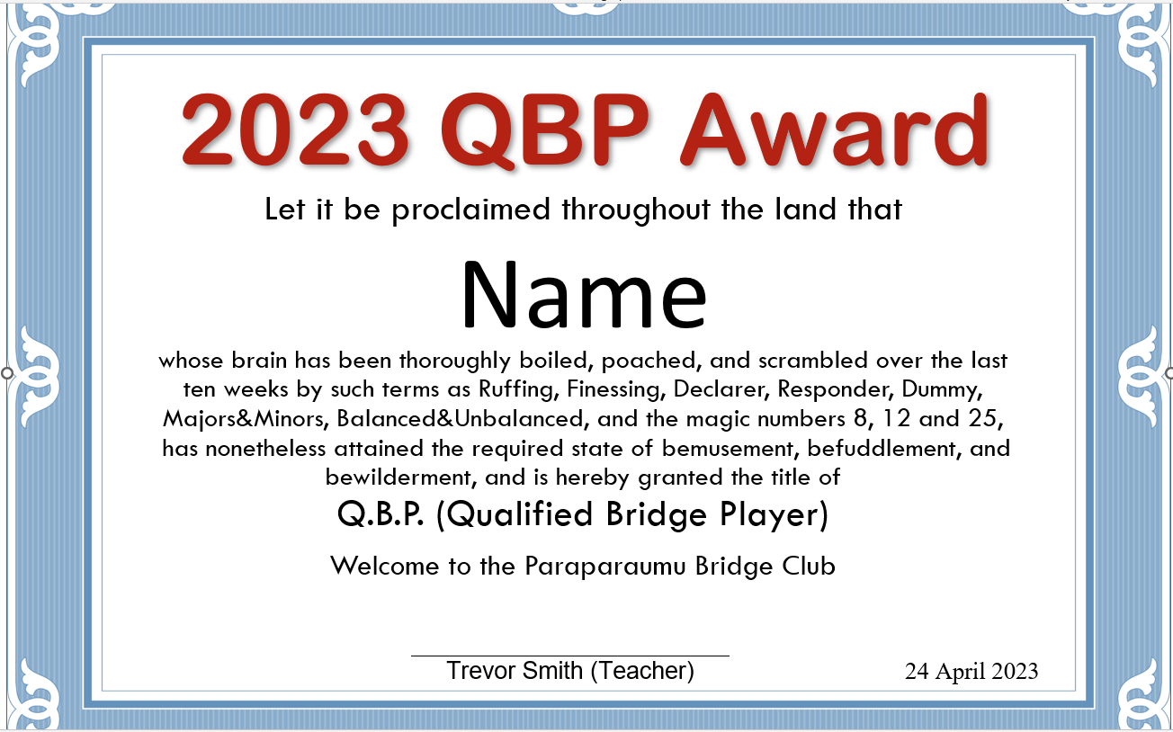
And there’s more. Here are four of the graduating class who all look as if they can’t wait to enter the fray. I do like the message on their goodie bags supplied by NZ Bridge. Yes, true, “bridge is indeed a game for life”, don’t you think?
Below (left to right) are Andrea Anuzis, Michelle Kendrick, Ross Anuzis, and Vikki Clarke. All of them are ready to play.
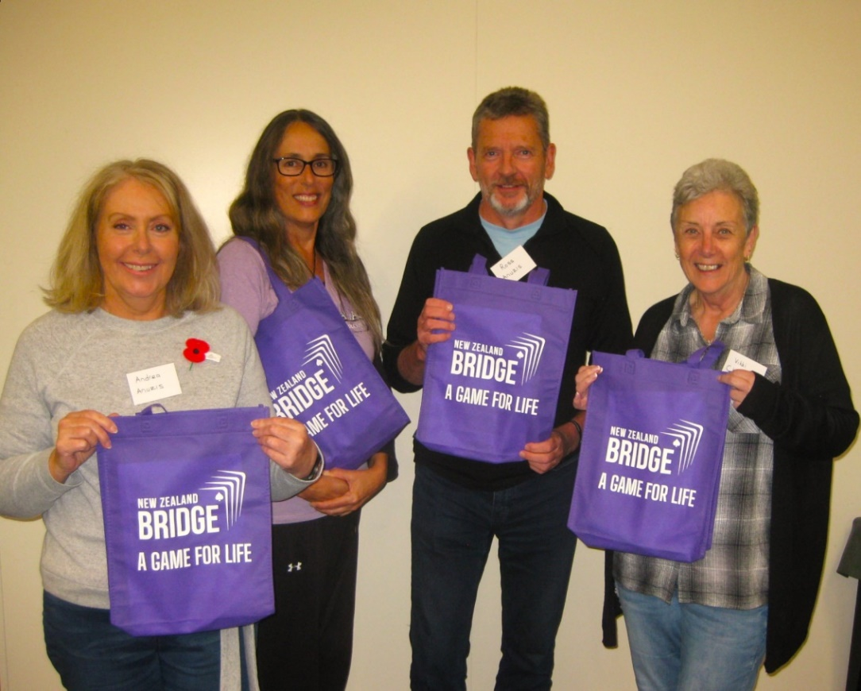
And a big, big thanks to all those members who maintained a supportive presence right through the weeks and months acting as mentors and helping to make up tables into groups of four. Some of these people have been helping with the beginner’s classes for many years. Thanks to Ken Thomas, Anne Brunt, Tina Connell-Pine, David Stagg, Yvonne Rowe, and Brian Pender and thanks to the Class Administrator, Linda Pender. The success of this series of lessons depended on the time and commitment of many members.

OUR TABLETS
The problem of slow response when entering results and scores onto the tablets has been a recurring and irritating issue. Many attempts had been made to improve the speed of response, with some limited improvement, but without overall success. Finally, the problem has been traced to an update of an application used by BridgePal called Android System Webview. A couple of months ago, an update to this application had the undesirable result of slowing BridgePal response. In consultation with John Goacher (creator of BridgePal) and Bob Fearn (creator of Compass – our scoring system), an uncorrupted version of this application has been located and loaded onto the tablets. Future updates have been disabled. Here’s looking forward to much speedier action on the tablets.

WHAT’S IN A NAME? IS IT LYNDA EVANS OR LINDA EVANS?
Club member Lynda reported that she had not been sent the usual email result of a club session she had played in. She wasn’t too worried, just a little surprised.
Trevor checked. Lynda’s registration/computer number is 45010. But for that session, her number had been incorrectly recorded as 45101 . . .
A very, very easy mistake to make in the rush to get the cards out of the boards and the show on the road etc. However, the wrong name should have been displayed and it should have been very easy to pick up after the session was over and the scoring was being completed – easy to correct when a name that does not resonate as one of our club members shows up. No?
Well, not so easy. The number 45101 belonged at the time to a player from the Crockford’s Club (Christchurch), and 45101 belonged to . . . Linda Evans!!! What???
Yes, that’s Linda with an “i” and not our Lynda with a “y”. But what kind of a scorer would have picked that up? Even an eagle-eyed and pedantic stickler for accuracy would be hard-pressed. That is a remarkable coincidence. Bizarre.

UPCOMING TOURNAMENTS
You might want to consider the Levin Junior and Intermediate Pairs on June 11th or perhaps the Kapi Mana Open Pairs, just a week later on June 18th.
You could even regard those events merely as practice play for our own In-House Law Connection Sponsored Pairs which will be held on Sunday June 25 June. This is a very popular one session tournament , only open for our own club members, so get your partner sorted and get your entries in NOW. I suspect entries will close before that weekend. This is one that has always been well supported.
I wonder if last year’s winning pair will be defending their title? Last year’s winning partnership was Jean Crafts and Robyn Mickelson. They won from Dennis Lahman and Pat McArthur, and then Linda Pender and Margaret Cachemaille. Will those pairings have another crack?
A month further down the track, on July 16, there will be a great opportunity for some of our less experienced players to compete in the Paraparaumu Junior Pairs, sponsored by the Kapiti Coast Funeral Home. Have a real think about having a go at this one.
By the way, you do earn double “C” points at tournaments, as well as “B” points, (and even the highly prized “A” points are up for grabs at Open Events). You can also earn some dosh, prizes in cash. Up to $100.00!

THE 70% HONOURS BOARD
Only five pairs have reached the 70% plateau (for scoring at that level in a club session).
Just this last week Tina Connell-Pine and John Barton swept to the very top with a score of 71.25%. A further four pairs have scraped over the mark, with James Jones featuring twice (once with Linzee Inkster and once with Tom Tidey).

BRIDGE : A GAME FOR LIFE ?
One of the many reasons why bridge is indeed a “game for life” is that just occasionally not particularly talented bridge players can score a winning result against master players, even against the international elite.
Imagine playing tennis against Djokovic. You won’t win a single game. You cannot do it. But you might just get a top board against a bridge Gold Master, even against a World Champion.
Janet de Botton is not a World Champion but she is an international player. She has played for England many times over the last twenty years. She also writes a bridge column, one that I particularly like because she is always prepared to tell a bridge story against herself.
Janet is also fabulously rich. Ridiculously rich. She has not made her fortune playing bridge.
But that’s another story. Here is a recent bridge story of hers. She noticed there was a low-key, quite smallish, local tournament in Marbella and on a whim, decided to go (as much for some decent weather as anything).
She took along her International partner. They “did well” despite the absolute walloping they got on the following board, the final board of the session.

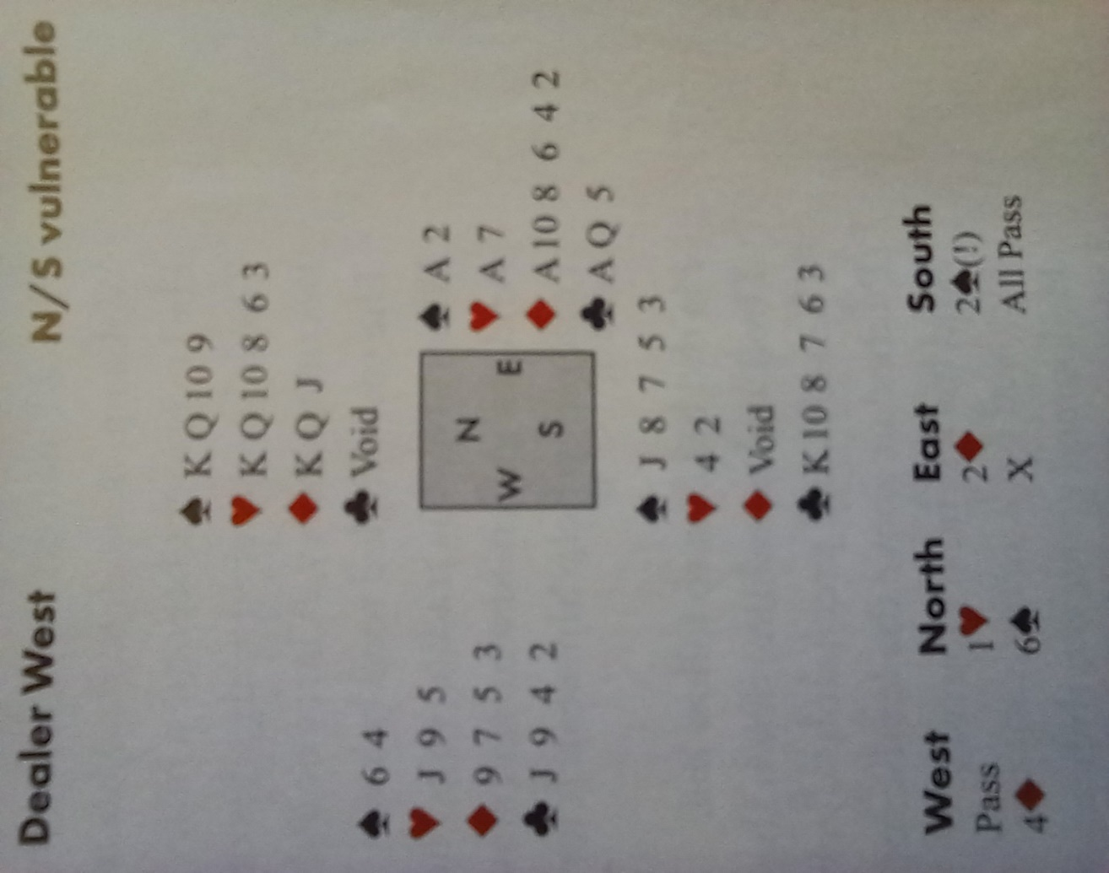

Janet is sitting East, with North/South Vulnerable. The bidding starts in a straightforward way. A pass from West, a Heart from North, and Two Diamonds from Janet de Botton. Then South’s Two Spades is just perhaps a tad problematic. Apparently, it suggested some values (?), five or more spades and was forcing for one round.
Janet’s International partner, sitting West, decides to make it more difficult for North/ South to communicate, and bids Four Diamonds. Optimistic perhaps but it is a pre-emptive jump and weak. (Really weak!)
North apparently saw no point in using Blackwood with a void, so she just bid what she thought she might possibly make. Six Spades! Yes, a small slam in Spades. Janet thought, “Well, I ought to double that.”
Note, the Ace of Trumps, another three Aces, 18 points, and a response from partner to her opening Bid. You’d have to double, wouldn’t you?
The play didn’t take very long at all. International expert West led a diamond and club player South ruffed East’s Ace. He then ruffed a club in dummy, then discarded his two small hearts on the two good Diamonds. Then South played the King of Hearts and ruffed away East’s Ace.
Well, it was now time to play out some trumps, and East does finally score one of her four Aces but with trumps splitting 2-2, and then the Hearts 3-2, there was no stopping the slam.
A mere 1660 for the local club players and a resounding, remarkable, total bottom board for the pair of internationals.
Janet de Botton commented at the end of her story that as she accepted the horrendous score, she thought briefly about asking her partner if perhaps her double might have suggested that an unusual lead might be useful . . . “but he was already at the bar”.

EDITOR: KEITH LEES

