PARAPARAUMU BRIDGE CLUB MARCH NEWSLETTER 2023

Hello, cheers, kia ora koutou
Another (brief) roundup of some club moments from the first couple of months of the bridge year. Two positives to start. First, table numbers do show a slight but discernible increase on last year and they are continuing to grow. Secondly, the 2023 class taking bridge lessons is a particularly large group. More on that later.
Regular club sessions recommenced on January 10 . . . first winners for 2023 were Dennis Lahman and Pat McArthur, who notched a pleasing 68%. Well done the two of you, straight back to bridge and into it!

THE WAIKANAE V PARAPARAUMU ANNUAL INTERCLUB MATCH
This was held on the 5 March. I had a quick look at the Shield on display in our clubrooms before the start of play, i.e. before this year’s result. A fair comment might be that the contest has been very even over three decades of play. By my quick count, the score was indeed in Waikanae’s favour but by very little . . . 16 wins to Waikanae and 14 to Paraparaumu. However, to the increasing chagrin of Jane Bradbury, we’ve now lost the last 6 encounters!
And almost nothing in it this time. 13 pairs for each club faced each other and by the end of the afternoon, Waikanae were ahead by the barest of margins, with an average score of 50.2 against 49.8 for Paraparaumu. Once again, the spoils of victory, the Shield, was taken back north across the river.
Jeanne Wardill and Graham Cheater topped the score sheet for our opposition. No great surprise there, but their 64.9% certainly helped nudge Waikanae. And then Waikanae had three further scores in the low 60s.
For the good guys, James Jones and Stu Thurston, Jane Bradbury and Doug Galyer, and Tine Connell-Pine and Trevor Smith, all bid and played well and had scores in the high 50s. We did match the bad guys across the middle and lower parts of the field but at the top end we were . . . nearly, but well, just not quite there.
Thanks to Gillian and Averil for the organization, to Francie Vagg for Directing, and to the Scorer, Jane McArthur.
And thanks to all the players who also contributed to the Charity aspect of this contest by raising the impressive sum of $1,066 for victims of the Cyclone Gabrielle flooding. A really generous tally. This amount was sent to the NZ Bridge Foundation who responded with a gracious letter of appreciation to Paraparaumu and Waikanae Clubs for our substantial donation.

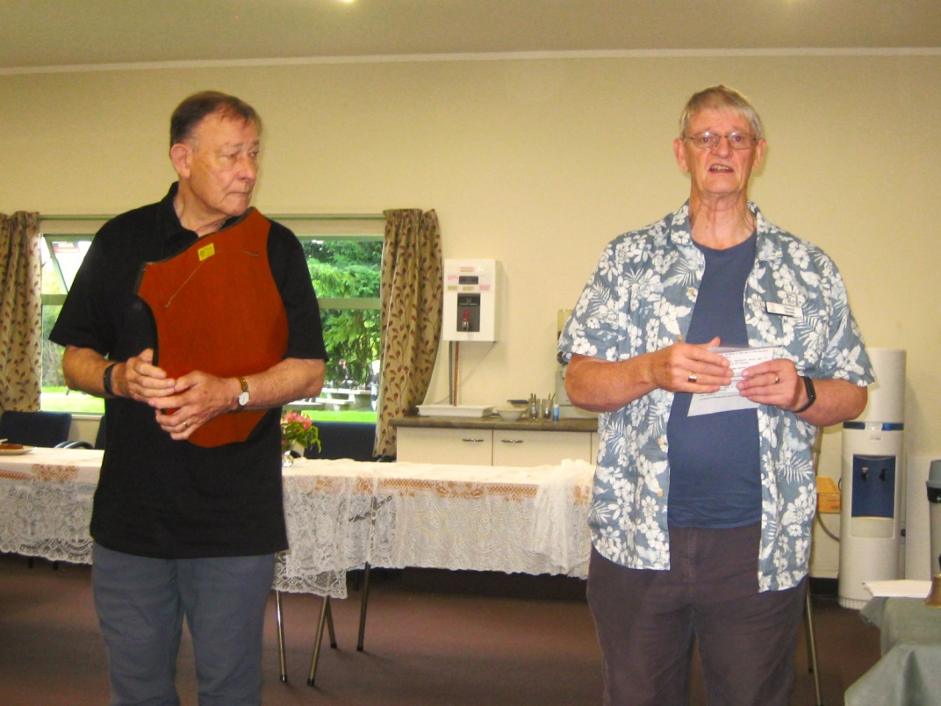
The after-match pleasantries.
Our President, Trevor Smith, explains carefully that the final result is so, so close, that there is nothing really in favour of one club or the other . . . notice how anxiously Waikanae President, Chris Farrow, listens as he clings desperately to the trophy. Then Trevor graciously offers to share the trophy, in light of the closeness of the scores . . .
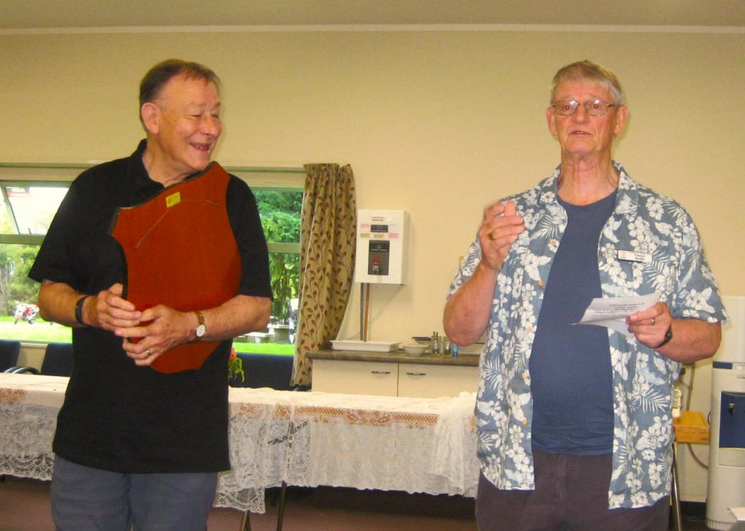
Look at that response to Trevor’s sporting suggestion. Chris is just as gracious in response to the courtesy of our President, and very gently declines his offer of sharing the shield i.e. calling it a draw. Chris just grins and clings – to the winnings.

IMPROVERS’ CLASSES
In mid-March, Richard Solomon came to the Paraparaumu Club and taught a three-session series to help us all improve our bridge bidding (and play). About thirty players signed up for the three sessions (numbers boosted a little by some from Waikanae, Otaki, and Kapi-Mana clubs).
We were lucky to get him. Richard is enthusiastic, positive, knowledgeable, yet also very reassuring. Richard has been involved in NZ Bridge administration for over 38 years, he is a Gold Grandmaster and he has represented NZ at the international level in the Open section (i.e. the top of the top). Above all, he is a superb teacher.
Topics included: Doubling (take-out doubles, negative doubles, when to penalty double); Competitive Bidding (pre-emptive v constructive bidding, combatting interference); and Slam Bidding (Roman key card Blackwood, HCP are NOT everything, and how to avoid poorly balanced slam attempts).
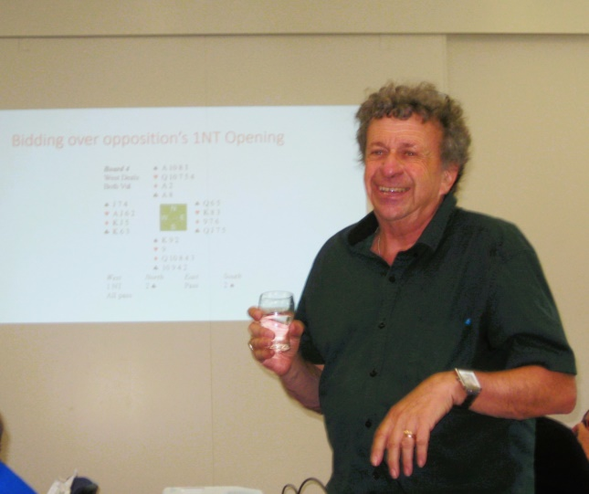
Richard in his typical teaching mode . . . and that glass is water, not gin.
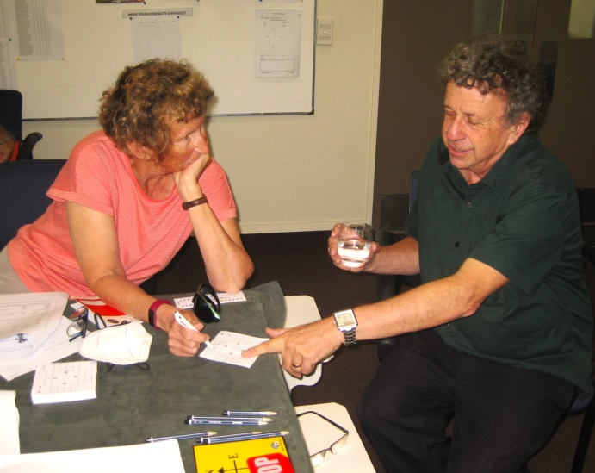
What are Jane and Richard discussing? Lightner Doubles? SOS Doubles? Snapdragons? Thrump Doubles ? (And yes, that is Thrump and NOT Trump!)

I enjoyed a chat and coffee with Richard Solomon during his time on the Kapiti Coast (and also thanks to members Tina and Will Fulton for hosting him).
His absolute best moment in over four decades of bridging? “Well, a joint effort really, with a partner . . . I’d longed to play for New Zealand for so many years, and in an Open section, rather than Seniors or Under 25s etc . . . and here I am playing against Australia at Open level, a Pan/Asian international event and I’m (we’re) out in front after two days . . . I just didn’t want that moment to end.”
And why has bridge been so very compelling for you? “It’s intellectually stimulating, you do have to think hard, don’t you? And every single hand is different, there’s always a challenge. And it’s a game that also involves people, other people, you have to encourage and even look after your partner, and your team . . .”
And the best way to build and create a bridge partnership? “Above all, you respect your partner, that’s at any level of the game . . . they might make a mistake but then don’t we all, and they are doing their best and they need to enjoy the game, just as you do.”
“Perhaps, one matter is not really done enough, with your partner you do need to look at the hands after the session is over, maybe in the next day or so, obviously not all of them but a select few of your tops and bottoms. If you never look at the hands later, you will never improve.”
I was interested that Richard and his tournament partner are both members of the same club, Te Aroha, but they have decided NOT to play together at club sessions . . . “it might be a bit intimidating, and yes, you do learn from playing with different people. In the end it’s better for your club if you do mix with others . . . I think the better players almost owe it to their club and to the game to play with various club members.”

LEARNERS’ CLASSES
The largest group of beginners for some years is well underway, Monday nights at the club. A few are repeating the bridge course, but most are very new to the game, and already enthusiastic and keenly reviewing their copious notes, under the watchful eye of their teacher, Trevor Smith and several “mentors” who give up Monday evenings to lend a hand, to the learners.
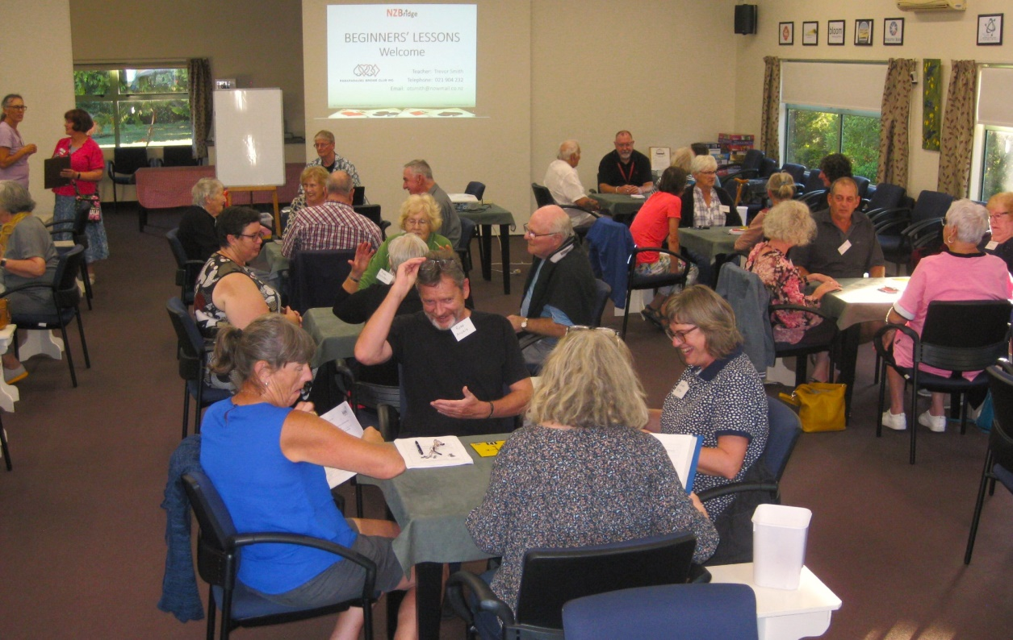
Seven and a half tables of learners at a recent Monday evening.
THANK YOU, HARRY
Those of you who know Harry Fancy, know that he always has a sweet (or two) for your table. I add that he often drives to Palmy to shop at the English/British shop so that some of you will consider these sweets are all the more desirable for being ENGLISH. Nice.
But he outdid himself at club bridge on 21 February when he liberally distributed a generous supply of chocolates and assorted sweets to the whole room. Yes, Harry “shouted” for his birthday.
His 91st birthday!!! Not bad at all. Well done, Harry and thanks for the chocs. Appreciated.
And . . . here’s Harry! Pictured here with last year’s regular partner, Johanna Thompson.
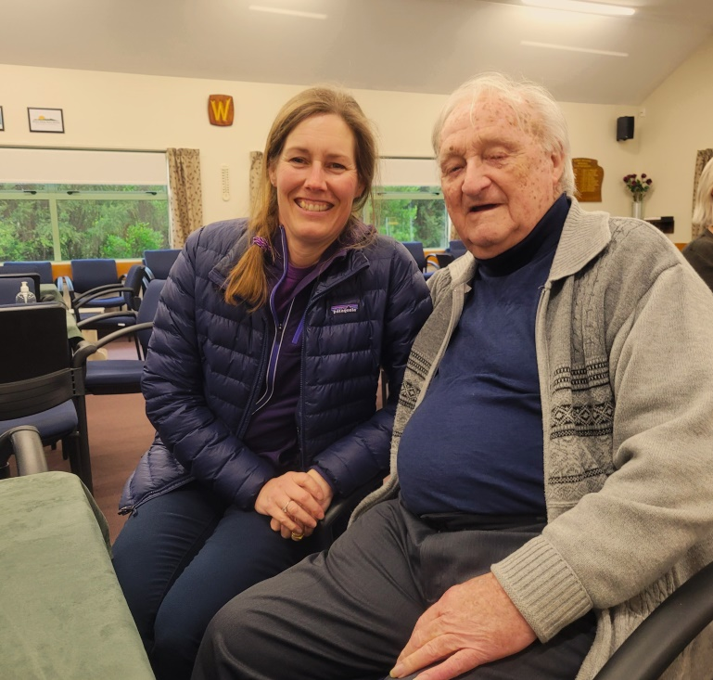

THE KAPITI RETIREMENT TRUST OPEN TOURNAMENT
You will have to be quick to get your entry in, as this runs on Sunday 26 March. It’s your own club, so please support if you possibly can. At Paraparaumu, it’s a two-session pairs tournament, morning and afternoon, with a “ploughman’s lunch” in between. Let Tournament Manager, Hugh Norton, know ASAP.
THE 70% CLUB
Surprisingly little to report here. Two months into the bridge year and only one pair on the 70% board! That is Megan Bruynel and Pauline Reid, 70.83% scored on 14 March. Well done, but there must be more to come . . .

WINTER TEAMS 2023
Note this addition to your programme book. This for all players who might like to contest in teams-of-four, one session a month during the winter six months. It’s a different and exciting form of Bridge. It will run every third Wednesday night of each month.
19 April: 17 May: 21 June: 19 July: 16 August: 20 September
Teams of Four (with 2 subs allowed over the 6 session season).
Entries on the news board at the club and/or contact Organiser Gillian Travers (04 2984554)

SAINT PATRICK’S DAY SESSION . . . ON 17 MARCH, OF COURSE.
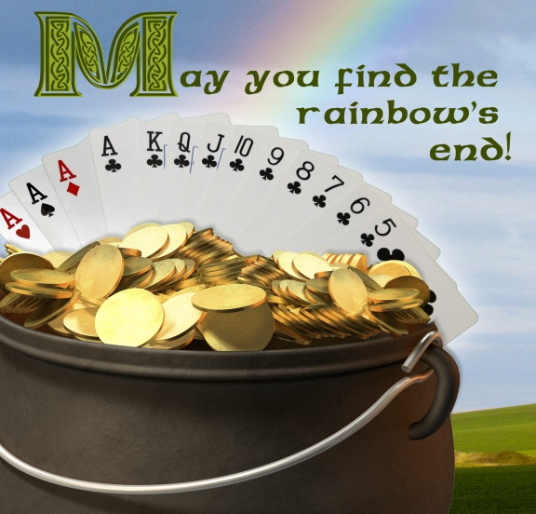
The usual Friday afternoon session was turned into an Irish-themed event to celebrate St Patrick’s Day. I’m not sure whether it was the luck of the Irish rather than skilled bidding and play that affected the results.
To be sure, to be sure, Thomas Ransom and Gillian Travers thumped the field (or should that be, trumped the field?) with 67%. Lucy O’Regan (perfect name for the 17 March, that’s to be sure) and Stu Thurston, and then Jane Bradbury and Ray Cachemaille were second and third respectively, East-West.
North-South were led in by Anne Kerr and Lottie Anderson, followed narrowly by Eliza Thomson and James Jones and then Linda Aarsen and Lyn Berry.
Thanks to Alan and Marsha Stevens for ensuring that the session was played with GREEN boards. A nice touch.

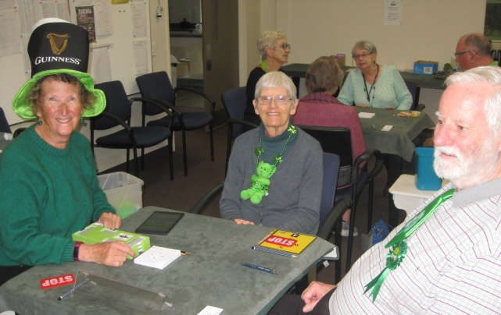
Various approaches to the Irish sense of humour? Jane in the most ridiculous hat, while the two Cachemailles are more restrained. Gillian is into the green!
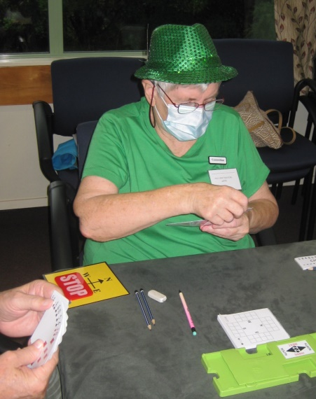
Pat is always more understated
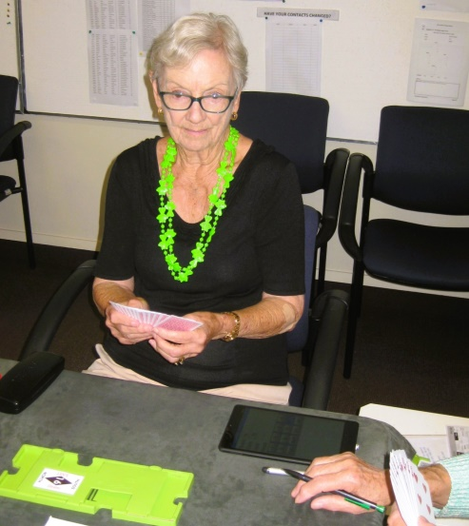
While Lyn is totally relaxed and calm … it’s “Paddy’s Day” And that is only water in that glass, isn’t it Lyn?
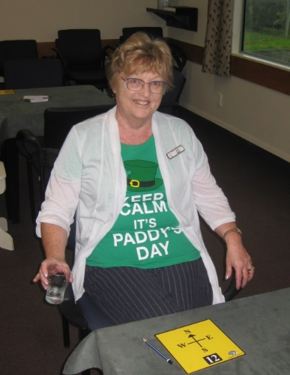
A prize for the best donning of the green – a premium (!?) bottle of wine – was awarded to Jane Bradbury. That a prize would be awarded was not pre-announced as it was hoped that members would not dress with ‘eyes on the prize’ but rather to honour dear old St Patrick himself.
I hope you all had a wee spot of the Irish at the end of the afternoon play . . . and NOT perhaps, at the beginning of play! Good sports, you deserved it.

HOW MANY NZBRIDGE AFFILIATED CLUBS ARE THERE IN AOTEAROA?
Did anyone catch the Jesse Mulligan interview with Sharleen Grounds? Sharleen had set herself the task of playing at every bridge club in NZ and thought she’d ticked that one off but immediately discovered that the list keeps growing – another two clubs have just started in greater Auckland.
She has visited and played at 108 clubs over the last three - four years.
She learned bridge in Palmerston (for you North Islanders, that’s the metropolis in East Otago and not Palmy North) but now plays bridge in Wellington. Her mission started more or less by accident when she often had to drive between Wellington and Auckland to help parents who were getting older. She had a camper van and decided to break the journey by calling in on friends and family and try the bridge club where she stopped.
Jesse asked her about her favourite clubs . . . “all the little ones around the country, all the places off the usual track, so many places where you think there won’t be a club. Tapanui was cool, a tiny place where they play at the RSA.”
(And here’s a touch, a trick, from Tapanui, there if anyone does score the magic 70% (which happens only every few weeks at Tapanui) then the partnership is required to provide the baking, some sweet things for supper at the following session). An interesting idea, no? But actually a disincentive perhaps?
Anyway, Sharleen suggested giving visiting bridge clubs a real go. “Just contact a club where you’re going, they’ll always find you a partner, it is heaps of fun.”
I wonder when Sharleen played here. Anyone know?
Nga mihi

EDITOR: KEITH LEES

