PARAPARAUMU BRIDGE CLUB NEWSLETTER DECEMBER 2022
Welcome, hello and kia ora koutou to all members with recent news from your bridge club, the last newsletter for 2022. Perhaps the most positive news I can give you is that table numbers are showing a slight but growing increase as we near the end of the year. We are still down in membership compared with previous years, and of course, some sessions have been cancelled, but any sign of a recent increase in playing numbers is worth noting.
THE KENA KENA REST HOME IN-HOUSE TOURNAMENT
This (rescheduled) tournament was held on Sunday October 30, and given the date, was accorded a Halloween theme. Generous sponsorship was provided by Kena Kena.
Goblins and ghouls, and witches and wizards filled the clubroom and players competed against a bizarre scenic backdrop of pumpkins, spiders, skeletons, and several twisted and tormented faces. (Editor’s note: perhaps even more tormented than that grimace when you end up as declarer and the dummy goes down, and it’s not what you hoped or expected . . . yes, the “thank you, partner” does sometimes emerge through gritted teeth.)
Congratulations to those who “dressed” the clubroom and congratulations to all the members who added a Halloween-inspired touch to their dress for the day.
Below, in this “composition in Halloween black” Jan Foley plans her path, while defenders Winnie Graham-Smith and Philippa Wynn are prepared to give nothing away. Jan’s partner, Jane Gilbert, does seem rather apprehensive . . .
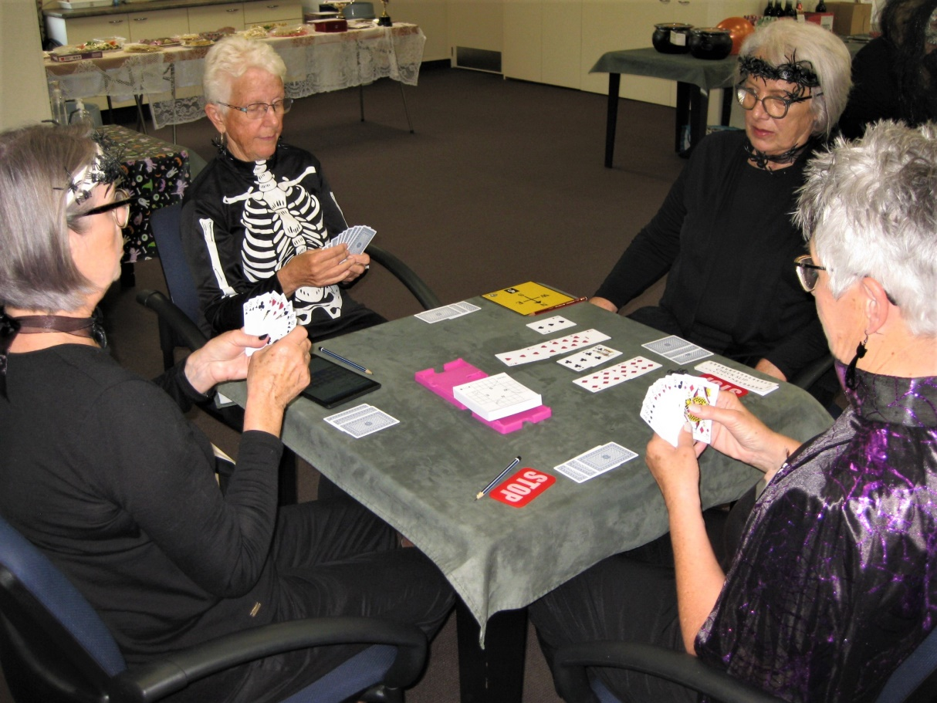
It all contributed to a scene of apparent chaos but amid all the cheerful and good-natured mayhem, nearly thirty pairs competed steadily against each other throughout the afternoon.
Linzee Inkster and James Jones, Dennis and Anne Kerr, and Alan and Marsha Stevens, all fought valiantly but in the end could not peg back the ultimate winners, the very experienced pairing of Robyn Michelson and Francie Vagg.
Another noteworthy result was achieved by Theresa Cook and Myfanwy Skuse who emerged from the C Section to reach fifth place across the entire field. A really pleasing result for them.
Not only did Kena Kena sponsor the event, Barbara Mador gave a surprise “extra”, a $100 voucher to dine at Soprano’s, for the best Halloween-themed costume. Very, very generous, Barbara!
Those in the shortlist included these examples . . . such as Trevor Smith, all grim mood and manly chest. And note the attention to detail : yes, that skull holding the “Stop” card !

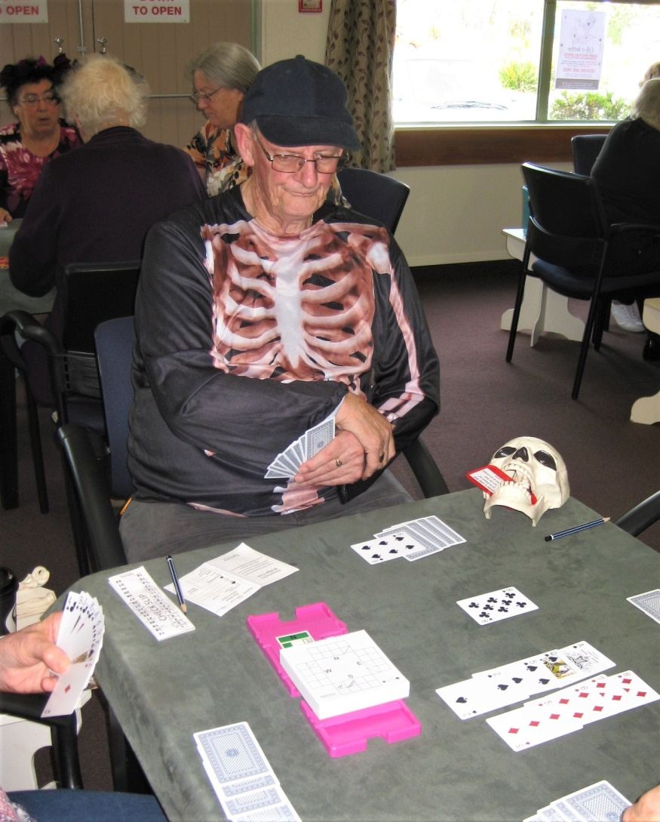

And here is yet another “study in black” with Barbara herself, resolutely defending against the declarer Jocelyn Graves . . . is Barbara giving Jocelyn the “evil eye”?
“O Mirror, Mirror, on the wall: who is the wickedest witch of all?”
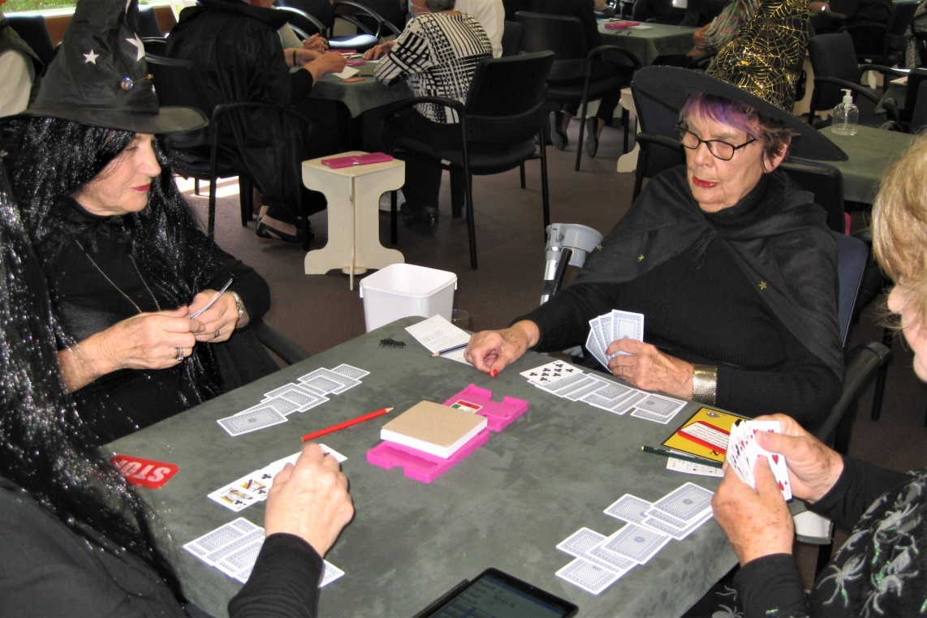
And here are Alan and Marsha Stevens accepting their prize for fourth overall, flanked by Trevor and the day’s organizer, Hugh Norton.
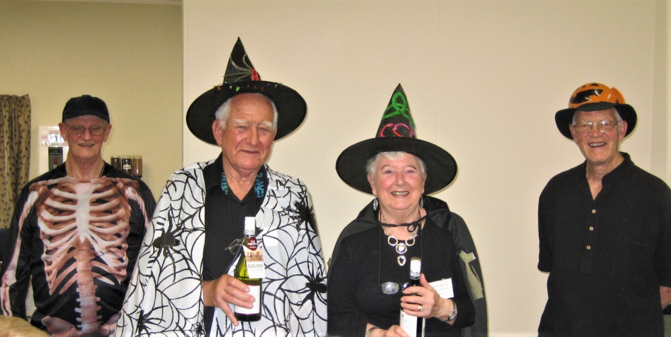

But, cue drum roll . . . the undisputed winner of Best Halloween Dressed was Gary Jenkins!!
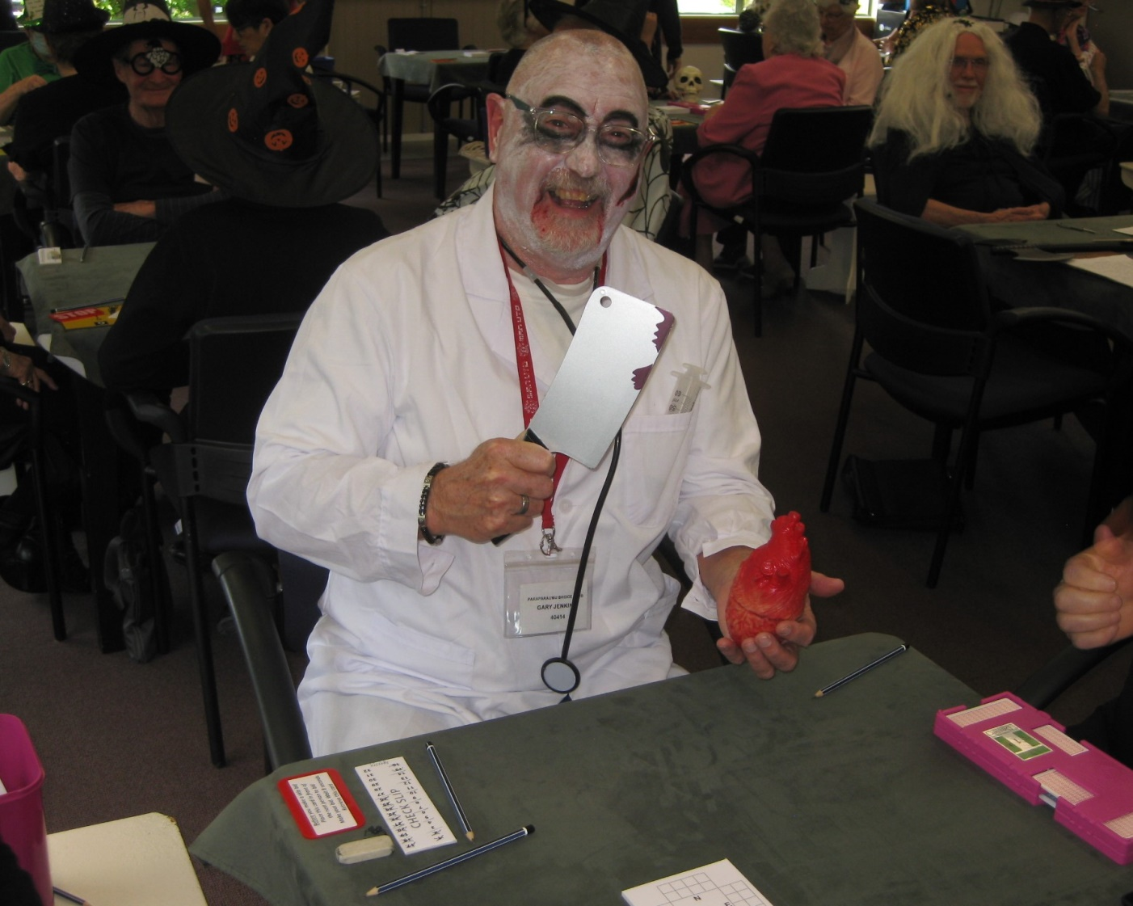
Who would want sit down at a table and bid and play against that? Total intimidation!! Great work Gary and I’m certain you enjoyed that meal at Soprano’s.
Thanks to all who made the tournament such a rollicking success and especially to Hugh and Trevor for the organization and to Brian Pender for the Directing and to Noella for her work in the kitchen.
THE HOME4ALL CHARITY TOURNAMENT
This was held at the clubrooms on Sunday 20th November, via the initiative and skilled organization from Averil Wotton. Largely through her efforts and enthusiasm and the follow through by our members, responding to Averil’s call to “come and play for charity”, nearly $1500 was raised for Home4All (13 tables).
Home4All is a non-profit Trust which has recently opened in Kapiti. It provides community-based day-care programmes for people with early-stage dementia and memory loss.
Brett and Sandra Windley were the winners, so congratulations go to them. Well done.
They were followed by a Wellington pairing, Barbara Leach and Hilary Patton, and a partnership from Otaki was third – Sheridan Evans and Claudia Duncan. (Welcome back, Claudia!)
Thanks also to Chris Farrow for his directing.
THE LOVEBLOCK NZ WIDE PAIRS (formerly the Babich Pairs)
In this unusual event clubs from all round New Zealand play the same pre-dealt boards at the same time (in this year’s event on Friday night, 11th November). A total of 56 clubs participated and there were 865 pairs.
It is a fundraiser for the NZ Bridge Foundation with sponsorship by Loveblock Wines. After the play, each player gets a booklet with comprehensive commentary on the possible bidding and play options on each hand.
14 pairs competed from our club and Dale Wills and Jane Bradbury were top East-West within the club and ranked 107th out of the 865 pairs nationwide. Gillian Travers and Dennis Lahman were top North-South and came 144th in the nation list. Significant results because the event does attract many Open class players from around the whole country.
Both of these pairs could not quite win a two-bottle pack of the sponsor’s fine product but they did each gain an A point for their skill and efforts.

TWO CLUB PRIZEWINNERS
At the recent AGM in November, awards for 2022 were made to both Johanna Thompson and Linda Aarsen. Johanna won the award for Most Promising Beginner and Linda won hers for Most Improved Player. Both awards were thoroughly deserved. Well done!

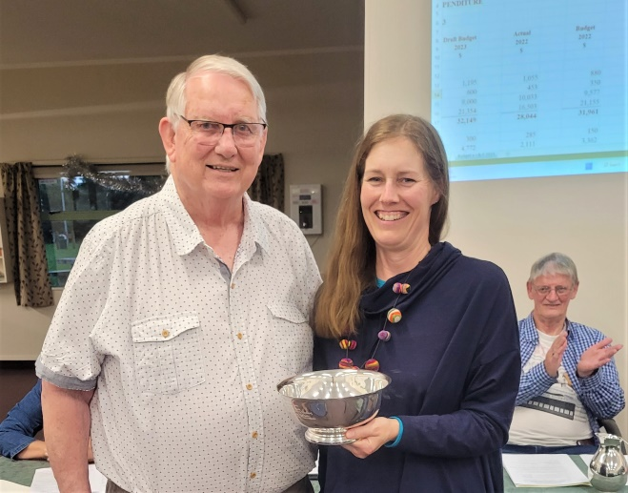 | 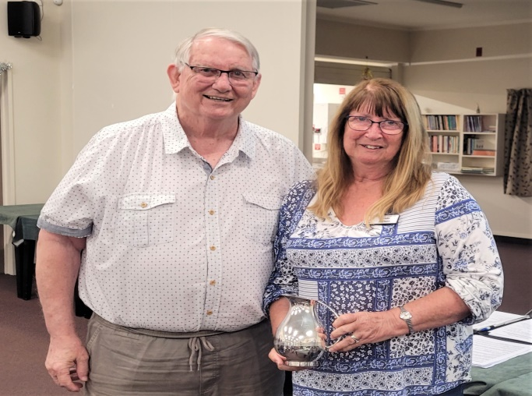
Johanna and Linda receiving their awards from David Stagg at the AGM.

THE 70% CLUB

Sixteen pairs had the pleasure of at least one spectacular session of skilled bidding and play during the year and breaking into that 70% threshold.

It will come as no surprise that Trevor Smith and Jane McArthur are right at the very top with a super score of 76.6% but it did take them some time to nudge Marg Lees and Moira Wilson down just a notch as Marg and Moira had been enjoying “top of the walk” since early May. It was even then a close thing: Marg and Moira had scored 76.2%.

Two pairs shared third place. Anne Kerr and Lottie Anderson and James Jones and Elizabeth Steinbauer were absolutely even stevens on 73.9%

THE SLAM CLUB

James Jones smashed the field. I know the number of slams bid and made does depend to some extent at least on how often you play . . . but James has accumulated 38 slams. Massive. There’s a very long way back to Ray Cachemaille with 30 and Ian Nicholls with 22.

THE FORSYTH BARR IN HOUSE CHRISTMAS PAIRS

This popular tournament provided a cheerful and fitting end to the year’s programme. The Director Marie Groves faced nearly a full clubroom with thirteen tables as she explained the movement and the intended process for the session. A clubroom with plenty of flashing earrings and necklaces and red and green tops and headgear.

Gary Jenkins has the difficult task of playing against Santa’s elves: Jocelyn and Claudia.

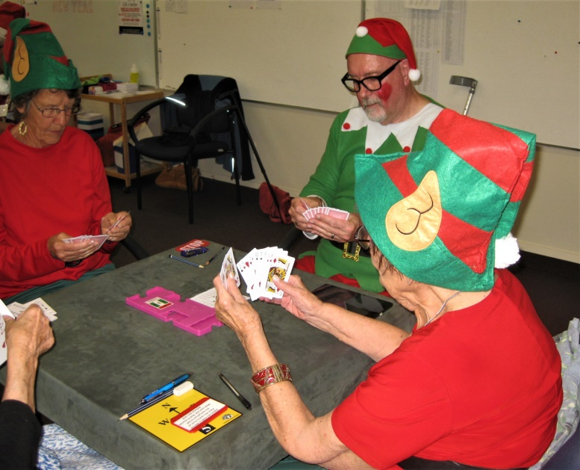

And just who is this masked man?

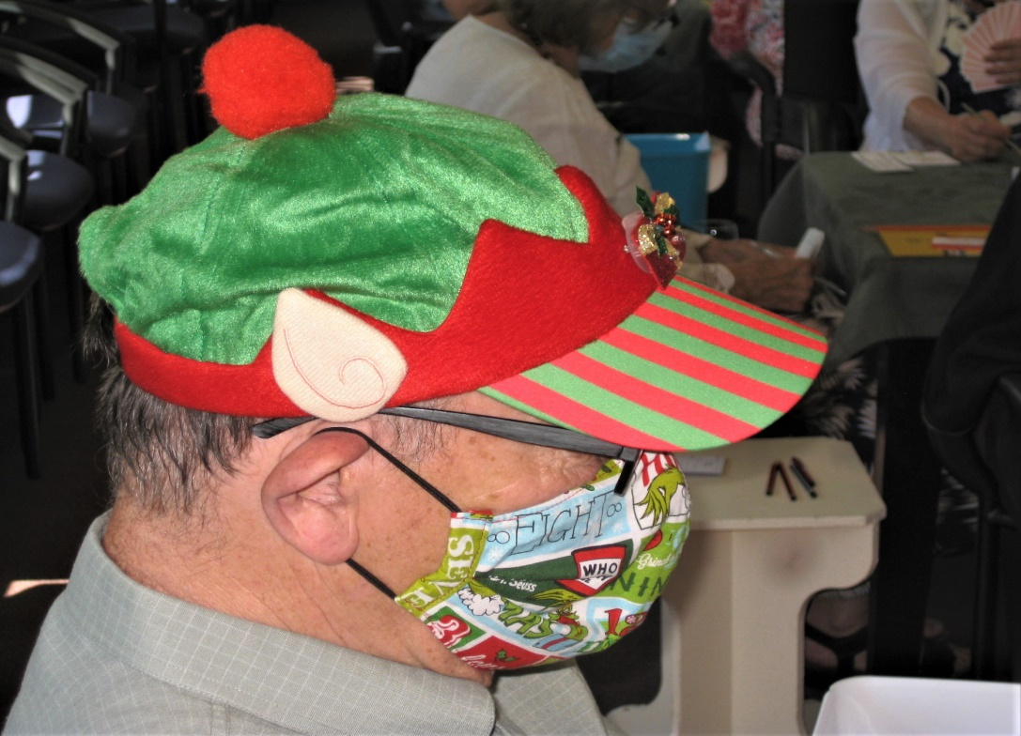

Members competed in five sections.

Lindsay Bryson and Alvaro Lacunza won Section E with some ease and they were also fifth North-South. A very pleasing and creditable result.

Section D was won by Alan and Marsha Stevens.

Section C winners were Martin Wren and Linzee Inkster and they were also second overall and top East-West. Section C runners-up were Linda Pender and Margaret Cachemaille and I’m sure they enjoyed their bragging rights over fellow competitors in the section, their respective husbands, Brian and Ray.

Section B was won by Murray Smith and Linda Evans, from Adrienne Rehioui and Narita Breingan.

And . . . drum roll, please . . . the overall top place on the day went to Lucy O’Regan and Pauline Reid. Maybe no surprise as this pair is ever present at or near the top, but their score of 65% is pretty decent at a tournament. Congratulations.

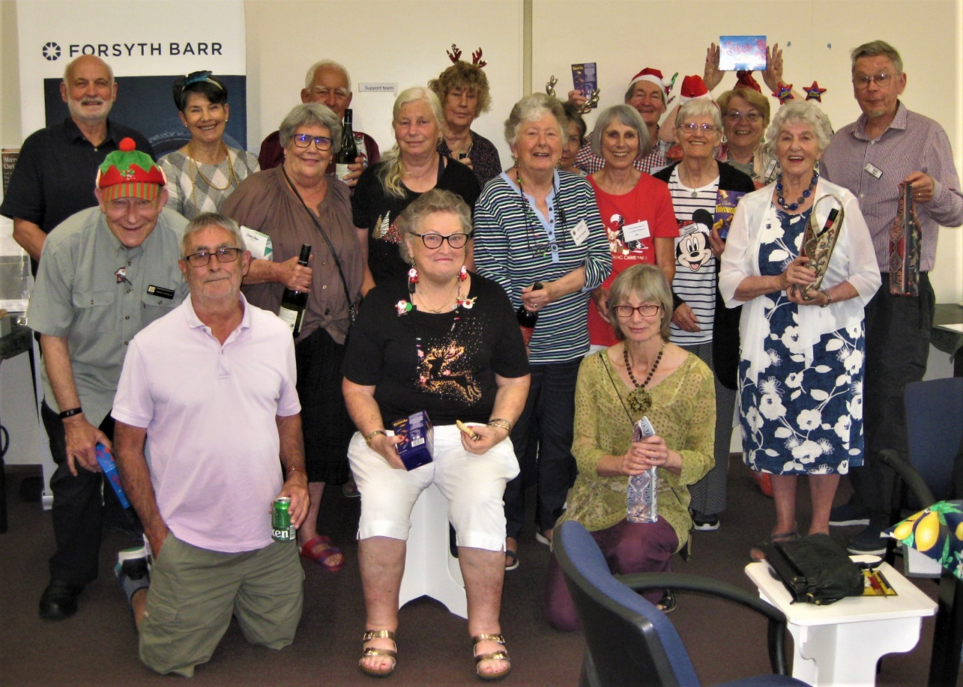

All the happy campers, all the winners on the day. Plenty of prizes for a good-looking bunch?

Some of the trophies for the various competitions throughout the bridge year were also awarded before the afternoon’s refreshments. And a new sponsor gave some of their products to some of the winners, thanks to Tuatara Brewery!
Lucy O’Regan gets a silver tray for winning the Grenfell Christmas Pairs AND gets to model the sponsor’s merchandise. Looking good for the causal summer look, Lucy!

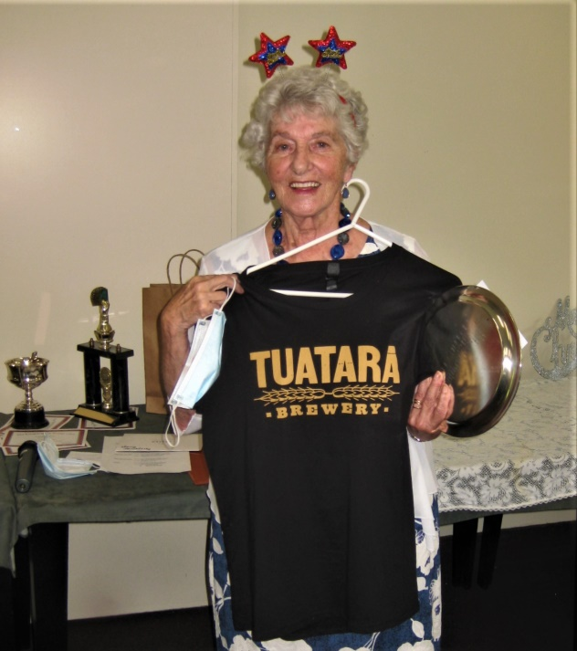
And there’s more! Anne Brunt and Lyn Boswell win the Thank You Christmas Pairs. Another silver tray but Lyn has gone for the box of beers! You’ll be Miss Popular at any summer barbecue, Lyn . . .

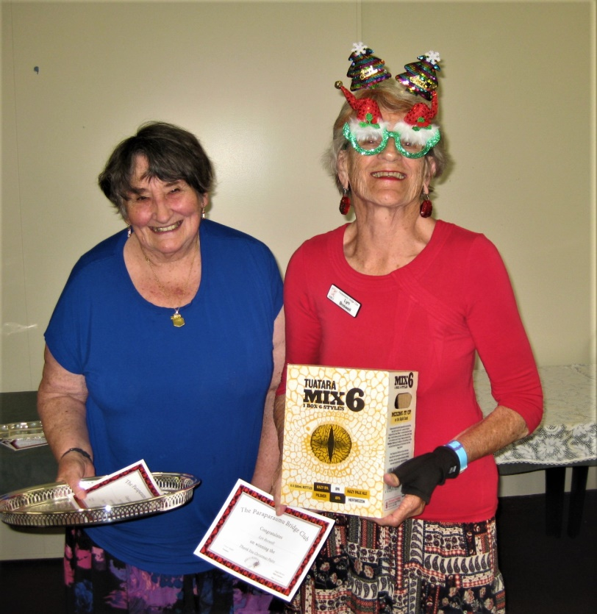

BRIDGE LESSONS

The lessons for 2023 start on Monday February 13 at 7.00pm at the clubrooms. They are Free!
Please encourage those you know (or even those you have just met) to come along. Don’t just encourage, you could cajole, nudge, persuade, lead, push . . . you get the idea. Yes, this would help our club a great deal.
Extra flyers for the lessons are available on the raffle table for you to give out.
Remember, “life is better when you play bridge” and in 2023 the lessons are FREE!
Members are also welcome to come along and learn. A chance to refresh and reset as the year’s competitions start to wind up.

BRIDGE PARTNERSHIPS

We all know that bridge is a game based on partnerships. It’s vital to play the game with real trust in your partner’s bidding and play. It’s vital to play with someone who can cope with ease and composure when the (inevitable?) misunderstanding and subsequent disaster occurs. Of course, it can be quite hard to find a partner that is that perfect fit.

Here’s someone looking for that perfect fit. A poem I found recently. Anyone you know?

IF ONLY I HAD A GOOD PARTNER (by Monica Pritchard)

I’ve always secretly relished the fact
That Bridge is a partnership game
So whenever I didn’t do so well
There was always the partner to blame.
So imagine my horror and disbelief
When a (so-called) friend made me see
That instead of me blaming my partners
My partners were all blaming me!!

I’ve looked at some really good players
And they’re not much better than me
But the reason they win when I never do
Is painfully easy to see.
They all have a really good partner
While I’ve got the partners from hell
And I know if I had a good partner
I would be winning as well.

My partners complain I’m erratic
And say that my bidding is crook
They say that I hog all the contracts
Then play like a psychotic chook.

Now I know it occasionally happens
That I do open when I’m a bit light
But when partner sees I support with just 2 or 3
There’s no need to be impolite!
Why should we always be docile
And always conform to the rules?
I tell my partners they’re spineless
They’re timid, incompetent fools.

I bid and I play by instinct
I like to perform with some flair
I won’t stick to a rigid system
That thousands of others might share
I’m idiosyncratic
My bidding and play must be free
So why can’t I find a good partner?
A partner who’ll just let me be me.

Now, strangely enough, my partnerships
Never last very long,
And when they break up it seems
I am the one in the wrong!

So if you’re a really good player
And your partner is not very hot,
Why don’t you get in touch with me,
And we could give it a shot . . . ?

Finally, have a lovely Christmas. It’s been a year of slow, slow, recovery from Covid and Covid lockdowns. A big ups to our committee who tried to keep the programme going despite a drop off in numbers. The committee have worked hard for our club. And thanks to all the directors. It’s a rather thankless task but you make it possible for so many of us to enjoy our bridge.

Have a great break and come back recharged.

All the very best for Christmas, for the New Year and right into 2023. (Bridge restarts the week of Jan 9 with open sessions throughout that week.)

“Merry Christmas to all – and to all a good night!”

Nga mihi

EDITOR: KEITH LEES

