PARAPARAUMU BRIDGE CLUB NEWSLETTER OCTOBER 2022
Hello everyone and kia ora koutou
Another in this series of occasional newsletters. Yes, it has been a long time since the last (too long?) but, in my defence, there have been so many postponed or cancelled tournaments, both at our club and in the wider region, that there has been little in the way of tournament results and consequent successes to highlight. All clubs seem to still be having difficulty in attracting sufficient entries and our club is no different.
One Paraparaumu Club tournament did take place back on June 26, though with a slim field on only 8 tables : the LAW CONNECTION SPONSORED PAIRS.
(By the way, members should note that our sponsors for this event do offer some free 30 minutes consultations (conditions apply). You should refer to their page in your programme booklets.)
Jean Crafts and Robyn Michelson were the tournament winners with a very satisfactory score of 61%.
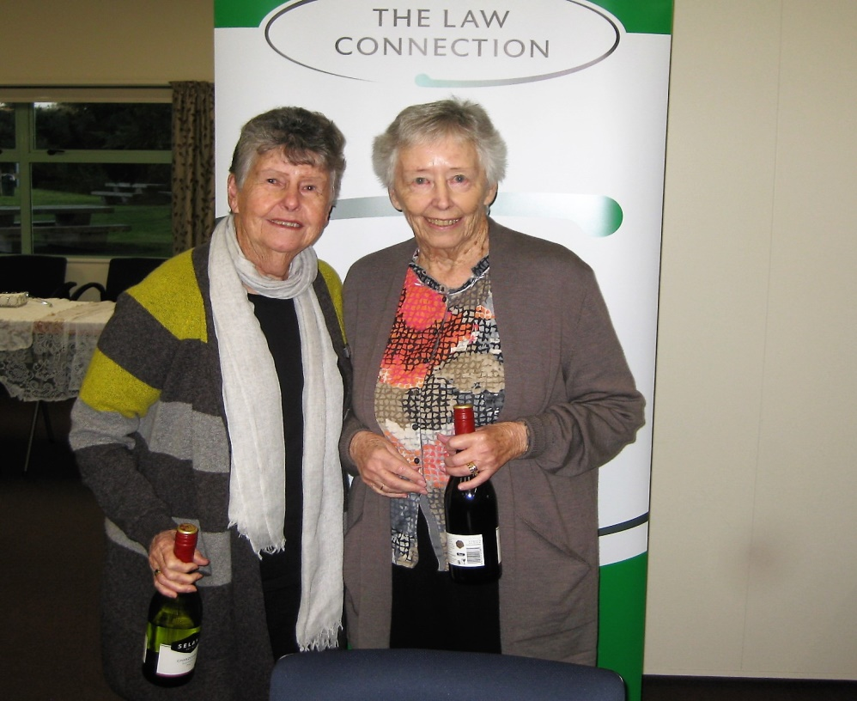

Here are Jean and Robyn. Wine and winners = a very satisfactory afternoon’s bridge!
Dennis Lahman and Pat McArthur were second (59%) and Linda Pender and Marg Cachemaille were third (54%).
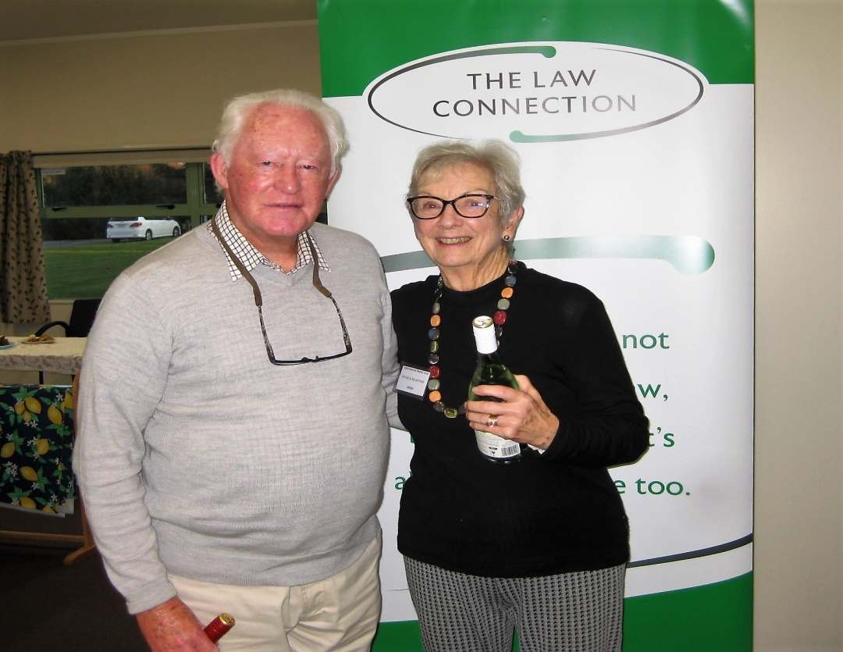
Second place on the dais = two silver foxes?

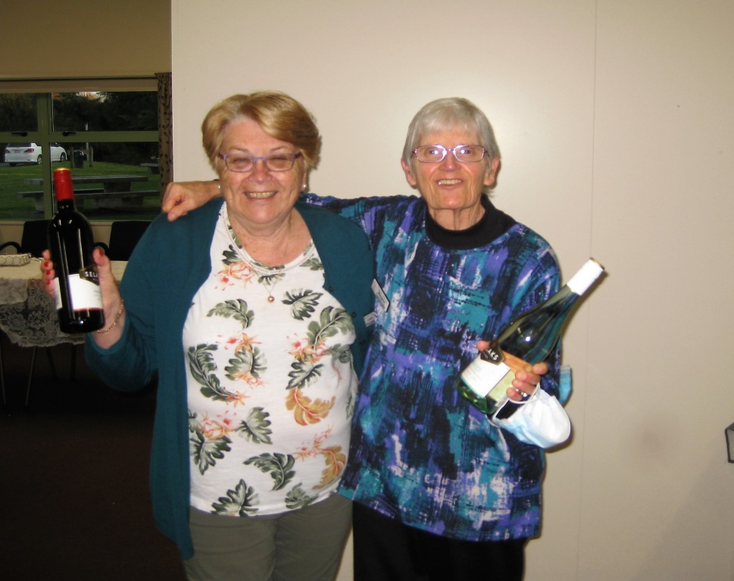
Don’t they look well pleased? Does Linda really imagine she has won a bottle of Burgundy Grand Cru?
Eventually, as members will know, government-mandated mask restrictions were lifted in mid-September and many clubs (ours included) quickly shifted to making “masking up” optional.
Almost in relief and celebration, your club organized and ran an “Impromptu” one session tournament on 18 September. This was almost entirely an in-house session, though there were a few pairs from our nearest neighbours, Waikanae.

IMPROMPTU TOURNAMENT
It was a pleasure to once again see our clubrooms full (well, nearly full) and there was a very cheerful atmosphere apparent – it was as if the chokehold required to fight against Covid infections had been suddenly released.

56 competitors meant 28 pairs and 14 tables and a rush of energy and anticipation . . . for a moment the room looked as it would have done pre-Covid!
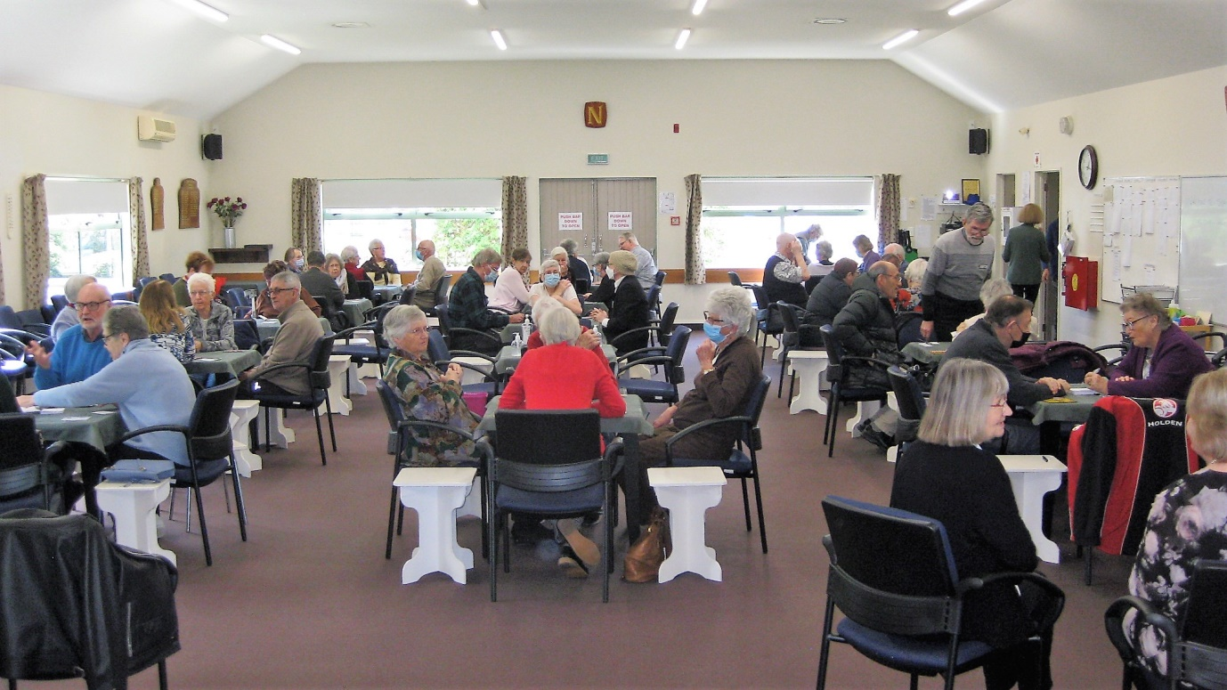

Masks now optional wear and a real buzz of anticipation . . .

Thanks are due to Hugh for the organization of this event, to Ray as barkeeper, to the two Tinas for the kitchen, to Marie for efficient and cheerful directing.
There were shared winners of the event. At the end, Ann and her partner Dennis Kerr, could not be separated from another pairing, Pauline Reid and Lucy O’Regan, with both pairs achieving 62.77% exactly. Well done all four of you! (All from Section A)
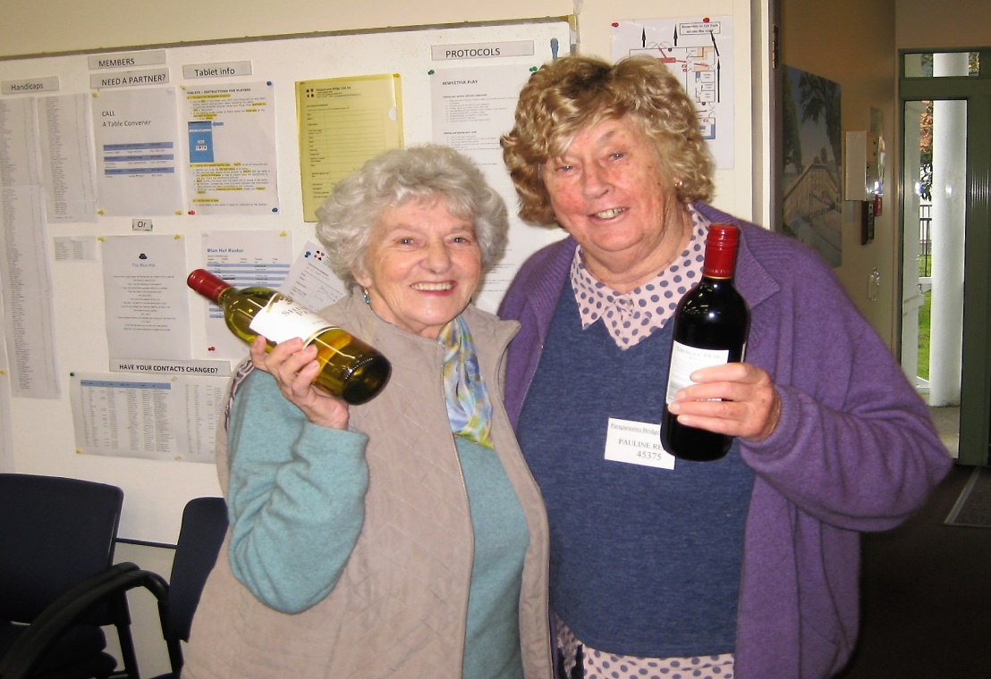

Pauline and Lucy look absolutely delighted with their solid result in a tight finish. (Apologies to Ann and Dennis for not nailing your photograph.)

Jocelyn Graves and Fay Manley were the winners of Section B and Lottie Anderson and Val Coe won Section C (and Lottie and Val were also 5th overall.)

Below, a delighted Val Coe is waving, even brandishing, twice the winnings of anyone else, but wait up, Val, one of those actually belongs to your partner . . .
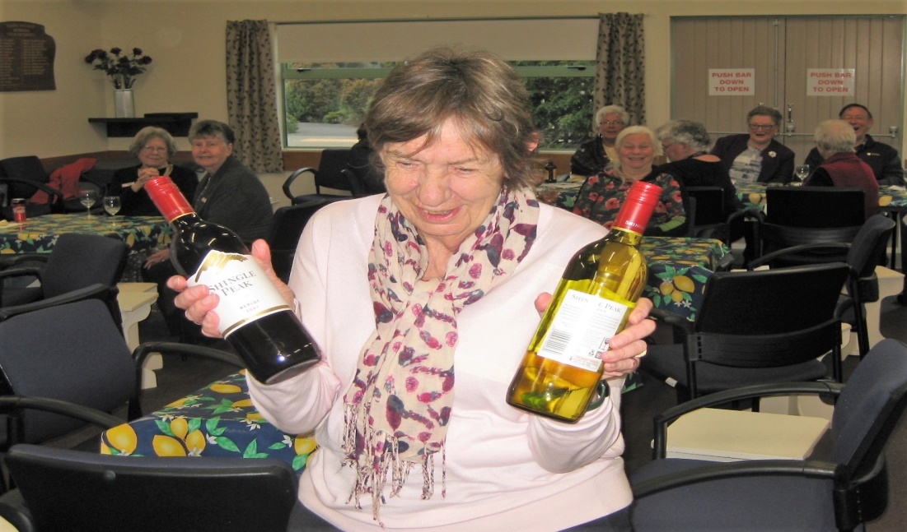

UPCOMING LOCAL TOURNAMENTS SCHEDULED IN THE NEXT FEW WEEKS.
The Kapi Mana Intermediate Pairs on 16 October, the Waikanae Junior and Intermediate Pairs (6 November) and the Kapi Mana Intermediate/Junior Multigrade (13 November). Note: the Kairangi Open set for 21-23 October has already been cancelled.
And above all, our own Kena Kena Rest Home In-House Tournament which will take place at our clubrooms on Sunday October 30.
This tournament will have a Halloween Theme – so dust off your witch’s outfits and rattle those skeletons in the cupboards and come along dressed as your favourite Halloween character. There’ll be a prize for “best dressed”.
Get an entry in and enjoy a pleasant day’s bridge while supporting your own club.
THE 70% HONOURS BOARD
As of late September, 15 pairs have reached the heady heights of scoring more than 70% in one club session. And the names of 25 different players feature on that list. Right at the very top are Marg Lees and Moira Wilson on 76.2% which must be hard to beat. Judy MacManus and Jane Bradbury are close behind on 75.9%, followed by Francie Vagg and Jean Crafts, and then Lottie Anderson and Anne Kerr.
THE SLAM CLUB
It’s a tight tussle at the top with James Jones (21 slams) being nudged by Ray Cachemaille (20). Then there’s a gap back to the chasers who will find it hard to make up the ground at this stage of the year . . . Ian Nicholls (15) and Jean Crafts/Trevor Smith/ Dennis Lahman (all on 14). What is worthy of note is that 40 members are now on this year’s slam club list, with at least 6 slams bid and made to qualify.
JACKWAYS SHIELD
A Sunday afternoon in spring . . . 12 pairs from Paraparaumu enjoyed a pleasant drive to the Kapi Mana Club at Tawa, then a pleasant afternoon’s bridge. But to the chagrin of our Manager/Selector/Coach, the team did not enjoy a pleasant result. Jane remains desolate at yet another interclub loss. No fault of hers.
The score? Let’s not bother with such mere trifling details. I’d rather concentrate on Kapi Mana’s warm welcome and the sumptuous tea. To be fair, Tina Connell-Pine and Trevor Smith, and Jane Bradbury and Linda Evans tried hard, stayed in the fight, scored well. But frankly, for the rest of us, “room to improve”.
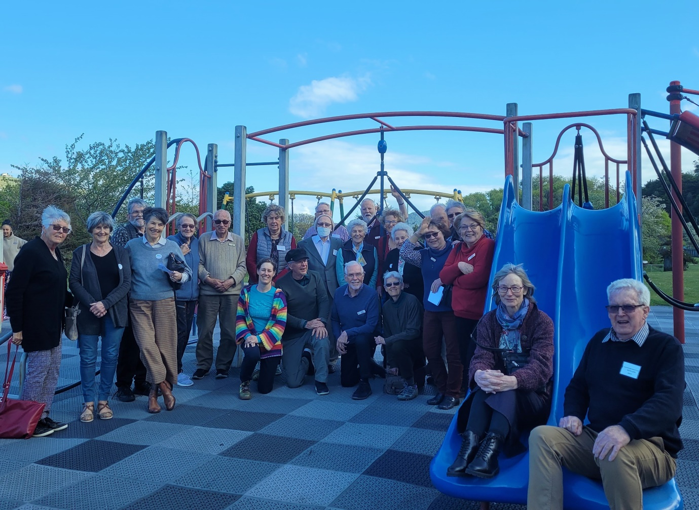
Team Paraparaumu, all cheerful despite the loss. Taken in the playground adjoining the Kapi Mana clubrooms. The other team were inside clustering around the Jackways Shield.

AN INSPIRATIONAL STORY, FROM FURTHER AFIELD
Recently I came across this article (it’s on the Australian Broadcasting Corporation website). Someone who is giving up club bridge after becoming a tad dissatisfied with having to “mask up” and with the club closing operations for several months due to Covid . . . doesn’t that sound like a familiar story?

But then I read on, and in mounting admiration. Joan has indeed decided to give her beloved bridge away . . . but at the age of a mere 106!!! You can read on here and wonder.

A Melbourne centenarian retires from bridge after eight decades of competition
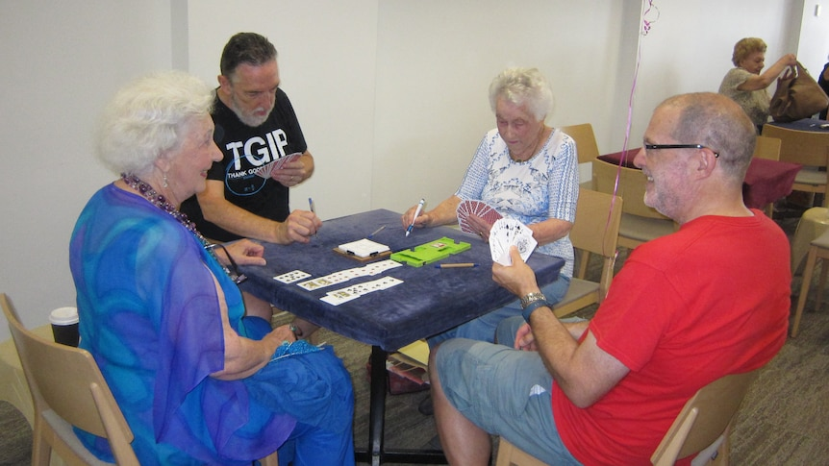
Ann Perrott, Steve Curtis, Joan Smurthwaite (106 year-old Declarer) and Henry Josling playing at the Melbourne Bridge Club.
Bridge is losing one of its oldest, longest — and fiercest — competitors.
The player is 106-year-old Joan Smurthwaite from Melbourne, officially retiring eight decades after learning how to play the great game.
The centenarian has been playing twice a week at the Melbourne Bridge Club for about 30 years but has now decided to lay down her cards.
"Lately, life has become more challenging for me and I am finding it hard to get around, and although the spirit is willing, the flesh is weak."

Competition -- and friendships
Joan says bridge had always been a big part of her life. "You do need your brain to be working well. There are so many conventions and rules with bridge.”
Learning in her 20s, she developed her skills by reading books about the game and having "good playing partners".
But what has kept her coming back is the competitive nature of the game, and the great friendships fostered along the way. “You do make great friends through bridge, but as time goes on, well yes, you do start to lose them too.”
While she enjoyed her decades playing, the COVID pandemic and closure of the club diminished her desire to compete. "When the bridge club closed for nearly two years, I seemed to have lost interest," she said.
While she is insistent that she is "not a very good player", Melbourne Bridge Club director Ian Mansell said she and her partners often won.
"Joan was a very friendly and cheerful player," he said. "But not only that, she was a good player ... you had to rise to the challenge."
Joan Smurthwaite is adamant she will not play another game again, even privately.
"There's not a lot in private bridge playing. Bridge really suits a club environment because it's very competitive," she said.
A voracious reader, she's also looking forward to having more time to tuck into a novel. "I've got no problem filling in my day. When the sun is shining, and I'm looking out at my garden with a good book, that's about as close to heaven as you can get.”
What an amazing spirit and what an amazing woman. I like to think there’s hope for a few of us yet. And at the same time, a respectful and admiring salute to our own more senior members who keep playing at the club, even when it’s not always easy to get out to a club session.
(I was also interested in what the Director/Manager of Joan’s club had to say about their membership numbers. “We’ll survive but we’ve gone from 420 plus in the pre-Covid days to about 250 now, a big drop, and we’re facing having to build our club up all over again.”)

Finally, how often have you been asked about your enjoyment of the game of bridge and then the inquirer has asked how close it is to five hundred?

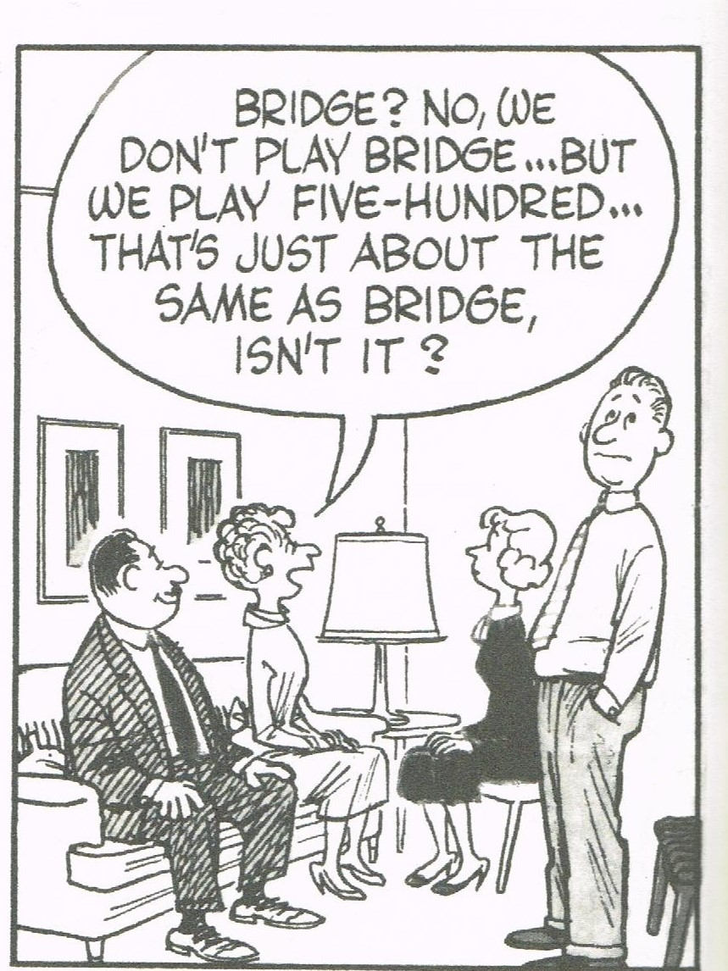

Enough for now. Kia ora and kia kaha everyone.
EDITOR : KEITH LEES

