PARAPARAUMU BRIDGE CLUB MAY NEWSLETTER

Welcome to another of these occasional newsletters and nga mihi to all our members.
THE INTERMEDIATE TOURNAMENT : SPONSORED BY BLOOM HEARING
This two session tournament was played on Sunday 15th May. Ten tables, which was a tad down on some pre-Covid contests but still a respectable number of players. Entrants came from the Hutt Valley, Levin, Kapi Mana, Waikanae and of course mostly from our own club.
Narita Breingan and James Jones were in good form in the morning session and led at lunch with a score of 58% along with the Waikanae pair of Anne Wolf and Ann Verboeket, while the Paraparaumu pairings of Lynda Evans and Averil Wotton, and Lucy O’Regan and Pauline Reid, were not far behind on 56%.
Our own Jean Crafts and Francie Vagg well and truly made up for their disappointing morning start by leaping to the top of the field in the afternoon session. They scored a remarkable 67.7% in the afternoon, which was impressive but not quite enough to peg back the Waikanae pairing.
So, in the end, Anne Wolf and Ann Verboeket from our closest rival, the Waikanae Bridge Club, were the deserving winners ahead of Jean and Francie. Charlie Villain and Jane Godfrey from Upper Hutt were third. Lucy and Pauline played steadily but couldn’t quite edge into third place.
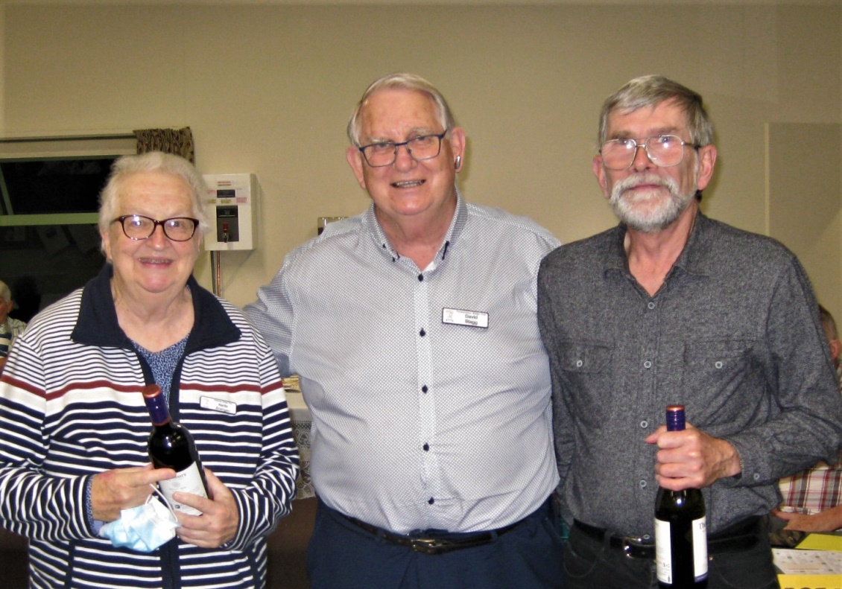
Narita and James clutching their wine for winning the first session.
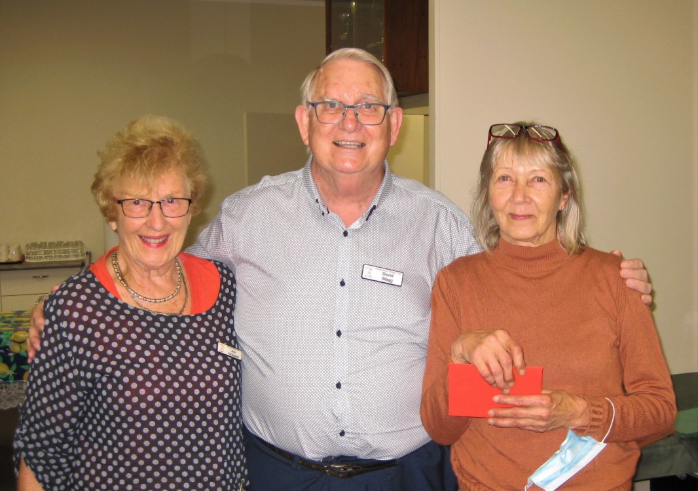
Here, David Stagg congratulates the overall winners from Waikanae. Well done to the two of you!

And here, is David with our best pair on the day . . . Jean and Francie !! A better start in the morning would have seen them romp home after accurate bidding and play of the cards once they warmed up.
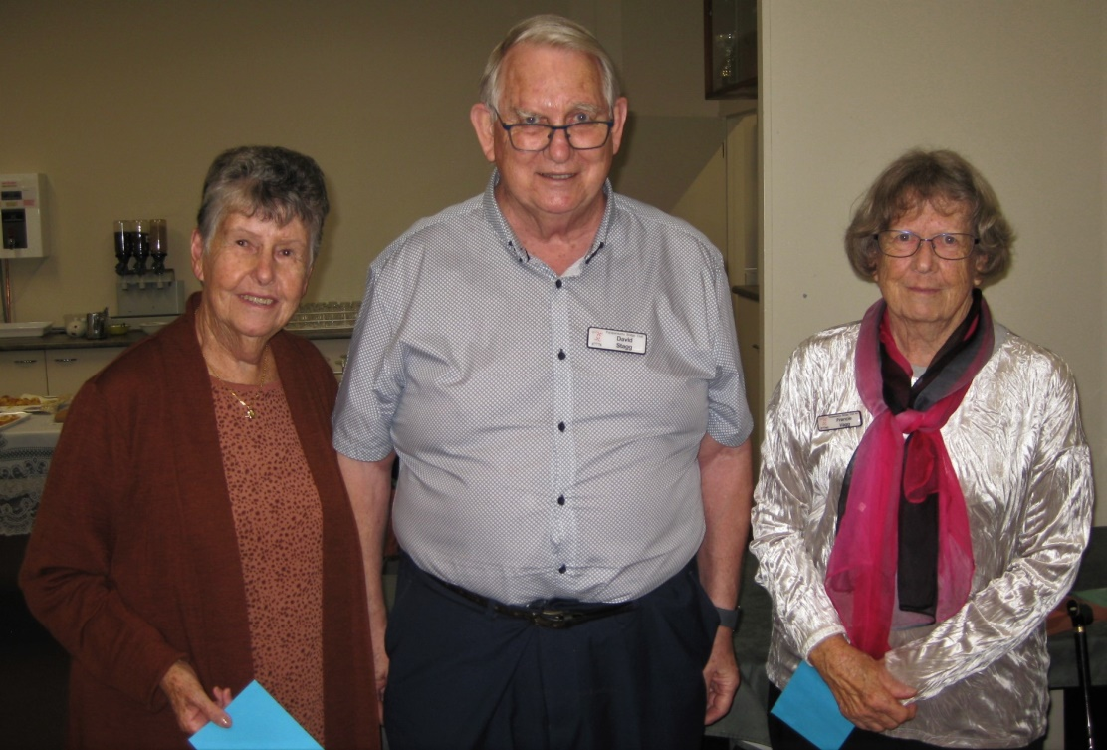
These tournaments do provide more of a test, a bit more “edge” than the regular club sessions.
They are also very useful for their contribution to club funds! Not a large tournament for Paraparaumu but nevertheless over $550.00 was raised (helped by Bloom Hearing Sponsorship).
All our thanks must go to the various volunteers, especially Tournament Manager Trevor Smith. I won’t mention all of you but Noella and Tina once again provided a thoroughly enjoyable lunch and then nibbles at the end of the day, Ken Thomas organized the raffles, Jane McArthur and Helen did the scoring, and Ray and David were the barmen.
By the way, a closer look at just one very interesting board from the day.
Even when you’re bidding and playing well, you can still suffer sheer disaster! Here, David Stagg and Hugh Norton are sitting North-South playing against . . . well, just let’s say playing against one of the very top pairs on the day. And the Dealer is East, both sides are vulnerable. So, have a guess at the final contract. What do you think? Note that South has 21 points and North has only 3 points. Yes, 3 No Trumps is VERY unlikely, especially with such flat North/South hands and no suit to run. In fact, North/South do not have a makeable game contract, despite South’s 21 point opening bid.
And note East’s singleton diamond. Would you now like another guess at the final contract?
North
K96
765
982
9852
West 5
K9 East QJT82
J7653 QJ832
KJT63 Q
74
South
A743
AT4
AKT4
AQ
Yes, the reference to East’s singleton diamond was indeed a clue. The final contract was 4 Diamonds x by East/ West with East having to play the contract. East/West somehow had a complete breakdown in bidding commmunication and ended up in 4DX! And how did East come to be the first of the pair to write D on the bidding pad ? Who knows ? But David and Hugh accepted the gift (especially with no prospect of making a game bonus), promptly doubled 4D, and ran all the way to the bank with buckets and buckets of points. 4Dx went a mere 6 light (vulnerable) giving our pair just 1700 and a top, top, top board. But then the final results tell us that East/West must have quickly reverted to their accurate bidding and play. They just put the disaster behind them, kept calm and carried on. Another bridge lesson right there.

UPCOMING TOURNAMENTS
The next important club tournament will be the Kapiti Coast Funeral Home Junior Pairs on Sunday 17 July. Discuss making an entry with your favourite partner and lock in that date.
Other regional events of note in the enxt few weeks are the Levin Intermediate and Junior Pairs on 12 June, the Kapi Mana Open Pairs on 19 June, and the Kairangi Multigrade Teams Event on 3 July.

SLAM MAKERS
The numbers of slams bid and made are starting to creep up . . . still early days of course, but at present Ray Cachemaille is heading the list of notables with ten scored. One question : where is the perennial favourite (and winner for the last 3 years) Jane Bradbury ? Always a surprise if Jane is not right up there. C’mon Jane.

70% CLUB
Two high scores in May have seen the positions change at the top. Anne Kerr and Lottie Anderson swept into first place with 73.9% in mid-May but then were just as swiftly knocked back into second by Marg Lees and Moira Wilson who smashed the Thursday night session with a remarkable 76.2 %. So Moira and Marg hold the bragging rights for the moment . . . (Editor’s note: It’s been suggested that I’ll have to up my game if I want to keep playing with Marg. Bragging rights are all very well, but do I have to hear them at home?)

CLUB VENTILATION
We do want you to stay warm at the club as we enter the winter period, and the heating will be on, but at the same time, one way of fighting Covid is to keep the ventilation going and keep clean air circulating. Indeed, some of the experts suggest that in places such as schools or meetings with reasonable numbers, good ventilation is even more useful than mask-wearing.
So, yes, heating will be on but we want to keep turning the air over as well. It might pay to dress just a bit warmer over the next weeks?
BEGINNERS CLASSES
Despite various Covid interruptions affecting attendances, this year’s class marches steadily on.
The group is 11-12 strong, meets on Monday nights at the club, and the lessons have reached beyond the half way stage. A team of volunteer mentors has proven invaluable as they generally play a few hands with the beginners to reinforce uwhat they have been learning each night.
Trevor Smith has been maintaining a positive and upbeat tone as he teaches some of bidding intricacies. (Another Editor’s note : Trevor has devoted hours and hours to the welfare and development our club throughout the last year, through his key roles as Club Director, Tournament Manager, and now Teacher of the Beginners Class. He deserves our acknowledgement and thanks for all that (ongoing) work.)
Here’s a recent pic of some of the class of ‘22’, grouped around Guru Trevor and still smiling after nearly two hours of a lesson on “takeout doubles”. Whoever knew there were so many ramifications after a “takeout double” ?

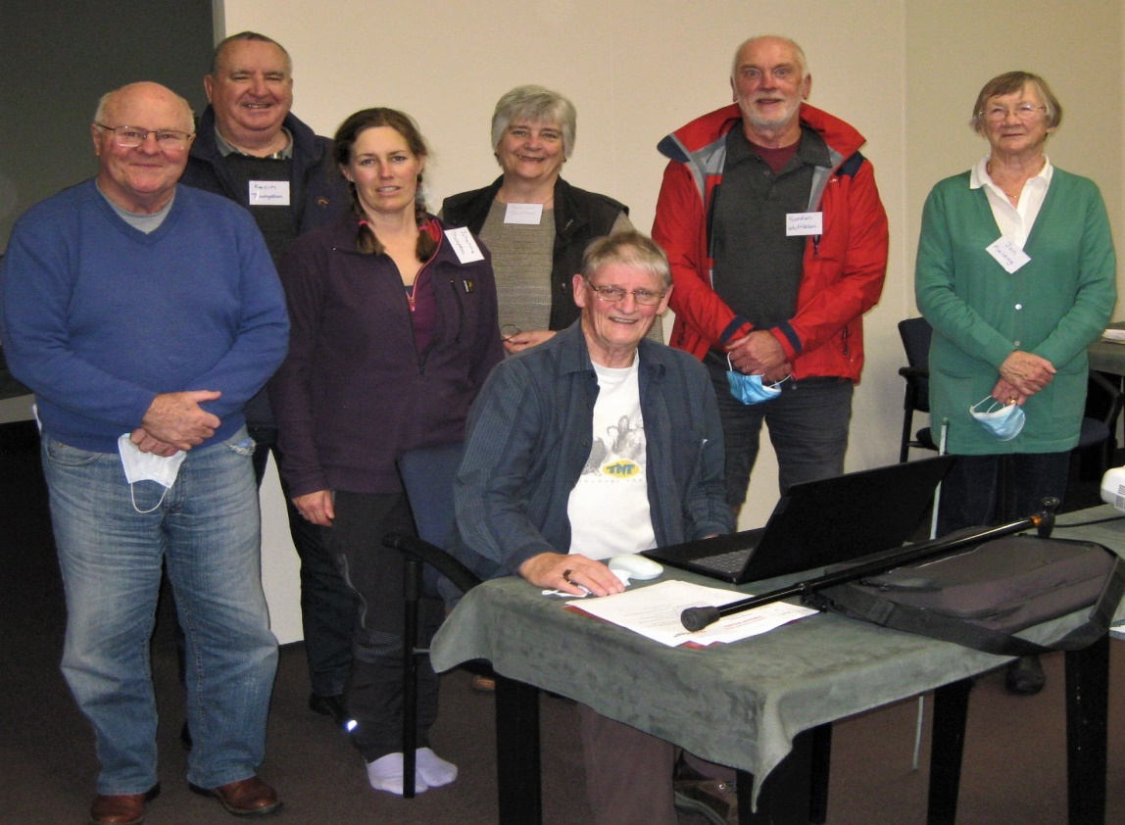

“Graduates” from these Monday night classes will be coming to play on regular club sessions, after the next few weeks. Please welcome them and look after them. Our numbers are down on the previous years and new members are like gold.

PARAPARAUMU V WAIKANAE
Spare a best wishes thought for the Paraparaumu Club team playing against Waikanae this Sunday (29th). Waikanae have won this contest for the last 2-3 years and our team captain and organiser, Jane Bradbury, is getting just a little bit irritated by our lack of recent wins. Jane is DETERMINED to win this 2022 encounter. Good bridging to the good guys ie Paraparaumu!

Finally, Charles Schultz who created the cartoon series “Peanuts”, was himself a particularly keen bridge player. He incorporated the game of bridge into that Peanuts series on several occasions. Schultz’s wry awareness of how bridge gets a hold on you is reflected in his drawing below. However, it is not from a comic strip but a one-off, perhaps from a single frame cartoon series entitled . . . “It’s only a game!”
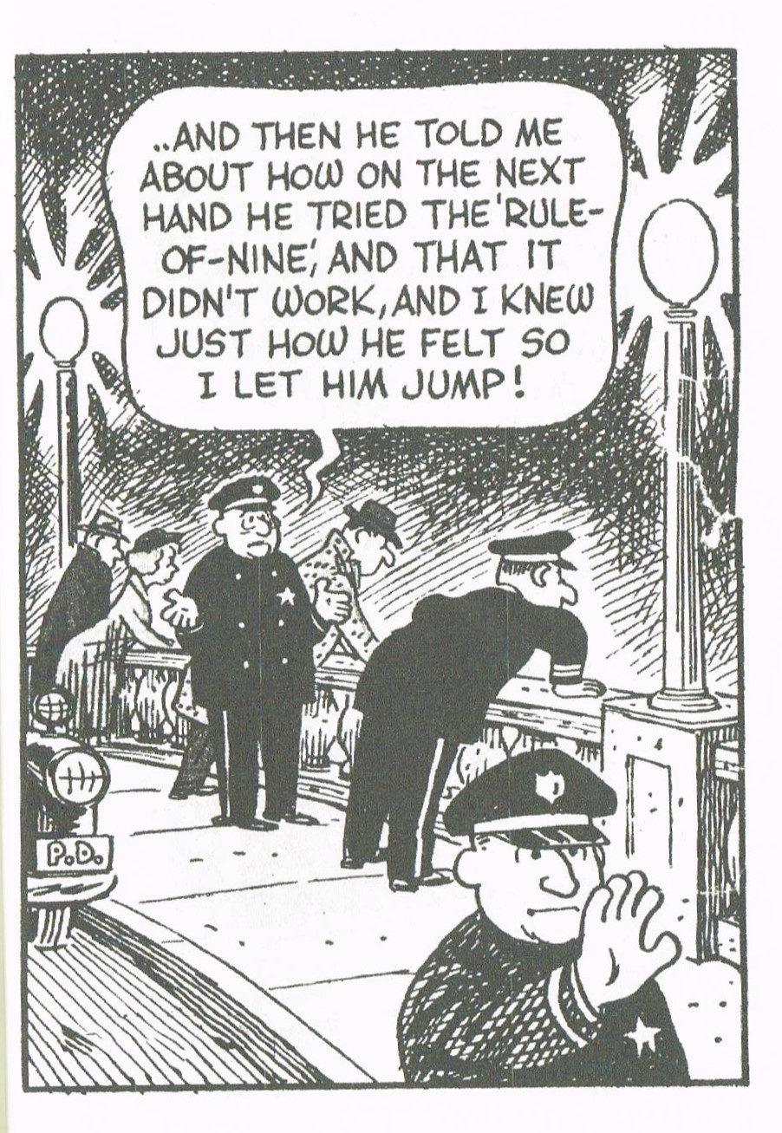
EDITOR : KEITH LEES

