PARAPARAUMU BRIDGE CLUB MARCH 2022 NEWSLETTER

Welcome to another year’s bridge and kia ora koutou.
A short newsletter as there is not a great deal to report! Overall, there is no doubt that playing numbers are down on previous years – with some members opting to stay at home until (one hopes!) the Covid/Omicron crisis passes. There is also no doubt that some find the wearing of masks during club play an irritant, and that method of reducing the risk of catching/transmitting Covid, along with forgoing the usual break for a cuppa halfway through the session, means that club bridge is just not quite as pleasant as it used to be.
Ah, how we sometimes yearn for the-way- things-used-to-be . . .
A reminder: an important reminder. Yes, the club is open for play, but, please do not come if you are not feeling well and /or have a cold or flu symptoms . . . just stay home, recuperate and then return when you have recovered and have a negative test result.

THE KNYSNA RESTAURANT AND BAR SPONSORED PAIRS
This “in house” tournament was our first tournament for the year, a one session contest held on Sunday 27 February. A smallish field of ten tables, but neatly divided into four sections with five pairs in each, by Manager/Director Trevor Smith. And plenty of prizes!!
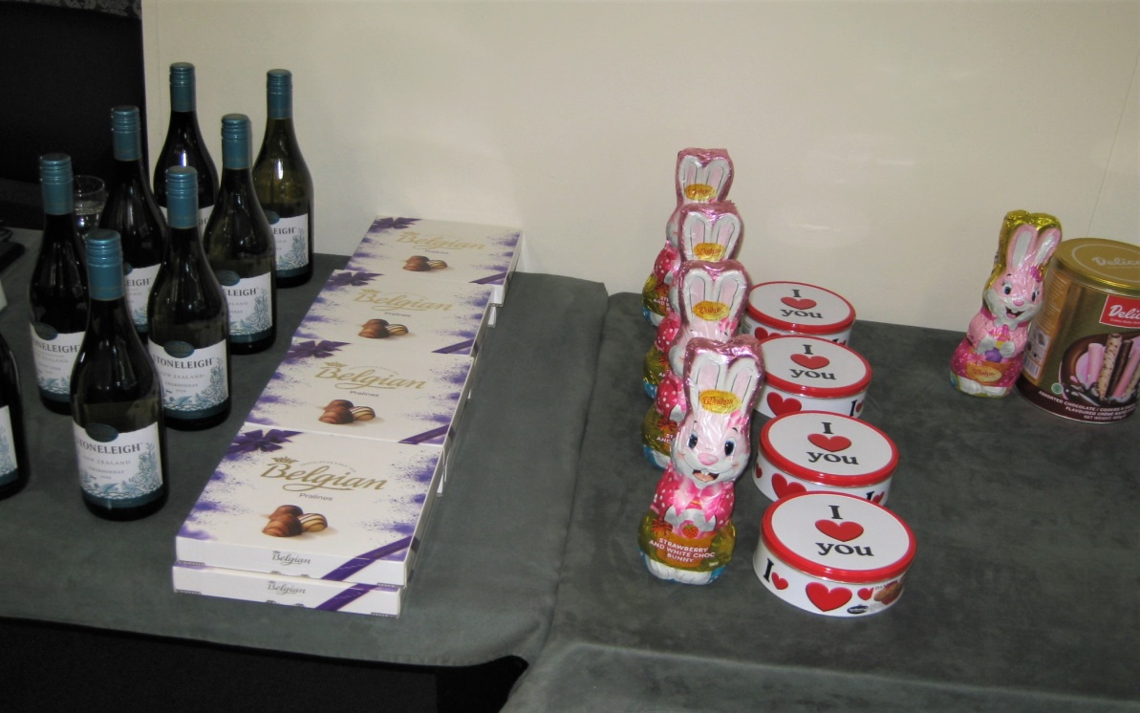

Plenty of wine and plenty of carbohydrates. Yes, Trevor, yes, this array of alcohol, chocolate, biscuits and Easter eggs, revealed a total disregard of health and nutrition advice but it is clearly much more popular than fresh lettuce, carrot and crisp salad options.
David Stagg and Hugh Norton were winners in Section D, ahead of Alan and Marsha Stevens.
And not only did they win their section, they leap-frogged over many more fancied pairings (well, more experienced anyway) to come second across the overall field. That was a really notable result. Well done, you two.
In section C, Tina Connell-Pine and Yvonne Rowe were first, ahead of Keith and Marg Lees. 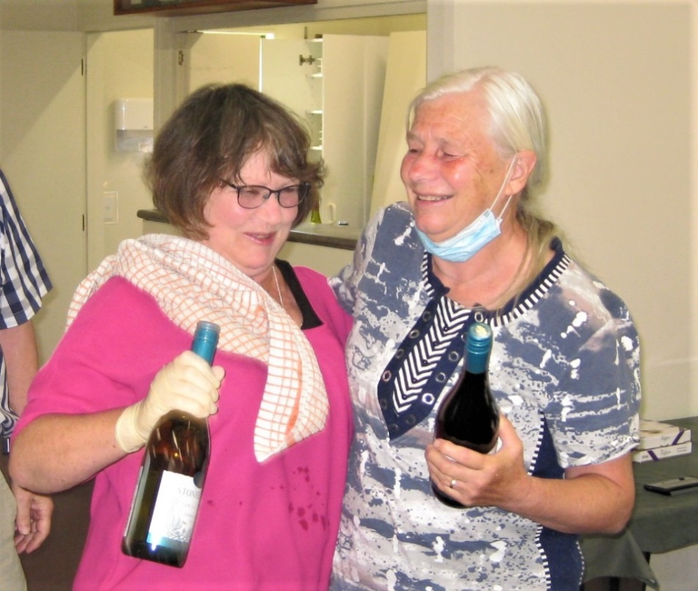
No, that is not a faux mask that is draped over Tina’s shoulder . . . to be fair Tina had to make a spirited run to claim her prize, a desperate sprint from her work in the kitchen to the podium.
In Section B, Ian Nicholls and Lauren Nalder prevailed over Brian Pender and Ray Cachemaille.
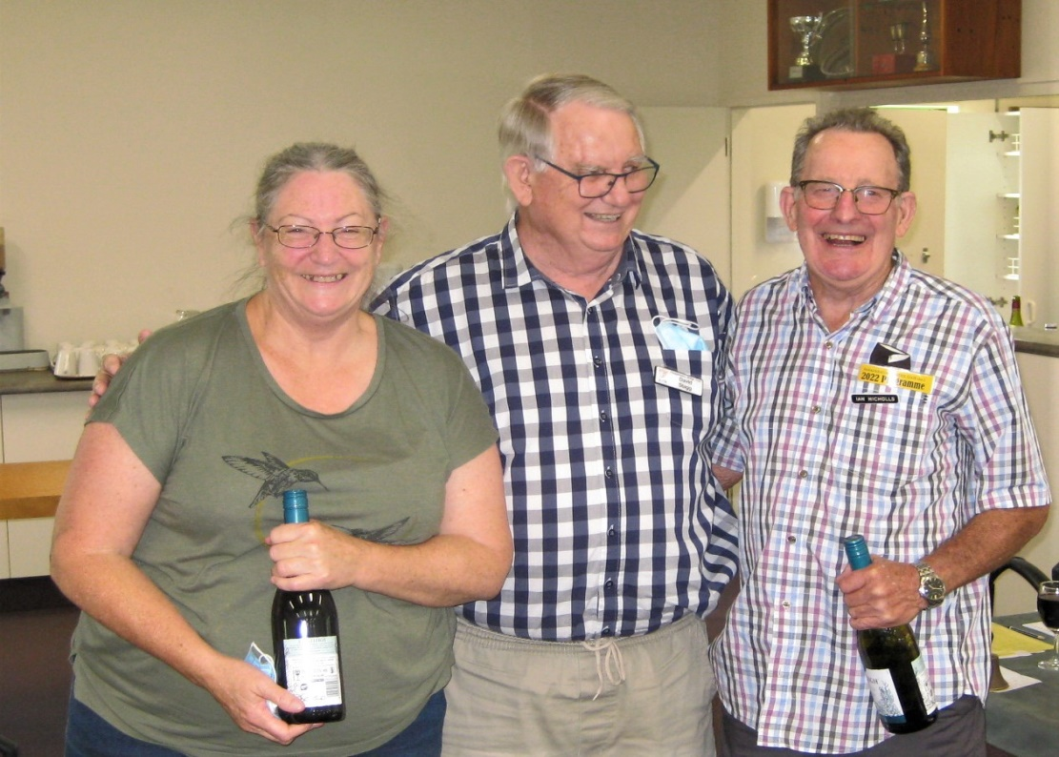
Yes, big grins all round as Ian and Lauren pick up yet more wine.

While Brian and Ray seem just as happy with second prize. A formidable looking front row, but a quick note to Linda – Brian will just have to bulk up a bit, especially at tighthead prop.

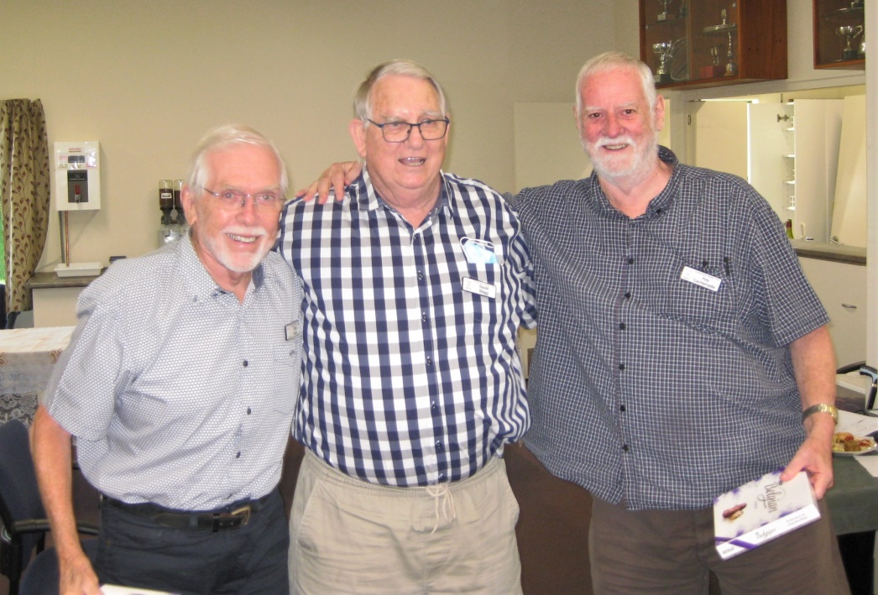

And, finally, Pauline Reid and Lucy O’Regan won Section A and were overall winners across all sections. They beat Averil Wotton and Lynda Evans in that premium section.
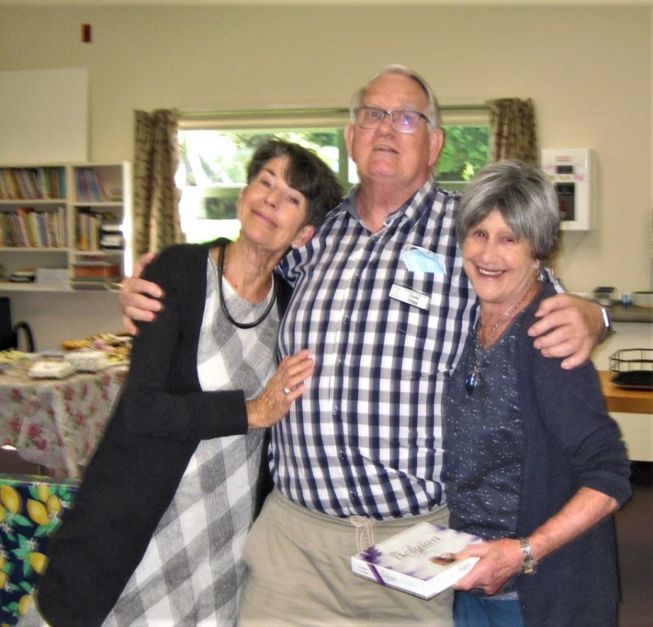
Here, Lynda “Lean-In” Evans and Averil “Always-in-the-Money” Wotton collect their prizes from Club President David Stagg who seems to be relishing all this attention . . .
Winners Pauline and Lucy are a tad more restrained but they deserve to be quietly satisfied. Not only were they the tournament winners, they achieved a score of 70% (nearly unheard of in a tournament such as this) and the next highest percentage was a distant 60% = a massive difference! Congratulations to you both! A great start to the bridge year for you.
And congratulations to Trevor for a highly organized and highly pleasant event. Thanks to Noella and Tina in the kitchen, Helen in the scoring room and Ray, an ever steady hand on bar duty. So satisfying to have an afternoon’s competitive bridge, a drink and some attractive food to complete the day in a friendly and warmly social situation.
(What about supporting our sponsor and paying them a visit? Knysna can be found between the Mediterranean WareHouse and The Warehouse, it is not a fastfood outlet but a Restaurant Bar, offering typical Kiwi fare but with a South African influence. It is open till 3.00 most days and till 8.30 on Thursday/Friday/Saturday nights. Tell them you are paying a visit in return for their generous sponsorship of our club.)
70% CLUB
That Pauline and Lucy reached that mark has already been noted but Narita Breingan and James Jones also achieved a 70% score at the end of January. (A smallish field, but still a high score.)
MST TICKETS
Members are notified that they need to allow 10 days from order to delivery.
Payment: Either (a) via Bank account (see the details in your programme book). You must include the references, ‘MST’, Name, Bridge Computer Number
Or, (b) via cash (in an envelope). Place your order in the Treasurer’s slot in the office, marked “MST” and include your Name.
EMAILS
“Sender” will from now on be the Paraparaumu Bridge Club rather than Admin. This should make for easier recognition. Also some members have reported not receiving our club emails. Please check your Junk/Spam folders, and mark as “Allowed” if your bridge emails have been ending up in Junk or Spam folders.
HANDICAP SESSIONS
Please note that all Tuesday and Thursday evening sessions are Handicap sessions. All club members can play at any club session but New/Novice/Junior members give themselves their best chance at winning a competition if they play on those nights, as the results are adjusted to determine the competition winners. (Of course, there are various Handicap sessions on offer on other days as well.) Check your programme books.
LEARNERS’ CLASSES
These begin on Monday 14 March with an introductory session followed by 10 Monday nights of lessons. Teacher = Trevor Smith. Organiser = Linda Pender. If you know someone who might like to learn, they could contact Linda (905 5647). It is not too late to join (though nearly).Various mentors will also be helping.

SOME UPCOMING TOURNAMENTS
Our next tournament is on Sunday 27 March. A two session contest, Open class, with A points there for the taking . . . Some of our better players should be eyeing this opportunity. Note, this is not an “in House” tournament. It is sponsored by the Kapiti Retirement Trust. And it will be played in “RealBridge” ie not at the club, but on computer/device.
Members should also consider noting our Bloom Hearing Intermediate Pairs Tournament will be held on Sunday 15 May.
Further afield ? What about the Wairarapa Intermediate and Junior Pairs (3 April), the Levin Multigrade Pairs (16 April), or the Hutt Open and Junior Pairs (15 May)??

TO “DOUBLE” OR NOT TO “DOUBLE” ?
Finally, a “double” introduces just that sliver of real tension, doesn’t it? At once, it ups the stakes. (And then, there’s also that quiet satisfaction when the opposition have “doubled” and YOU MAKE IT!)
But is the increased tension good for you?
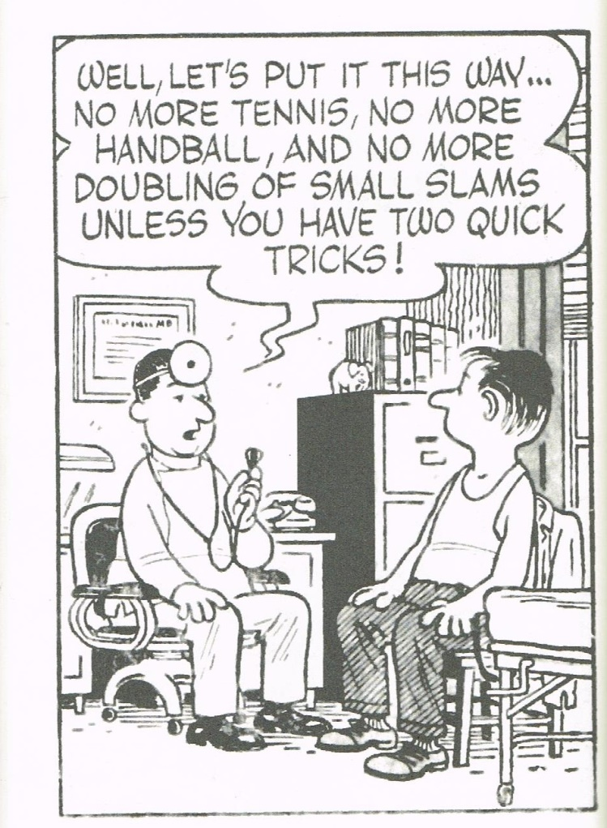

EDITOR: Keith Lees

