PARAPARAUMU BRIDGE CLUB DECEMBER 2021 NEWSLETTER
Meri kirihemete me te tau hou !
OK, I know, I know, a lot to catch up on. No newsletter since early August. Not good enough, perhaps, but we were Covid-closed throughout September and then well into October, so not so much to report.
The Law Connection Pairs was held in late August with a good turnout (31 pairs competing). Overall winners were Pauline Reid and Lucy O’Regan (and winners of Section A) with a very impressive percentage score of 66%. Marie Groves and Lorraine Borland were second overall (and winners of Section B).
They were followed by Dennis Lahman and Leon Hunia, then Ian Nicholls and Laurel Nalder (who also won Section C).
Below, Laurel seems reasonably satisfied while Ian is in sheer delight. The Law Connection Sponsor (thanks to you) looks on.
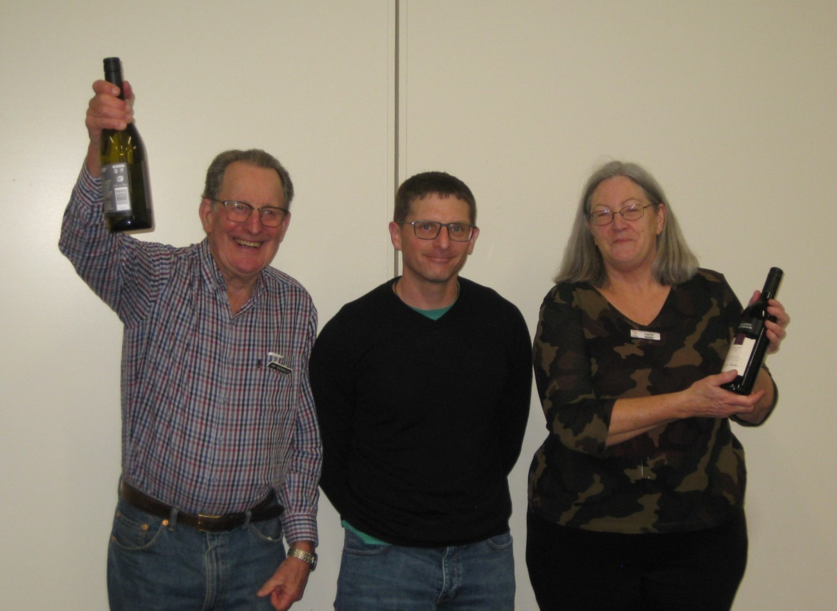
Other Section winners were Yvonne Rowe and Lindsey Bryson (in Section D) and David Stagg and Hugh Norton (Section E). Alvaro Lacunza and Martin Wren were second in Section D (and some more about Alvaro and Lindsey later).
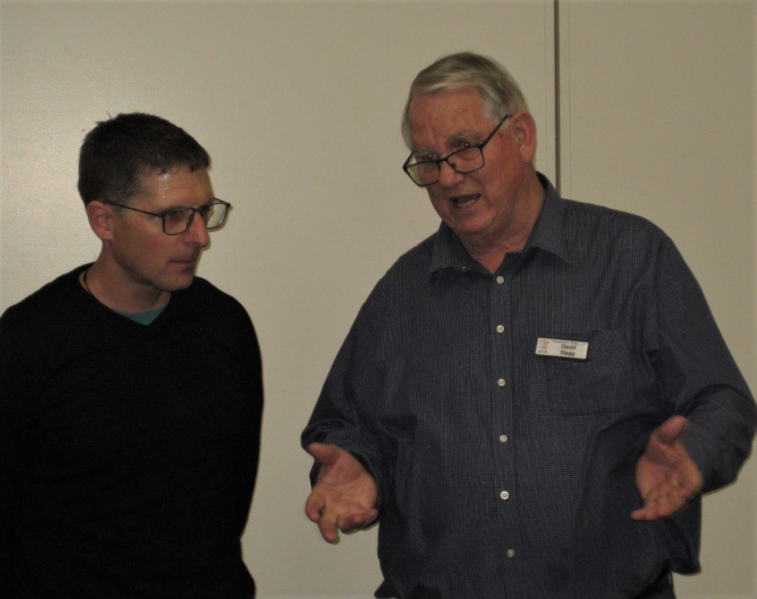
Here, President David Stagg explains to our Sponsor how much the Sponsorship needs to increase in 2022. “Could we have just this much more, please?”

Slam Club for 2021
Simply, there was the winner, Jane Bradbury and then there was a large gap through to the rest of the field. Jane bid and made 38 slams (to 17 November). Doug Galyer and Pauline Reid were the best of the rest.

70% Club for 2021
Not surprisingly, the usual suspects. Claudia Duncan and Francie Vagg notched the best percentage score of the year, 73.61%. But it was a near run event with Marie Groves and Jane Bradbury very close with 73.58%. Helen Edwards and Leon Hunia were third.

The Most Promising Beginner (Couch Award)
This was awarded to Adrienne Watkin (acknowledged at the AGM in November).

Now, a giant leap to last weekend’s Forsyth Barr Christmas Pairs.
Members entered into highly decorated and brightly festive clubrooms. A full room with 32 pairs contesting this one session tournament on December 12, through 7 Sections . . . so plenty of prizes to be distributed. Thanks to Forsyth Barr who have been sponsoring bridge at our club for well over 25 years.

Averil Wotton and Linda Evans were the Section A winners, followed by that wonderfully consistent pair, Pauline Reid and Lucy O’Regan.

Here, Averil and Linda seem to be combining to suggest to the Sponsor’s rep that he is welcome to return at any time. And he does seem, well, to be enjoying their friendly attention . . .
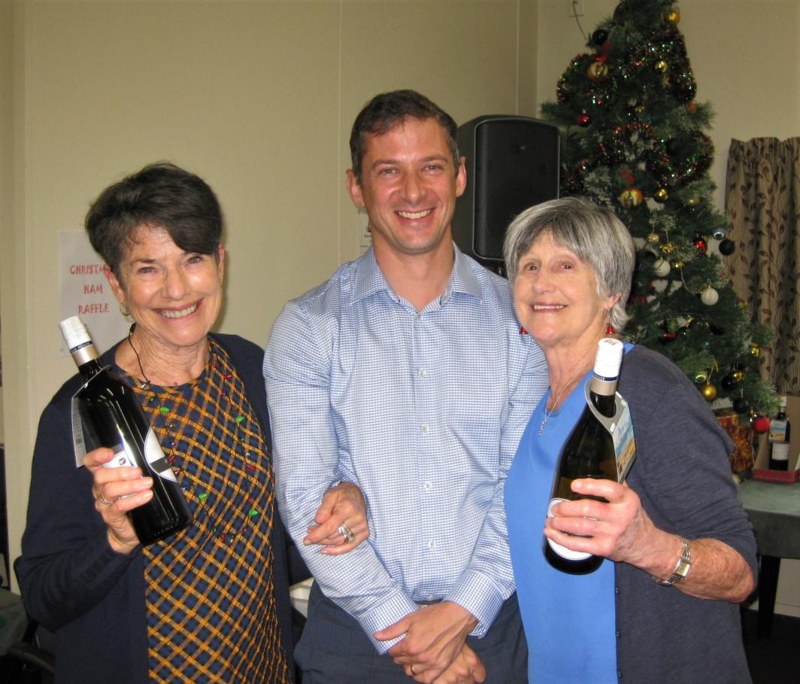

James Jones and Tom Ransom were the winners of Section B with Pat McArthur and Dennis Lahman in second place. But James and Tom were the overall winners of this year’s Christmas tournament, so well done to both of you! A minor on-going problem from the day is shown here: when is wearing “the mask” the right approach? James and Tom got plenty “right” on the day but obviously couldn’t decide on a team approach to the question : to “mask” or not to “mask”??
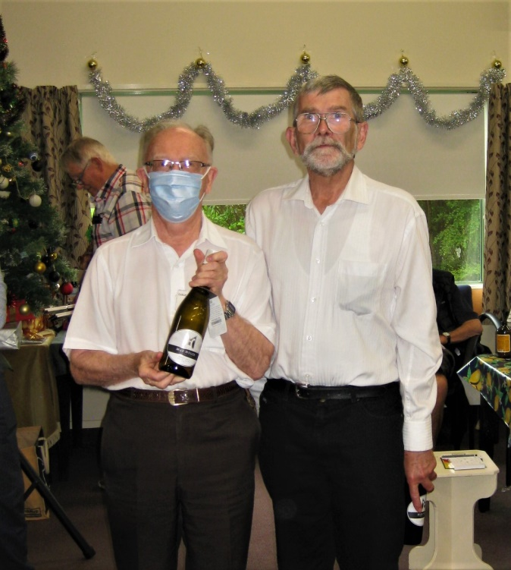
Section C was won by Jocelyn Graves and Fay Manley, with another tournament placing by Ian Nicholls and Laurel Nalder who were second.
Section D winners were Linzee Inkster and Moira Wilson, captured here with Moira’s very festive reindeer antlers on vivid display. Look at those smiles!
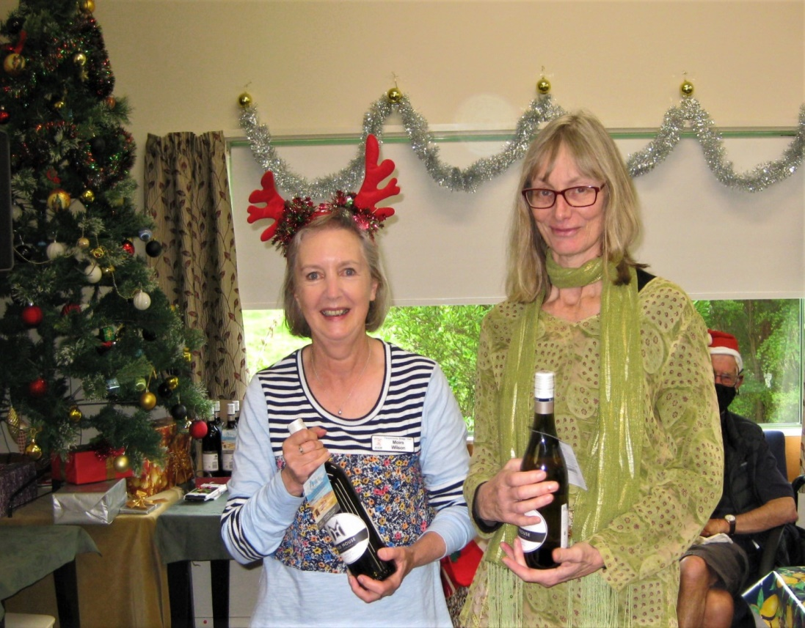

Section E winners were Marsha and Alan Stevens . . . Marsha always holds a bottle of wine so easily and naturally and that is a truly elegant shirt, Alan.
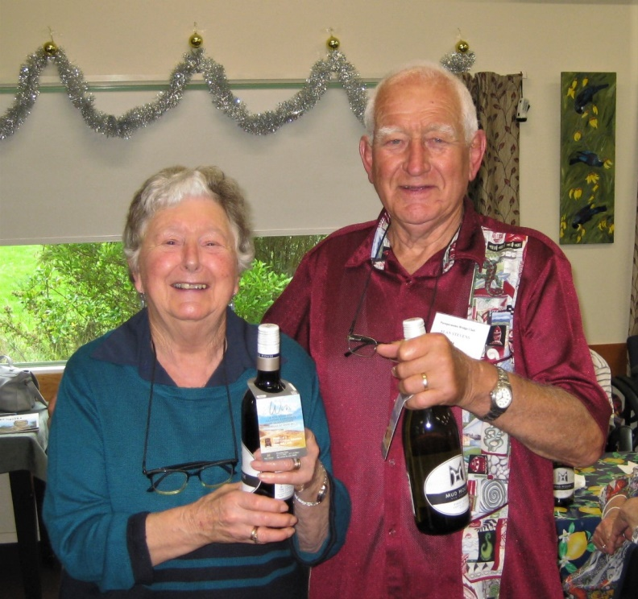
Finally, the winners of Section E were Lindsey Bryson and Alvaro Lacunza. Much more importantly, they were placed SECOND across the whole field! And for my money this was THE outstanding result of the afternoon. Both Alvaro and Lindsey are relatively new to the game, they entered with only a meagre single rating point each, and then they combined to beat many very experienced and capable players,
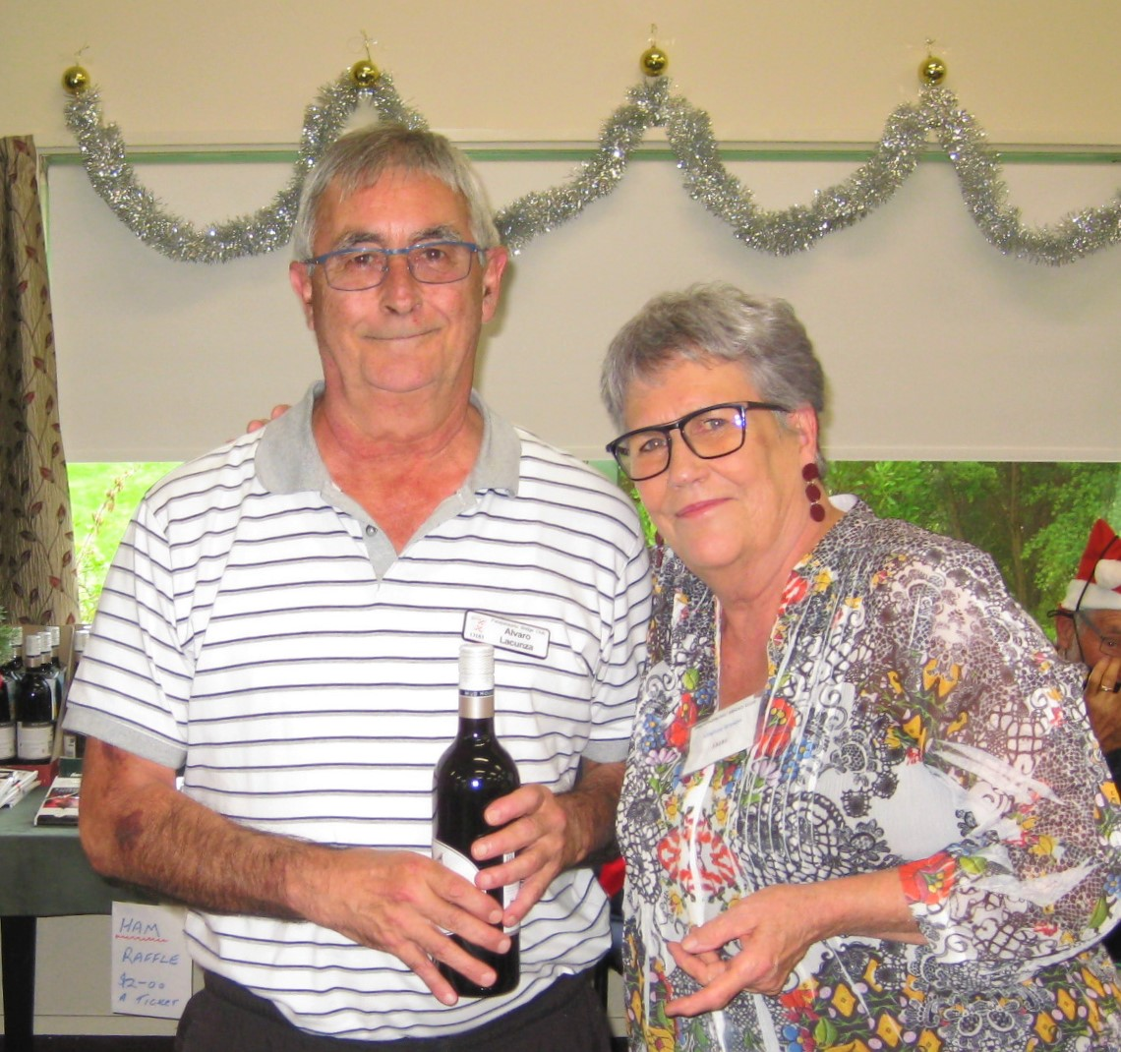
Here, above, Alvaro and Lindsey certainly appear pleased but also restrained, almost as if wondering “what have we just done?”

It was a wonderful afternoon’s entertainment and a positive finale to this most difficult year. As David pointed out it was particularly pleasing that so many entered into the spirit of the Christmas Tournament and dressed so well. Well (?) . . . well, maybe there was more elan (and joie de vivre) than true elegance.
This year the Editor’s Award for Elan and Elegance was given on the day itself after various members were encouraged (dragged) to the podium for closer inspection. There was indeed a bewildering array of Christmas array, of trinkets and earrings and antlers and T shirts and sparkly lights and socks and red and green and white everywhere you looked.
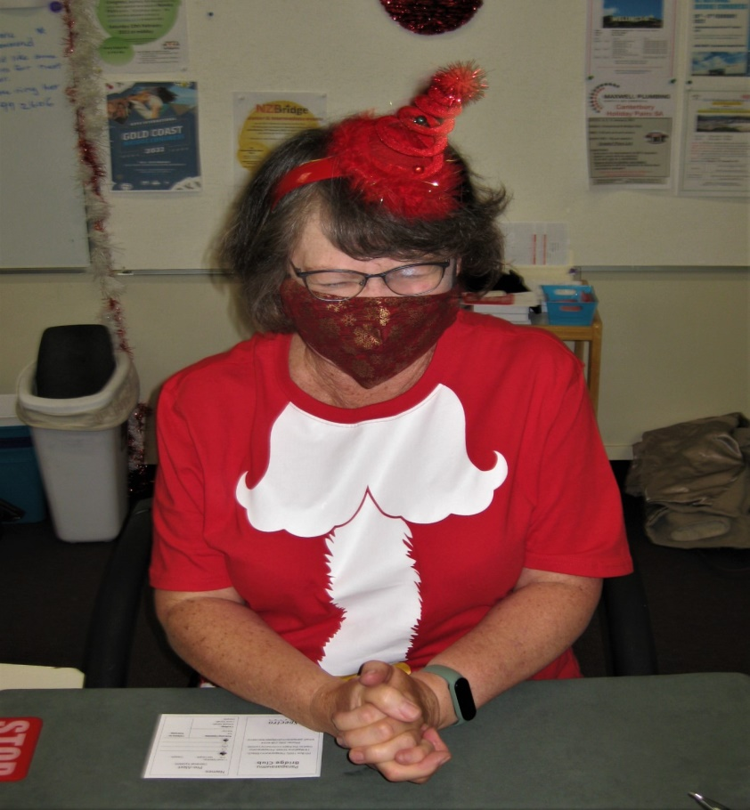
For example, elfin Tina is resplendent in red but what is she praying for? Better cards? Or, the right responses to Stayman? What system are we playing again?

And here, Santa has forgone the Ho Ho Ho! for a more reflective approach to the giving of presents . . . “I do wonder if Linda will really like that new vacuum cleaner when she opens my present on Christmas morning?”
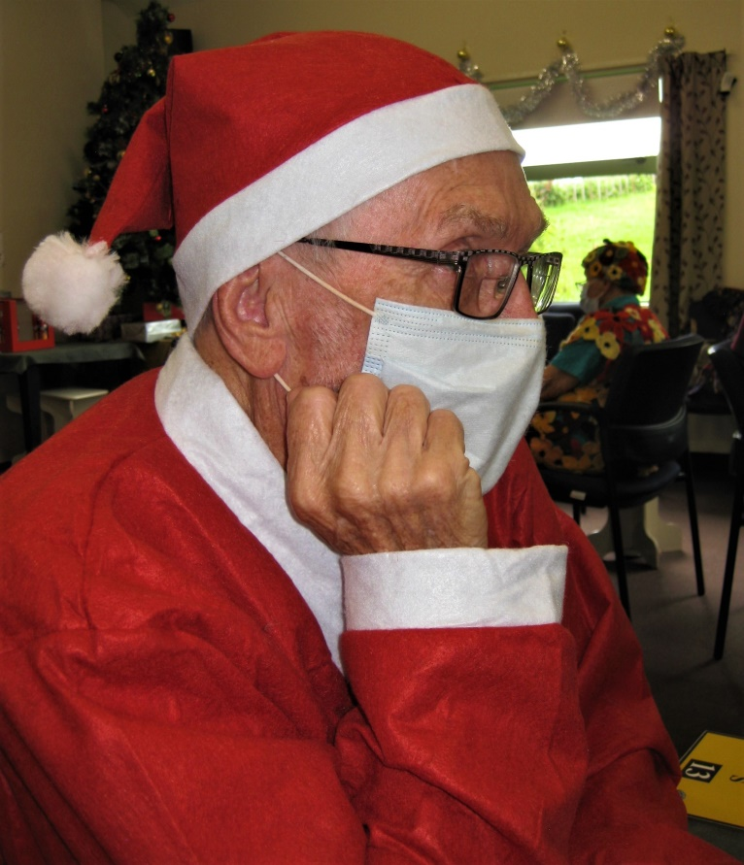

And Chris Farrow and Elva Brown are always up for the spirit of Christmas.
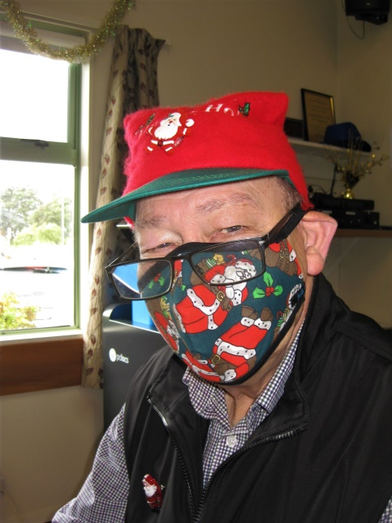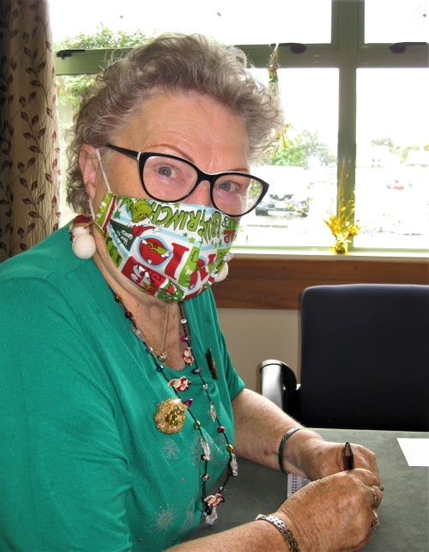

President David Stagg is a massive supporter of the festivities and always prepared to put that spirit out there . . . overall a pleasing effort, and full marks for the reindeer antlers, but David, David, while those red shorts may symbolize the season they will really have to go. No “elegance” there at all, mate.
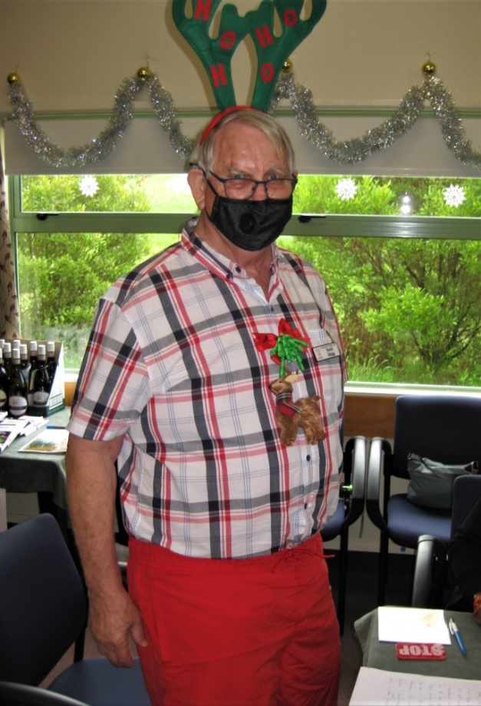
In the end, the Editor’s Award for best dressed went to a matching pair, Jan Foley and Jane Gilbert, combining red tops and black trousers with Christmas earrings and massed holly necklaces adorned even further with striped candy canes. Well done to the two of you.
A final thank you for such a cheerful and positive conclusion to bridge in 2021 is extended to Noella and Tina in the bustling kitchen, to Ray tending the well stocked bar, to Michael Stace for his efficiently low-key directing, to Helen for the scoring, and above all to Trevor Smith who was the Tournament Manager of the 2021 Christmas Pairs.
Get back into this great game in January. Enjoy those open sessions before the scheduled competitions begin. The best to all of you this Christmas and into the New Year. And, as well, all the best for your bridge in 2022!
Kia kaha, kia manawanui.
EDITOR: KEITH LEES

