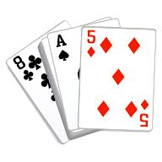
NEWSLETTER NO 2 FEBRUARY 2013
The Bridge year is well under way and we have already had two tournaments.
The Interclub against Waikanae was won by Paraparaumu by 5 points.
Congratulations to the junior team Tina Connell-Pine, Helen Horsfall, Anna Kennett and Fay Manley who did so well.
The In House tournament was sponsored by Pak ’N Save
Thanks to all those whose hard work made these events such a success.
Club members are reminded that if they sign up for an event they must let the organisers know in good time if they cannot be there. This is not a normal club day and it makes it very difficult for the organisers who try to avoid having a phantom
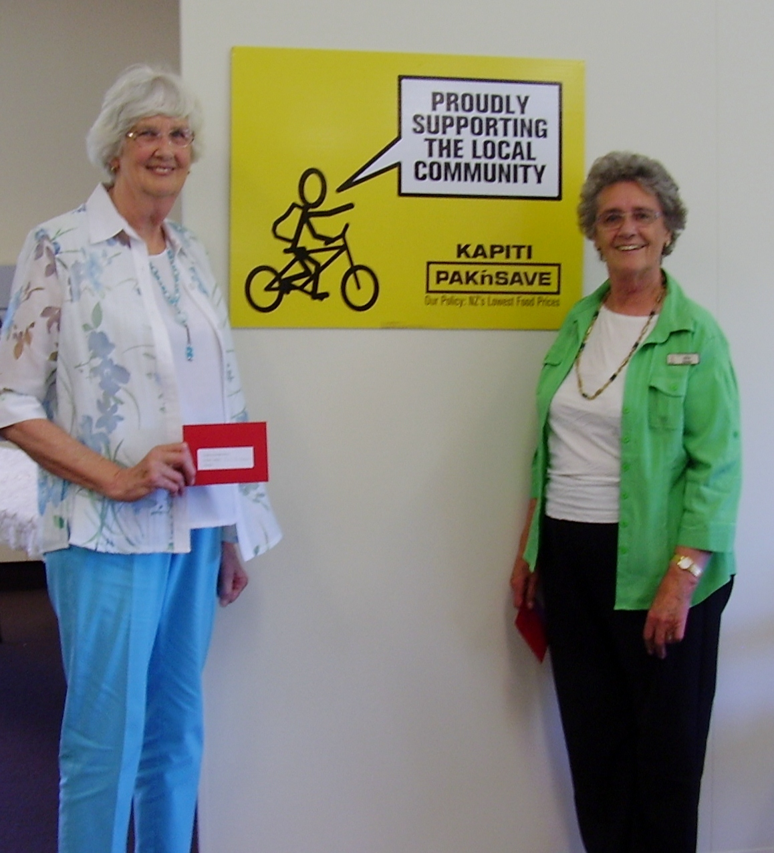
Winners of the Section A prize in the In house tournament: Lois Anderson and Alice Henke.
Alice Henke

^{Coming events}
March 11 Beginners’ lessons start on Monday nights
March 10 Open Tournament sponsored by The Floor Store Ltd.
Please sign up – the list is on the notice board

.Different formats for bridge sessions
X clubs. This is a way of playing simultaneously with other clubs. It was trialled last year and the committee decided not to approve it for normal club events this year.

^{The Howell movement}
A presentation was made to the committee suggesting that we trial this as an alternative to the Mitchell Movement which we normally use. This is not new. The advantages are that each couple plays every other couple making it fairer and it may prevent people being phantom twice. What may be seen as the disadvantages are that only the first three pairs get C points, there is a lot more movement so it will not work if there are too many people with sitting rights. The committee agreed it could be trialled on a Tuesday night if there is a Director willing to run it but so far none of our Directors are willing to do this.

^{New Computer}
The committee agreed to the purchase of a new computer. Thanks go to Ralph Brown for his work on this and to Helen, Marion and the Scorers for their tolerance whilst this was being installed. A few heated emails were sent during the process

^{Directors}
There is always a need for more Directors especially for Thursday night. Anyone who would like to give it a try will be partnered with an experienced Director. Let Jean Murray know. A course will be run if there is enough interest.

^{Scorers}
If you are interested incoming a scorer, please contact Helen Edwards. We are short on Monday, Thursday day and Friday.

^{Entertainment Book}
If you are interested in purchasing the latest Entertainment Book please let Jane McArthur know.

^{Chairs}
Bill van Waas and Tony Gibbons have developed a process to strengthen the backs of the chairs we are currently using. This will lengthen their life by possibly two years and give us time to raise funds for new ones. Tony is donating the materials free of charge and he and Bill will do the necessary work on Saturday afternoons when they have time.

^{Raffles}
There has been some very positive feedback about the Raffles Anna Kennett is running. Please continue to support her. The prizes are innovative and interesting. Thanks also to Beverley Ferrier for donating the bottle of Gin and a watch and to Irene Galloway who won the hamper but donated it back to the club

^{A little bit of History}

Many of you will not know Clarice Lochead, a long standing member.
Clarice will be 97 this year and still plays bridge on Friday afternoon. For many years whilst we were fund raising for the new building and also when we moved into it Clarice raised $10,000 over a number of years by running raffles

^{The last word}
Several times the building has been left open or windows have not been closed. Although it is the Director’s responsibility to ensure this is done, it would be most helpful if members could leave their table tidy with the chairs pushed in and close any windows they see open. At night, if you are the last out of the toilets make sure the light is turned off. It is very easy to walk out and leave it to others.

^{Jennette Newport}
^{President}

