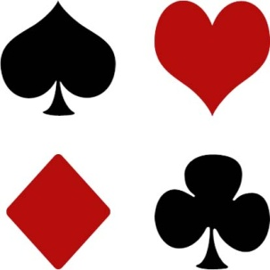
Paraparaumu Bridge Club Inc

NOMINATIONS

Nominations For the 2013 Officers and Committee are now open and you should give consideration to offering your services to the club in this area. The offices of President and Secretary are vacant and it is particularly important that these be filled. “Ask not...etc.”

THURSDAY
The results of the straw poll indicated a majority wish for Thursday to continue as an am/pm session - so it will.

MONTEITHS PUB QUIZ
Thank you to those who have entered a team in this fun evening at Monteith’s Pub on Sunday, November 11 starting at 7 pm. You may have a meal there beforehand if you wish. We need at least four more teams so get your name down!

DIRECTORS
There is a continual need to bring on more directors so a further training session is being organized for Saturday October 20 from 9.30am-12 noon at the club. As well as for budding directors this session will also be appropriate for members who just wish to update themselves on the rules. If you haven’t registered just come along.

BABICH PAIRS FRIDAY, NOVEMBER 2, 7 PM

There has been a good response so far, but room for many more pairs to enter. This is an excellent tournament to check your play with the ideal through a booklet on the hands provided after the event. It is suitable for all skill levels. Have a go.

TOURNAMENTS

Congratulations to all those who played in the Jackways Shield competition against Kapi Mana club which we won.

Congratulations to Phillipa Gardiner and Trevor Gane who came second at the recent Waikanae Intermediate/Junior tournament. Our three other pairs were in the middle of the field.

BRIDGE IMPROVEMENT – SHORT NOTICE

First level improvers. All day Saturday November 3. Wellington Bridge Club. Run by Alan Grant. Entry $40 includes books and material. Notice on board.

NEW MEMBERS
A pleasing swag of new members from the current lessons: John Ashton, Barbara Ashton, Paul Benefield, Angeline Bryan, Heather Carter, Mike Cunniffe, John Fairbairn, Kristen Hickman, Monica Martin and Jan Wilson. Please make them welcome.

NAME TAGS
Speaking of which, why is it so difficult for some members to wear name tags. Starting to play bridge for new members is harrowing enough without not knowing who they are playing against. Please make an effort.

ANNUAL GENERAL MEETING

This is to be held at the clubrooms on Monday, November 19, at 7.30pm. Be there.

