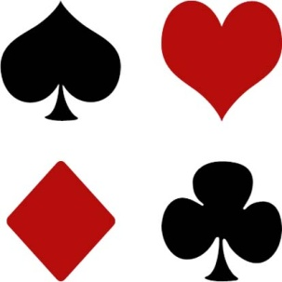
Paraparaumu Bridge Club Inc

MONSTER GARAGE SALE
This proved to be a very successful day with just over $1600 being raised. A very big thanks to the volunteers who assisted by bringing stuff in, helping sort it out, selling it and, some, buying stuff. We all enjoyed the day working together.

2013 PROGRAMME
The Committee is now working on the 2013 programme so if you have any thoughts or ideas could you let a Committee person know.

One major change being contemplated is moving Thursday from a 10.30am start to a 1pm time slot. Before any final decision is made we would welcome your comments.

MONTEITHS PUB QUIZ
Following the successful evening with more than 60 members attending the quiz in May, it has been decided to hold a further fun night on Sunday, November 11. Full details will be posted on the notice board shortly. In the meantime you might like to begin getting a team of friends together to compete.

DIRECTORS
There is a continual need to bring on more directors so a further training session is being organized for Saturday October 20 from 9.30am-12 noon at the club. As well as for budding directors this session will also be appropriate for members who just wish to update themselves on the rules. A notice will be posted shortly.

TOURNAMENTS
The Multi Grade tournament this Saturday has been fully subscribed with twenty-four tables.

More players required for the Jackways Shield match against Kapi Mana September 30. See notice on board.

Check out the other tournament notices and consider entering.

The Babich New Zealand Wide Pairs will be held on November 2 and is a popular tournament. Notice on board shortly.

BRIDGE IMPROVEMENT
Waikanae are holding improver lessons and you are encouraged to attend. There will be five classes of two hours on Wednesday evenings starting on October 24, at a fee of $25. A notice is one the board.

NEW MEMBERS
Lynda Evans and Jenny Smith. We look forward to seeing you playing often. Please make them welcome.

PLAYING SESSIONS
The number of players at some sessions has been declining. Our Table Conveners do the best that they can to promote and arrange attendance but it really depends on the members themselves. If you want to play but have no partner ring the Table Convener who will almost always find someone to play with you.

