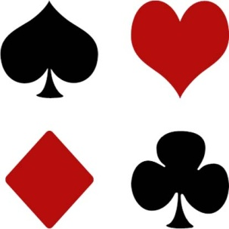
Paraparaumu Bridge Club Inc

New Years greetings to all. We trust you will have a very active and successful year at bridge.

Our aims for 2012 are the same as last year: complete the refurbishing; actively pursue increased membership; and help improve your bridge game. We look forward to your support in all these areas.

REFURBISHMENT:
The carpet, curtains and drapes are now installed. The next task is to do the painting and decorating but because of the time it will take, this needs to be done over the break at the end of the year. We will need to raise about another $10,000 and are planning a Pub Quiz night, a couple of fun tournaments, and a Monster Garage Sale. Details of these events will be advised when appropriate and we ask you to become involved.

MEMBERSHIP:
Robyn will be running the next set of lesson beginning March 12. We will be advertising in the Kapiti News Club Section shortly and also on radio. As well we will follow up last year’s learners so they can reinforce the lessons from last year. Most new members come from personal contacts so if you know of anyone who might be interested, please twist their arm.

BRIDGE IMPROVEMENT
There will be various activities over the year but the first is the Richard Solomon Improvers’ Seminar on Saturday March 3. A notice is on the board and we would encourage your participation. Richard is the Bridge Director for NZBridge, editor of “New Zealand Bridge” and organiser of the Babich Pairs competition. If you register please complete the questionnaire so Richard can tailor the seminar to suit your needs.

TOURNAMENTS
We would encourage all members to take part in the various tournaments that occur during the year. The upcoming ones (details on the notice board as appropriate) are: Teams Competition with Waikanae on Sunday February 19; In House Tournament Sunday February 26; Open Tournament Sunday March 11. Put these in your diary now.

DIRECTORS, SCORERS, DEALERS.
The club is indebted to the volunteers who undertake these tasks. To lessen the load we would like to have a few more offer their services. If you are interested in helping please contact a committee member.

PLAYING TIMES
Generally a session of bridge takes three hours. But on occasion events may cause the session to run a bit longer. Members are advised to allow a reasonable time between the expected end of a session and any other engagements.

